Transcript: Civil Rights Lecture

[ON LOCATION, LINCOLN MEMORIAL]
THOMAS PATTERSON: The Declaration of Independence proclaims all men are created equal, yet when the Declaration of Independence was written, one in six Americans was in slavery.
Slaves were first brought to America in 1619. That was a year before the pilgrims landed in Massachusetts. Slavery lasted for 250 years.
In issuing the Emancipation Proclamation, Abraham Lincoln said, "I never in my life felt more certain I was doing right." Nevertheless, the repression of black Americans did not end with the Civil War. After the war, the white South established a two-race system. Blacks could not attend the same schools as whites. They could not go to the same restrooms.
They could not eat in the same hotels.
That two-race system crumbled because of what happened here about 50 years ago.
I'm at the Lincoln Memorial where, in 1963, Martin Luther King gave his famous "I Have A Dream" speech.
A quarter of a million people had gathered here.
They stretched all the way to the Washington Monument 3/4 of a mile away.
Said King, I have a dream that one day this nation will rise up and
live out the true meaning of its creed. We hold these truths to be self-evident that all men are created equal.
A year later, Congress passed the Civil Rights Act, which banned discrimination in restaurants, hotels, and other public accommodations.
The struggle of African Americans to achieve a fuller measure of their rights mirrors the struggle of other disadvantaged groups, including women, Native Americans, Hispanics, Catholics, Jews, Mormons, gays.
Each group has had to wait and to fight to get the rights and opportunities that more privileged groups took for granted.
#
[STUDIO PORTION]
Equality has always been the least well-defined of America's core values.
Even Thomas Jefferson, who penned the words all men are created equal
in the Declaration of Independence, declined to give equality an exact meaning. But whatever it meant, the writers of the Constitution knew it was incompatible with slavery.
Luther Martin, a Maryland delegate to the Constitutional Convention, declared that slavery is inconsistent with the principles of the revolution.
So how many provisions for individual equality do you think there are in the Constitution as originally written--
1, 2, 3?
Actually, the answer is zero.
There's not a single provision for equality in the original Constitution.
How about inequality?
How many times is it addressed in the original Constitution?
The answer is three times.
I'll describe them later.
Here's a final question.
How many of the Constitution's 27 Amendments explicitly provide for individual equality?
One of them-- it's the 14th Amendment which says, in part, no state shall deny to any person within its jurisdiction the equal protection of the laws. Now a single Constitutional reference like that might seem somehow insignificant. However, the 14th Amendment's Equal Protection Clause is one of the Constitution's most important provisions.
It's a cornerstone of American's civil rights.
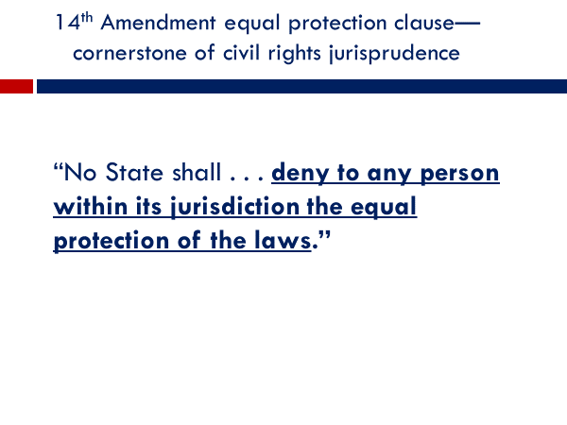
In this session, we'll look at issues of civil rights or as they're also called, equal rights.
In a previous session, we discussed civil liberties, which are ndividual rights, such as freedom of speech, that are protected from action by government.
In contrast, civil rights have to do with whether members of particular groups--racial, ethnic, religious, gender, and the like-are treated equally by government and in some areas by private parties.
In this session, we're going to focus on three pivotal civil rights policies--
the 14th Amendment's Equal Protection Clause,
the 1964 Civil Rights Act, and
affirmative action.
#
When the Framers met in 1787 to write the Constitution, the issue of
Slavery nearly brought the convention to a halt. Slaves were concentrated in the South, which had a plantation economy. On the other hand, the North was made up largely of small businesses and family farms. It had little need for slave labor.
To many of the Northern delegates, the writing of the Constitution presented an opportunity to phase out slavery, but the South's delegates weren't buying. South Carolina's John Rutledge declared, we will never be such fools as to give up so important an interest.
The South's delegates threatened to walk out on the convention and form their own union if slavery was abolished. The Northern delegates gave in, negotiating a series of compromises in order to save the union.
One such compromise was the Fugitive Slave Clause.
It required all states to return a runaway slave to the state of origin.
A more contentious issue was whether slaves would be counted in determining a state's population, which would affect the number of seats it would hold in the House of Representatives.
Southern delegates wanted slaves to count one for one.
Northern delegates didn't want to count them at all since they were denied citizenship. After heated debate, the delegates agreed to a compromise. Each slave was to be counted as 3/5 of a person.
This formula meant that the South would control roughly 45% of House seats, rather than the less than 40% it would have if slaves were not counted.
The South was looking ahead. It would need a strong presence in the House to stave off future attempts to abolish slavery.
The Northern states did wring one concession out of the South.
It was a Constitutional provision that gave Congress the power after a 20-year delay to ban the import of slaves.
When that time came, Congress did ban their import, though by then, the slave population was large enough to be self-sustaining.
70 years after the Constitution was written, its slave clauses led to what is widely regarded as the worst decision in the Supreme Court's history.
In its Dred Scott ruling, the court used convoluted logic to conclude that African-Americans, even those who were not slaves, were not citizens and never could be. Black people or instead items of property to be bought and sold like any other piece of merchandise. The court supporters claim that slavery was actually good for blacks, that they were better off in the care of a master.
After hearing countless such arguments, Abraham Lincoln remarked, "whenever I hear anyone arguing for slavery, I feel a strong impulse to see it tried on him personally."
The Civil War brought an end to slavery, but not to the mistreatment of black Americans.
They thought the war had assured them their rights.
The 14th Amendment, ratified in the war's aftermath, prohibited states from denying any of their residents equal protection under the law. But as soon as the Union troops left the South, its white majority governments began to suppress the black population.
They were forbidden to attend the same schools, use the same hospitals, or access the same public accommodations as whites.
In an 1898 ruling, Plessy v. Ferguson, the Supreme Court upheld that arrangement, saying that separate facilities for blacks were Constitutional as long as they were equal.
It was a farce.
The court knew full well that the South had no intention of providing blacks with equal facilities.
Black children were forced to use the white schools' worn-out books and desks.
Black hospitals had to get by with almost no medical equipment.
At times, Southern states didn't even bother with appearances. The state of Texas, for example, forbid black students from enrolling in its law school, but never built them one of their own.
America's system of racial discrimination came into sharp focus during World War II.
Black soldiers helped defeat the Nazis and their fanatical brand of racism.
12 million Jews and Slavs were murdered in Nazi concentration camps.
At war's end, it was clear to all but the white South that the United States had to change. In 1954, the Supreme Court took a strong step in that direction. In Brown v. Board of Education.
The court ruled that racially segregated public schools violated the 14th Amendment's Equal Protection Clause. Said the court, separate educational facilities are inherently unequal.
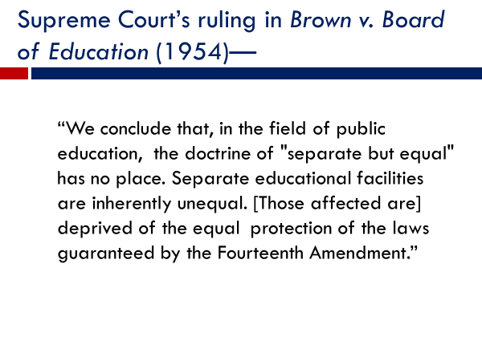
That decision enraged the white South.
Billboards on Southern highways called for the impeachment of Chief Justice Earl Warren.
In Arkansas, President Dwight Eisenhower had to dispatch federal troops
to quell the rioting surrounding the desegregation of Little Rock Central High School.
Little Rock was not an isolated case. It took 500 US marshals and a US army unit to desegregate the University of Mississippi.
As the first black student, James Meredith, entered the university, white students yelled out racial insults, vowing to make his time on campus a living hell.
The Brown decision set an important precedent. It marked the first time the Supreme Court had forcefully applied the 14th Amendment's Equal Protection Clause. In ensuing years, the precedent served to advance the civil rights of other disadvantaged groups. Women were one of these groups.
Women had long been treated as second-class citizens.
They were, for example, effectively barred by law from working in a number of occupations.
One such law effectively kept women from becoming commercial pilots. Under the law, unless the skies were clear, they couldn't fly a passenger airliner. So on a cloudy day, they had to sit it out. No one would hire them, obviously.
Today, due largely to the 14th Amendment's Equal Protection Clause, nearly all such laws have been eliminated. One of the few that remains is registration for the military draft.
At age 18, men are required to register, but women are not.
The Supreme Court in 1980 upheld that law, saying government had a legitimate interest in protecting women from involuntary combat duty. Women can volunteer to serve in combat in time of war, but cannot be compelled to do so.
Asian-Americans, Native Americans, and Hispanics are among the other groups that have benefited from the Equal Protection Clause.
An example is a 1982 Supreme Court decision striking down a Texas law that prohibited undocumented immigrant children from attending Texas public schools. The Equal Protection Clause has also served to protect gays and lesbians.
The Supreme Court applied the clause in 2015 in striking down state laws prohibiting same-sex marriage. Writing for the court's majority, Justice Anthony Kennedy said, "the generations that wrote and ratified the Bill of Rights and the 14th Amendment did not presume to know the extent of freedom in all of its dimensions. And so they entrusted to future generations a charter protecting the right of all persons to enjoy liberty."
Now the Brown decision in 1954 signaled the end to state-sponsored segregation.
But public schools and hospitals were not the only segregated facilities in the South.
Blacks were not allowed to use hotels and restaurants reserved for whites.Even famous black Americans, like the singer Ella Fitzgerald and the baseball player Jackie Robinson, were denied access.
Now why was that allowed?
Why was discrimination of that type not prohibited by the 14th Amendment's
Equal Protection Clause?
Look again at the wording of the Equal Protection Clause.
Notice that it prohibits discrimination by state government.
It says nothing about discrimination by private parties, such as hotels and restaurant owners.
Relief from discrimination at their hands came in 1964 with passage of the Civil Rights Act, which prohibits discrimination by owners of public accommodations.
An Alabama restaurant owner challenged the law, arguing it violated his rights.
The Supreme Court ruled otherwise, invoking the Constitution's Commerce Clause, which gives Congress the power to regulate interstate commerce. The court held that Congress has the power to regulate local business activity, such as hotels and restaurants, as long as any part of that activity is related to interstate commerce, for example, an out-of-state employee needing a meal or a room.
Passage of the Civil Rights Act produced one of the most drawn-out fights in congressional history.
Southern members of Congress tried every conceivable legislative tactic to defeat the bill, including a record-breaking 75-day Senate filibuster.
In the end the votes in the House and Senate broke sharply along regional lines, with nearly every member of Congress from the South voting against it and nearly every member from the North and West--Republican or democrat-- voting for it.
Public opinion also divided along regional lines.
A nationwide poll found that more than 90% of Northern whites but less than 50% of Southern whites thought blacks should be allowed to use the same parks, restaurants, and hotels as whites.
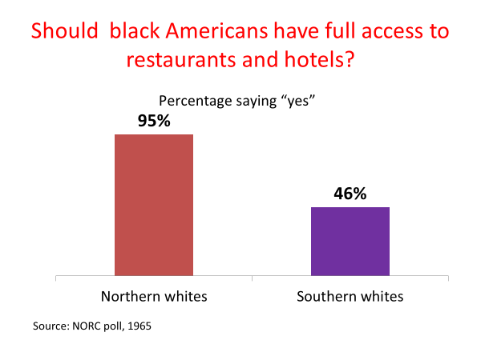
As yet unmentioned is another provision of the 1964 Civil Rights Act-the one that prohibits job discrimination.
It promised to be as important for women as for minorities.
Women had long experienced discrimination in the workplace-less pay for the same work less opportunity for promotion, less chance of being retained in a layoff. The Civil Rights Act reduced some of these inequalities, but did not greatly improve the job prospects of most women.
Now why was that?
Why was the Civil Rights Act less effective in addressing job discrimination than in addressing hotel and restaurant discrimination?
One reason is the job discrimination is a lot harder to prove. If 50 applicants apply for a job and a white male gets it, a woman or minority applicant has considerable difficulty proving in court that discrimination was the reason they didn't get the position.
It's also the case that a lawsuit brought under the Civil Rights Act normally helps only the individual directly involved. If you win the case, you get relief, but that decision doesn't apply to others in similar situations.
These limitations created demands for a policy that would change the ground. It would shift much of the burden of proof from the individual to the employer, and it would help a whole category of people rather than just the individual claimant.
What would you guess this policy is?
It's affirmative action.
Affirmative action refers to programs aimed at giving women, minorities, and other traditionally disadvantaged groups equal opportunities in employment, education, and other areas of life.
Affirmative action represented something new.
Earlier Civil Rights policies had targeted what's called de jure discrimination, which is discrimination based on law, as in the case of state laws mandating segregated schools.
In contrast, affirmative action targeted what's called de facto discrimination--the situation where historically disadvantaged groups, such as women and minorities, have fewer benefits and opportunities because of prejudice and the effects of past discrimination.
Affirmative action on a large scale began when Presidents Johnson and Nixon issued executive orders requiring recipients of federal grants and contracts to take steps to give historically disadvantaged groups equal opportunity.
Affirmative action shifted the burden of proof to the provider.
For instance, if a federal contractor hired a nearly all-male workforce, he needed to provide a compelling reason for the imbalance such as the physical demands of the job.
If the contractor failed to do so, the contract could be canceled.
As affirmative action took root, spreading to ever more firms and institutions, it met increased opposition. Polls indicated that most Americans, though believing women and minorities should have a fair chance, we're opposed to giving them preferential treatment.
In a 1977 poll, for example, more than seven times as many respondents expressed opposition to preferential treatment than supported it.
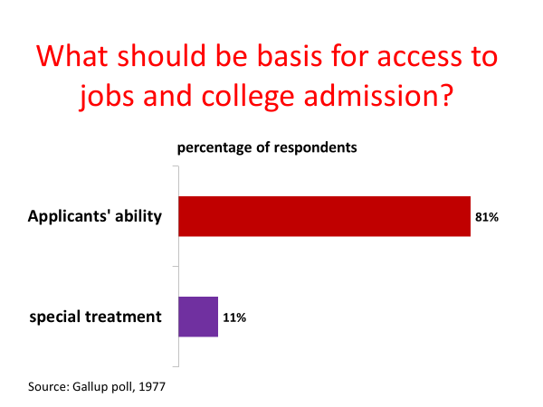
Some of that opposition came from unsuccessful job seekers and college applicants. They assume that they were denied an opportunity because it went instead to a woman or minority, unmindful of the fact that the odds might have been against them in the first place.
It's a bit analogous to a driver pulling into a parking lot that's full except for a space reserved for the disabled. The driver thinks he would have a parking place if the space was not reserved. In fact, however, if it didn't have a disabled sign on it, the space, like all the others in the lot, would have been filled earlier by another driver. Like parking spaces, jobs in college admissions are scarce resources. If you get a job, other applicants don't.
If you get admission to the college of your choice, somebody else is denied a slot. Not surprisingly, affirmative action has been the target of countless lawsuits.
In 1978, the US Supreme Court ruled for the first time on affirmative action.
Alan Bakke, a white male, had been denied admission to University of California medical school, even though his test scores were higher than several successful minority applicants.
Bakke sued this medical school, claiming it had violated his 14th Amendment Equal Protection rights by setting aside a specific number of slots for minority applicants.
The Supreme Court ruled in Bakke's favor, saying that the school's quota system was unconstitutional. However, the court also held that government has a compelling interest in fostering a more equal society.
Accordingly, it said that race could be taken into account in admissions decisions along with other factors such as an applicant's extracurricular activities, as long as race was not the decisive factor. The net result of the Bakke decision-quotas were unconstitutional but affirmative action per se was not.
In the 1990s, the Supreme Court, which by now was dominated by conservative justices, began to narrow the scope of affirmative action.
In a key 1995 decision, the court invalidated the federal law, setting aside a percentage of federal contracts for minority-owned firms.
The court said that affirmative action had to be narrowly tailored to fit the particular situation and that government had to have a compelling reason for granting a racial preference.
A minority-owned firm cannot benefit simply from the fact that other such firms in the past had been discriminated against. To allow that, said the court's majority, would be to violate the equal protection rights of competing firms.
This 1996 decision led some observers to conclude that the court was moving to the point where it might end affirmative action completely. That's opposition was tested in a 2003 case involving the University of Michigan Law School.
Its admission policy took race into account along with things such as an applicant's test scores, grades, and extracurricular activities. No specific weight was attached to any of these factors.
In a 5 to 4 decision, the Supreme Court upheld the admission policy, concluding it was narrowly tailored and served a compelling interest-the law school's goal of creating a diverse community in which students can learn from being around others with a different background.
That precedent still holds. Affirmative action is lawful policy, as long as it's narrowly fitted to the situation and serves a compelling interest.
That precedent was reaffirmed in a 2016 case involving the University of Texas at Austin.
The University was sued by a white applicant who after being denied admission claimed that her equal rights had been violated because of the university in its admission decisions had taken race along with extracurricular activity and other non-academic factors, such as musical or athletic talent, into account.
In a 4 to 3 decision, the Supreme Court held that the University's affirmative action policy met Constitutional standards, that it served the university's compelling interest in creating a diverse student body, and that it was narrowly tailored in the sense that race was not heavily weighted.
The court concluded that the university had met its burden of showing that the admissions policy was narrowly tailored.
#
OK, now let's summarize what we've said about civil rights in this session.
We started with a brief history of slavery and the post-Civil War era in the South.
This history is important because it drove the flurry of civil rights activity that took place after World War II.
We then examined the 14th Amendment's Equal Protection Clause, which was applied in the 1954 Brown school desegregation ruling and has since served to protect the civil rights of other disadvantaged groups.
We then noted that because the 14th Amendment applies only to action by state governments, Congress saw fit to enact the 1964 Civil Rights Act, which bans discrimination by private individuals and firms in areas such as public accommodations and jobs.
And we closed by looking at affirmative action policy, which was devised as a broad remedy to the problem of discrimination.
Affirmative action has had the effect of shifting some of the burden of proof to providers of opportunities. They have had to take steps to ensure that women and minorities are given equal opportunity.
We noted, however, that the Supreme Court has steadily narrowed the scope of affirmative action.

