Transcript: Limited Government Lecture

[ON LOCATION – SUPREME COURT BUILDING]
THOMAS PATTERSON: I'm in Washington standing in front of the Supreme Court building, where in 2004, 2006, and 2008 the Supreme Court declared that the Bush administration had acted outside the law and had to stop.
At issue were policies that Bush had put in place after the terrorist attacks of September 11, 2001.
Bush had concluded that the United States was engaged in a new kind of war that required a different set of rules. Captured enemy combatants, instead of being tried in regularly constituted courts, would be tried in secret military tribunals. Those that were thought to have important information would be subject to harsh interrogation, including waterboarding, which the United States had condemned as torture when used on American soldiers in World War II, Korea, and Vietnam.
In one case, the Supreme Court said that the Bush administration had violated the Constitution.
In another case, the Supreme Court said that had violated the laws of Congress and the Geneva Conventions.
In its final decision, the Supreme Court rejected the Bush administration's claim that the president alone had authority to decide the rules of law during a time of war.
That judgment, said the Court, belongs to us, the Court, not to the president.
The Supreme Court in those decisions was acting as the framers of the Constitution would have preferred. In the words of John Adams, the nation's second president, the Constitution was designed to create "a government of laws rather than of men."
A century after the US Constitution was written, William Gladstone, the four time prime minister of Britain, declared it to be "the most wonderful work ever struck off by the brain and purpose of man."
Gladstone admired the Constitution for the precedent it set. The nation's highest authority would be the words of a document rather than the dictates of a top ruler.
Today we take that idea for granted. But in 1787 when the Constitution was written, it was a revolutionary idea. Elsewhere in the world, the law was what the king said it was. His word was law.
America would be governed instead by a constitution that put limits on what those in power could do.

#
[STUDIO PORTION]
In this session, we'll look at why the framers of the Constitution were determined to limit the power of government. Then we'll look at how they built the concept of limited government into the Constitution.
Finally, we'll examine whether the Constitution has actually served as an effective check on government.
The American Revolution was fought to overthrow what the Declaration of Independence called the absolute tyranny of the British King.
The framers worried that the US government might itself become tyrannical.
It is said that Benjamin Franklin, asked by a woman what type of Government the Constitution had created, replied, "a republic, ma'am--if you can keep it."
How do you prevent government from becoming tyrannical?
You might think it's a constitution that strips government of nearly all power.
Some Americans today think that way. A US senate candidate recently ran on a platform that claimed the government which governs best is the government that governs least. The writers of the Constitution knew better, a lesson they had learned the hard way.
When the American states declared their independence from Britain, they wrote a constitution called the Articles of Confederation. The Articles established a national government, but gave it almost no authority. It had no power to tax, but instead had to petition the states for money.The states were slow to pay and often paid less than their promised share. During one 5-year period, Georgia and North Carolina paid nothing, not a single dime to the National Treasury.
So think about your own finances. What do you do when you're short of cash? Well, for starters, you probably cut back on your spending. If you get really desperate, you might try to sell your valuables.
Well, that's exactly what the government of the Articles did. To save money, it slashed the army to less than 1,000 men. To raise money, it sold the Navy ships, this at a time when Britain still had a large army in Canada and Spain had one in what is now Florida.
How would the country defend itself if attacked by Britain or Spain?
No wonder that George Washington questioned whether the United States deserved even to be called a nation and worried that it would descend into chaos, opening the door to a tyrannical leader.
Now the Constitution was meant to fix the defects in the Articles of Confederation.
But the writers were also determined that the new government not be so strong as to threaten liberty.
So their strategy was to grant the national government necessary powers, including the power to tax, while at the same time placing strict limits on its authority.
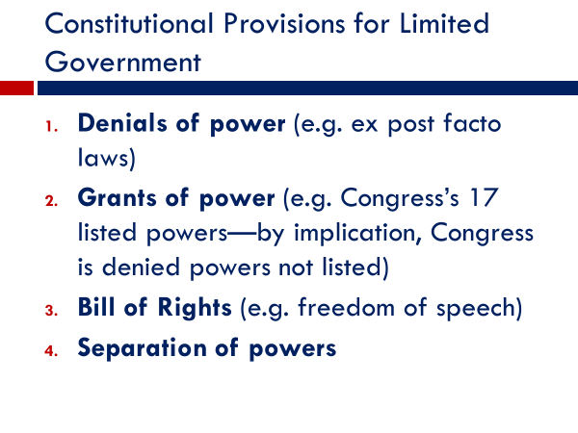
This strategy included denials of power.
Officials would be prohibited, for example, from putting someone in prison and throwing away the keys.
This was a common practice at the time in Europe. Opponents of the king were locked away for as long as wanted, forever in many cases. That practice would be prohibited in the United States.
The Constitution gives the accused the right to appear before a judge, who will determine whether authorities have enough evidence to warrant detention.
The writers also sought to limit government through grants of power.
Article I of the Constitution, the very first article of the Constitution, gives Congress 17 specific powers, such as the power to tax, the power to raise an army and navy, the power to regulate commerce.
These grants give power, but they also deny power. Powers not granted to Congress, those not on the list, are denied it. In a period of history when other governments admitted to no limits on their powers, this was a substantial limitation.
As originally written, the US Constitution did not include a bill of rights, a list of specific individual rights, such as freedom of speech.
The framers thought a list was unnecessary because government had only those powers granted to it. And it had not been granted the power to deny people their rights.
Thomas Jefferson was among the many who thought otherwise.
Jefferson had included a bill of rights in the Virginia constitution he wrote at the outbreak of the Revolutionary War. And other states had followed his example. Said Jefferson, "a bill of rights is what the people are entitled to against every government on earth."
In response to such objections, the first Congress passed a series of amendments that were quickly ratified by the states.
These amendments, the first 10 to the Constitution, are called the Bill of Rights.
The Bill of Rights is a clear example of limited government. If you were arrested tomorrow and had no money, the judge doesn't have the option of saying, tough luck, buddy. The government is required by the Sixth Amendment to provide you a lawyer and to pay for it.
#
Now, the framers didn't think that words alone, written grants, and denials, would be enough to control those in power. They wanted something stronger.
That something was to divide the government into separate branches and pit them against each other.
This was not a new idea.
The French theorist Montesquieu had proposed it nearly half a century earlier. "Where there is no separation of powers," he wrote, "there can be no liberty.
But the framers gave modest whose idea, a new twist.
Rather than completely separating the branches as he had proposed, they overlapped them so that each was better positioned to act as a check on the others.
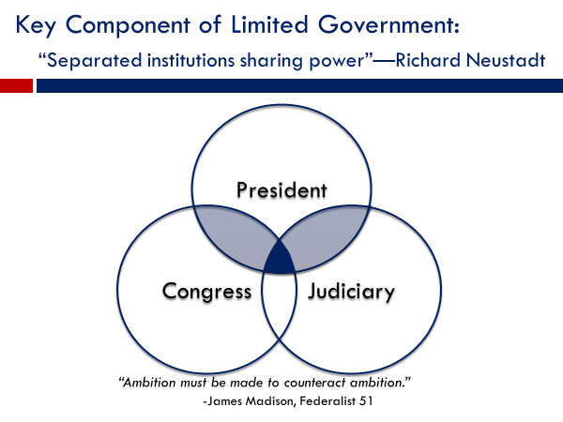
So instead of granting all legislative power to Congress, they gave some of it to the president-- for example, the power to veto laws--and some of it to the courts-the power to interpret laws. The same with executive power, the president has most of it, but not all of it. For example, Congress controls how much money the president can spend and on what. The president doesn't have the option of taking money allocated for highways and spending it on the military. The same with judicial power, for example, by giving the president the power to nominate federal judges and the Senate the power to confirm them.
This system of divided power was described by Harvard's Richard Neustadt as one of "separated institutions sharing power." The powers of government-- legislative, executive, and judicial-are granted to separate branches. But no branch has all power within its sphere of authority. Part of it in every case is shared with the other two branches, providing them a means of checking that branch's power.
So that's the theory, each branch acting as a check on the others.
Now as you know, theory and reality aren't always the same thing.
The English poet John Wilmot quipped "before I got married, I had six theories about raising children; now I have six children and no theories."
What about the framers' theory? Well, the record is far from perfect.
After Japan attacked US forces at Pearl Harbor in December 1941, President Franklin Roosevelt ordered the forced relocation of more than 100,000 Japanese Americans from the West Coast, saying they might try to help the enemy.
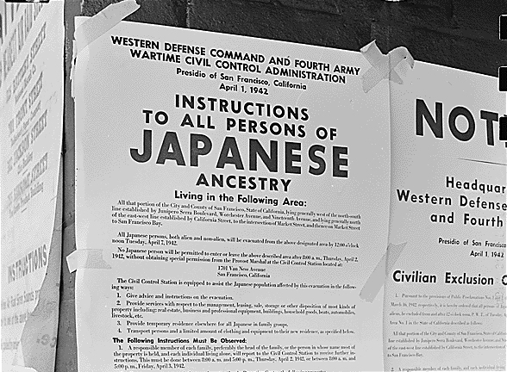
They were forced to sell their homes at rock bottom prices and were shipped to detention camps in Utah and other inland states. They lived out the war behind barbed wire, were watched over by armed guards. Their advocates looked to Congress for help.
Instead, Congress embraced Roosevelt's policy. Not a single senator or house member voted to rescind it.
Three times the Supreme Court reviewed the policy. Each time it upheld it, though it was clearly unconstitutional.
Racism played into the relocation policy. America had a long history of discriminating against Asians. Chinese were blocked from entry in 1883. Japanese emigration was effectively blocked in 1907. When the survivors of the Titanic arrived by rescue ship in New York Harbor in 1912, they were taken ashore, except for a handful of Chinese crewmen. They were not allowed to set foot on American soil.
Ironically, Japanese-Americans were allowed during World War II to volunteer for combat in Europe. They made up the entirety of the US Army's 442nd regiment. That regiment became the most decorated combat unit of its size, not only in World War II, but in the whole of US military history. 21 of its soldiers received the Congressional Medal of Honor, the nation's highest award.
In 1988, the United States issued a formal apology for its mistreatment of Japanese Americans, saying it was the result of "race prejudice, war hysteria, and a failure of political leadership."
As the relocation policy indicates, America is not a stranger to tyranny-the powerful trampling on the rights of the weak. Such episodes, however, are relatively few in number.
And the system of checks and balances is a reason. Scores of times, the president, Congress, or the Supreme Court has intervened when another branch has overstepped its constitutional authority.
The Watergate scandal is a textbook example.
On a June night in 1972, a security guard at the Watergate buildings in Washington DC noticed that the latch on the door to the Democratic Party's national headquarters had been taped open. He removed the tape and went away. Coming back later, he noticed the door had been taped open again.
He called police. They caught five men inside installing bugs in the phones and ceilings. As it turned out, they had links to President Richard Nixon's re-election campaign.
Nixon denied that anyone at the White House had knowledge of the break in. In truth, the Watergate break in was part of a much larger dirty tricks campaign aimed at guaranteeing Nixon's re-election. The dirty tricks included wiretaps, tax audits, burglaries of Nixon's opponents, paid in part with money laundered illegally through Mexico.
A turning point occurred when during a Senate investigative hearing, a White House assistant revealed that Nixon had tape recorded all his Oval Office conversations.
Nixon at first refused Congress's demand to hear the tapes.
As the pressure mounted, he released transcripts of what he claimed were all the relevant ones. When Congress demanded more tape material, Nixon refused. Congress then filed suit to get the tapes.
In a unanimous decision, the US Supreme Court, which included four Nixon appointees, ordered Nixon to turn over the tapes.
They were incriminating. Nixon was heard telling his assistants to cover up the Watergate break in, including using the CIA to block the FBI from investigating it. With that, the House of Representatives began impeachment hearings.
At that point, Nixon resigned, the first and only president to do so.
President Nixon, despite holding what is often called the most powerful office on Earth, was powerless to stop Congress and the Supreme Court from acting. The writers of the Constitution had established them as separate and independent branches of government. And they acted in precisely that way.
Now, as I'm sure you recognize, America's system of checks and balances doesn't always operate that decisively.
Politics is a rough and sometimes deceitful game.
What if the Watergate burglars had not been so stupid as to get caught?
Would Nixon's illegal action have been discovered in time to do anything meaningful about it? Presidential secrecy is one of the major threats to the effectiveness of America's system of checks and balances.
Congressional secrecy is not a problem. Congress has 535 members, and it couldn't keep a secret if it tried. The presidency is different. Presidents have the loyalty of their assistants and can sometimes withhold potentially damaging information, as occurred during the impeachment of President Donald Trump. During the inquiry, Trump refused to let White House officials testify at House hearings and blocked them from Turning over documents to House investigators.
#
Now a different type of threat to limited government is illustrated by the federal government's detention of Japanese Americans during World War II. In that case, all three branches thought a breach of the Constitution served the nation's interests in time of war.
There's another threat that has shown itself to be important. It can be seen in a situation we discussed earlier, the Bush administration's anti-terrorism policies.
As mentioned, the September 11 terrorist attacks convinced the Bush administration that the war on terrorism required a new set of rules. The rules for handling enemy captives were hatched in secrecy to keep them from scrutiny by Congress.
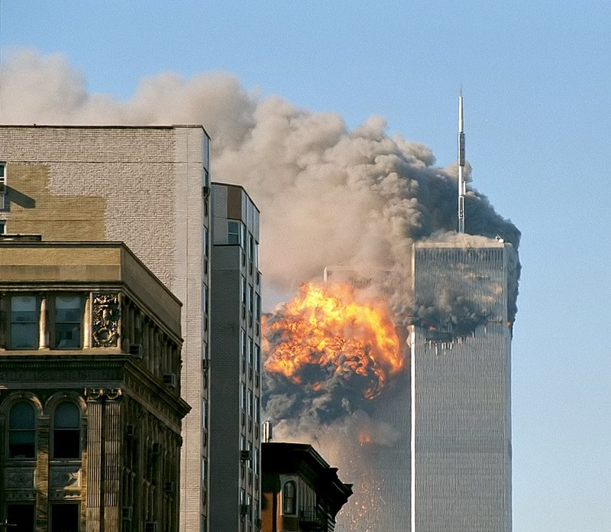
They were also kept secret from those in the administration, including Secretary of State and former Army general Colin Powell, who would have objected.
Slowly, information about the policies leaked out, in some instances through news stories, in other instances through legal cases being argued in federal courts.
As the information came out, there were calls for congressional hearings.
But almost none were held. Even the Supreme Court rulings in 2004 and 2006 against Bush administration policies did not prompt Congress to launch high profile hearings.
Then in 2007, the number of congressional hearings increased dramatically.
Why was that?
Why was Congress initially slow to scrutinize Bush policies but then suddenly eager to do so?
As you might have guessed, the answer is partisanship.
Through 2006, Republicans controlled the House and the Senate and thereby controlled the scheduling of hearings. They were not at all interested in holding a Republican administration to account for its policies, knowing that it would hurt their party. Things changed abruptly after Democrats swept the 2006 congressional elections and took control of the House and Senate in early 2007. The Democrats now controlled the hearing process. And they called one hearing after another.
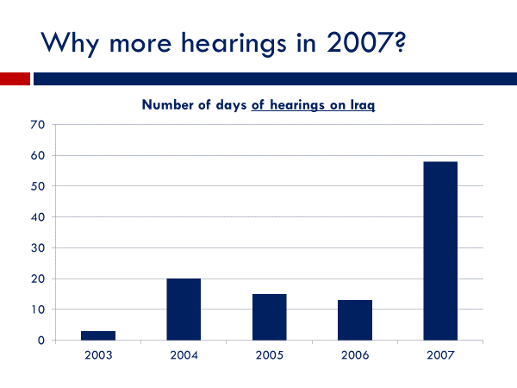
Seeking partisan advantage, Democrats were keen to grill the Bush administration on its war policies.
That situation arose again in 2019.
During the previous two years, when Republicans controlled the House of Representatives, Russia's effort to tip the 2016 presidential election in Donald Trump's favor was the subject of relatively few hearings.
And the issue of the Trump campaign's contacts with the Russians was the subject of even fewer. But when Democrats took control of the House in 2019, the number of hearings multiplied. And the inquiries probed more deeply, including whether the president had unlawfully tried to obstruct the Russia investigation.
#
OK, let's wrap up what we've said in this session. As we noted, the Constitution was designed in part to provide for limited government, meaning a government not so powerful as to threaten liberty.
The Constitution contains various controls on government, including grants of power and denials of power.
However, the key mechanism is the separation of powers between the three branches-- the executive, the legislature, and the judicial.
The powers of the branches are overlapped so that each branch can more effectively act as a check on the others.
This system doesn't always work as intended.
It weakens when, as in the World War II relocation policy, the three branches are united in thinking that the national interest is served by ignoring the Constitution. It weakens when a president succeeds, even for a time, to keep unlawful actions secret. And it weakens when the presidency and Congress are controlled by the same party. Then the majority party in Congress might seek to play down the issue.
Although the US system is not a perfect check on power, the record also shows that on many occasions, dozens and dozens of them, it has helped to rein in abuses of power.
We'll never know, of course, how US history would have differed if the Constitution had not been based on a system of checks and balances.
But the fact that some leaders have tried to operate outside the law suggests they would have done so more readily and more outrageously if the other branches had been powerless to check their actions.
There was a great deal of wisdom in what John Adams said in a letter to Thomas Jefferson. "I say that power must never be trusted without a check."

