Transcript: Representative Government Lecture

[ON LOCATION, THE CAPITOL]
THOMAS PATTERSON: Etched in stone in the rotunda of the capitol are the words "Here, Sir, the People Govern." Those words were spoken by Alexander Hamilton when he asked what Congress represented.
To the framers of the Constitution, the Congress was the first branch of government, the place where the people's representatives met to decide the people's business. Yet when the Constitution was unveiled, many leading Americans were outraged.
One of them was Richard Henry Lee of Virginia, who had been president of the Continental Congress during the Revolutionary War.
Richard Henry Lee said, "This constitution has very little democracy in it." What he was objecting to was the fact that the people were not allowed to vote for the president or for members of the Senate. Only the House of Representatives would be chosen by vote of the people.
When Henry Clay of Kentucky, one of the great legislators of the 19th century, left the Senate to run for the House, he said, "I prefer to serve in the people's chamber."
Some critics today wonder whether that label still applies to the House.
They point to House elections, which have become increasingly expensive.
It was not that long ago that these were relatively modest affairs funded largely by donations from people living in the district.
Today, it's easily the case that a House election can cost a million dollars or more, with much of that money coming from wealthy individuals and groups from outside the district.

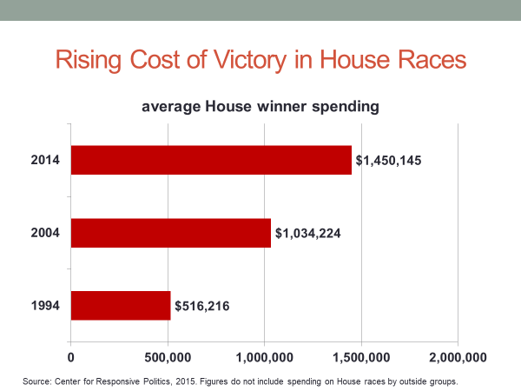
Critics also point to redistricting, the tendency of state legislatures to pack House districts with voters from a particular party, thereby guaranteeing the election of that party's candidate in the fall.
So who's doing the electing?
Is it the voters, or is it the state legislatures and the wealthy donors?
Those kinds of issues about self-government have been part of the American debate since the writing of the Constitution.
Over the course of American history, few features of the Constitution have been subject to more debate or more manipulation than its provisions for representative government.
#
[STUDIO PORTION]
In this session, we'll look at the Constitution's provisions for representative government, a government in which the people rule through their representatives. We'll start by examining the Constitution's initial provisions for representation, and then explain how and why they were changed. We'll then turn to voting laws and how they have affected the public's role.
Finally, we'll look at a couple of current issues: voter ID laws and congressional redistricting.
Before I start, I have a question for you to think about.
In your view, what's the bigger threat to our democracy in America as practiced?
Is it public officials, those who set the rules for elections, or is it the people themselves, who can weaken democracy by not bothering to vote, or voting even when they're not eligible to vote?
I'm not going to answer the question for you. I want you to think about it.
When the delegates gathered in Philadelphia in 1787 to write the Constitution, they had a number of factors that had to be taken into account. The first was that the states had their own governments and intended to keep them.
In addition, the states differed greatly in size and wealth.
Powerful states like Virginia and New York were not interested in a union that failed to recognize their prominent role.
At the same time, small states like Rhode Island and Delaware were not interested in a union where their interests would be pushed aside.
There was also the question of the role the people would play.
Under the nation's first constitution, the Articles of Confederation, members of Congress were chosen by the states. Voters had no say whatsoever in this election of their representatives.
That would not work under the new Constitution. The national government would have the power to tax the people.
They would likely rebel if denied all say in the election of federal representatives. These considerations were resolved by what
has become to be called the Great Compromise, the decision to create a two-chambered Congress, the House and the Senate. The House would have members in proportion to each state's population, elected by the voters to two-year terms.
This arrangement satisfied the larger states: they would have a bigger share of House seats, and also served to satisfy those who believe the people should have a direct vote.
In contrast, the Senate would have two members per state, chosen by the state legislatures, for six-year terms. This arrangement satisfied the concerns of small states: they would have equal representation in the Senate. It also mollified those who wanted the states to have a say in the selection of federal officials. State interests also figured into the method of choosing the president.
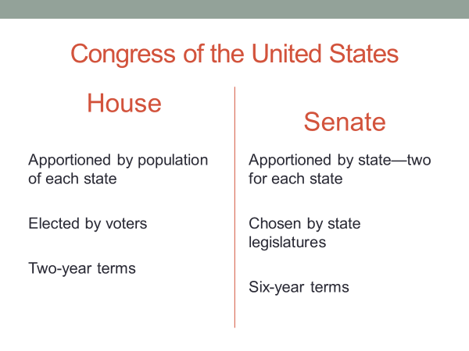
Pennsylvania's James Wilson twice proposed that the president be popularly elected. Twice the delegates voted him down. A proposal to have Congress choose the president was also rejected.
That method would have weakened the president's ability to act as a check on the Congress.
Congress would pick presidents who promised to do its bidding.
Having pretty much run out of ideas, the framers invented what has come to be called the Electoral College. Each state would have as many electors as it had members of Congress, House and Senate combined.
The state legislatures would choose the electors, and the candidate with a majority of the electoral votes would become president.
Thomas Jefferson was 3,000 miles away when the Constitution was written, serving as US ambassador to France. He admired many of the Constitution's features, particularly its separation of powers. But Jefferson worried that the people had been given too little power. Jefferson also thought officials should be term-limited.
If not, they might come to believe that public office was theirs by right.
Other critics noted the contrast between the Constitution's provisions and what the states were doing. In nearly all states, governors and legislators were chosen by direct popular vote.
Why should the national government be any different?
In defending the Constitution's provisions, the framers argued that the history of unrestrained democracies was the history of tyranny where the many trampled on the rights of the few.
Said James Madison, "Pure democracies have ever been spectacles of turbulence and contention, and have in general been as short in their lives as they have been violent in their deaths. The framers even had a homegrown example, Rhode Island, to prove their point.
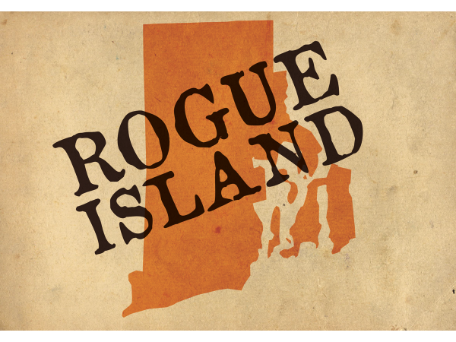
In that state, debtors had gained control of the legislature and concocted a scheme for getting rid of their debt. They passed a law authorizing the use of paper money, which was largely worthless, to pay debts incurred by borrowing gold.
Creditors were hunted down, tied up in public places,
and people lined up to pay off their debts with the worthless paper money.
Soon the Rhode Island economy was a wreck with inflation running at 800%.
Most of its shops had shut down and creditors had fled the state.
A Boston newspaper labeled the state "Rogue Island."
The framers were so convinced of the dangers of democracy that they refused even to call the new government a democracy.
They called it instead a republic.
The people would have a voice in the government, but it would be filtered through representative institutions, only one of which, the House, would be subject to direct election.
The Constitution, said Madison, was "a republican remedy for the ills of uncontrolled democracy."
Now whether intended or not, the Constitution's provisions for representative government virtually guaranteed that the federal government would initially be controlled by wealthy or otherwise prominent Americans.
Through the first six presidents, very few small farmers, craftsmen, or merchants were elected to Congress or held high-ranking executive positions, even though they made up the vast majority of the population.
That situation changed with the election of the seventh president, Andrew Jackson.
Raised in poverty by a widowed mother in the backwoods of Carolina, Jackson won national fame as commanding general at the Battle of New Orleans, where US forces defeated the British in the War of 1812.
Upon assuming the presidency, Jackson appointed ordinary citizens to executive office and pressured states to eliminate property ownership as a requirement for voting.
He tried but failed to get rid of the Electoral College, but then persuaded the states to tie their electoral votes to the popular vote.
Jackson's system is the one we have today.
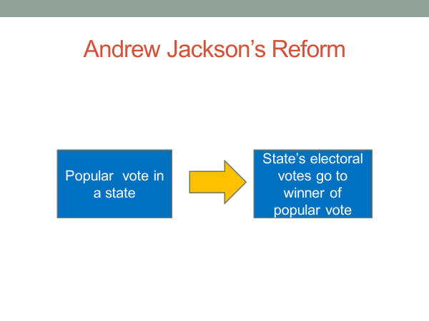
The winner of a state's popular vote receives its electoral votes, giving the voters a decisive say in the choice of the president. Seven decades later, the Constitution was amended to provide for the popular election of senators.
The Senate had become a corrupt institution. Powerful corporations had bribed and bullied state legislatures to choose senators who would protect their interests.
The ensuing scandals helped fuel the progressive movement, which was the leading force behind the amendment. The progressives also challenged the party machines that had taken over control of candidate nominations.
They succeeded in getting states to adopt primary elections where the voters, rather than the party organizations, chose the nominees. As you might have noted, these changes basically undid the work of the framers. The presidency, House, and Senate were now all subject to vote of the people who had two chances to be heard: once in the primary and once in the general election.
This was a remarkable change. At the beginning of the republic, the people had a relatively small voice in their governing.
Today, as has been true ever since the progressive era, the United States has more elections for national office than any other democracy.
Lots of elections doesn't mean that Americans vote regularly. In fact, the United States has nearly the lowest voting rate among Western democracies. As this chart indicates, the voting rate in US presidential elections is roughly 60%, below that of other leading democracies.

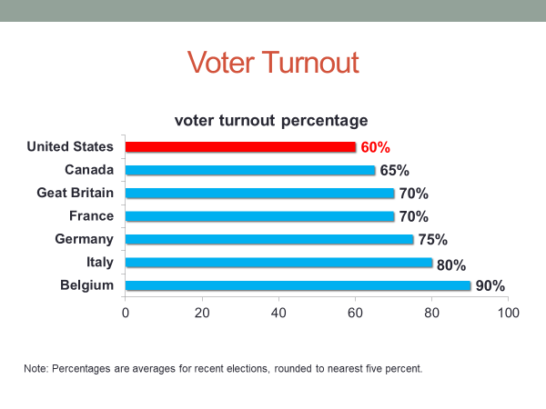
In some countries, Italy being an example, the rate exceeds 80%.
To understand why the United States lags behind, we need to go back to the writing of the Constitution. As originally written, the Constitution did not provide for the right to vote.
Some Americans were held in slavery and were denied even citizenship.
For their part, women were thought not to have a rightful place in public affairs. Not until ratification of the 19th amendment in 1920 did women get the right to vote.
The original Constitution had a single clause on voting.
It gave the states authority to determine voting eligibility in federal elections, saying only that a state's restrictions on voting
could not be greater than those placed on voting for members of the
largest chamber of the state's legislature. That clause seemed harmless at the time, but it has turn out to be a source of mischief.
It has been used at times to deny some people the right to vote.
In the early history of the United States, most states denied the vote to males without property, a policy that Ben Franklin thought worthy of ridicule.
"Today," wrote Franklin, "a man owns a jackass with $50 and he is entitled to vote, but before the next election the jackass dies and the man cannot vote.
Who is the voter, the man or the jackass?"
By the 1830s, urged on by Andrew Jackson, nearly all states had dropped the property requirement.
The ugliest chapter in America's voting history began in the South after the Civil War and lasted nearly a century. The 15th Amendment, which was ratified soon after the war, prohibits states from denying the vote on the basis of race or color.
When Northern troops left the South a decade after the Civil War ended, the South's white majority governments concocted every trick imaginable to keep Blacks from voting. Louisiana wiped clean its registration rolls and required its residents to re-register.
The state made it so hard for Blacks to re-register that less than one in ten were able to do so.
Throughout the South, literacy tests and poll taxes were adopted.
In order to register to vote, citizens had to pass a literacy test and pay a tax.
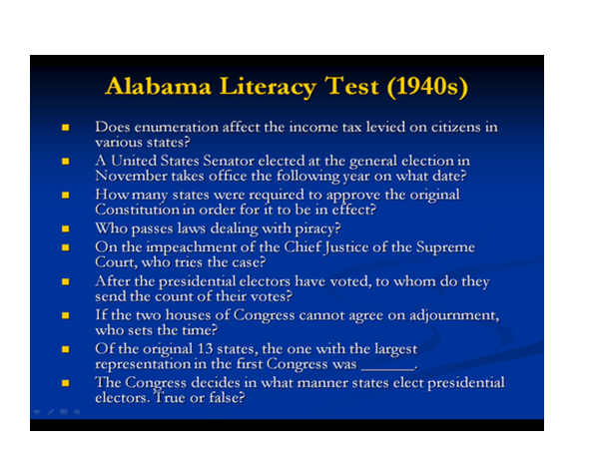
To ensure that white voters were not disenfranchised by these requirements, a grandfather clause was placed in the law. Anyone whose father or grandfather had been eligible to vote was exempt from the requirements. Obviously, no former slave or child of a slave qualified for that exemption.
The Supreme Court waited until 1915 before declaring the scheme unconstitutional. Whites-only primaries were also devised. The Democratic party was in control throughout the South.
Every governor, every state legislature, and nearly every member of Congress was a Democrat.
As a result, the key election throughout the South was the Democratic primary.
Whoever won that primary was virtually assured of winning the general election. Blacks were prohibited from voting in primaries. The Supreme Court waited until 1944 to strike down that practice.
The court refused, however, to strike down literacy tests and poll taxes, and they effectively kept Blacks away from the polls.
The literacy tests were so difficult that those administering them had to look up the answers and were given discretion in determining whether an applicant had passed.
Whites routinely did.
Blacks who scored as high or higher were frequently told they had failed.
In some places, it took courage even to apply for the vote.
The local newspaper would publish the names of those who had applied so that white employers would know which Blacks not to hire. In the entire state of Mississippi, fewer than 5% of eligible Blacks were registered to vote even as late as the 1950s.
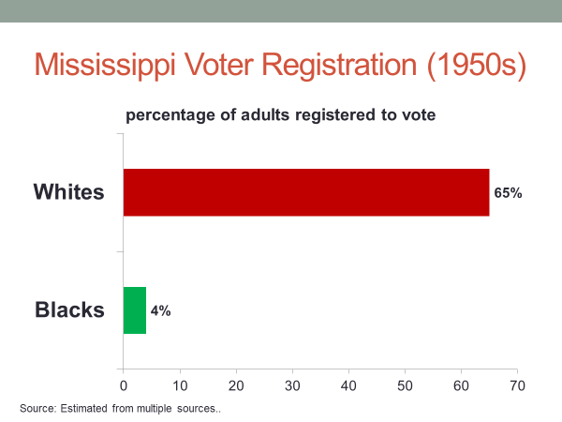
The Voting Rights Act of 1965 brought an end to these tricks.
The legislation empowered federal officials to register voters in states and counties with histories of racial discrimination. In less than two years, Black registration in Mississippi had jumped tenfold.
In Alabama it climbed from less than 20% to over 50%.
The Voting Rights Act produced a regional split in Congress not seen since.
The Senate vote was 77 to 19, with all 19 no votes cast by Southern senators.
Every senator from outside the South, Republican or Democrat, voted for the bill.
The House vote also divided sharply along North/South lines.
Once the law was in place, Southern states challenged it in court, arguing it violated the Constitutional clause that gives states the power to determine voter eligibility.
The Supreme Court rejected the challenge, holding that another clause of the Constitution, the 14th Amendment's equal protection clause took precedent.
The Voting Rights Act also temporarily banned the use of literacy tests, which were later banned completely by the Supreme Court.
Ratification of the 24th Amendment brought the poll tax to an end.
Since passage of the Voting Rights Act in 1965,
Black voting has edged steadily upward such that today the rate is not greatly different from that of white voters.
Now, if the politics of voting until the 1960s were largely the politics of race, it has since been a case of party politics, as the Republican and Democratic parties have jockeyed for voting regulations that might help them win elections.
A major target has been voter registration, which is handled differently in the United States than in Europe. In European democracies, government assumes responsibility for registering voters.
If a citizen moves to a new address, for example, the postal service will notify election officials to change the individual's registration. The result is that over 90% of eligible European voters are registered.
By comparison, only about 75% of vote eligible US citizens are registered.
The difference stems from the fact that registration in the United States is the individual's responsibility.
Eligible citizens must personally take the time to register.
Where government comes into this picture is that it can make that process easier or harder. If it lowers the barriers to registration, you expand the electorate.
If it raises them, you shrink it.
So which political party do you think would benefit from making registration easier? The Democrats, the Republicans, both about equally.
It's the Democrats.
Voting in the United States tilts heavily toward those of higher income.
As you can see from this chart, the voting rate among those in the top fifth of income is far higher than those in the bottom fifth.
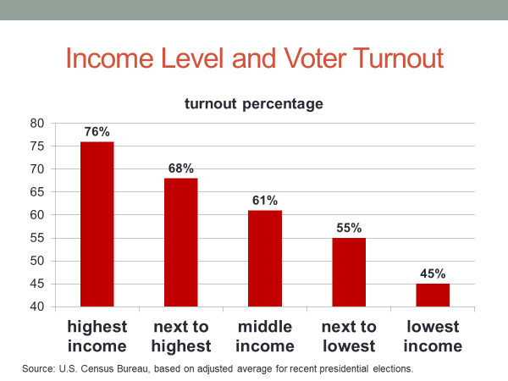

Income correlates with party preference.
Upper income voters tend to cast their votes for Republican candidates, while those at the bottom of the income ladder tend to vote Democratic as a result of the party's leadership on policies that benefit those of lower income such as welfare services and the minimum wage.
The arithmetic of voting has not been lost on the parties.
The Democratic party has pressed hard to make voter registration easier.
Its most notable success was the 1993 Motor Voter Act.
The Act requires states to offer voter registrations when they apply for a driver's license or public assistance. The Motor Voter bill first passed Congress in 1991, but a Republican, George H.W. Bush, was in the White House. He vetoed it.
The Democratic-controlled Congress passed it again in 1993. This time a fellow Democrat, Bill Clinton, was in office, and he signed the bill into law. In the Senate, only three Republicans backed the bill, while all 59 Democrats did so.
Voting in the House also divided sharply along party lines with Republicans overwhelmingly opposed and Democrats overwhelmingly in favor.
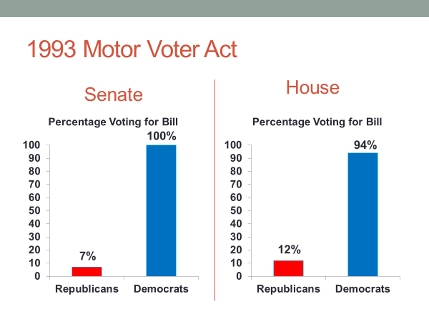
Studies of the Motor Voter Act indicate it accounts for about a third of new registrants.
To the surprise of both parties, however, the number of new Democratic registrants resulting from the law has only slightly outpaced the number of new Republican registrants.
Now, the Republican Party has worked the other side of the fence, seeking to hold down voter registration.
The centerpiece of this effort in recent years has been voter ID laws.
In strictest form, an applicant must have a government-issued photo ID such as a driver's license or passport in order to register.
In other states with voter ID laws, other forms of ID are acceptable as long as they suggest the applicant is a citizen.
Now, the express purpose of these laws is to prevent voter fraud, to keep people who are non-citizens from voting.
The real intent is different. They are designed to make it difficult for those without a formal ID to register.
About 10% of vote-eligible citizens do not have a government-issued identification card and they are disproportionately young, poor, and minorities.
All of these groups tend to vote Democratic.
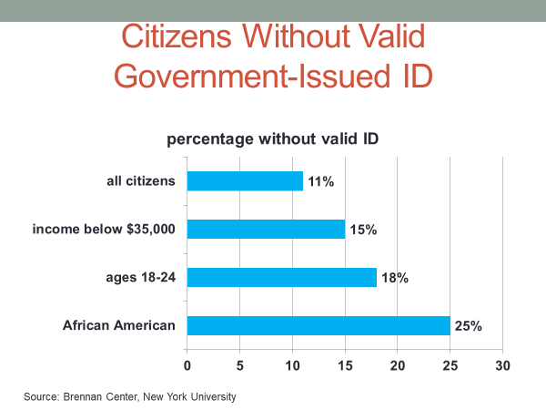
The first voter ID laws were enacted by the Republican-controlled legislatures of Georgia and Indiana.
Of the more than 30 states that have followed their lead, all but one, Rhode Island, had a Republican-controlled legislature.
In a 6 to 3 ruling, the Supreme Court upheld Indiana's law.
All six judges in the majority were Republican appointees, and though they acknowledged Indiana's law had a partisan purpose, they said other purposes, including the public's faith in the integrity of the ballot, justified the ID law.
The court said that the law should not be disregarded simply because partisan interests may have provided one motivation for the votes of individual legislators. Research indicates that voter fraud is extremely rare.
It appears that almost no one is willing to risk being arrested and fined for illegal voting.
Sometimes it's even tough to get legal voters to show up at the polls.
Research indicates that the suppressive effect of voter ID laws has been smaller than many opponents of the laws had predicted.
The research has shown, however, that those who are disenfranchised by the requirement are disproportionately the poor and minorities.
In 2017, the Supreme Court invalidated North Carolina's voter ID law.
Enacted by the state's Republican legislature after a surge in registration by the state's Black residents, the law required registrants henceforth to have a government-issued photo ID.
The Supreme Court held that the law had a discriminatory intent, concluding that its purpose was to suppress the Black vote. It's too early to tell whether the Supreme Court's ruling in the North Carolina case might lead it to restrict voter ID laws more generally.
Finally, let's briefly examine partisan gerrymandering, a tactic used by both parties. After the population census every 10th year, House seats are reapportioned to states on the basis of their populations.
The more populous the state, the more House seats it gets.
California, for example, has 53 House seats, while South Dakota has only one.
Under the Constitution, state legislatures have the authority to set the boundaries of House districts.
The majority party in these legislatures typically divides up the state in a way that will help its party's candidates, a process called gerrymandering. The safe way to do this is to pack targeted districts with enough of the party's voters to assure victory in the election.
The other party is also likely to receive safe seats. This happens because if some districts are stacked to the top with the opposing party's voters, there will be fewer such voters in other districts. More than 85% of House seats today are uncompetitive, virtually certain to be won by the candidate of the stronger party.
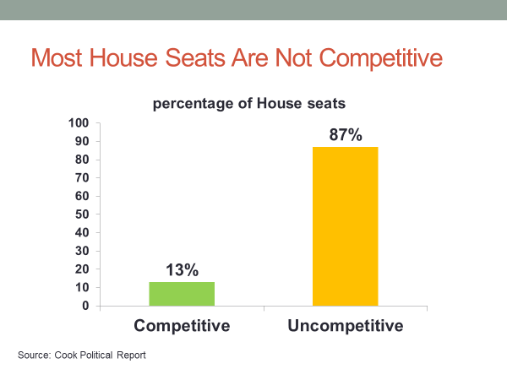
There are several reasons for this, including the fact that some states are so heavily Democratic or Republican that it's hard to design competitive districts.
But gerrymandering is among the reasons that many House races are effectively decided before a single vote is cast.
Now, gerrymandering worked to Democrats' advantage until the early 1990s, at which time an increasing number of state legislatures came under Republican control.
Republican legislatures did such a precise job of gerrymandering after the 2010 census that in the 2012 election, they won a comfortable majority of House seats even though Republican candidates received fewer votes nationally than did their Democratic opponents.
As gerrymandering has become ever more precise as a result of computers, it has increasingly come under legal challenges. In 2019, the Supreme Court refused to rein in the practice, holding that courts do not have the authority to limit gerrymandering.
The case was decided by a 5 to 4 vote with all five Republican-appointed justices voting against placing limits on gerrymandering, and all four Democratic-appointed justices voting to restrict it.
The five-member Republican majority said that unrestrained gerrymandering may be incompatible with democratic principles, but that judges lack a precise standard for determining when partisan gerrymandering has gone too far.
In their dissenting opinion, the four Democratic-appointed justices said, "For the first time ever, this court refuses to remedy a constitutional violation that deprives citizens of the most fundamental of their constitutional rights."
Now, a few states, Iowa, California, and Montana among them, have recently decided to place redistricting in the hands of a nonpartisan commission.
It's unlikely that a great many states will follow their example given the fact that most state legislatures have signaled their intent to retain control of redistricting. Before wrapping up, let me say a few words about the electoral college.
Democratic elections are generally based on the principle of one person, one vote. The winner is the side that gets the most popular votes.
But in US presidential elections, the winner is the candidate who gets a majority of the electoral votes. Now, in most presidential elections, the popular vote winner also wins a majority of the electoral votes, but not always.
That's happened four times in American history, two of them recent. In 2000, Al Gore received half a million more votes nationally than did George W. Bush, yet lost the election. It happened again in 2016 when Hillary Clinton, though receiving nearly 3 million more votes nationally than Donald Trump, was defeated.
If the US Constitution were being written today, the idea of having the president selected through the electoral college would not be taken seriously.
The principle of one person, one vote is now an established democratic practice, yet the electoral college survives because of the difficulty of amending the US Constitution. It requires a 2/3 vote in the House, plus a 2/3 vote in the Senate, plus ratification by 3/4 of the state legislatures.
That's an imposing barrier to change.
There have been hundreds of unsuccessful attempts in Congress to abolish the electoral college. The reason is that some states benefit from it.
Because each state, regardless of size, gets two electoral votes as a result of having two US senators, the smallest states gain leverage from the electoral college. The dozen smallest US states have 8% of the electoral vote even though they constitute less than 4% of the US population. They have twice the voting power under the electoral college than they would under a popular vote system. These states alone have nearly enough votes in the Senate to block an amendment.
#
OK, let's wrap up what we've covered in this session.
We've focused on representative government as provided by the Constitution.
It was noted that the voters originally had a say only in the election of House members, a reflection of the framers' determination to prevent a passionate majority from taking control and running roughshod over the minority.
With time, due in part to the Jacksonian and progressive movements, popular voting came to include Senate and presidential elections. The adoption of primary elections, an American invention, also served to shift power to the voters. Today, Americans vote more often for more offices than voters elsewhere.
On the other hand, the public's influence is diminished by partisan gerrymandering and by the efforts of officials to manipulate the size of the electorate through control of the voter registration process.
Although these recent efforts pale alongside those used in the past to keep Black Americans from voting, they are a source of court challenges and intense partisan debate. In other words, representative government in America is still a work in progress.

