Transcript: Civil Liberties Lecture

[ON LOCATION – COURTROOM, HARVARD LAW SCHOOL]
THOMAS PATTERSON: The US Constitution provides for a number of individual rights, most of them listed in the Bill of Rights.
The First Amendment, for example, provides for freedom of speech, freedom of the press, and the fourth through eighth amendments include a number of fair trial guarantees, such as the right to an attorney and protection against double jeopardy.
A central issue of these rights is what they mean in practice-whether government will take the steps necessary to make sure that people in fact can enjoy their rights. Take the case of Clarence Gideon.
He was on trial in Florida in 1961 for allegedly breaking into a pool hall and stealing a pocketful of change.
Gideon had no money.
And when he came up for trial, he asked the judge to provide him a lawyer.
The judge refused.
Gideon, an eighth grade dropout, was forced to defend himself.
He lost his case.
The Florida judge sentenced him to five years in prison-the maximum allowable for the crime of which he was accused. While in jail, Gideon wrote a handwritten note to the Supreme Court, appealing his conviction.
The likelihood that the court would respond to such a note was almost infinitesimal.
The court hears less than 100 cases a year out of the tens of thousands that are heard annually in federal court, and they've almost never taken a case on the basis of a handwritten note.
To everyone's surprise, the Supreme Court said, we're going to hear this case.
They provided Gideon with an attorney.
And when his case came before the Supreme Court, his attorney argued that the right to counsel is fundamental. How, he asked, can a poor individual like Gideon possibly win out in a trial against a trained district attorney?
In rebutting that argument, the state of Florida said that its judges were fair minded and wouldn't let anything but the evidence decide the outcome of a case.
The Supreme Court disagreed with Florida.
It said that the 14th amendment due process protection included the right to an attorney and at government expense if the accused was too poor to afford a lawyer. In his retrial in Florida, Gideon's lawyer expertly picked apart the state's case.
He showed convincing evidence that its main witness had actually been part of the crime, acting as a lookout while his friends broke into the pool hall.
The jury acquitted Gideon of the crime of which he was accused.
#
[STUDIO PORTION]
In the Gideon case, the US Supreme Court, which is a federal court, overturned the ruling of a state court. There was a time in American history where that type of decision was prohibited.
That's because the Bill of Rights initially applied only to the national government. The First Amendment for instance says, Congress shall make no law abridging freedom of speech, the press, and so on. It doesn't say, Congress and the state legislatures shall make no law.
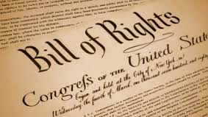
Thus, whereas Congress was bound by the Bill of Rights, state governments were not.
Today, nearly all the rights in the Bill of Rights are protected from action not only by the federal government, but also by the state governments and the local governments, which are agents of the state. The key to this change was the 14th Amendment, which was ratified after the Civil War.
It reads, in part, "No state shall deprive any person of life, liberty, or property, without due process of law." Notice that the 14th Amendment refers to life, liberty, or property. It doesn't say that no state shall deprive any person of freedom of speech or any other specific right listed in the Bill of Rights.
And it was not until 1925, nearly six decades after the 14th Amendment was ratified, that the Supreme Court began to say what was meant by life, liberty, or property.
The breakthrough case was Gitlow versus New York, which involved a man, Benjamin Gitlow, who had been convicted of violating a New York state law aimed at silencing political anarchists.
In its ruling, the Supreme Court held that state governments are not completely free to decide for themselves what their residents may legally say.
The 14th Amendment's due process clause, said the court, protects free speech from action by the states.
Then, during the next dozen years, the Supreme Court used the 14th Amendment to strike down state laws infringing on the remaining First Amendment rights-freedom of the press, religion, assembly, and petition.
At this point, the Court stopped, choosing not to protect the other rights in the Bill of Rights from state action.
Then, in the 1960s and early 1970s, it resumed the process, one by one, bringing most of the fair trial rights in the Bill of Rights into the 14th Amendment. The Gideon case, the right to an attorney, was one of those landmark rulings.
Other rulings addressed such rights as the right to remain silent.
This process, whereby rights contained in the Bill of Rights are extended to the state governments by the 14th Amendment, is called selective incorporation.
It is selective because only particular rights in the Bill of Rights are given protection, and it's called incorporation because the process involves incorporating or bringing into the 14th Amendment rights that are contained in the Bill of Rights, thus protecting them from state action.
In the Gideon case, for example, the Sixth Amendment right to an attorney, which protects citizens from action by the federal government, was incorporated into the 14th Amendment, thereby extending the right to an attorney to cases involving state and local governments.
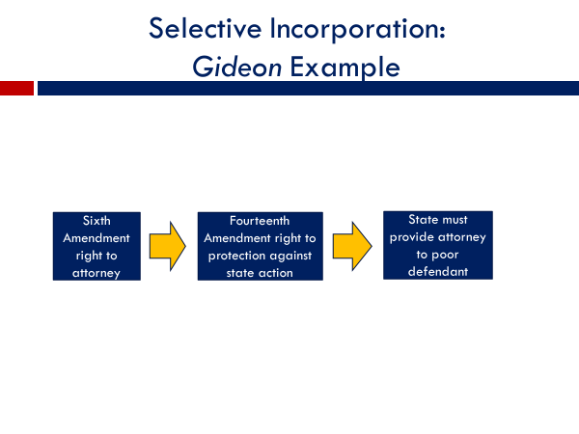
Selective incorporation is one of the most important developments in the history of American Civil Liberties. Think about it for a minute. Which level of government is more likely to violate your rights?
Is it the federal government, or is it state and local governments?
Although many Americans are more distrustful of the federal government, the state and local governments are actually more likely to intrude on people's rights. Well over 95% of the court cases alleging a violation of constitutional rights originate with these governments. The major reason is that these officials have primary responsibility for policing and for maintaining public order, precisely the situations where citizens are most likely to come into conflict with authorities. You ever been stopped by a federal officer, such as an FBI agent?
Probably not. Not many Americans have.
Have you ever been stopped by a local police officer or the state highway patrol?
Well, if you drive a car or hang out on city streets, there's a good chance you have.
That's why the 14th Amendment and the Supreme Court's application of it to the actions of the states and localities has been so key in protecting Americans' rights.
In the rest of this session, we'll explain some of the individual rights protected by the US Constitution and describe what they mean in practice.
We'll concentrate on the two areas that have received the most attention from the Supreme Court--
Americans' political expression rights and their fair trial rights.
In later sessions of the course, we'll examine rights not in these two areas, particularly freedom of religion, which has been the subject of a number of key court decisions, the right to bear arms, which the Supreme Court recently decided includes handgun ownership, and the right of privacy, which applies, for example, to issues of abortion and same-sex relations.
#
Let me note at the outset that no right is absolute. Rights can be limited, for instance, if they cause harm to others.
You have a right to free speech but not to tell malicious lies that destroy another person's reputation. You could plead the First Amendment if you did that, but it wouldn't get you very far. You'd be found guilty of slander and ordered to pay for the damage you caused to the person's reputation. Rights can also be limited when they conflict with each other.
In that case, one right has to take a back seat to the other.
The First Amendment, for example, guarantees freedom of the press, whereas the Sixth Amendment guarantees a fair trial. At times, press coverage of a crime can be so sensational that it jeopardizes the right of the accused to a fair trial.
In some instances, though rare, judges, in an effort to protect the defendant's rights, have ordered reporters to stop reporting on the crime.
There is a third situation in which rights can be limited-- when they conflict with an overriding government interest, such as national security or public safety.
Take, for example, freedom of assembly, which gives citizens the right to stage political meetings, rallies, demonstrations.
But can citizens hold a rally at a time and place of their choosing?
For example, can they go into the middle of a busy intersection at rush hour and begin to protest?
The Supreme Court has said no, ruling that authorities can regulate the time and place of public gatherings for reasons of public order and safety, as long as they do so in an even-handed way.
For instance, it would be unlawful for a local government to allow a favored group-- one that it likes--to hold a rally in a beautiful downtown park while forcing a disliked group to rally in a rundown lot on the far edge of town.
Keeping those limitations in mind, let's look at what Americans' rights mean in practice, starting with their free expression rights.
Free expression has long been viewed as the most basic of individual rights.
Unless citizens can express themselves freely, they cannot easily hold officials accountable. And it will not be long before they're stripped of their other rights as well.
Authoritarian governments understand this.
One of their first actions upon seizing power is to silence their opponents.
Americans have never experienced that type of situation, but they have had their rights to free expression curtailed, typically during time of war.
In 1917, soon after entering World War I, Congress passed the Espionage Act, which prohibited dissent harmful to the nation's war effort. Two years later, in Schenck versus the United States, the Supreme Court ruled on the Espionage Act. The first time in the Supreme Court's history it had addressed the question of how far government can go in restricting free expression.
The case involved a socialist who had been convicted under the Espionage Act for distributing anti-war leaflets.
The Court upheld his conviction, saying Congress could restrict speech that presented a clear and present danger.
In a famous passage from that decision, Justice Oliver Wendell Holmes wrote that free speech does not permit someone to yell "fire" in a crowded theater, thereby endangering those who would be harmed in the rush to the exits.
Soon thereafter, the Court gave government even more leeway, saying even expression that promoted a bad tendency could be curtailed.
That rule was applied in a key 1951 case which took place at the height of fears about the growing threat of Soviet communism.
The Court upheld the convictions of 11 members of the US Communist Party for advocating the violent overthrow of the US government, even though they themselves had not engaged in any violent acts.
Then, in the late 1950s, the Supreme Court reversed course, taking a fundamentally different approach to free expression.
It overturned the convictions of another group of communist party members, saying that they had a right to express themselves freely unless the government could demonstrate that their words were a direct and substantial threat to national security.
The Court did not say that words are always harmless.
What the Court had concluded was that society was in far greater danger
if government had too much power to tell people what they can say and
what they cannot say than if people were allowed to express themselves freely. Since that decision, a period that includes the Vietnam War which sparked the largest anti-war protests in the nation's history, no American--not a single one-has been convicted solely for speaking out against government policy. Protesters have been convicted for other reasons, such as assaulting a police officer, but not for what they said.
The imminent lawless action test is the legal standard that the courts have normally applied in recent decades. It holds that speech, to be unlawful, must seek to incite imminent lawless action and be likely to produce it.
It is extremely rare for words alone to lead people into lawless behavior, and thus rare for a speaker to cross the line into speech unprotected by the Constitution.
The US news media too are free to say nearly anything they want.
The landmark case here is New York Times versus the United States, which arose when The Times obtained secret government documents showing that President Lyndon Johnson had lied to Congress and the American people about the war in Vietnam, saying it was going well when in fact, it was going poorly.
The government tried to block publication of the documents, but the Supreme Court sided with The New York Times, saying, "Any attempt by government to limit the press carries a heavy presumption against its constitutionality." In other words, the American press is virtually free to report as it will.
During the same period that the Supreme Court was shifting its position on free expression, it was also expanding Americans' fair trial protections.
In addition to the Gideon decision, which held that government must provide an attorney to poor defendants, the court put limits on warrantless police searches.
It upheld defendant's right to trial by an impartial jury.
It outlawed double jeopardy, the situation where a defendant is tried a second time for the same crime after being acquitted in the first trial.
The best known of these 1960s-era court decisions is Miranda versus Arizona.
The case arose when Ernest Miranda confessed to kidnap and rape.
Miranda appealed his conviction on grounds police had not informed him of his constitutional rights to remain silent and to have an attorney.
The Supreme Court agreed that Miranda's rights have been violated and stipulated that his confession could not be used as evidence in his retrial.
Now as it happens, police had plenty of other evidence of Miranda's guilt, and he was convicted and jailed a second time. The legacy of that 1960s decision is the now familiar Miranda Warning which police are required to read to suspects at the time of arrest. You have the right to remain silent. Anything you say can and will be used against you in a court of law. You have the right to an attorney.
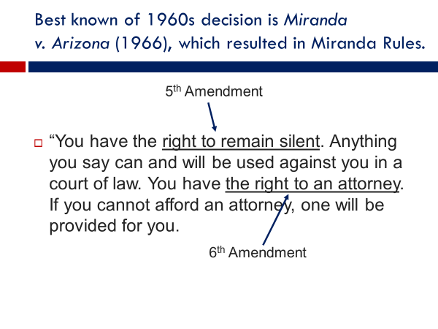
Let's look at one more issue, search and seizure, as a means of clarifying what Americans' constitutional rights mean in practice.
The Fourth Amendment says, "The right of the people to be secure in their persons, homes, papers, and effects, against unreasonable searches and seizures, shall not be violated." Notice that the Fourth Amendment doesn't explain what's meant by unreasonable.
So what's the difference between an unreasonable search and seizure which would violate the Constitution and a reasonable one which would not?
Let me give you an example of each type.
Assume that police catch a suspect in the act of robbing a bank and then check the suspect's pockets for a weapon.
That would constitute a reasonable search.
In fact, police would be derelict in their duty if they failed to see whether the suspect was armed.
Now compare that situation with police behavior in a 1962 case that became the Supreme Court's landmark ruling on what constitutes an unreasonable search. Police had come to Dollree Mapp's house without a warrant, believing that a suspect was hiding inside.
When she objected, they handcuffed her.
They didn't find the suspect, but they rummaged through her personal belongings anyway.
In a box tucked away in the basement they found pornographic material.
She was convicted under Ohio's pornography law and sentenced to prison.
In 1961, the Supreme Court overturned her conviction.
The Court held that the constitutional protection against unreasonable search and seizure would be an empty promise if police could push their way into a person's home without a warrant and search high and low for something that might be incriminating.
The Mapp decision involved what's called the exclusionary rule-the legal principle that evidence gathered by unconstitutional means cannot ordinarily be used against the accused during a trial. Now, keeping that distinction in mind, imagine for a moment that you're a Supreme Court justice having to decide the following case.
Assume that a man is arrested in the course of what appears to be a small drug sale. Police confiscate his cell phone and begin searching through it.
They find his phone number, look up his address, go to his house.
They find additional drugs.
He's convicted.
He appeals his conviction on grounds his constitutional protection against unreasonable search and seizure was violated.
How would you judge this case?
Was the cell phone search reasonable and therefore lawful or unreasonable and therefore unconstitutional? The situation I've just described is taken from a 2014 Supreme Court case.
It was a landmark case in that it marked the first time the court had ruled on police action involving an electronic device capable of storing large amounts of personal information.
In its 2014 ruling, which was decided by a unanimous vote of the justices, the court held that the police search of the drug dealer's cell phone violated his constitutional protection against unreasonable search and seizure.
The court reasoned that a cell phone, and by extension, a computer or any similar device,
is different from a gun taken from a suspect's pocket at the time of arrest.
A cell phone can hold a great amount of information and allowing police to search through it without a warrant is not unlike allowing police to search a person's home or papers without a warrant.
The Court noted that police had a legal option. They could have gone to a judge to present evidence as to why they should be granted a warrant to search the cell phone. But in that case, it would be up to the judge, not the police, to decide whether the evidence was sufficient to allow the search. In the American constitutional system, judges alone have the power to issue warrants. Police can't do it on their own.
The case illustrates the complexity of civil liberties issues when the balance between public safety and individual rights is at issue.
Society would not be safe if police were prohibited in all cases from acting immediately on what they see or what they were told.
On the other hand, society also would not be safe if police could do as they pleased. You wouldn't be safe in your home or your car or on the streets if police could stop and search you at will.
That's the mark of a police state rather than a free society.
As Supreme Court Justice Felix Frankfurter once wrote,
"The history of liberty has largely been the history of the observance
of procedural guarantees."
Of course, legal protections are no guarantee that those charged with upholding the law will always do so or will apply it equally.
Studies have found that Black Americans accused of the same crime as white Americans are more likely to be convicted, and when convicted, to receive longer sentences.
Black Americans are also more likely to be victims of police violence. Unarmed Black men are 30% more likely than unarmed white men to be killed by police.
One such killing, that of George Floyd at the hands of Minneapolis police in 2020, sparked nationwide protests that lasted days on end.
America's promise of equal justice is an unfulfilled promise, a topic that will be examined in our next session, which focuses on equal rights.
OK.
Let's wrap up this session by summarizing what we've said. We indicated that free expression rights have been gradually expanded.
They have now reached the point where Americans are largely free to voice any political opinion they would like, however critical of government it may be.
Fair trial rights have also received greater protection, such that the United States now has some of the world's strongest protections for those accused of crime.
As we noted, a key part of this development has been extending the protections to include action by state and local governments.
This was achieved by the Supreme Court through the process of selective incorporation, bringing the guarantees in the Bill of Rights one by one into the 14th Amendment so that they're protected from state and local authorities.

