Transcript: Political Culture Lecture
[ON LOCATION –LEXINGTON MASSACHUSETTS]
In the words of historian Louis Hartz, the United States was born free. Its liberation from British rule began where I'm standing-on the Village Green in Lexington, Massachusetts. It was here, on a spring morning in 1775, that American colonists first fought the British.
Paul Revere had ridden through the night to warn local militia that
the British were marching their way.
The militia men were farmers, merchants, and craftsmen. They numbered less than 100.
The British force was 10 times larger, and they were regular soldiers-part of the world's finest army.
It was no contest.
The firing stopped within moments. Eight Americans lay dead.
The only British casualty was a lightly wounded soldier.
But the battle came to be known as the Shot Heard Round the World.
Democracy had found its champion-of people who were willing to fight to free themselves of the King. From here, the British force marched on Concord, seven miles to the west.
There, they faced off against a larger group of local militia. This time, men on both sides fell.
As the British marched the 20 miles back to Boston, they were fired upon by Americans positioned in the woods.
More than 1,000 Americans-one of them 80 years of age-had grabbed their muskets and joined the fight. The British were trained to fight in the open field-not against men protected by rocks and trees.
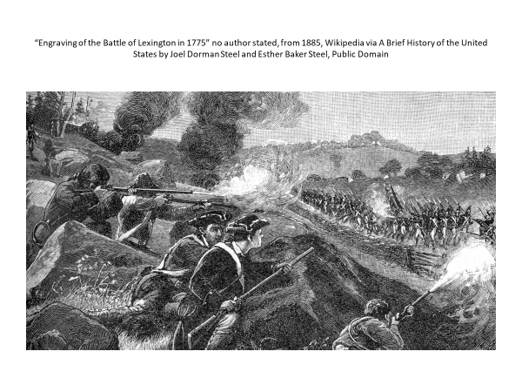
Soon the British were in full retreat.
When they finally reached Boston, they had lost nearly 100 men-double that of the Americans.
On that April day more than two centuries ago,
Americans fought for a different form of government-one where the people would govern themselves.
That vision was idealized a year later in the words of the Declaration of Independence--
"We hold these truths to be self-evident,that all men are created equal; that they are endowed by their Creator with certain unalienable rights; that, among these, are life, liberty, and the pursuit of happiness."
The ideas that sparked the American Revolution are today the foundation of America's political culture.

#
[STUDIO PORTION]
Political culture is a term that refers to the deep-seated and widely shared
beliefs of the people--
beliefs that are so much a part of their thinking
that they're almost second nature. Habits of the heart is how the French writer Alexis de Tocqueville describes such beliefs.
Now a nation's political culture gives its politics a distinctive character.
Roughly half the world's nations today are classified as democracies.
Yet, as a result of cultural differences, they differ markedly in how they're governed. German politics is not the same as Greek politics any more than Japanese politics is like the politics of India. In this session, we'll examine the American political culture.
We'll explore the origins and distinctiveness of Americans' political ideals. We'll talk also about the endurance and the challenges of those ideals.
And then we'll conclude with examples of how these beliefs affect contemporary politics.
Now Americans' cultural beliefs originated
in the nation's colonial period, which culminated in the American
Revolution.
The revolution was a rejection of an old way of governing for what, at the time, was a radically new way.
As James Madison, the nation's fourth president, said,
"We were testing whether governments do better without kings than with them."
But the revolution was more than a question of whether ordinary people were capable of governing themselves.
It reflected a far-ranging change in how people thought.
In the Europe that American settlers had left behind, power was in the hands of a small few.
Hereditary kings set atop the political ladder.
Ordinary people were their subjects, possessing few opportunities and even fewer rights.
It was an age old system, and the British King tried to impose it on the American colonies.
It didn't hold.
The American continent was too big and too uncharted to be tightly governed.
In today's high-tech world, it's hard to imagine what the settlers found upon arriving in the new world-the seemingly endless tracts of harsh and uncharted wilderness land. That untamed expanse gradually changed how people thought about themselves and about government.
Why should they surrender their liberty to a king when personal freedom was as close as the next wilderness area?
Why should they bow to a king when greater equality could be had by moving to the next frontier?
Why should they work in the fields of a king?
Why should they accept the age-old feudal system
when land was freely available and could be made productive by their own hand?
And why should they be governed by laws created by a king an ocean away
when they knew their governing needs far better than any distant ruler?
It was the gradual dawning of these radical beliefs that constituted the real American Revolution.
As the nation's second president, John Adams, said,
"The American Revolution started first in the minds and hearts of the people."
The armed revolution served to crystallize what Americans had come to believe-that they should be free, equal, self-reliant, and self-governing. Today, the beliefs nurtured during the colonial period are the cornerstone of the American political culture.
They define even what it means to be an American.
The people of most countries derive their identity from shared ancestry.
What makes someone French or Chinese, or defines them as a Turk or a Russian?
It's common ancestry.
They share land and a bloodline that goes back centuries.
The French have a nation that's more than 1,000 years old. The Chinese have one that's even older.
It dates back more than 4,000 years. Americans are different. They don't have a common bloodline. They come from every corner of the globe-- England, Mexico, Ireland, India, Vietnam, Africa, Germany, you name it.
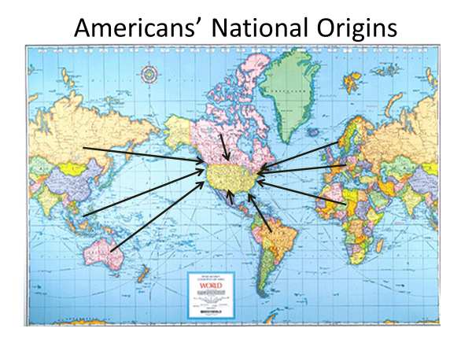

I was at a concert recently and struck up a conversation with the American next to me. As it turned out, he was born in Chad, a country in central Africa.
So what, in the absence of shared ancestry, is Americans' common bond?
What do they share besides the fact they live in the same country?
Writing in the late 19th century, the British historian James Bryce
said that Americans' identity stems from the ideals that emerged during the colonial period. Bryce was struck by the fact that wherever he traveled in the US, people voiced the nation's founding ideals.
At the time, the nation was still expanding westward-a frontier experience that further ingrained the beliefs that had sparked the revolution. Even today, these ideals--
liberty, equality, individualism, self-government-are central to Americans' identity. Collectively, they've been called the American creed.
They have been imprinted in Americans' minds by rituals, such as 4th of July
celebrations, and the reciting of the Pledge of Allegiance by Americans' children at the start of each school day. They have also been sustained over time by the words of America's leaders.
Abraham Lincoln's call for a government of the people, by the people, and for the people.
Franklin Roosevelt's proclamation that "We are a nation of many nationalities bound together
by the unity of freedom and equality."
Barack Obama's plea in his first inaugural
that America reaffirm the promise that "All are equal, all are free, and all deserve a chance to pursue their full measure of happiness." But Americans' ongoing embrace of the nation's founding ideals is more than a matter of rituals and rhetoric.
Americans have found that their nation's founding ideals are worth keeping--
to be free of repressive government, to be the equal of others, to be economically independent, to have a say in your own governing.
Those are abiding principles.
Now high ideals don't come with a guarantee that people will live up to them.
The clearest proof of that in the American case is slavery.
For 250 years, black Americans could be bought and sold, subject to the dictates of their masters.
And even when freed by the Civil War, black Americans continued to suffer
second-class status--
denied access in the south to whites-only schools, hospitals, restaurants, and hotels.
Unequal treatment was also the fate of Native Americans and of women. Asians too.
For a long period, America made it clear that Asians were not wanted here.
Chinese and Japanese laborers had been brought here to do the work of laying the tracks for the western railroads. Once the work was done, they were pressured to leave.
Many did.
Later they were barred from entry.
Through the Immigration Act of 1924, Congress imposed a complete ban
on Asian immigration--
not just Chinese and Japanese, but Koreans, Indians, and other Asians as well.
Racism was behind these policies.
But America's leaders found it more convenient to say that the Asian way of life didn't conform to the American way.
In justifying the 1924 ban, President Calvin Coolidge said that "Those who did not want to be partakers of the American spirit ought not to settle in America." Echoes of Coolidge's words have been heard in recent years in response to the threat posed by terrorist groups like al-Qaeda and ISIS.
During the 2016 presidential campaign, after a mass killing in San Bernardino, California, Republican candidate Donald Trump was quoted as saying that there should be "a total and complete shutdown of Muslims entering the United States."
Such examples might suggest that America's cultural ideals
are devoid of meaning-high-sounding words but little else. And that's sometimes been true. Cultural values are not commandments. They are principles that people can live up to or ignore.
Americans' cultural beliefs are particularly challenging. They are rooted in high ideals. Liberty, for instance, is not licensed. It's not freedom to do whatever you please.
It's rooted in free choice, but it entails responsibility-freedom up to the point where it infringes on the freedom of others.
Americans' cultural beliefs also conflict.
Self-government, for example, implies the right of the majority to rule,
whereas liberty implies that individuals have rights beyond the reach of the majority.
When majority rule and minority rights come into conflict, each side can say that it has Americans' ideals on its side,
and no resort to logic can persuade either side that the other has the larger claim. Yet despite their conflicting implications and unfilled promise, Americans' ideals have left their mark on the nation's politics.
It's impossible to understand the course of American history without taking its cultural ideals into account.
It's true, for example, that racial, gender, ethnic, and other forms of discrimination constitute the darkest chapter in the nation's history.
Yet it's also true that the struggle of Americans across the generations to build a more equal society is one of the nation's brightest chapters.
How, other than a commitment to equality, can we explain the frequent political movements that have sought to make America a more equal place?
There have been scores of such movements,
including the abolitionist movement, the suffragist movement, the women's rights movement, and the contemporary gay rights movement. Particularly noteworthy is the black Civil Rights Movement of the 1950s and 1960s.
America's mistreatment of blacks came into sharp focus with the end of World War II. Black soldiers had fought bravely to defeat Nazi racism in Europe, only to return home to racism.
Black Americans began to agitate for their rights in ever more forceful ways, eventually turning to boycotts, sit-ins, rallies, marches.
A major breakthrough came in 1954, when the US Supreme Court invalidated
state laws in place throughout the South that required black children to attend public schools separate from those of white children.
In its ruling the court said, "Separate educational facilities are inherently unequal."
As the Civil Rights Movement grew--led by inspirational leaders like Martin Luther King and Ralph Abernathy-it attracted ever broader white support.
By the early 1960s, polls indicated that 3/4 of non-southern whites favored an end to racial discrimination in restaurants, hotels, and other public accommodations. In 1964, Congress passed the Civil Rights Act, which did precisely that.
As he prepared to sign the legislation, President Lyndon Johnson said, "We believe that all men are created equal. Yet many are denied equal treatment. We believe that all men are entitled to the blessings of liberty.
Yet millions are being deprived of those blessings--
not because of their own failures, but because of the color of their skin.
But it cannot continue.
The principles of our freedom forbid it, and the law I will sign tonight forbids it."
The Civil Rights Movement would not have succeeded without the courage and determination of the black community. But the movement also had behind it the moral force of Americans' professed belief in equality.
It was that force that Martin Luther King summoned when he challenged America to "Rise up and live out the true meaning of its creed-that all men are created equal."
Now as I noted earlier, a nation's political culture gives its politics a distinctive form. Cultural beliefs clearly do not determine precisely what a people will do.
But in the long run, they affect what a people will regard as appropriate and desirable, and thus what they will try to achieve. Cultural beliefs serve as unstated rules of behavior. They act as boundaries on what people will find acceptable and what they will strive for.
Take, for example, Americans' belief in individualism. Although individualism is also a part of the political culture of European nations, it takes exaggerated form in the United States because of its unique history.
Americans' heightened sense of individualism can be seen in the results of a recent cross-national survey that was conducted in four European countries and the United States. Respondents in each of these countries were asked, "What is more important-- that nobody is in need or that individuals have the freedom to pursue life's goals?" As you can see from the figure, Americans responded differently to this question than did Europeans. Most of the European respondents ranked helping those in need more highly. In contrast, most American respondents placed individual freedom at the top.
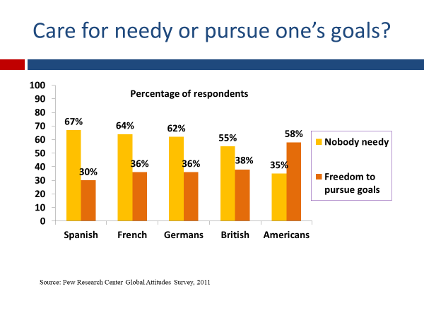
Not all American respondents ranked individual pursuits ahead of helping the needy, but the majority did-the reverse of the pattern for Europeans. Now if this difference was simply one of opinion, it would be interesting but not of great consequence.
In fact, the difference has consequences. Consistent with its greater cultural emphasis on individualism, the United States, though it has a higher poverty rate than do European countries, spends less on programs for the poor-about 25% less.
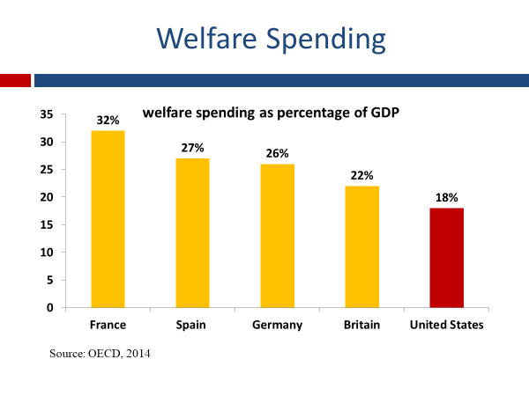
The rules of welfare eligibility also differ. In most European countries, for example, citizens are entitled to government-provided health insurance. They don't have to prove that they're poor to be eligible for it. In the United States, proof is required.
Individuals must show that they cannot buy it on their own--that they lack the financial means--before they are eligible for government help in obtaining health insurance.
Americans are not necessarily less sympathetic with the poor. Compared with Europeans, they are twice as likely to give to charities.
But Americans are less inclined to enact welfare policies that could weaken self-reliance.
From America's individualistic perspective, people are obligated to work hard and take care of themselves, unless they have a verified need for government help. Public education provides another example of how America's cultural values affect its policy choices.
The United States has easily the world's largest higher education system--more than 4,000 colleges and universities. Most of them are public institutions created by government and supported in substantial part by government funding.
The United States also spends more per pupil for primary and secondary public education than does nearly every other country. The European average per student is slightly more than $9,000 annually. The United States spends about $12,000 per student.
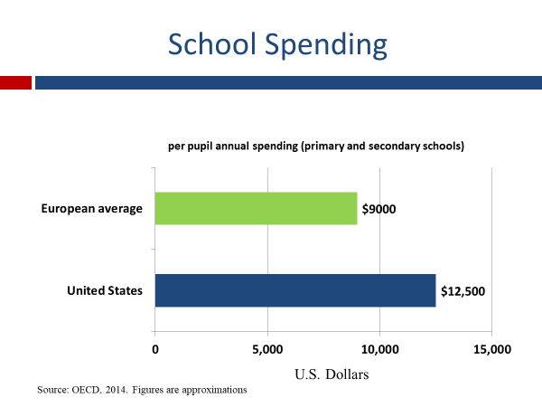
Now why is that?
Why does the United States invest so heavily in public education? Its political culture is among the reasons.
If individualism is to be upheld, you have to give people the means-a proper education-- to succeed.
And if equality is to be upheld, educational opportunities
have to be plentiful-available to the many rather than to the few. Equality of opportunity-- giving every child a chance to succeed-is the guiding principle of America's system of public education. When that system began to take root two centuries ago, it was called the great equalizer.
It sought to give children of widely different backgrounds a somewhat equal start in life so that each could succeed or fail on their own merits.
Writing in the late 19th century, the socialist Leon Samson noted the stark difference between the philosophy of public education in the United States and Europe. Said Samson, "The European ruling class were open in their contempt for working people.
But in the United States, equality and liberty were extolled in the public schools." Samson concluded that American schools embodied a unique conception of equality. Everyone was being trained in much the same way so that each person would at least have a chance at success. Since then, of course, European nations have broadened the reach of their education systems.
Nevertheless, differences remain.
In some European systems, high school students are separated into those that receive pre-college training and those that get vocational training. In contrast, most American schools offer a relatively standardized curriculum.
Each student takes more or less the same set of courses-math, science, language, and the like.
Some American educators have questioned the wisdom of this approach.
Given the differences in students' interests and aptitude, they think vocational training should be a larger part of the US educational system. But a standardized education is consistent with America's core values.
It's squarely in line with the principle of equal opportunity.
I could give you other examples-- everything from homeownership to gun laws-- that illustrate the impact of America's political culture on its policies.
But the point would be the same.
Any assessment of US politics must take into account the influence of its cultural values.
It's far from the only important factor-as we'll see in subsequent sessions of this course-but it's one of them.

#
Now before summarizing what's been said in this session, I'd like to speak briefly about the nature of politics.
Political scientist Harold Lasswell described politics as the struggle over who gets what, when, and how.
In other words, politics is the process through which a society settles its conflicts over who gets the benefits and who pays the costs of public policy. There are two basic reasons why conflict is at the center of politics.
One is scarcity.
Even the richest nations do not have enough wealth to satisfy everyone's demands.
That sets up a conflict over how a nation's resources are distributed.
Everyone wants a piece of the pie, but the pie is not big enough to give everyone what they want. Consider, for example, the difference in the quality of America's public schools. Wealthy suburban districts have better school facilities than do poor, inner city neighborhoods. The reason for this is that public schools are financed in large part at the local level.
Roughly half of school funding is provided by local taxes.
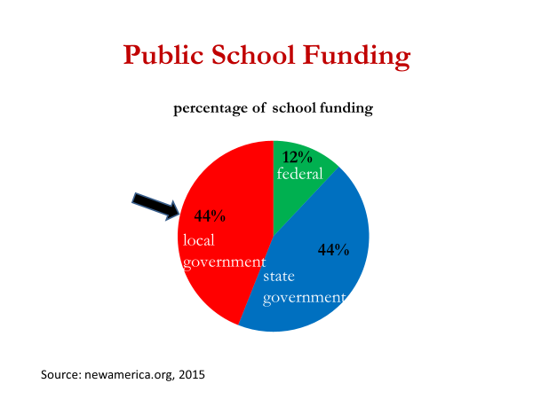
And wealthier communities have a stronger tax base.
In an effort to improve their schools, poorer districts have pressured state governments to equalize spending across districts.
This proposal has been strongly opposed by wealthier districts, which fear it will weaken their schools. Such conflicts stemming from insufficient resources to satisfy everyone's demands are an everyday part of politics.
Nearly any time that money, status, or other type of resource is at issue, people will fight over its distribution. The second major source of conflict in society is values-more precisely, values that diverge.
One person's beliefs about what's right and wrong may differ radically from another person's.
When such value differences exist around an issue of policy, conflict is almost inevitable. A case in point is the abortion issue.
Ever since the Supreme Court in 1973 declared that women have a right to choose abortion, the issue has been a persistent source of conflict. To some, abortion is a woman's right to choose. To others, abortion violates the rights of the unborn.
These are opposing beliefs and largely incompatible. One side would ban abortion. The other would leave the choice to the woman. How do you bridge that difference? Well, you don't do it easily.
Ever since the Supreme Court's 1973 ruling,
abortion foes and supporters have been fighting the issue in the courts
through street demonstrations and in the Halls of Congress and state legislatures.
Such conflicts are an everyday part of politics.
Whenever people's values clash, each side will fight to come out on top.
Now who wins out when there is conflict over resources or values? Which side gets what it wants?
The abstract answer is that the winners are those with the most political power.
Power is a basic concept of politics.
Political scientists define power as the ability of an actor, such as an individual, group, organization, or institution, to influence policy or control the behavior of others.
Influence and control-- those are the marks of power.
Actors with enough power can impose or cut taxes, prohibit or permit
abortion, increase or reduce welfare benefits, you name it.
Given what power can do, it's not surprising that much of what happens in politics centers on power-trying to get it, as in the case of campaigning for election to office,
and trying to use it, as in the case of lobbying to influence legislation.
In subsequent sessions, we'll examine the distribution of power in the American political system.
Who has power in America and who doesn't?
That's one of the most important questions to ask and answer about any political system.
#
OK.
Let's wrap up what we've said in this session.
We noted that Americans' core beliefs-- their political culture-- originated in the conditions of the new world, particularly its vast tracts of wilderness land.
It opened the minds of colonial Americans to a new way of governing-- one rooted in beliefs about personal liberty, individualism, equality, and self-government.
We also noted that these ideals have been passed along to each succeeding generation of Americans, ensuring their continuing influence on the nation's politics. Americans have argued over the meaning of these ideals, but not whether they're worth keeping.
We pointed out some of the challenges that Americans face in living up to their ideals--challenges that stem in part from the demanding and sometimes conflicting nature of these ideals.
We then looked at how these beliefs affect public policy, pointing out that they set boundaries on what people will regard as desirable, and thus what they will try to achieve politically.
Finally, we noted that politics is the process by which society settles its conflicts over scarce resources and opposing values.

