Transcript: Political Movements Lecture

[ON LOCATION, BOSTON HARBOR]
THOMAS PATTERSON: I'm at the Boston Harbor in front of our replica of a British ship from the Revolutionary War era.
That ship was part of one of America's best-known escapades, the Boston Tea Party. The Tea Party was part of a protest in the American colonies against attacks on tea.
It had been imposed by the British Parliament, where the colonists had no representation, to show the colonists that Britain was in charge of their affairs.
The tax protest took its most extreme form here in Boston. The local British governor refused even to meet with community leaders to discuss the tea tax, so they took matters into their own hands. Under the cover of darkness, some of them dressed as Mohawk Indians. They boarded three ships in this harbor and tossed their cargoes of tea overboard.
Outraged, the British governor closed the Boston harbor. That further angered the colonists, and the protests spread. And within a year, the United States and Britain were at war.
The Boston Tea Party launched America's first successful protest movement.
Since then, the United States has witnessed hundreds of such movements. Some of them, like the progressive movement of the early 1900s, and the Black civil rights movement of the 1950s and the 1960s, have been extremely successful.
#
[STUDIO PORTION]
This session will examine political movements, or as they are also called, social movements.
We'll concentrate on the nature of political movements, why they occur, and what purpose they serve. Then we'll look at the factors associated with the success or failure of political movements.
We'll conclude the session with a look at two recent movements-- the Tea Party and Occupy Wall Street movements.
A political or social movement is defined as an active and sustained effort to achieve social and political change by people who feel government is unresponsive to their concerns. Political movements seek to bring about change. They are protests of the status quo.
Political scientist Sidney Tarrow notes that political movements are characterized by a challenge to authority from outside the established institutions-- most dramatically, when people take to the streets and protest.
In this way, advocacy through social movements difference from advocacy through political parties or interest groups. Those forms of advocacy take place within established institutions, such as elections or legislative bodies. A sense of deprivation is what typically drives people to participate in a political movement.
That deprivation does not have to be absolute. In most cases, in fact, it tends to be relative, meaning that movements tend to emerge when people think they are unfairly deprived in comparison to another group.
Consider the history of voting movements in the United States.
When property holding males alone had the right to vote, it was not the case that everyone else engaged in protest. The protest came from propertyless males.
When voting was extended to all male citizens, it was women who began to protest. When voting was in practice, reserved for white citizens, it was Black Americans who began to demand equal access to the ballot.
Now over the course of US history, there have been literally hundreds of political movements, including a number of highly successful ones. But they have been the exception.
Most movements eventually falter. The Prohibition movement has the distinction of being both successful and unsuccessful. In 1919, the movement achieved a Constitutional amendment that prohibited the manufacture, sale, and transportation of alcoholic beverages. The amendment turned out to be a boon to organized crime, as mob bosses like Al Capone stepped in to supply liquor to thirsty Americans. The Constitutional ban on alcohol was repealed in 1933.
So what are the factors that affect whether a political movement is likely to succeed?
Take a look at the following chart.
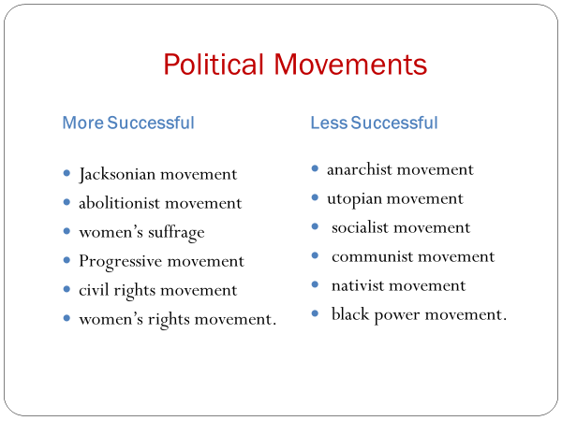
Compare the successful political movements in the left column, the Jacksonian, abolitionist, women's suffrage, progressive, civil rights, and women's rights movements, with the less successful ones in the right column, the anarchist, utopian, socialist, communist, nativist, and black power movement.
Do you detect any difference in the type of goal they were seeking?
A difference I see is that the successful ones based their claim on a widely accepted American ideal.
A greater degree of equality, for example, was the goal of the civil rights and women's rights movement, whereas a greater degree of self-government was the aim of the Jacksonian and progressive movements. Alignment with an accepted ideal gave these movements an advantage. It made it harder for opponents to portray their goal as illegitimate and made it easier for them to attract supporters outside the group.
That was the case, for instance, with the Black civil rights movement of the 1950s and 1960s. The movement was Black-led, but it had the support of tens of thousands of white Americans who shared their commitment to equality.
On the other hand, the less successful ones on the list, including the anarchist, socialist, and communist movements, had that ran counter to American values. The anthropologist David Aberle has labeled such protests as revolutionary movements. They seek to overthrow the existing value system.
That's a tall order. Value systems are deeply rooted, difficult to change. No less a revolutionary than Friedrich Engels, Karl Marx's closest associate, recognized that when he said in 1893, a time when communism was spreading throughout continental Europe, that he had little hope for a communist revolution in the United States. American workers, he said, were individualists. Self-reliance, rather than class consciousness, was their creed.
Now what else might affect the success of a political movement?
Well, here are three factors that scholars have identified as important.
One is a movement's ability to sustain itself. Does it have or can it generate the resources needed to keep it going?
A second is institutionalization. Can it, for example, get its goal enacted into law, thereby giving it a permanence it would otherwise lack?
The third is legitimacy. Can it convince others that its cause is a worthy one?
Legitimacy is not simply an issue of a movement's goals. It's also a matter of its tactics and methods. For example, when the anarchist movement of the early 1900s resorted to bombings and other forms of violence, it lost whatever small chance it had of winning broader public support.
Now the importance of these three factors can be seen by looking at the Black civil rights movement of the 1950s and 1960s.
In terms of sustainability, it had extraordinary leadership. Individuals like Martin Luther King, Jr., Whitney Young of the National Urban League, and Roy Wilkins of the NAACP not only had strong leadership skills, but they stayed with the movement for years, lending it stability.
Outside support also helped sustain the movement. This chart, for example, shows the funding sources of the National Urban League, which led the push for civil rights in America's cities.
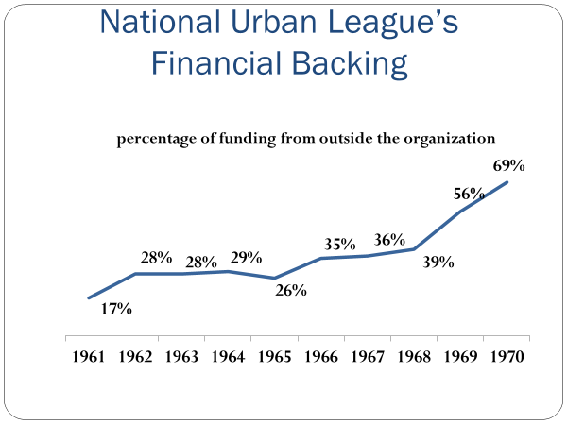
As you can see, the Urban League was increasingly supported by donors from outside the organization, nearly all of whom were white.
In terms of legitimacy, the Black civil rights movement had a degree of it from the start. Opinion polls as early as the 1930s indicated support for racial change.
But that support was not widespread enough or intense enough to force that change. Over time, the civil rights movement was able to generate broad support, in part because the nonviolent tactics of Martin Luther King contrasted sharply with the brutal attacks on civil rights marchers by police in Alabama and elsewhere.
By the time Congress passed the 1964 Civil Rights Act, the large majority of white Americans outside the south favored giving Black Americans equal access to restaurants, hotels, and other public accommodations.
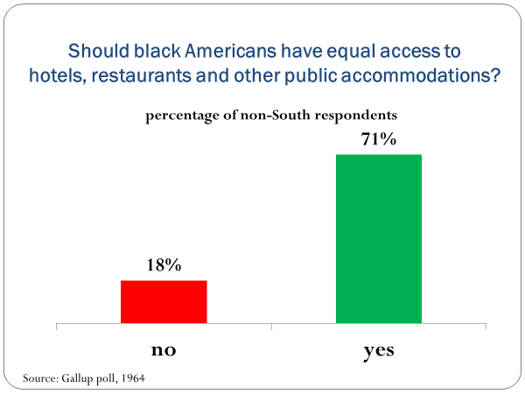
The Black civil rights movement also succeeded in institutionalizing itself. The Civil Rights Act of 1964, for example, outlawed discrimination in the use of public accommodations.
Institutionalization was also achieved by the movement of Black voters into the Democratic Party. Blacks had been Republicans. After all, it was a Republican president, Abraham Lincoln, who freed the slaves. But in the 1950s and 1960s, as the Democratic Party took the lead on civil rights, African Americans increasingly identified themselves as Democrats. The importance of this development was that it gave Black Americans a secure institutional base. They could count on the Democratic Party to help them protect and promote their rights going forward.
Now let's look at a contrasting case, focusing solely on the question of legitimacy.
Although it's widely assumed that the Vietnam War protests hastened the end of the war, some scholars believe that they might actually have prolonged it. They base their argument on the fact that most Americans had a negative view of the protests, which conceivably made it harder for them to reach the conclusion that the war should end. Here are the results of a Gallup poll taken in 1968, a peak here in the Vietnam War protest movement.
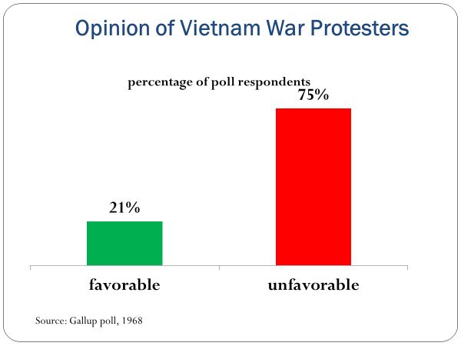
As you can see, the great majority of Americans, 3/4 of them in fact, had a negative view of the protesters. Only one in five had a favorable view.
Now why was that? Why did most Americans react so negatively to the protesters?
It was because of the way some protesters chose to express their opposition. Trampling on the American flag, burning their draft cards, clashing in the streets with police.
In the minds of many Americans, the protesters were not simply antiwar, they were anti-American.
The public's opinion of the protesters came into sharp focus in 1970 when national guardsmen opened fire on unarmed student demonstrators at Kent State University, killing four, wounding several others. There was no conceivable excuse for the shooting. It was callous and senseless. But who did most Americans blame for the shooting? They blamed the students.
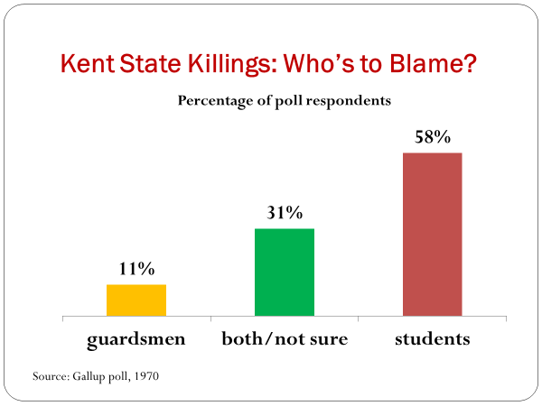
The Gallup poll indicated that only one in nine respondents faulted the National Guard.
Five times that many said it was the students' fault.
We can't resolve here the question of whether the Vietnam protests shortened or lengthened the war. What's clear, however, is that the protest movement's tactics weakened its legitimacy.
#
Before wrapping up the session, let's look at two recent movements, the Tea Party and Occupy Wall Street, through the lens of their sustainability, legitimacy, and institutionalization.
Both movements succeeded in changing the national debate-the Tea Party by focusing attention on the size of government, and Occupy Wall Street by directing attention at America's widening income gap.
Before digging in on them, I'd like your opinion.
If you were to look back 30 years from now, do you think the Tea Party or Occupy Wall Street will have had the larger impact on American politics?
Keep your answer in mind as we look at them, starting with the Tea Party movement.
The Tea Party surfaced in 2009 as a tax protest, a negative reaction to the sharp spike in government spending, including the nearly $800 billion stimulus program and the nearly $500 billion bailout of financial institutions. They were prompted by a steep downturn in the economy.
The spending activated the simmering resentment that some Americans had toward federal spending.
They were particularly angry, and had been for a long time, about spending on welfare programs, believing that their hard-earned tax dollars were supporting people who could work but chose to live off welfare.
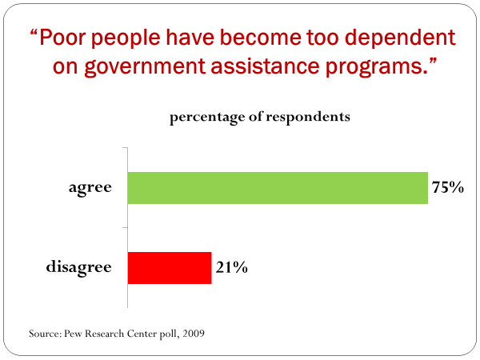
Their resentment boiled over on April 15, 2009, the date Americans' taxes came due. In locations across the country, Tea Party protesters gathered to express their anger.
At the White House, they tossed tea bags over the fence.
Republicans, as this figure shows, were the Tea Party's strongest supporters.
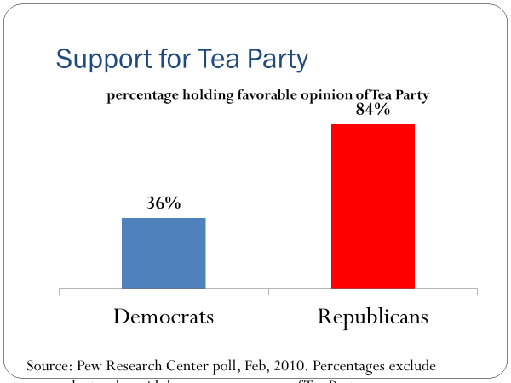
That was to be expected, given the Republicans' greater opposition to federal welfare and spending programs. The Tea Party was also able to tap into the Republican Party's money base. Conservative donors and organizations funneled millions of dollars into the movement.
Conservative talk show hosts and media outlets trumpeted the Tea Party. Fox News gave it 10 times more coverage than did the average broadcast network.
Sarah Palin, who had been the Republican vice presidential nominee a year earlier, said, "The Republican Party would be really smart to absorb as much of the Tea Party movement as possible."
Capitalizing on its Republican support, the Tea Party endorsed and helped fund nearly 150 Republican congressional candidates in the 2010 midterm elections. When more than a third of them won, the Tea Party had an institutional base within the Republican Party.
The Tea Party's weak spot was its legitimacy. Its followers came to be widely seen as stubborn and inflexible. The perception was reinforced in 2011 when Tea Party Republicans in Congress refused to bend on the debt ceiling limit, which nearly led the federal government to default on its debt obligations for the first time in history.
Missouri Senator Claire McCaskill said of the Tea Party's tactics, "When the Tea Party comes to town, compromise goes out the door."
The Tea Party's tactics in the debt ceiling crisis hurt its public standing. A Gallup poll showed its approval rating had reached a new low. Less than a third of Americans said they had a favorable opinion of the movement.
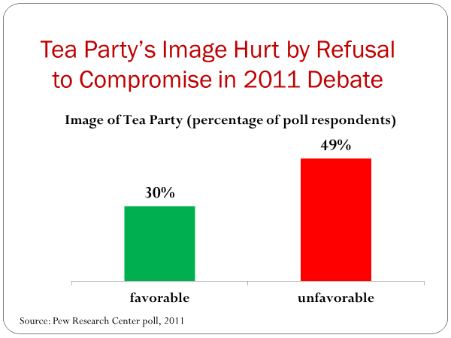
Occupy Wall Street, the other recent movement also ran into a legitimacy problem, one stemming from its tactics.
Occupy began in 2011, when a group of protesters pitched their tents in New York city's Zuccotti Park, located near Wall Street. Within a few weeks, Occupy encampments had sprung up in virtually every sizable American city.
Occupy's anger was directed at taxes. But unlike the Tea Party's complaint about taxes, Occupy was angry that the wealthiest taxpayers, those it called the 1%, were being taxed at relatively low rates-this at a time when the income gap between rich and poor was steadily widening.
As this chart indicates, Occupy had its strongest backing among Democrats.
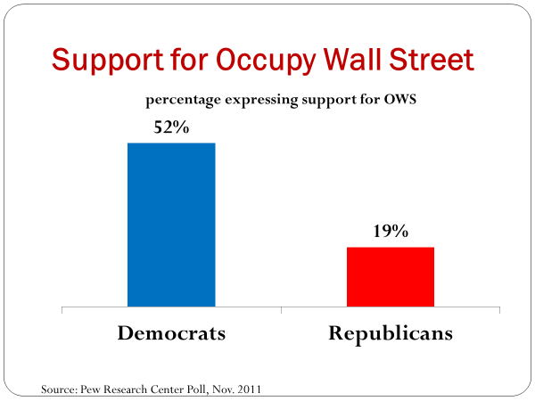
They were far more likely than Republicans to hold a favorable opinion of the movement-not surprising, given the fact that Democrats are more likely to favor increased taxes on the wealthy.
However, Occupy rejected suggestions that it align with the Democratic Party. Occupy also refused to take contributions from large donors, saying that to do so would violate its principles.
For more than a month, the Occupy Movement was front page news. But as the media's interests began to wane, so did the small donations that were sustaining it. Within two months, the donations were falling fast, and the movement was slowing.
Occupy had another problem as well. It didn't have a strategy for moving from encampments to an alternative form of protest. Some of the protesters stayed put when local governments ordered them to decamp. In some cities, they clashed with police. It was a public relations disaster. Polls indicated a sharp drop in Occupy's public support.
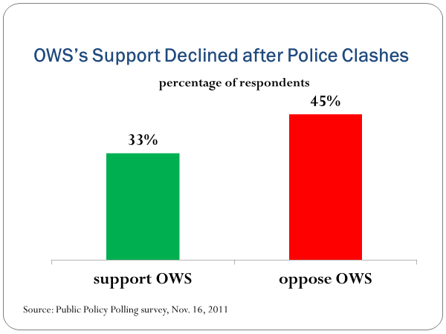
Today, as a result of not having institutionalized itself, Occupy Wall Street exists mostly in the form of a lightly trafficked website.
That's only part of the story. Even now, several years after Occupy disbanded, most Americans support its position-that taxes on the wealthy should be increased. But would Occupy have had greater impact if it had been institutionalized?
In all likelihood, it would. As author and journalist Janine di Giovanni noted, "Occupy was a disorganized movement without a clear focus and power base--essential in any successful revolution."
Occupy Wall Street and the Tea Party are not the only recent important political movements. Another is Black Lives Matter, which began in 2013, in response to the killing in several cities of unarmed young Black men by police officers. Through public demonstrations, marches, and the re-enactment of the police killings, the movement has sought to highlight disparities in how white and Black citizens are treated by police and other local officials.
The killing of George Floyd, an unarmed and handcuffed black man by Minneapolis police in 2020 heightened the call for large changes in how police treat Black Americans.
Another recent movement is #MeToo, which arose in 2017 to bring attention to sexual assault and harassment. The movement resulted in the firing or resignation of a large number of powerful men, including Hollywood producer Harvey Weinstein, television host Charlie Rose, casino magnate Steve Wynn, and US representative John Conyers.
The #MeToo seeks to raise the awareness of the extent of sexual misconduct, show its devastating effect on victims, and encourage firms and organizations to adopt policies aimed at stopping the practice.
Another recent movement is the student-led movement against gun violence that was sparked by the 2018 mass killing of students of staff at Marjory Stoneham Douglas High School in Parkland, Florida. The school's students responded with an impassioned plea for an end to school shootings. Their efforts led to a national school walkout day and demonstrations in hundreds of cities and towns.
The movement's goal is to pressure lawmakers at the national, state, and local levels to enact tougher gun control measures.
It's too early to say with certainty whether Black Lives Matter, the #MeToo movement, or the movement against gun violence will bring about major and lasting policy changes.
The history of the Black civil rights movement suggests that any judgment on the success of these movements could come years from now.
It took several decades before the Black civil rights movement led lawmakers to enact the landmark legislation that is now its permanent legacy.
#
OK, let's wrap up this session.
As I mentioned, America has a long history of protest movements, including some, like the Black civil rights movement, that have had a lasting impact on our politics.
We pointed out that political movements are often rooted in people's sense of deprivation, and that several factors affect a movement's success in the long term.
Movements tend to be more successful when their goals align with society's dominant values and ideals. In such cases, movements are more likely to attract support from the broader public.
Political movements are also more likely to succeed if they can acquire resources with which to sustain their activities, and if they can institutionalize their goals, giving them lasting power.
Finally, a movement's success can depend on whether it is seen as legitimate, which is in part a function of the tactics it uses. Americans tend to admire orderly protests, and not disruptive ones.

