Transcript: Campaigns & Elections Lecture

[ON LOCATION, BOSTON NEIGHBORHOOD]
THOMAS PATTERSON: Nothing symbolizes democratic government more than the vote.
Behind me is the polling place where I vote on Election Day. On Election Day, there's a long line outside the door.
Election Day is the last day of the campaign. In the case of the United States, it's the last day of a very long campaign.
We have marathon campaigns. That's different than European campaigns.
They last a few weeks.
In the United States, they last for months and months. One reason for that is that we have primary elections. Candidates have to run first in the primary, and if they win, then they run in the general election. European democracies do not have primaries.
American campaigns differ also in other ways.
If you're watching an American campaign on television, you'll see lots and lots of televised political ads. Some democracies prohibit, or ban, the use of televised ads, others restrict the time period in which they can be shown. Another way in which American elections differ is that they're a lot more expensive. A federal campaign, now, in the United States will cost more than a billion dollars. That's 20 times what a campaign would cost in Germany, or Britain, or Spain.
Make no mistake, there is an American way of conducting elections.
#
[STUDIO PORTION]
In this session, we'll examine US election campaigns. We're going to concentrate on presidential elections given that we studied congressional campaigns in earlier sessions.
We'll look at the background influences that affect the outcome of presidential campaigns. We'll study how presidential nominating campaigns are structured, and what it takes to win the party's nomination. And, finally, we'll look at the nature of the general election campaign with particular attention to the electoral college. US presidential campaigns are billion dollar affairs. They're loud, and they're long.
Yet, the outcome often depends less on what the candidates do than on factors beyond their control.
The most significant of these factors is voters' partisanship, their loyalty to one party or the other.
When a campaign starts, most voters have already made their pick, even if they don't admit it.
When Election Day comes around, the great majority of Republicans will back their party's candidate, while Democrats will align up, overwhelmingly, with their party's nominee.
And at times in American history, one party has had such a huge advantage over the other that its presidential nominee could have stayed home and still won.
After the party realignment of the 1890s, for example, there was a three decade period when only a single Democrat, Woodrow Wilson, was elected president.
And he was lucky. Wilson slipped into the presidency in 1912 with a mere 42% of the popular vote.
Republicans split their votes between their party's incumbent nominee, William Howard Taft, and their party's former president and third party candidate, Theodore Roosevelt.
Today, the parties are more evenly matched.
As you can see from this chart, the average margin of victory in recent presidential elections has been less than 5%, compared with as high as 20% in earlier periods.
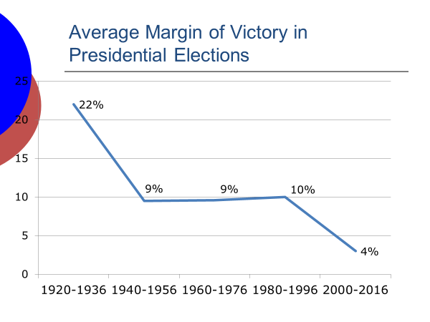
Even so it's still true that most votes are decided before the campaign starts.
Democrats lined up with the Democratic nominee, and Republicans behind their party's nominee. In fact, the number of votes up for grabs in presidential campaigns has been declining.
To see that, let's look first at the poll results from the 1976 presidential election, which pitted Republican Gerald Ford against Democrat Jimmy Carter. As you can see, Carter had a huge lead at one point in the race.
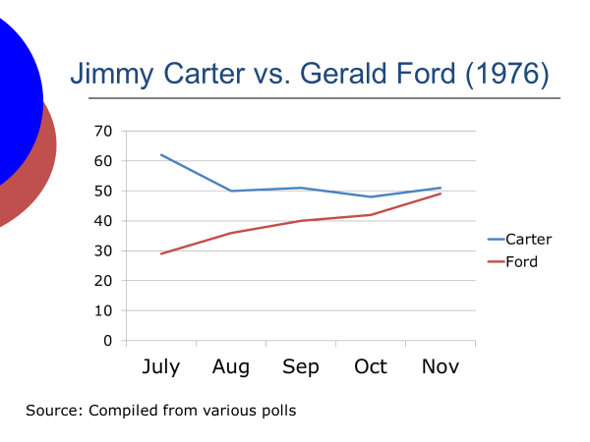
But as the campaign progressed, a lot of voters changed their minds. Carter won by a mere two percentage points.
Now, compare that pattern to polls of the 2016 race between Republican Donald Trump and Democrat Hillary Clinton.
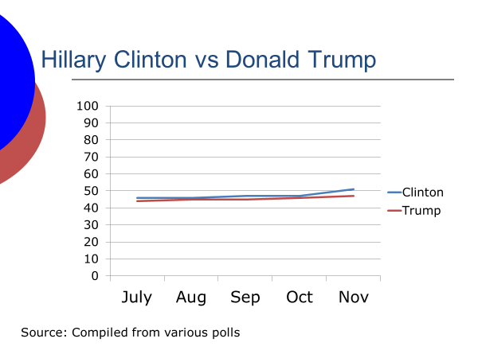
As you can see, the gap between Trump and Clinton support stayed within a narrow range throughout the general election. Some movement did take place, but it was small compared with the shifts that occurred in 1976. Voters preferences have been more stable during recent campaigns than earlier ones. There's been less switching from one candidate to the other as the campaign moves along.
Now, why do you think that's the case?
Is it a result of higher levels of spending by both sides in recent presidential campaigns, such that the influence of one side's spending cancels out that of the other side?
Or is it the result of the rising level of party polarization?
Polarization is the main reason.
Republicans are more conservative than in the past, and Democrats are more liberal.
And, therefore, they're harder to lure across party lines.
Estimates of the number of swing voters, those that today could conceivably be won by either party in a presidential campaign, vary widely. Some analysts put it at roughly 5% of voters, other analysts put it at closer to 10%.
Either way, it's a smaller number than the 15% to 20% of voters who are up for grabs in a presidential election a few decades ago.
Candidates also have to deal with the fact that election turnout in US elections is relatively low.
Turnout in a presidential election is only about 60%.
Tens of millions of potential voters stay away from the polls on Election Day. Through their get out the vote efforts, candidates can affect turnout to a degree, but not in a huge way. Some candidates have convinced themselves otherwise.
When he ran for the presidency in 1964 on an avowedly conservative platform, "a choice, not an echo," as he put it, Republican nominee Barry Goldwater predicted that Americans would come out of the woodwork to back his campaign. They didn't.
Turn out in the 1964 election actually declined slightly from his 1960 level.
Candidates also can't do that much to alter enthusiasm differences between the partisans. In the 2016 presidential campaign, Republicans had intensity on their side as a result of having been out of power for eight years.
A Gallup poll taken during the 2016 general election, for example, found an 11-percentage point intensity edge for Republicans, the largest difference between supporters of the two parties in any recent election.
Republicans higher level of intensity might have won them the election. The 2016 election was decided in the electoral college.
The winner, Donald Trump, lost the popular vote to democratic nominee Hillary Clinton, but squeezed by in enough states to gain a majority of the electoral votes. Clinton lost by less than 1 percentage point in Wisconsin, Michigan, and Pennsylvania. If Democratic turnout had been higher in those three states, she might have captured them. In that case, she would have won the presidency.
Now, a third factor largely beyond the candidate's control is the issues voters care about.
In this respect, few things matter more to voters than their sense of whether the country is on the right track economically.
When the economy is doing well, the nominee of the party in control of the White House gets a boost.
When it's doing poorly, that nominee has more trouble winning.
Since 1976, three incumbent presidents Gerald Ford, Jimmy Carter, and George H.W. Bush have lost their bid for reelection. Each one of them was saddled with a weak or deteriorating economy.
During his term of office, for instance, Jimmy Carter saw both unemployment and inflation rise sharply contributing to his defeat in 1980 at the hands of Ronald Reagan. In fact, it's more accurate to say that Carter lost the 1980 election than to say Reagan won it.
Ever since 1936, the Gallup poll has asked Americans if they have a favorable or unfavorable opinion of the presidential nominees.
Reagan had the lowest favorability rating in Gallup polls of any winning candidate to the point. His luck was that the voters had an even less favorable opinion of Carter.
This diagram, created from a study by political scientist Lynn Vavreck, provides a systematic look at the effect of economic conditions on vote choice.
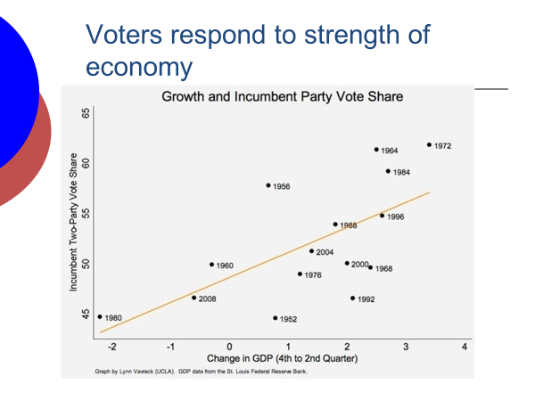
It's a scatter plot showing the relationship between the rate of economic growth and the share of the two party presidential vote won by the incumbent president's party.
As you can see, the relationship is a positive one. The stronger the economy, the higher the vote total of the incumbent party.The lower, the lower the vote total of the incumbent party.
Now, foreign policy issues don't figure all that heavily into the outcome of presidential campaigns, except when a war has turned out badly. That invariably hurts the candidate of the party holding the presidency.
The Vietnam conflict, for example, contributed to the defeat in 1968 of the incumbent party's nominee, Democrat Hubert Humphrey. The Iraq war, along with a wobbly economy, hurt incumbent George W. Bush in 2004, but he, nonetheless, scrape by. His winning margin was the smallest ever for an incumbent president.
Now, keeping in mind that presidential candidates don't entirely control their fate, let's look at how a presidential campaign operates.
The United States has primary elections, which place a heavy demand on presidential candidates. Instead of a single primary, they have to compete in 50 state contests.
States have a choice, they can hold a primary or they can hold a caucus.
The difference is that in a primary, the voters simply go to the polls and cast their ballots whereas, in a caucus the voters go to a local site where they meet and discuss the candidates before voting. Caucus participation is more time consuming, and turnout is substantially lower than in primaries. About 10 states use the caucus method. The other 40 hold a primary.
Whichever method they use, a state’s contest determines which candidates delegates will represent it at the national convention where the party's nominee is formally chosen.
The candidates thus compete for delegates, seeking to win enough of them to have a majority by the time the convention meets.
Now, this system was created after the 1968 presidential election in which Hubert Humphrey won the Democratic nomination even though he hadn't entered a single primary.
At that time, state parties had the option of choosing their delegates through a primary or at a state convention. Most delegates were chosen in state convention, which were controlled by party leaders. They provided the delegates that gave Humphrey the 1968 nomination over his chief rival, who had run in the primaries.
When Humphrey then lost the general election to Nixon, party reformers succeeded in bringing about a change in the rules. Thereafter, states would be required to choose their delegates through either a primary or caucus-the system we have today. Because of the change, presidential hopefuls have no choice but to compete in the state contests. They can no longer sit back and wait for the party to come to them, as Humphrey did in 1968.
The change has also created a more wide open nominating process.The earlier system favored candidates who had the backing of top party leaders. The current system is open to any politician who thinks they can get the voters' support.
Except in the case of a party where the incumbent President is seeking re-election, nominating races, since 1968, have normally attracted a large field of contenders. The 2020 Democratic nominating race set the record pulling in two dozen contenders, including Joe Biden, Kamala Harris, Bernie Sanders, Elizabeth Warren, Pete Buttigieg, Amy Klobuchar, Beto O'Rourke, and Cory Booker.
Now, the presidential nominating process is a lengthy one. In simplified terms, it has three phases.
First, in the months before the first contests, candidates raise funds, engage in televised debates, hit the campaign trail, spending most of their time in the states that vote first. Then, in January of the election year, the first state contest, the Iowa caucus, is held.
That contest is followed sequentially by the New Hampshire primary, the Nevada caucus, and the South Carolina primary.
After these four states vote, the other states are then free to hold their contests.
Usually, several states will schedule their contests on the same day within a short period after the Nevada caucus, creating what's come to be called Super Tuesday, a day when a large number of convention delegates are chosen.
Finally, in the summer after the states voted, the parties hold their presidential nominating conventions where the state delegates come together to choose the party's presidential nominee.
The convention is now largely a formality. Since the rules were changed after 1968, one candidate has always captured enough state delegates to win nomination on the first ballot.
Now, which of the following do you think best predicts which candidate will get the party nomination--
the winner of the Iowa caucus,
the winner of the New Hampshire primary,
or the candidate who is best positioned as a result of what happens before any votes are cast into the primaries or caucuses?
Now, a fast start in Iowa or New Hampshire is important.
A candidate with a poor showing in both states is in trouble. As one scholar wrote, there is no time for losers.
Voters aren't interested, donors aren't interested, reporters aren't' interested in a candidate who finishes at the back of the pack. Yet, more often than not, the winner in Iowa has lost in New Hampshire.
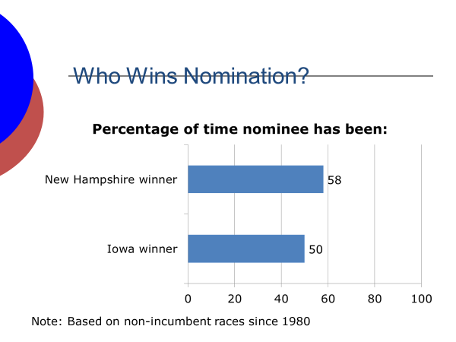
Since 1980, of the 12 open nominating races, meaning those without an incumbent president seeking re-election, only John Kerry, in 2004, and Al Gore, in 2000, won both contests.
In 1992, the eventual democratic nominee Bill Clinton lost both, though he ran well enough in the two states to retain credibility.
So, although a degree of success in Iowa and New Hampshire is a must, neither contest by itself is predictive of the nominee.
The better predictor is the candidate's ability to get in a strong position before the first votes are cast in Iowa.
Scholars describe the pre-Iowa period as the invisible primary. It's a time, even though no votes are cast, when the candidates try to put in place the elements of a winning campaign.
Name recognition is one of those elements. Unless voters know of a candidate, they're not going to back that candidate.
It's hard for a candidate who lacks name recognition to acquire it.
When George H.W. Bush ran unsuccessfully for the presidency in 1980, he campaigned long and hard before Iowa. And, yet, in Eagleton poll, taken shortly before the Iowa caucus, found that only 8% of voters said they were aware of him, while 53% said they thought his name sounded familiar, nearly 40% said they'd never heard of George Bush.
Candidates who start the campaign with poor name recognition are doubly disadvantaged, because they inevitably end up at the bottom of the pre-campaign polls. The news media queue off those polls concentrating their reporting on those who are at or near the top. It's a classic catch-22.
You need press coverage to acquire a name recognition. But if you don't have name recognition, it's hard to get press coverage.
At the start of the 2016 Republican race, the candidate with the highest level of name recognition was Donald Trump, who was widely known through his real estate
dealings and his role as host of The Apprentice, a top rated TV reality show. Trump also had a second publicity advantage. He was skilled at attracting reporters’ attention. His fiery statements on everything from immigration to trade quickly found their way into the headlines.
In the period leading up to the Iowa caucuses, Trump received a third of all news coverage given to the dozen and a half Republican contenders.
He got twice as much coverage as the next most heavily covered Republican, and 10 times more coverage than most of the Republican contenders. By the time the Iowa caucuses rolled around boosted by his news coverage, Trump was far ahead of his Republican competitors in the national polls.
Since 1980, the only poll leaders to lose nomination were Democratic Gary Hart, in 1988, who got derailed by a sex scandal, Democrat Howard Dean, in 2004, who had begun to slip in the polls a few weeks before Iowa, and Democrat Hillary Clinton, in 2008, whose lead had been steadily shrinking in the months leading up to Iowa.
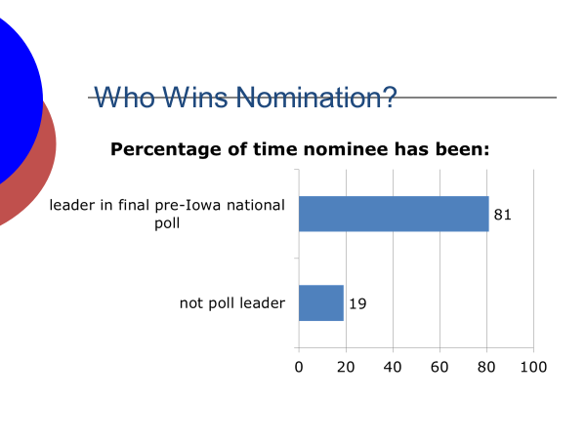
Name recognition is critical.
It helps a candidate withstand a setback in Iowa or New Hampshire, and enables the candidate to pick up votes on the margins.
Voters choose among the candidates they know, an advantage denied a candidate who voters find unfamiliar. Now, fundraising is also a key part of the invisible primary.
It takes a huge amount of money to mount a successful national nominating campaign.
Estimates of the minimum run upwards of $50 million.
Not surprisingly, in the year before the Iowa caucus, candidates devote a great amount of time to fundraising with varying degrees of success. The news media, as they do with polls, see money as an indicator of which candidates to take seriously.
And as with the polls, money and media go together. The more of press coverage a candidate gets, the easier it is for that candidate to raise additional money.
Barack Obama's 2008 campaign illustrates the point. Even though Obama, a relative unknown at the time, trailed badly in the early polls to his main Democratic rival Hillary Clinton, he astonished the pundits by raising $26 million in the first quarter of 2007.
As a result, his news coverage shot up, boosting both his poll standing and his fundraising efforts.
By the time the Iowa caucus rolled around, Obama had raised $102 million, roughly what Clinton was able to raise.
So why is a large amount of early money so important?
Well, it enables the candidates to spend heavily on the first contests in Iowa, New Hampshire, South Carolina, and Nevada, while also buying early TV advertising in the Super Tuesday states.
Personally, a candidate can only be in one state at a time.
Money allows the candidate to have a presence in a lot of states at once.
This chart indicates the percentage of time that the candidate who wins the money game in the year before the Iowa caucus receives the party nomination.
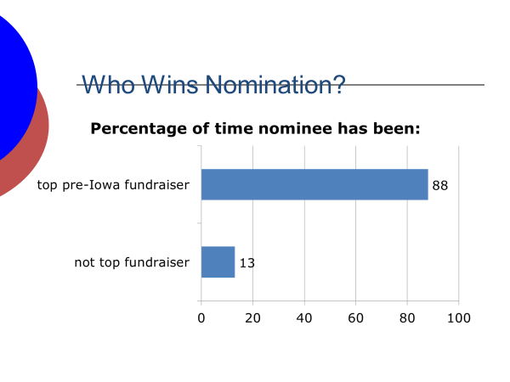
As you can see, the money winner nearly always gets the nomination. Since 1980, the only clear exceptions are Howard Dean, in 2004, Mitt Romney, when he first ran in 2008, and Donald Trump, in 2016.
Trump lost the Republican money race in 2016 to Senator Ted Cruz. In Trump's case, the money was not all that important. He was receiving so much attention from the news media that he had less need for campaign funds than did his Republican rivals.
Now, I'm not suggesting that the invisible primary counts for everything in a nominating race.
A candidate must still campaign effectively when the voting gets underway. But nominating races are not won by candidates who are poorly position at the start.
#
Let's jump ahead now to the presidential general election.
By this point in the campaign, the race has narrowed to the Republican and Democratic nominees. What determines their strategies? Well, several things, none more so than the electoral college.
Each state has electors equal in number to its representation in Congress, House and Senate combined. The candidate who gets a majority of the state's electoral votes wins the presidency.
All states, but Maine and Nebraska, apply what's called the unit rule in allocating their electoral votes. The candidate who gets the most votes in the state gets all of its electoral votes.
So in terms of candidate strategy, which states are most important?
Those that have the largest populations, and therefore the most electoral votes, or those where the candidates are most evenly matched?
Now, size matters.
There's no question about that.
The most populous states have outsized influence in the electoral college. California, for example, has 55 electoral votes, a fifth of the 270 electoral votes needed to win the presidency.
But from a strategic perspective, a state's competitiveness is more important. California is largely ignored by the candidates during the general election, because it's heavily Democratic. Its electoral votes are known in advance.
That's the case with most states--they are heavily enough Democratic or Republican that the outcome is not truly in doubt.
Accordingly, candidates concentrate on what are called the battleground, or swing states, those that conceivably could be won by either side.
During the 2016 general election, roughly 95% of Trump and Clinton's campaign appearances were concentrated in just 12 states. The states where each candidate had a shot at victory.
The campaign in the battleground states is intense.
US presidential campaigns are costly affairs. In 2016, Trump and Clinton together raised and spent hundreds of millions of dollars. She had the fundraising advantage, outspending him by a clear amount.
Nevertheless, as was true during the nominating phase of the 2016 campaign,
Trump had less need for advertising dollars because he was getting most of the news coverage.
The news media's fascination with Trump kept him in the headlines. He received 12 percentage points more news coverage during the general election than Clinton did.
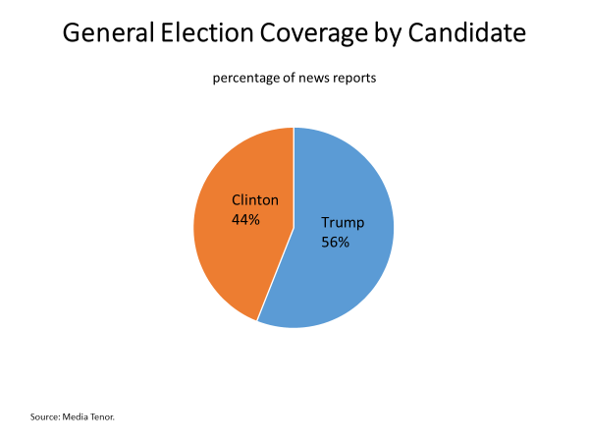
During the general election, most of the money that the candidates spend goes to buy televised ads in the battleground states. Now, most candidate ads are negative in tone. They're attack ads aimed at tearing down the other candidate.
Candidates' media strategists believe it's easier to persuade someone to vote against an opponent than to get them to vote for their candidate.
Attack ads also get the attention of the news media, which act as a megaphone carrying the message to those who don't see them directly.
Recently, a media consultant was asked how many of his ads had been constructed with the news media in mind, he replied, well, about all of them.
Attack ads also help to fire up the party's core voters. If they think the opposing candidate is unfit to be president, they're more likely to get involved. That goal, getting one's supporters whipped up and to the polls, has become increasingly important.
At an earlier time, candidates aimed their TV messages at persuadable voters. They're still a prime target, but there are fewer of them as a result of party polarization. As a result, candidates have increasingly targeted their supporters seeking to get as many of them to the polls as possible.
That strategy in full form was first employed by George W. Bush, in 2004. His chief strategist, Karl Rove, believed that more votes could be gained by targeting the Republican base than by trying to convert swing voters.
Now, of course, candidates have always done both these things-directing appeals at the persuadable and exhorting the faithful to vote-but the balance between the two has shifted somewhat. No candidate has pursued the turnout strategy more effectively than did Barack Obama, in 2012.
His strategists recognize that the voter enthusiasm driving his 2008 victory would not be there in 2012. Re-election campaigns rarely generate the same energy as the first one. And Obama was more vulnerable in 2012 than he had been four years earlier. In 2008, the nation's weak economy, which the voters blamed on President Bush had helped Obama. But since then, Obama had been in charge of fixing the economy and it was still sputtering.
So the Obama team set out, in 2012, to build the most massive targeting and get out the vote organization ever assembled. The effort involved hundreds of thousands of campaign volunteers, a mobile app, for example, allowed a volunteer to identify and contact everyone on his street, and enter their opinions into a master databank all without having to meet with a supervisor. Volunteers knocked on 7 million doors and contacted more than twice that number of voters by phone.
After the election, Stuart Stevens, Romney's top strategist, credited the size of Obama's victory, which was larger than polls had predicted, to his get out the vote effort.
The Obama campaign contacted 50% more voters than did the Romney campaign, and delivered a targeted message to each person contacted.
#
OK, let's wrap up the session.
We started by noting the factors outside the campaign, including voters' party loyalties and the top issues of the moment affect the outcome, and to a considerable degree are beyond the candidate's control. We, then, studied the presidential nominating process, noting that rule changes after the 1968 election altered the process.
Ever since, presidential hopefuls have had no choice but to compete in state primaries and caucuses seeking the delegate votes necessary to win nomination. We pointed out the importance of a fast start in Iowa or New Hampshire.
But even more importance before the first contests of building the name recognition and war chest necessary to run a sustained nominating campaign.
With regard to the general election, we noted the importance of the electoral college to the candidates’ strategies. Their efforts are aimed at the battleground, or swing states, those that conceivably could go either way.
Finally, we talked about the huge sums of money spent on presidential campaigns and where the money goes, primarily into televised ads, most of which are attack ads, and into targeting, and get out the vote efforts, which have become increasingly important as the number of persuadable voters has declined.

