Transcript: News Media Lecture

[ON LOCATION: WASHINGTON POST BUILDING]
THOMAS PATTERSON: The most famous news story of all time unfolded behind me, the headquarters of The Washington Post. The story was the Watergate scandal. And the Post's reporting on it helped bring down a president.
The story began when five men were caught burglarizing the Democratic National headquarters in the Watergate complex.
As it happened, they had links to President Nixon's re-election campaign.
Their capture sparked a flurry of news coverage, but then it quickly died down. Five months later, Richard Nixon was elected to the presidency by a landslide.
And the break-in at the Watergate complex seemed almost like a footnote to the campaign.
And it might have remained there except for two young Washington Post reporters, Bob Woodward and Carl Bernstein. They pursued lead after lead, revealing, in one instance, that Attorney General John Mitchell had a secret fund that was used to spy on democratic officials. The Nixon administration charged that their reporting was biased and baseless.
And they pressured the Post's publisher Katharine Graham and the Post's editor Ben Bradlee to call off the two young reporters. Graham and Bradlee refused. But they had their doubts. If what Woodward and Bernstein was reporting was so accurate and so important, why were other news organizations not following up on this story?
Eventually, the Post's reporting convinced Congress that there was something to the story. And Congress began its investigation that, in the end, led to the resignation of President Richard Nixon.
The Post's Watergate coverage illustrates the press at its best, pursuing its watchdog role under the First Amendment, carrying out its duty to keep an eye on those in power and to reporting when they engage in wrongdoing.
#
[STUDIO PORTION]
The media serve as our window onto the world of politics.
For most of us, politics is a secondhand experience, something we know of through the media rather than directly.
To assess the media's political role, we're going to examine in this session, the public's attention to news and information sources, what people see and hear through the media, and how the media function, their norms and imperatives.
Now in America's early years, newspapers were aligned with one party or the other. The parties were a main source of revenue. Newspapers needed government printing contracts to stay in business. Early newspapers had circulations of less than 1,000.
Printed one page at a time on the flatbed press, the newspaper was too expensive for most people to afford. Technology solved the cost problem a step at a time, beginning in the 1830s with the introduction of the rotary press. Although hand cranked, it could print the newspaper faster and more cheaply than the old flatbed press. In the late 1800s, the steam-powered press came along, as did newsprint, continuous rolls of paper. Newspapers could now be printed even more rapidly and cheaply. And their circulation increased rapidly.
In the 1920s and '30s, radio news, which was free to anyone with a radio set, further expanded the size of the news audience, as did TV news when it came along in the 1950s.
TV news was a major breakthrough. Americans were so captivated by television that they'd watch almost anything. That was a good deal for ABC, CBS, and NBC, which had the only channels available in most media markets. It also turned out to be a good thing for news. At the dinner hour, people didn't have a choice. News was the only programming carried by the three networks.
And watch people did. The TV news audience was huge, in the tens of millions.
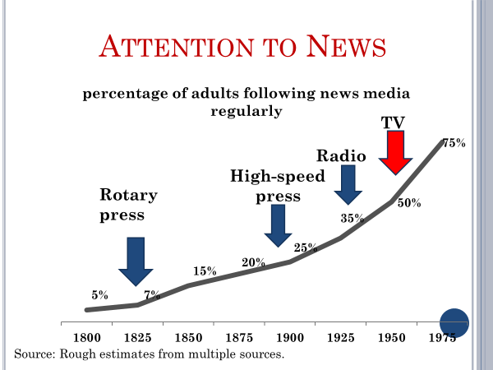
Newspaper readership was also very high in this period. Daily circulation, in 1960, exceeded the number of US households. Many subscribed to both a morning paper and an afternoon paper.
The newspaper, by then, had long shed its partisan roots. Advertising was the chief source of revenue. And the larger the circulation, the more a newspaper could charge its advertisers. Newspapers could make more money by reaching out to Republicans and Democrats alike.
And by law, television and radio outlets were required to treat the Republican and Democratic parties equally. As a condition of their license to broadcast on the public airwaves, station owners were forbidden from playing favorites.
Now a consequence of all this was that Americans everywhere were getting a relatively standardized version of the national news. Most news outlets carried pretty much the same national stories and presented them in much the same way.
The result was what scholars describe as an information commons, a shared base of public information.
Moreover, because Americans were consuming so much news, they were becoming better informed about politics. Information, as we noted in our earlier session on public opinion, is not citizen strong suit. There is much about politics they don't know or misunderstand. Nevertheless, as the research of Princeton's Markus Prior has shown, knowledge of politics was on the rise in the 1960s and 1970s, particularly among the less educated. Television, Prior noted, made it easier for them to learn about politics.
The trend did not last.
Since the 1970s, Americans have become less politically informed and, at times, alarmingly so. A 2009 Pew Research Center poll, for example, asked respondents whether the TARP program, which provided emergency loans to financial institutions to keep them afloat during the 2008 economic crisis, had helped prevent a more serious economic crisis or did not help.
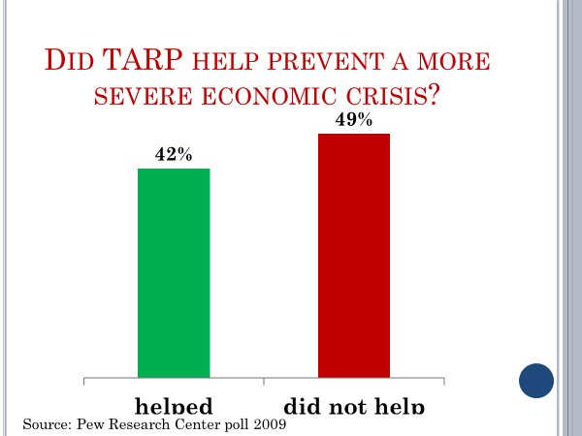
Did not help was the more frequent answer, even though TARP is widely credited with preventing an implosion of the American financial sector, which could have triggered a global economic collapse.
A more systematic study of public knowledge was conducted by researchers at the University of Maryland in 2010. They polled respondents about a series of top issues. One question, for example, asked respondents whether the Obama administration had increased, decreased, or kept constant the number of US troops in Afghanistan. In the period before the poll was taken, President Obama had twice ordered very large troop increases in Afghanistan in an effort to reverse enemy gains. Nevertheless, nearly half the respondents in the University of Maryland poll picked one of the wrong answers or claimed not to know what the Obama administration had done in regard to the troop level in Afghanistan.
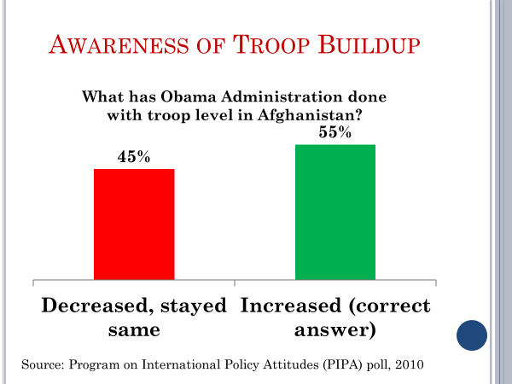
As dismal as that response is, it produced one of the highest percentages of correct answers among the nine factual policy-based questions asked in the poll. On most of the questions, a majority of respondents got it wrong.
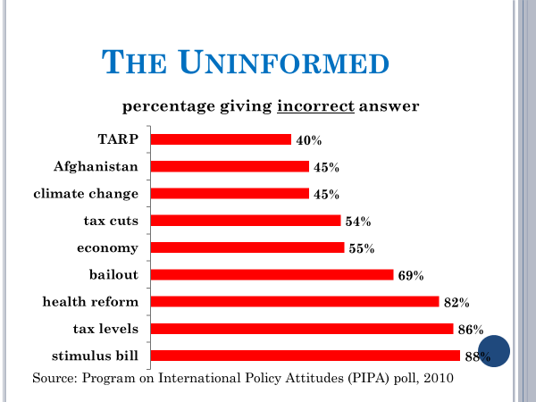
On a couple of issues, the majority opinion was way off the mark.
Now where do the media fit into this picture? What developments in recent decades might account for such findings? The explanation starts with the entry of cable television into the American home. Few homes had cable in 1980. But by 1990, half had it. And the number continued to rise.
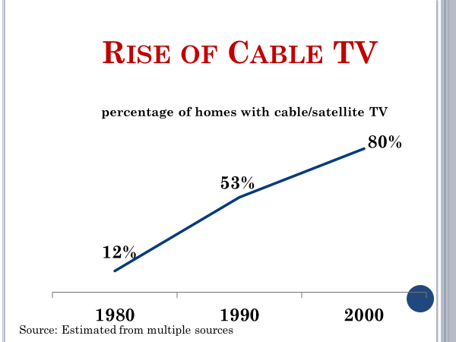
Some early assessments of cable TV claimed it would create a better informed public. CNN, the first all-news cable network provided 24 hours a day coverage. What could be better than that?
But as it turned out, another feature of cable television was more important.
Because of cable, Americans no longer had to watch the news at the dinner hour. They could choose instead to watch movies or sports or any of the other alternatives. The broadcast news audience began to shrink and has been declining ever since, as this chart indicates.
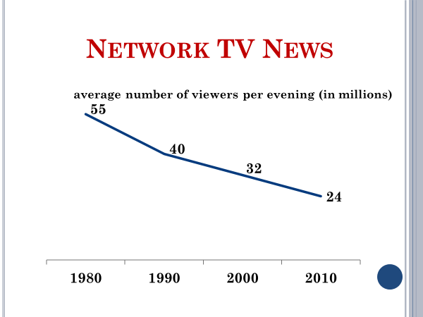
Newspaper readership also dropped steadily after cable came along.
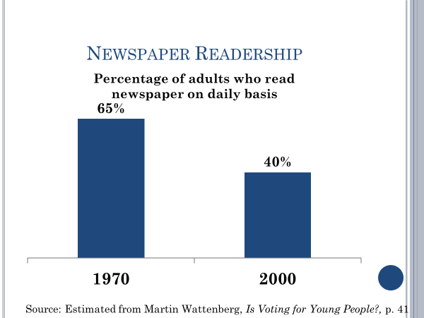
People have only so much time each day to spend with media. As cable entertainment took up more and more of their time, their newspaper reading tailed off. In the 1970s, about 65% of Americans read the paper on a daily basis. By 2000, the figure had dropped to roughly 40%. By 2000, Americans had additional options from which to choose. They also had the internet, electronic games, and more.
Today, Americans spend an average of eight hours a day consuming media. That's up from roughly five hours a few decades ago. Yet, in both relative and absolute terms, the amount of time that Americans spend on news has declined from its earlier level. As this chart shows, it's fallen among all age groups. The drop off has been particularly sharp among young adults.
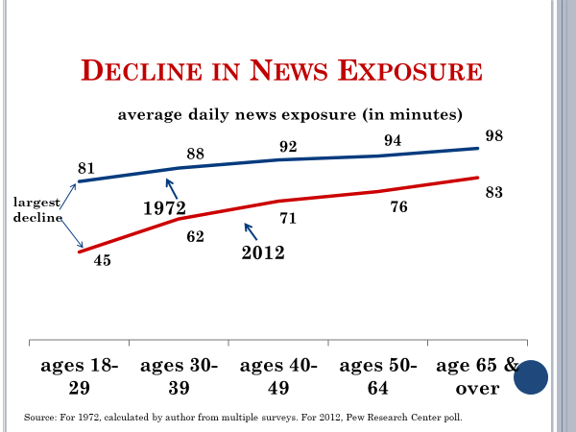
In the 1970s, young adults were only marginally less attentive to news than older adults.
Today, they're far less attentive. In fact, compared with senior citizens, they're only about half as likely to follow the news closely.
Now as this chart shows, young adults are more likely than older ones to get their news online. Some observers assume from this that young adults are getting as much news as older adults or as young adults did at an earlier time. But the question of where people get their news is different from the question of how much news they get.
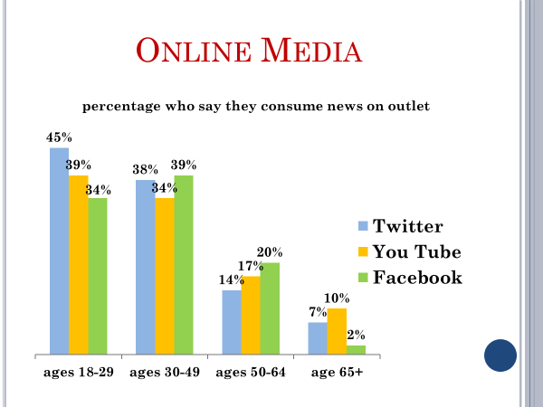
Young adults spend a lot of time online. So it's not surprising that many of them say it's their main source of news. But that doesn't automatically mean that they're paying a lot of attention to online news.
In fact, national politics is not even in the top 10 among the subjects that young adults pursue when they're online.
Now like many things, news consumption is a habit. For people with the habit, the news is an indispensable part of the day.
Most of today's young adults don't have a news habit. Or if they do, it's a weak one.
And that's a break from the past. During the broadcast era, most adolescents saw a lot of television news because, like their parents, they would watch almost anything. By the time they finished high school, many of them had developed a liking for news. They had acquired a news habit.
Cable television disrupted that process. Fewer parents were watching the news. And even if they were, the children were often in another room watching an entertainment program.
The depressed level of news consumption among young adults has made them the least informed young generation in the history of polling.
Here's an example taken from a 2014 Pew Research center poll. Respondents were asked to identify the current prime minister of Israel and were given four choices, Benjamin Netanyahu, David Cameron, Ariel Sharon, Hosni Mubarak.
Among young adults, those between the ages of 18 and 29, only 19%, a mere one in five, identified Netanyahu correctly.

Older adults didn't do particularly well either. But they were more than twice as likely as young adults to pick Netanyahu.
The decline in Americans' news consumption helps explain the drop in their information level. It's hard for people to keep up with current affairs if they don't follow the news regularly. Poll after poll has shown that news exposure and information levels are positively correlated. That is, people who consume more news are typically better informed than those who consume less.
Changes in the news itself have also undermined the public's awareness of public affairs.
The news media have a dual purpose. On the one hand, they're a civic institution protected by the First Amendment's free press guarantee and charged with informing the public.
But the media are also business organizations. They depend on advertising for revenue, which requires them to attract an audience.
That imperative has always conflicted somewhat with their civic duty.
And it's been a bigger problem ever since cable TV began to siphon off their audiences. Much of today's news is aimed more at luring an audience than informing it.
A study of 154 local TV stations in 50 media markets found, for example, that crimes and accidents received twice the coverage of local public affairs. Hook and hold is the operative strategy. Local newscasts often open with a sensational crime or accident story, sometimes several in a row, to hook the viewers. Teasers about similar stories to be aired later in the newscast are used to hold the viewers. Civic affairs stories are jammed together in the middle of the newscast and given short shrift. Two in five are 30 seconds or less in length.
National news outlets have also softened their news seeking to make it more competitive by making it more entertaining. Stories about celebrities, crime, dramatic incidents, personal health have become a larger part of the news.
Soft news had to displace something. And that something is news about public affairs, as you can see from this chart. In 1980, roughly half of all news stories had a public policy connection. By the year 2000, only about a third of news stories were of this type.
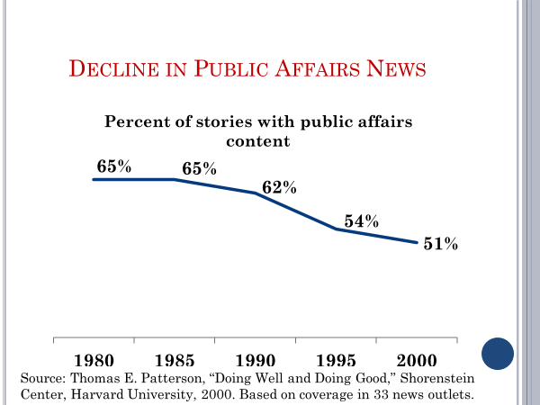
The softening of news was accompanied, as this chart shows, by increased sensationalism, the hyping of stories as a means of drawing attention to them.
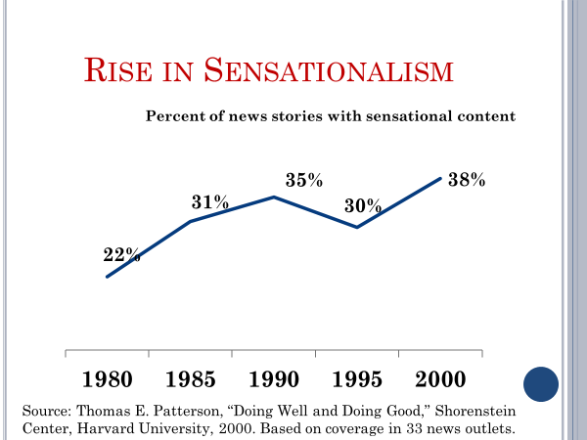
Now not all outlets have watered down and jacked up their public affairs coverage. A study of front page news in The New York Times over a two decade period found that its coverage had changed only slightly. But the Times is an exception, not the rule.
Even serious subjects get distorted by the tendency to sensationalize. In 2014, an Ebola epidemic broke out in West Africa. When the first Ebola patient in the United States was diagnosed, many news outlets hyped the story.
Some reports went so far as to speculate what would happen if Ebola, which is transmitted by direct contact with bodily fluids, went airborne and could be contracted in the same way as influenza. “Ebola in the air, a nightmare that could happen” is how CNN headlined one of its stories, which went on to say that most people who contract Ebola end up dead.
Now the fact is, no known fluid transmitted disease has ever transformed itself into an airborne transmitted disease. It could theoretically happen. But according to the World Health Organization, it has never happened.
The news coverage of Ebola scared the heck out of Americans, even those who were hundreds of miles from the nearest infected patient. A Pew Research Center poll conducted early in the scare found that 41% of Americans, two in every five, were very or somewhat worried that they or a family member would be exposed to the Ebola virus.

The point is this. The content of today's news is very different than it was several decades ago.
Although public affairs is still the primary focus of news, it is increasingly competed for space with lighter fare and with sensationalized stories.
The change is part of the explanation for why the public's understanding of public affairs has declined. As the scholar Neil Postman put it, we seem intent on amusing ourselves to death.
A final noteworthy change in the media system is the rise of partisan outlets. Until 1987, broadcasters were required by the government's fairness doctrine to be politically neutral. If a broadcast station carried a conservative talk show, it also had to carry a liberal talk show in an equivalent timeslot.
Less than 100 station owners found that worth doing. In 1987, the fairness doctrine was abolished on grounds that the availability of additional channels through cable and FM radio had resolved the scarcity problem that had justified regulating the broadcasters fortunate enough to have a license.
Free to do what they wanted, station owners embraced talk radio. By the mid-1990s, there were 1,300 dedicated radio talk stations in the United States.
Their cumulative weekly audience was huge, numbering in the tens of millions. One in five Americans had become a weekly listener.
The talk radio audience is largely made up of conservatives. All the top-rated talk shows have a conservative host. Rush Limbaugh and Sean Hannity, for example, have weekly audiences exceeding 10 million listeners.
Talk radio's success convinced Rupert Murdoch to start Fox News in 1996 as a conservative TV alternative. Within five years, Fox's audience had passed that of CNN.
In turn, Fox's success inspired MSNBC to change its marketing strategy. In 2005, it switched from traditional reporting to positioning itself as the liberal alternative to Fox.
By this time, political bloggers were also part of the partisan media, having discovered that the most heavily trafficked blogs are those that cater only to liberals or only to conservatives.
Comedy programs are also in the mix inspired by the success of Jon Stewart's The Daily Show. As it happens, unlike talk radio, partisan comedy appeals primarily to liberals. The top-rated shows like The Daily Show and Bill Maher's Real Time have liberal hosts.
Now the audiences for partisan media programs are not representative of the public as a whole. Most people prefer partisan content that fits with what they already believe.

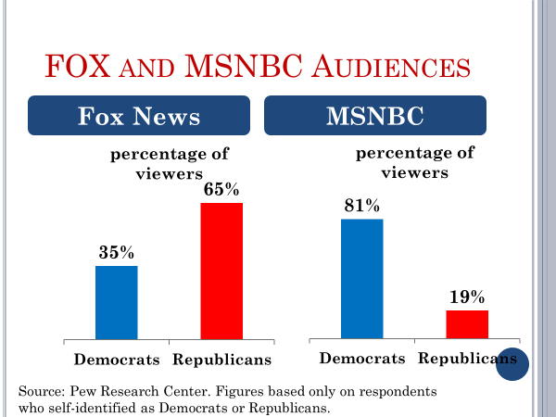
For example, the audience for radio talk show host Sean Hannity, a conservative, is overwhelmingly Republican.
Echo chambers is how scholars Kathleen Hall Jamieson and Joseph Capela describe partisan media. Their audiences get a version of politics that matches what they already think.
Consider, for example, the difference in how Fox and MSNBC covered the release of the Mueller report, which detailed the nearly two-year investigation into Russian meddling in the 2016 presidential election campaign.
The report offered three major findings, only one of which was highlighted on Fox, that, although there were contacts between the Russians and the Trump campaign, there was no evidence of collusion on President Trump's part.
The other two major findings were highlighted on MSNBC. First, that the Russians had meddled deeply in the 2016 election in an effort to get Trump elected. And second, that the president's effort to impede the investigation might have constituted obstruction of justice, which is a crime under US law.
Now the format used in the regular news programs of partisan outlets like Fox is similar in appearance to that employed by traditional outlets like CBS and NBC. Each relies on an anchor and reporters to tell the news.
But the content is very different.
Consider, for example, how Fox's main evening newscast reported the 2016 presidential campaign compared with traditional news outlets. Fox's coverage of Republican nominee Trump was far more positive than was his coverage on broadcast network news or in major newspapers. And Fox's reporting on democratic nominee Hillary Clinton was far more negative than was their coverage.
Studies indicate that exposure to partisan media tends to reinforce partisan beliefs.
Exposure also leads the audience to have a less favorable opinion of the other party and to hold a distorted view of its position on policy issues.
Partisan outlets have helped transform America's media system. Instead of the information commons of the 1970s, where citizens were exposed to, more or less, the same news, we have, today, a system where Americans are exposed to alternative versions of reality.
This complicates the public debate. Factual agreement serves as the foundation, the starting point from which people can argue out their differences. Without agreement on the facts, the debate tends to break down almost as quickly as it starts.
In the midst of a policy debate in Washington that was going nowhere, Daniel Patrick Moynihan, who served in both the executive branch and the Senate, blurted out, "everyone is entitled to his own opinion, but not to his own facts."
On the other hand, information is not the core ingredient of politics.
Politics is largely about competing interests and the struggle of those interests to control policy decisions. That puts a different light on partisan media. They seek to promote partisan interests.
Only a few decades ago, that job belonged to political parties, interest groups, elected officials. They still have the job, but it is now also shared with partisan media.
Looked at as a whole, the American media system is still dominated by its information function. Traditional news outlets have a larger audience than do the partisan outlets.
And even most citizens who rely on partisan outlets also follow the news in traditional sources.
Is the new media system better than the old one?
Is it better to have a mix of traditional and partisan outlets than a monolithic system?
The answer to that question depends in part on what one wants from the public. The old system clearly was better at creating an informed public. The new system is clearly better at creating an engaged public.
Whichever system one prefers, the new system is here to stay.
The time when a few broadcast networks and the local newspaper had a monopoly on the news audience is a thing of the past. Cable and the internet have brought scores of media competitors into the mix.
And neither the news nor the public will ever be quite the same again.

#
OK, let's wrap up the session by summarizing what's been said.
We began by looking at the media system of several decades ago, where news consumption was high, the public's information level was rising, and Americans everywhere were getting, more or less, the same version of national news, the information commons.
We then looked at the changes that have led to a decline in the public's information level and an increase in competition for people's attention, the emergence of cable television and the internet, which have been accompanied by a drop in American's exposure to news, the increase in soft news and sensationalized news, which are the result of intensified competition among media outlets for people's attention, and the rise of partisan news, which appeals to like-minded audiences and where accuracy to some degree has been sacrificed to partisan agendas.

