Transcript: Political Parties Lecture

[ON LOCATION, REPUBLICAN NATIONAL COMMITTEE HEADQUARTERS]
THOMAS PATTERSON: I'm standing outside the headquarters of the Republican National Party. The Democratic National Party headquarters is only a few blocks away.
The Republican Party is one of the world's oldest parties. It was formed in 1854, shortly before the Civil War. The Democratic Party is even older. In fact, it's the world's oldest political party. It was formed in 1792 by Thomas Jefferson. That was the second year of the Washington administration.
So what accounts for the durability of these two American parties, the Republican Party and the Democratic Party? You know, that's hard to say.
If you look at other democracies, parties have come and gone with some regularity.
The last time a major American political party disappeared was the Whig Party. And it was supplanted by the Republicans.
What's easier to say is why democracies have political parties.
Whenever you've had a democracy form, political parties have followed shortly thereafter. In the early 1990s, for example, when the Iron Curtain came down and the countries of Eastern Europe became democracies, you soon saw parties forming in Hungary, Poland, the Czech Republic, and the other countries.
And the reason why parties are inseparable from democracy is that we need some instrument by which to combine our voices. If we lived without parties, we still could speak our minds freely. But who would listen to you? Who would listen to me?
By combining together, we can become collectively powerful.
And if we have a majority of the votes, we can take control of the government.
And that's why democracy and parties go together.
As the political scientist, E.E. Schattschneider said, democracy without parties is unthinkable.
#
[STUDIO PORTION]
In this session, we'll look at America's political parties, exploring the reasons why, unlike most democracies, the United States has a two-party system. We'll also look at the causes of party realignment and the consequences for parties and public policy. And finally, we'll look at the nature of the Republican and Democratic coalitions.
Now, one of the more remarkable features of American politics is the persistence of its two-party system.
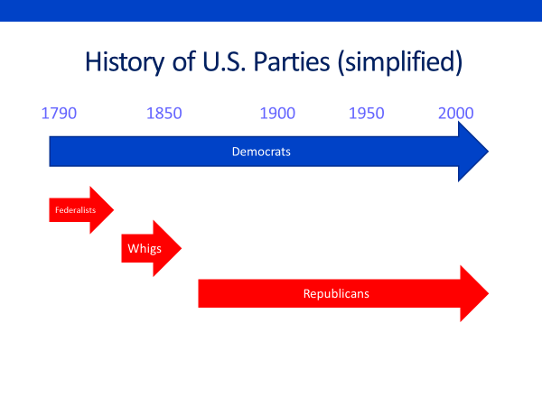
In the nation's early years, a political rivalry between Thomas Jefferson and Alexander Hamilton gave birth to the country's first parties.
Hamilton led the federalist party, while Jefferson led the Democratic Republicans, whose name was later shortened to the Democratic Party.
The Federalists enjoyed considerable success at first.
But then they faded, with the Whig Party rising up to challenge the Democrats.
When the Whigs then faded, the Republican Party emerged as the Democrats challenger.
This pattern, competition between two major parties, is unusual.
In most democracies, the competition, at any given time, involves three or more parties. Germany's parliament, for example, currently has representatives from several parties. So why does the US have a two-party system, rather than a multi-party one?
Do you think it's attributable primarily to our political traditions or our electoral system?
The second is the main reason.
The United States has what's called a single-member district system or, as it's also called, a First Past the Post system.
This type of election system differs from a proportional representation system, which is what most democracies have. Under proportional representation, parties win legislative seats in proportion to the number of votes they receive in an election. The party that wins 35% of the vote for example, gets 35% of the seats.
One that wins 20% of the vote, gets 20% of the seats, and so on. That system helps smaller parties to compete. 10% of the vote might not sound like a lot to you.
But a party that gets 10% of the vote in a proportional representation system, ends up with 10% of the legislative seats.
Now let's look at America's single member district system of elections. It's called such because each elected official is chosen singly from a separate district.
Each member of the House of Representatives, for example, is elected by getting the most votes in his or her congressional district.
This system favors big parties. To win a legislative seat, a party must have enough popular support for its candidates to place first in their districts.
Consider how a third party that receives 10% of the vote in every congressional district would fare under the rules of the American election system. How many seats would it win? Zero, its candidates would lose every single race.
They would lose each time to whichever major party candidate received the largest share of the remaining 90% of the vote. Now, there's nothing to stop smaller parties from contesting elections in America, and some do. But they're virtually sure to lose. And that makes it difficult for them to build a following. Who wants to be on the losing side all the time?
Now, although a single member district system of elections favors the two major parties, it doesn't guarantee that they'll be around forever. A century ago in Britain, which also has a plurality district system, the Conservative Party's main rival was the Liberal Party. Today, the Labor Party is its chief rival.
So why have the Republican and Democratic parties lasted so long? What's the key to their durability?
As it happens, they've been skilled at adapting to changing conditions, particularly during periods of crisis or unrest.
They've shown a remarkable ability in these periods to reinvent themselves with new sources of support, new policies, and new ideologies. Scholars use the term party realignment to describe these periods of party change. A party realignment is not just a temporary change in party control. That happens with some frequency.
In the 2010 midterm elections, for example, Republicans took control of the House of Representatives from the Democrats. Then, in the 2018 midterms, Democrats recaptured the house.
Neither of these elections constitutes a realignment. They were merely a momentary shift in power from one party to the other.
In contrast, a party realignment is long lasting. It produces fundamental changes in the parties, affecting for years to come their coalitions, their governing philosophies, and their chances of electrolytic success.
The Civil War, for example, triggered a party realignment. The North's victory in the war, under Lincoln's leadership, revamped the partisan map.
Called the Union Party by many, the Republicans became the dominant party in the north, while the Democrats developed a stronghold in the southern states. The former Confederate states were so heavily Democratic that they became known as the Solid South.
However, because the north was by far the more populous region, the Republican Party, helped along by another favorable realignment in the '90s, was able to dominate national politics for the next seven decades.
During that entire period, those 70 years, only two Democrats, Grover Cleveland and Woodrow Wilson, won the presidency.
Republican domination of Congress was nearly as one-sided. Between 1861 and 1930, Republicans held the Senate for 32 terms, compared to only three for the Democrats, and control the House more than two thirds of the time.
The 1930s, the Great Depression, triggered another realignment, this one favorable to the Democrats. Republicans were in power when the Depression began and Americans blamed the Republican Party and its business allies for the crisis.
When the Democratic party, led by Franklin Roosevelt, then won the presidency in 1932 and gained the confidence of the American people through its economic recovery programs, it set itself up to be the nation's dominant party for a lengthy period.
Three things happened in the 1930s that created a realignment favorable to the Democrats.
One was the fact that the Great Depression was hugely disruptive. It was so severe that Americans changed their view of who they wanted to place in charge of government.
Here is the electoral vote map of the 1928 presidential election, held just before the Great Depression. The Republicans won the states shown in red. As you can see, they won nearly everywhere but in the south.
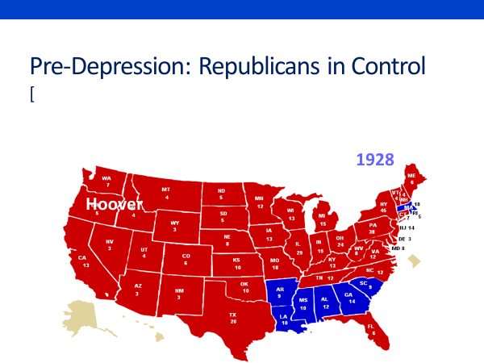
But now look at the electoral vote map from 1932, the first presidential election held after the Depression began.
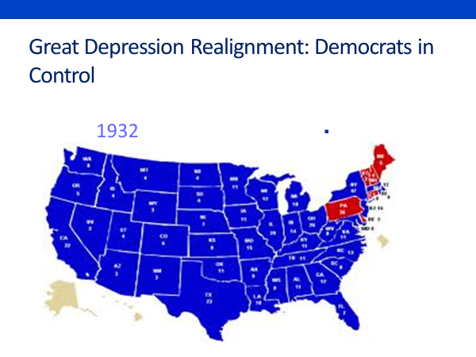
There is very little red anywhere on the map.
In 1936, Democrats so thoroughly dominated the election that they almost swept the board, losing only two states, Maine and Vermont.
Now, a second development that made the 1930s a realigning period was that it created a permanent shift in voters' party loyalties. In her book, The Creation of a Democratic Majority, Christy Anderson shows, for example, that first-time voters, many from Republican families, identified with the Democratic Party over the Republican Party by a ratio of two to one. Most of them became lifelong Democrats, helping the party to dominate national politics for a long period.
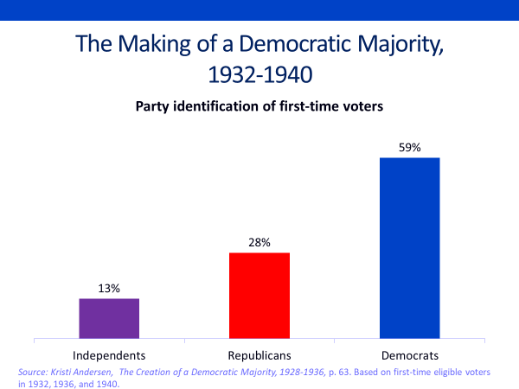
Over the next three decades, the Democrats held the presidency, except for Dwight Eisenhower's two terms, and controlled Congress for all but four years. The third development that marks the 1930s as a realigning period is that it prompted a change in party ideology. Before the Depression, the Democrats were widely seen as the party of states rights, reflecting its southern base.
Although the south stayed in the Democratic camp during the Depression and had some influence over its policies, Roosevelt's New Deal was rooted in a different ideology.
The New Deal sought to use the power of the federal government to alter and offset the power of private wealth and markets.
That ideology found its way into policy initiatives such as social security, higher taxes on the rich, the minimum wage, collective bargaining for workers, the regulation of the stock markets.
It was during the New Deal that the term liberal came into regular use as a description of the Democratic Party's ideology. Consistent with that ideology, the Democratic Party prided itself on being the party of the little man.
The New Deal coalition was made up largely of low and modest income groups, blue collar workers, inner-city dwellers, welfare recipients, small farmers, and the like.
That makeup can be seen in this figure, which shows the breakdown of the 1948 presidential vote by occupation and education.
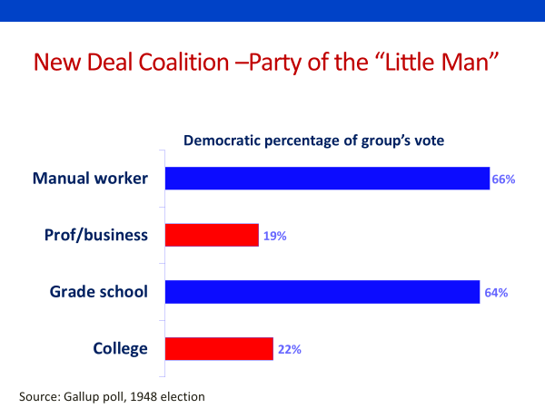
As you can see professionals, business people, and the college educated, cast relatively few votes for the Democratic nominee Harry Truman. In contrast, manual laborers and those with a grade school education voted heavily democratic in 1948.
Their interests drove Democratic politics through the early 1960s, culminating in president Lyndon Johnson's Great Society initiatives, including Medicare and Medicaid, government provided health care for the elderly and the poor.
Partisan conflict in this era was centered on the economic divide. Democrats aligned with labor and the less well-off and Republicans aligned with business and the better off.
However, it's the nature of party realignments that they can't last forever. Eventually, a disruptive new issue will come along.
For the New Deal coalition, that issue with civil rights. After World War II, northern Democratic leaders gradually took up the cause of black civil rights, seeking to put an end to racial segregation in the South. That effort peaked with passage of the 1964 Civil Rights Act and the 1965 Voting Rights Act. Those acts split the northern and southern Democrats in Congress.
Virtually every northern Democrat backed the civil rights and voting rights acts, while virtually every southern Democrat opposed them. The fight in Congress was a bitter one. Race was not a small issue to the white South, it was their issue. The New Deal coalition fractured and did so.
Quickly in the 1968 presidential election, the first one held after the 1964 and 1965 legislation, the Democrats presidential nominee, Hubert Humphrey, carried only one southern state. It cost the Democrats the election.
That election also signaled the start of a new party realignment, the one we have today. Now, political scientists did not initially regard 1968 as a realigning election. It lacked the characteristics of past realignments. Instead of being nationwide, the partisan shift was concentrated in the South. And though the Democrats lost the presidency, they held onto the House and Senate.
Moreover, Republican leaders didn't overtly try to exploit the race issue. They chose not to turn their backs on the party's civil war legacy.
Nevertheless, Richard Nixon, who won the presidency in 1968, saw an opportunity to turn the Democrats loss into a Republican gain.
He devised what came to be called the Southern Strategy. Rather than opposing racial change directly, Nixon signaled his determination to slow it down, for example, by seeking to ban racial busing as a means of school desegregation.
Now, in the 1970s, the racial divide was reinforced by the emergence of what analyst Richard Scammon and Ben Wattenberg called the Social Issue, a loose set of controversies including crime, abortion, drugs, school prayer, and changing cultural, sexual, and family norms. Although the social issue lacked a sharp focus, components of it did, abortion particularly.
Since the 1970s, ever Republican national platform has had a plank expressing opposition to abortion, while every Democratic national platform has expressed support for a woman's right to choose.
The abortion issue resonated most strongly with evangelical Christians, who are concentrated in areas where racial conservatism is strong.
Now, a third issue, the size of the federal government, was also on the rise during this period.
Although federal spending had been a source of partisan conflict since the 1930s, Roosevelt's New Deal, Johnson's Great Society, had broad public support, which dampened the opposition.
By the 1970s, however, Republicans have become more vocal in their opposition to federal spending, especially on welfare programs, claiming that too many Americans were choosing welfare over work. When Republican Ronald Reagan took office in 1981, he made federal spending a centerpiece of his presidency.
Declaring that we spend too much and that too many people were abusing the welfare system, Reagan pledged to trim the size of the federal government. He also called for a new federalism that would return power to the states.
In his inaugural address, Reagan declared, "The federal government did not create the states, the states created the federal government. Reagan's declaration was an acknowledgment that the Republican Party had a new ideology. The party of Lincoln, the Federal Party, was now the party of states rights.
Now, the issue of federal spending deepened the divide between Republicans and Democrats.
America's racial and social conservatives also tend to be conservative on federal welfare spending, as political scientist William Jacoby found in his study of public attitudes toward government spending.
Now, as the Republican Party shifted to the right, its support in the northeast and the west coast weakened. Republicans in these regions had been aligned with the party's progressive wing.
And many of them were finding that they now had more in common with Democrats than with the newer Republicans. Today, these regions, which were once predominantly Republican, are heavily Democratic.
This map, based on a recent electoral vote, shows the change. 50 years ago, the south was solidly democratic, now it votes Republican. On the other hand, the once Republican New England and west coast states are now reliably Democratic.
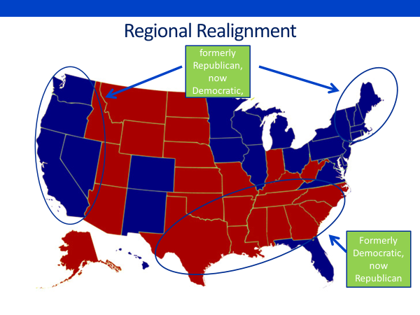
That's a reason the recent realignment, unlike the past ones that we talked about, has not worked to the full advantage of one of the parties. Although the Republican Party has gained strength, overall, and in the south particularly, its new positioning has cost it voter support elsewhere.
Here are a few indicators of today's party alignment based on the exit poll results from the most recent presidential election.
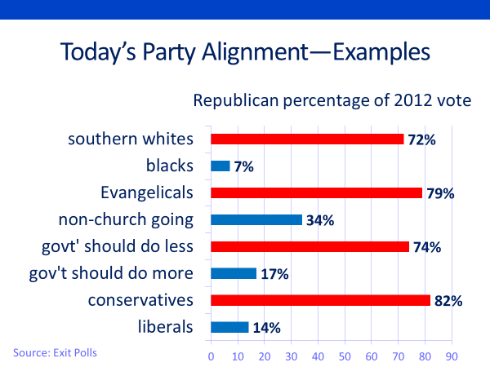
Race is a dividing line, as you can see by comparing the Republican percentage of the vote among white southerners with that of black Americans.
So, too, is religion evangelical Christians are strongly Republican. People who don't attend church lean strongly in the democratic direction.
Attitudes toward government spending also distinguish Republicans from Democrats. Those who say government should do less, vote heavily Republican. While those who say government should do more, tilt heavily toward the Democratic side.
The final set in the chart compares self-identified conservatives who vote heavily Republican with self-identified liberals who vote heavily Democratic.
Now what happens when issues come together in a way where they reinforce each other, as is the case with the race, social, and federal power issues?
The effect is to solidify people's opinions and to convince them that those who think differently hold unacceptable views.
Said differently, party polarization is the result. Since the 1980s, Republicans and Democrats have moved ever further apart politically. Consider, for example, the results of two Pew Research center polls, one conducted in 1987 and the other in 2012, 25 years later.
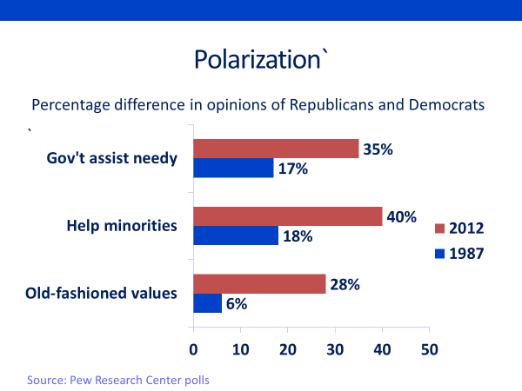
On the question of whether government should take care of people who can't take care of themselves, the gap between Republicans and Democrats was 17 percentage points in 1987. And it's widened to 35 points by 2012.
On the question of whether we should make every effort to improve the position of minorities, even if it means giving special treatment, the gap grew from 18 percentage points to 40 points between 1987 and 2012.
On the question, I have old fashioned values about family and marriage, the gap grew from 6 percentage points to 28.
Now, before discussing the implications of this polarization, let me take a moment to talk, generally, about the nature of party competition in a two-party system. The overriding goal of a major party in a two-party system is to become the bigger of the two parties.
Only then can it dominate elections and take control of government.
As a result, major parties in a two party system normally take relatively moderate positions. If one party concedes the middle to the other party, it loses out.
A few decades ago, political scientists treated that proposition as gospel and had powerful examples to illustrate their point.
In 1964, the Republican presidential nominee, Barry Goldwater, proposed the elimination of mandatory social security and said he might consider the use of tactical nuclear weapons in Vietnam, extreme positions that contributed to his landslide defeat.
Goldwater won only 39% of the presidential vote, compared to Democratic nominee Lyndon Johnson's 61%.
Eight years later, Democrats got pummeled by nearly the same margin when their presidential nominee, George McGovern, took positions on Vietnam and income security that were outside the political mainstream.
However, the moderate party thesis assumes that voters are clustered in the middle of the political spectrum, as in this diagram. As you can see, if a party moves too far to the conservative side, as Goldwater did, or too far to the liberal side, as McGovern did, it leaves the middle open to the other party. But what if moderate voters are outnumbered by liberals and conservatives, as in this diagram?
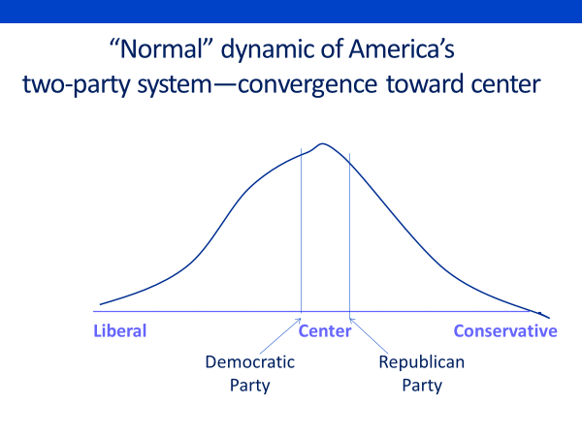
What happens in that case? Well, if a party positions itself too close to the center, it risks alienating its core voters. And that's somewhat the position the parties are in today. There are still plenty of moderate voters.
But as you can see from this chart, Republican voters have become increasingly conservative and Democratic voters have become increasingly liberal. And as they have shifted toward the extremes, their party's candidates have also shifted from the center.
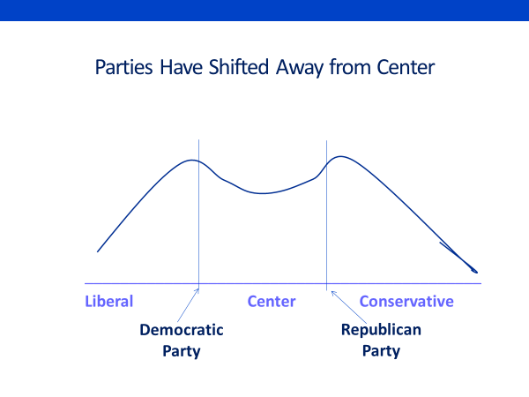
That's changed the nature of American elections.
Our campaigns have become increasingly bitter and negative, a subject we'll talk about in the next session, which focuses on election campaigns.
#
OK, let's wrap up this session.
We began by pointing out that the US electrolytic system, the single member district system of choosing officeholders, is the main reason why party competition is dominated by two major parties.
We then discussed party realignment and the role they play in the party system.
We looked at the Civil War realignment, the Great Depression realignment, and the most recent realignment, to show the remarkable ability of America's parties to reinvent themselves with new supporters and new ideologies.
We noted, particularly, how race, religion, and the size of the government, as issues of partisan conflict, have helped shape the current alignment of the Republican and Democratic parties.
We then examine party strategy in a two-party system, pointing out that the normal tendency is for the parties to moderate their positions in order to appeal to voters in the middle.
We noted, however, that today's party polarization, the widening divide between Republican and Democratic identifiers, has led the parties to position themselves further from the center than they once did.
That subject, party polarization, will be addressed in greater depth in later sessions.

