Transcript: Interest Groups Lecture

[ON LOCATION, K STREET, WASHINGTON, DC]
THOMAS E. PATTERSON: I'm standing on K Street. Now, K Street may not mean anything to you, but in this city, Washington, it symbolizes power.
Congressional power is symbolized by Capitol Hill, presidential power by the White House, judicial power by the Supreme Court building.
So what does K Street symbolize?
It's here that lobbying firms traditionally concentrated-- the firms that represented business, and trade associations, and citizens' groups.
The power of these groups is not easily overstated. Lobbying touches on nearly every public policy issue, and it's relentless. There's an election season-- lobbying never goes out of season.
So how big is lobbying?
Well, there are more lobbyists in Washington than there are journalists. There are more lobbyists than there are congressional staffers. More money is spent on lobbying than on elections. At the same time, lobbying takes place largely out of sight.
Invisible power brokers is how a news editor recently described lobbyists.
#
[STUDIO PORTION]
This session, we'll look at the political role of interest groups, or as they're also called, pressure groups, lobbying groups, and special interests.
Such groups have two characteristics-- they pursue public policy goals, and they have an organized membership.
Thus, not every group meets the definition of an interest group. A college marching band, for instance, is an organized group, but it doesn't pursue public policy goals. In contrast, the National Rifle Association fits the definition of an interest group. It has members, and it seeks to influence policy.
In this session, we'll explain why the United States has an abnormally large interest group sector.
Then we'll explore why some US interests are more fully organized than others.
Then we'll examine the ways in which groups lobby for influence over policy.
And we'll conclude the session by asking, but not answering the question of whether interest groups have too much power.
#
Now, a striking feature of American politics is the great number of its interest groups. The number is so large that no one has a firm estimate, but scholars concede that the number exceeds that of other countries.
Now, why is that?
Here are two of the reasons. Which do you think is the more important one? The country's great size? Or the structure of the US political system?
Well, America's great size helps to explain its abundant groups, but size is not quite as important as it might appear.
France, for example, has only a fifth as many people of the United States and occupies an area roughly the size of the New England states.
Yet, France is large enough that nearly every interest found in the US can also be found there, whether it's types of farmers or types of small businesses. Nevertheless, France's interests are much less organized than those in America.
The second factor-- the structure of the US political system-is the key to understanding why America has so many interest groups. Because of the separation of powers, groups at the national level have three branches to target. And one of them, Congress, offers two inviting targets-the House and the Senate. Each of these chambers has 20 standing committees to target, and nearly all of them have several subcommittees-- another set of targets. Each member of Congress-- all 535-- is also a target of lobbying. Under congressional rules, each member has the power to propose legislation.
And that's just the national government.
Because the United States is a federal system, the state governments are power centers in their own right. Each of them is an inviting target, with their three branches of government and scores of legislative committees and state agencies.
Below the state governments in the United States are the local ones, with their mayors and city councils, which by tradition have a lot of policymaking authority.
Now compare the American system with a parliamentary government in a unitary system such as France.
There, national political power is concentrated at the top in the hands of a relatively small number of policymakers, who even have a major say in the policies of provincial and local governments. There aren't early as many opportunities for group influence in France.
The point is this.
If there is such a thing as interest group heaven, the United States is it. It offers countless points of access for groups.
That gives interests a reason to organize themselves. The possibility to make a difference are nearly endless.
Now America's large number of interest groups doesn't necessarily mean that the country's interests are all equally well organized.
Organizations develop when people with a shared interest have the resources and an incentive to work together.
Those factors-- resources and incentives--differ across society, with the result that some interests are far better organized than others.
The most thoroughly organized interests in the United States are those that have economic activity at their core, such as business firms, workers, and farmers. We'll call them economic groups to distinguish them from other groups.
Of the economic interests, business firms are by far the best organized. Nearly 2/3 of all groups registered to lobby Congress have a business focus. Examples are General Motors, Microsoft, and the American Petroleum Institute, which represents the nation's oil companies.
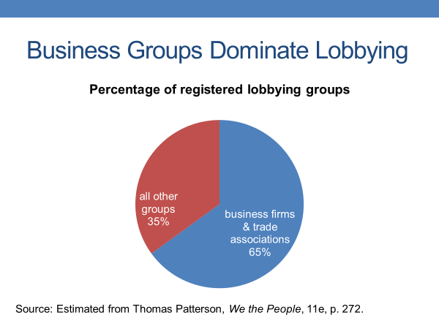
Some business-related groups have a huge presence in Washington. An example is the US Chamber of Commerce, which represents more than three million American businesses of all sizes and sectors. The chamber employs hundreds of staff members in its Washington headquarters and spends tens of millions of dollars each year on lobbying.
So why are economic interests so highly organized?
Well, for starters, many of them have built-in resources as a result of their economic activity. Business firms, for example, can take some of their profits and use them to support lobbying activities. Economic interests also have a powerful incentive to offer potential group members. They provide what are called private or individual goods-- benefits that a group can give directly to an individual. Corporations and unions, for example, are positioned to give people jobs.
That's a strong reason for joining.
Compared with economic interests, other interests-- and for ease of discussion, let's just call them non-economic interests-- are far less organized.
To be sure, some of them have imposing organizations. The National Rifle Association, for example, has three million gun owners on its membership rolls. But the NRA is an exception. Most non-economic interests are poorly organized. Take college students, for example. Although they share a number of policy interests, such as access to low-interest student loans, few college students belong to a group that lobbies on their behalf. Such groups do exist. One is the United States Student Association. Yet, few students have ever heard of it and even fewer belong to it.
So why the difference?
Why are non-economic groups far less organized than economic ones? Well, for one thing, non-economic groups have to come up with the money.
Unlike corporations, which can dip into their profits to fund lobbying efforts, non-economic groups have to rely on voluntary contributions.
That can be a problem. America's poor, for example, are not highly organized. They don't have the money.
Non-economic groups also face what's called the free rider problem.
Such groups seek what are called public or collective goods.
Now public goods, by definition, are available to everyone, whether they belong to the group or not. For example, if the United States Student Association were to succeed in getting officials to lower the interest rate on student loans, all student loan holders would benefit whether they belong to the group or not.
That situation allows potential members to free ride. If the benefit is going to be available anyway, why pay the cost of membership?
Take National Public Radio as an example. It offers a public good-- quality news that's freely available on the airwaves. News costs money to produce, and NPR relies on listener contributions for most of its funding. Several times a year, NPR stations make on-the-air fundraising appeals.
How many listeners contribute? Only about 10%. The other 90% of NPR's listeners are free riders.
The fact is, non-economic groups depend on the goodwill of people who believe in contributing to a cause they think is worthwhile. There are many such people in the United States, and they support a wide range of non-economic groups that lobby on everything from the environment to campaign reform, to religious issues.
Yet, in relative terms, such groups are much less organized and more poorly funded than our economic groups.
This table summarizes the difference between economic and non-economic groups, and helps explain why economic groups are more fully organized.
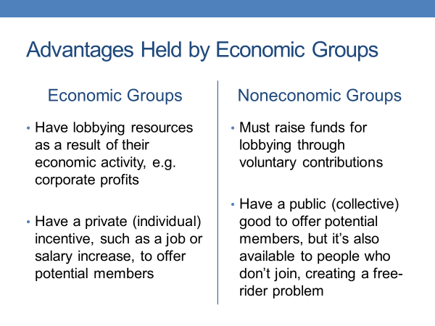
For one thing, they have a stronger resource base as a result of their economic activity, such as corporate profits. Economic groups also provide a private good, such as a job, that is exclusive to their members. To get it, you need to be part of the group.
In contrast, non-economic groups have to raise their money through voluntary contributions. Moreover, because the benefit they offer is a public good, available without cost to non-members, such groups face a free rider problem. People can get the benefit without contributing.
#
As I mentioned previously, the structure of the US political system is as close to heaven as an interest group can get. There are countless entry points where groups can try to influence policy.
At the national level, groups concentrate most of their efforts on Congress and the executive agencies. Lobbying also takes place through the White House and the courts.
But these institutions are less accessible to lobbying groups.
Congress is a particularly inviting target, with its two chambers and its 40 standing committees, plus the roughly 200 subcommittees. Money is a key part of congressional lobbying-not in the form of outright bribes. Congress is relatively free of that form of corruption. Every once in a while, a member of Congress takes a bribe, but it's risky. In 2005, Louisiana Congressman William Jefferson was arrested and later imprisoned after FBI agents found $90,000 in a freezer in his congressional office. He had taken a bribe.
On the other hand, there is a type of money that members of Congress can legally take from groups. It's campaign funds, and groups are more than happy to oblige-- knowing that such contributions will give them a better chance of getting a lawmaker's attention. As one lobbyist said, talking to politicians is fine, but with a little money they hear you better.
Most group contributions occur through political action committees-- PACs for short.
A group cannot give organizational funds such as corporate profits or union dues directly to a candidate, but a group can create a PAC to solicit voluntary contributions from its members, which can then be given to candidates. $10,000 is the maximum amount a PAC can contribute to a candidate-- $5,000 for the primary, $5,000 for the general election.
About 4,000 groups have PACs, which collectively provide about a fourth of what congressional candidates spend on their campaigns.
More than 2/3 of this PAC money comes from business-related PACs, such as Coca-Cola PAC and RPAC, which is the PAC of the National Association of Realtors.
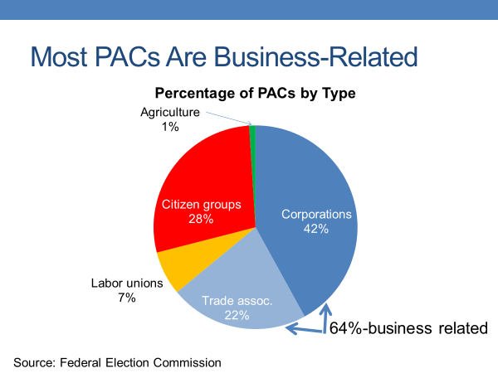
In the most recent congressional campaign, RPAC spent more than $3 million. Now PACs are strategic in their contributions.
More than 85% of PAC money goes to incumbents-- a recognition by groups that incumbents typically get reelected. PACs are particularly inclined to fund incumbents, who sit on the committees that deal with policies affecting the PAC. They're the ones most likely to have influence over the issues of interest to the PAC.
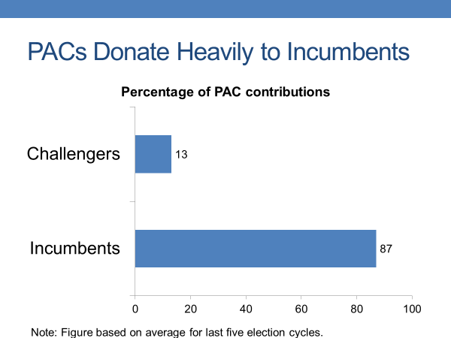
Now, although groups spend heavily on campaigns, they spend even more heavily on lobbying.
During the most recent two-year congressional cycle, groups spent roughly $6 billion on lobbying-four times what they spent on the most recent congressional election.
In lobbying Congress, groups typically work with lawmakers who share their policy goals. They understand that it's hard to get opposing lawmakers to switch sides.
And lobbyists rely primarily on information to make their case. Lawmakers react negatively to pressure tactics. They don't like to have their arm twisted. But they do value information. The volume of legislation in Congress is enormous, and members rely on trusted lobbyists to identify bills worthy of their attention. Moreover, lobbyists often have a better understanding of a particular bill than do many of the members. Members deal with a lot of bills each session. A group typically has only one or two on its agenda.
I've emphasized in previous sessions of the course that knowledge is power in policymaking. To decide what to do, you first have to know the issue.
That's a reason many lobbying groups conduct research.
When they meet with a congressional member or top staffer, they're positioned to explain in detail how a bill will affect them.
Now clearly, information alone will not get a group what it wants. That's why groups target lawmakers they trust. They need lawmakers who can be expected to look after their interest, as a bill is working its way through the legislative process.
But that trust has to be mutual. The group has to play it straight when supplying information to a lawmaker. If the information is flawed and the member uses it to argue on the group's behalf, the member will look foolish when the facts come out. As one member of Congress said, “if any lobbyist gives me false or misleading information, that's it. I'll never see him again.”
There's one last thing about the relationship between lobbyists and members of Congress that needs to be noted, and it's critical in understanding whether a group is likely to succeed in its lobbying efforts.
The fact is senators and representatives, above all, are politicians. When talking with a lobbyist, they're always mindful of who the lobbyist represents.
Is it a group vitally important to my political career?
If the answer is no, the lobbyist might get a polite hearing, but nothing more.
However, if it's yes-- if the group is important to the member's reelection-the lobbyist normally can expect help, sometimes a lot of it.
Now executive agencies offer nearly as inviting a target for lobbyists as does Congress.
There are several hundred such agencies, and they have influence over how legislation will be interpreted and implemented. Agencies are also a source of policy ideas that later make their way into law. Like members of Congress, bureaucrats depend on lobbying groups for information. Although top administrators are well versed on their agency's policies, they don't necessarily have detailed knowledge of how a policy could affect a particular group. Lobbyists help fill in that knowledge gap.
In addition, many agencies get much of their data from groups. For example, publicly traded companies are required to file information on their stock offerings and balance sheets to the Securities and Exchange Commission, which uses the data in its regulatory decisions.
There are rules governing these filings and penalties for lying, but the requirements are subject to interpretation, giving firms some leeway in the information they provide the agencies. Groups' position as a source of information enables them to influence agency decisions.
So too does the lobbying support they can give an agency when its budget comes up for a review in Congress.
#
Now to help you better understand how groups operate, let's take a look at two cases-- one illustrating congressional lobbying and one illustrating bureaucratic lobbying-- both in the context of the 2010 Dodd-Frank Wall Street Reform and Consumer Protection Act, or as it's commonly called, Dodd-Frank.
The legislation was named for its chief sponsors--Senator Christopher Dodd of Connecticut and Representative Barney Frank of Massachusetts.
I picked the two cases not because they're representative, but because they show lobbying at its most intense. Most lobbying is not as feverish nor as successful as the ones we're going to look at.
Dodd-Frank was enacted in response to the near collapse of the financial sector in 2008 and was designed to end the business practices that had contributed.
One goal of Dodd-Frank was to protect borrowers from the reckless and deceptive lending practices that fueled the collapse of the housing market.
Banks had given large numbers of mortgages to unqualified homebuyers. When home prices then dropped sharply, many of these mortgages were underwater, meaning the house was worth less than its mortgage. At that point, many of these buyers stopped making their monthly payments.
Banks were left with vacant homes and mortgage defaults.It put some of them in the red, driving down their stock prices and sparking the financial crisis.
Dodd-Frank addressed this problem by banning risky lending on everything from mortgages to credit cards, to consumer loans. However, one type of lending was removed from the bill as it made its way through Congress.
Which type of lending do you think that was?
Do you think it was all mortgages, credit union loans, auto loans, or credit cards?
The answer is auto loans.
That exemption came about when, as Dodd-Frank was being written in Congress in 2009 and 2010, automakers and dealers, who spend $100 million a year on lobbying, mounted a furious effort to get the exemption.
Why did they succeed?
Well, they based their case for an exemption on information showing that auto loans do not pose anywhere near the same risk to the economy as do mortgages.
Failed mortgages are one thing-- repossessed cars another.
The used car market operates more efficiently than does the market for vacant homes. Yet, if that argument was all that the auto industry had to offer, it's doubtful that it would have received the exemption.
The auto industry also had something else to offer.
There are auto and auto supply plants in every state and nearly ever congressional district. And auto dealers are prominent local business leaders, as well as heavy campaign contributors.
During the debate over Dodd-Frank, more than 500 auto industry lobbyists went to Capitol Hill-- about one lobbyist per member of Congress--to remind lawmakers of the importance of car sales to their districts and states. It made the difference. The auto industry got its exemption. Now let's shift to the case illustrating agency lobbying.
It involves another goal of Dodd-Frank-- the regulation of derivatives.
A derivative is a security whose price depends on the assets it contains. Mortgage-backed derivatives were a leading cause of the financial meltdown in 2008. Risky and non-risky mortgages had been bundled together as derivatives and sold to investors often with the claim that they had a triple A rating, the highest and safest level for an investor.
The mortgage derivatives commanded a high price, and financial institutions made millions of dollars from them. When the housing market collapsed, it was soon apparent that the derivatives were worth much less than what had been claimed.
Yet it was difficult to determine their value, because good and bad mortgages together had been bundled. Uncertainty about their value made it hard for those holding the derivatives to sell them.
Who would buy something of unknown value? Dodd-Frank sought to rein in derivatives, subjecting them to regulation in much the way that stocks and bonds are regulated.
Financial institutions didn't like the idea that a profitable item would be subject to closer scrutiny, and they lobbied Congress to remove the regulation of derivatives from Dodd-Frank.
Their lobbying effort was based in part on research indicating that some types of derivatives were actually easy for the markets to price.
They also produced information showing that the proposed regulations would weaken their trading position relative to foreign competitors.
Through its lobbying effort in Congress, the financial sector succeeded in watering down some of Dodd-Frank's provisions, but not to the degree it wanted.
As a result, after the bill was passed through Congress, the sector's lobbyists turned their aim on the executive agencies that would implement Dodd-Frank, seeking to get them to further weaken the regulations.
That effort is still going on, and some of it has spilled into the courts, so it's impossible to say just how fully successful the lobbying effort has been.
But a recent assessment by a nonpartisan, nonprofit group concluded that the financial industry got most of what it wanted from the federal agencies.
But even if that's not the case, the industry certainly got a full hearing from the agencies.
According to a study by the Sunlight Foundation, federal regulators in charge of implementing Dodd-Frank met 14 times more often with bank lobbyists than they did with consumer lobbyists.
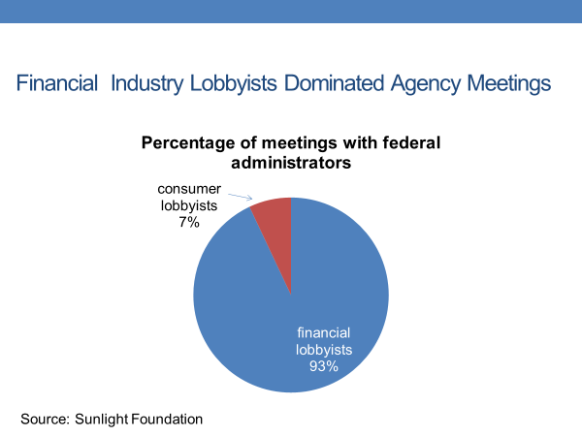
Lobbyists for Goldman Sachs alone attended 222 meetings with regulators-- almost as many meetings as regulators granted to all consumer groups combined.
#
OK, let's step back from the two cases. Think about the influence of interest groups in a broader context.
For starters, no one questions the right of or even the need for groups to speak out on policy issues affecting them.
It's entirely appropriate for groups, whether they be automakers, banks, consumers, farmers, college students, to advocate on their own behalf. But that's not simply because Americans have a right to free association and expression. The fact is society as a whole has a stake in the well-being of its separate interests.
Where would we be without a healthy banking, or food, or construction, or higher education sector?
Society is not like a large ball. It's made up of constituent parts that are linked together-- the health of one affecting the health of the others.
For this reason, scholars of the pluralist school of thought prefer to think of the public interest as a question of whether a large number of groups distributed across the wide range of society benefit from group activity. If they do, pluralists say, the group system contributes to the public good.
Yet one can reasonably ask whether some groups have too much power in the United States.
If a group routinely gets its way at a cost to the rest of society, the interests of the majority are brushed aside.
That situation is not easy to reconcile with democratic theory, which emphasizes government by the majority rather than by well-placed interest groups.
That concern, however, cannot be addressed in isolation. The group system is only one of the ways that policy benefits in America are distributed.
The party system is another way, and it operates differently. If lower-income Americans are disadvantaged by the group system, which they are, they do number in the millions, and their votes can affect a political party's electoral fortunes, which also affects public policy.
Business interests might get tax breaks through the group system, but lower-income Americans get government assistance programs through the party system.
We saw that in the 1930s, for example, with passage of social security.
It was not that retirees were an organized group. There, the Democratic Party, under Franklin D. Roosevelt, responded to their interests.
My point is that the group system, though biased in favor of business and upper-class interests, is only part of the answer to the question of who governs America. Other parts of that answer are explored in other sessions of the course.
#
OK, let's wrap up what we've said about interest groups.
We noted at the outset that the United States has an unusually large number of interest groups, which we attributed primarily to the division of power between the branches and levels of government.
This division created multiple power centers that groups can target in their effort to influence policy.
Congress alone is a ripe target, with its two houses, its numerous committees and subcommittees, and its 535 members-- all of whom have the power to introduce legislation.
We then explored why some US interests are more fully organized than others, noting that interests differ in their resources and in the incentives they can offer potential members.
Because of their profits and their individual incentives, such as jobs, economic groups find it relatively easy to organize and engage in lobbying.
In contrast, non-economic interests have to rely on voluntary donations to support their lobbying efforts.
They also face a free rider problem in that they pursue public or collective goods, which are goods that are available to non-members as well as group members. Individuals may choose to free ride, getting the benefits of the group effort without contributing to it. For such reasons, non-economic interests are less thoroughly organized than our economic interests.
We then turned to the ways in which groups lobby for influence, pointing out that they typically work with trusted lawmakers and rely on information to make their policy arguments.
Campaign contributions and the promise of voter support are also part of lobbying.
We ended the session by asking whether groups have too much power in the American system. We noted the extraordinary influence on policy of economic groups, particularly business firms, while also noting that groups are only one way that Americans can influence public policy.

