Transcript: Public Opinion Lecture

{ON LOCATION, HARVARD SQUARE]
THOMAS PATTERSON: Public opinion is the holy grail of democratic politics.
It's impossible to ignore public opinion. But at the same time, it's hard to put your hands on it. What's going on in the minds of the people that you can see behind me? Are they thinking about the problems facing the nation?
Are they thinking about the conflicts in the Middle East or the growing income gap?
Well, probably not.
More likely, they're thinking about where they're headed, what they'll do once they get there, what they might have for lunch. If they're planning ahead, what they're going to do this weekend.
As the journalist Walter Lippmann put it, "We are concerned in public affairs, but immersed in our private ones."
That's a problem for democratic theory.
Theoretically, government in a democracy rests on the will of the people.
But that assumes that the will of the people is an informed and engaged will, that people are interested in politics.
And so that's one of the puzzles of democratic politics, where public opinion fits into the equation. How attentive to public opinion should government be? How attentive to public opinion is government? And what happens when government ignores public opinion?
#
[STUDIO PORTION]
The rise of democracy led political theorists to ask what was meant by the phrase "the will of the people." Did that mean officials had to pay heed to people's everyday opinions? Edmund Burke, an 18th-century British theorist, said no.
He argued that citizens were ill-equipped to make policy judgments and that representatives should decide what was best for them.
Said Burke, "Your representative owes you his judgment; and he'd betrays you, if he sacrifices it to your opinion."
Jeremy Bentham, the founder of utilitarian theory, thought differently. Bentham argued that citizens deserved to be heard, indeed, that public opinion was the best protection against misrule. That view, that people's everyday opinions matter, gradually prevailed.
But a practical question remained. How was public opinion to be determined?
Was it to be judged by what was said from the pulpit and in the community hall, by what newspaper reporters were hearing on the streets, by studying election results? The introduction of scientific polling in the 1930s more or less settled the question of how public opinion would be determined.
Polls gained early and instant credibility when the first ever Gallup presidential poll accurately predicted a landslide victory for Franklin D. Roosevelt over Alf Landon in 1936.
Many newspapers had predicted otherwise. They had reported voters couldn't wait to get rid of Roosevelt.
As it turned out, newspaper publishers were living in an echo chamber. They and their wealthy friends hated Roosevelt's New Deal and had been listening to each other.
Polls are now the dominant method of gauging and researching public opinion.
#
In this session, we'll examine that research, focusing on the nature of opinion polling, the attributes of public opinion, and the influence of public opinion on officials and public policy.
Let's start with a few observations on polling.
In a poll, a small number of properly selected individuals or, as they're called, "the sample," are used to estimate the opinions of an entire population, such as the residents of a city or country.
Now, how is that possible?
How can interviews with, say, 1,000 respondents possibly provide a reliable estimate of what millions of Americans are thinking?
The answer is found in the laws of probability.
Consider the hypothetical example of a huge jar filled with a million marbles, half of them blue and half of them red. If a blindfolded person reaches into the jar, the probability of selecting a marble of any given color is 50-50.
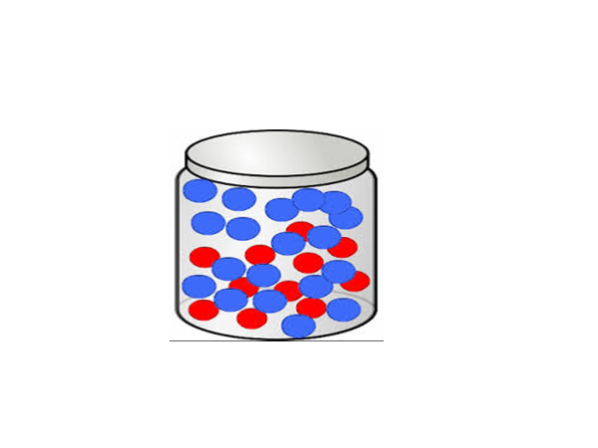
And if 1,000 marbles are chosen in this random way, it is likely that roughly half of them will be red and roughly half will be blue.
Opinion sampling works on the same principle. If respondents are selected at random, they can be used to estimate what the population as a whole is thinking.
Now, which do you think is more important in determining the accuracy of a poll?
Do you think it's the size of the sample?
Or do you think it's the size of the population, whether the poll is of a city or a state or the nation as a whole?
It's sample size.
Think again of the jar full of marbles, half red, half blue. As long as the marbles were thoroughly mixed, it wouldn't matter whether the jar held 1 million, 10 million,100 million marbles. In each case, the odds of drawing a red marble or a blue one would be 50-50.
The size of the sample would matter, however.
If you drew only 10 marbles from the jar, you'd stand a good chance of getting six or more marbles of one color, rather than five of each. If you tried to generalize from a sample of 10, you'd stand a good chance of being wrong.
On the other hand, if you drew 1,000 marbles from the jar, the odds greatly improve that the sample distribution will come closer to the actual number.
For example, the mathematical odds of drawing as many as 600 marbles of the same color are more than 100,000 to 1, close to the odds of being struck dead by a meteorite falling from the sky.
The accuracy of a poll is expressed in terms of sampling error. This error occurs because a sample is being used to estimate the characteristics of the full population.
The error refers to the difference between the estimate obtained from the sample and what the actual figure would be if the entire population had been contacted. As you would expect, the larger the sample, the smaller the sampling error.
In other words, the more people surveyed, the less likely the poll will be inaccurate. Most public opinion polls are based on samples between 400 and 1,500 respondents. A properly drawn random sample of, say, 1,200 respondents has a sampling error of roughly plus or minus 3%. Thus, if 55% of such a sample-say they intend to vote for the Republican presidential candidate, It's highly likely that somewhere between 52% and 58%--that's 55% plus or minus 3% sampling error--of the population actually intend to vote for the Republican candidate.
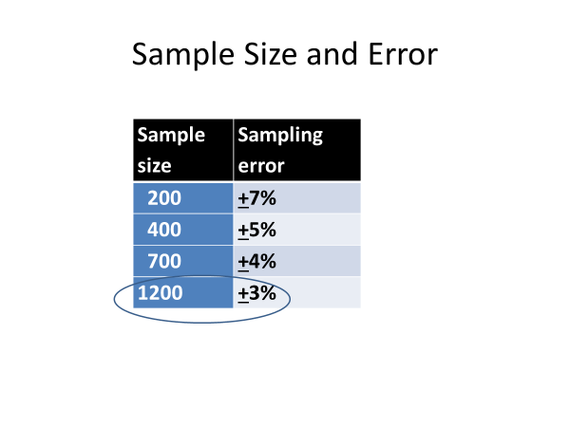
Now, polls can go wrong for a lot of reasons.
Poorly worded or slanted questions, for example, can confuse or mislead respondents. As well, pollsters can only approximate random selection in choosing their respondents.
Most polls, for example, are conducted by telephone. In this case, pollsters are sampling telephone numbers, rather than people directly.
Nevertheless, reputable polling firms have a solid track record. The Gallup organization, for example, has polled every presidential election since 1936, a total of 19 elections in all. On average, the final Gallup poll's election prediction has come within two percentage points of the actual result.
Now, pollsters ask Americans a great many things-their feelings about the president, their party identification, their opinions on issues, their religious affiliation, and so on.
Here, we'll concentrate on policy opinions, focusing on three of their attributes, direction, intensity, and salience.
Opinions have direction. That is, people can favor or oppose a policy.
A 2014 Washington Post ABC News poll, for example, asked respondents whether undocumented immigrants living in the United States should or should not be given the right to live and work here legally.
46% said they should. 50% said they should not.
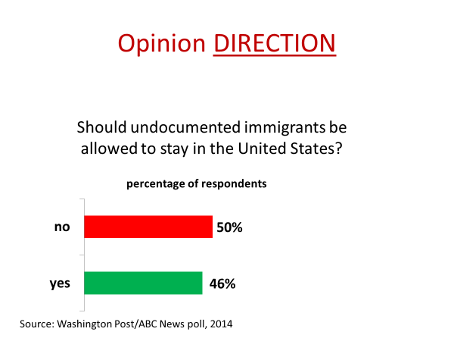
When, as in this case, the public is divided in its opinions, the issue is likely to be a source of partisan conflict. On the other hand, when opinions are one-sided, conflict is usually limited.
After the terrorist attacks on US soil of September 11, 2001, the public was largely of one mind on the issue of taking the war to the terrorists. There was relatively little debate over whether to invade Afghanistan. When polled at the time of the invasion whether it was the right thing to do, 89% said it was. A mere 9% felt the invasion was a mistake.
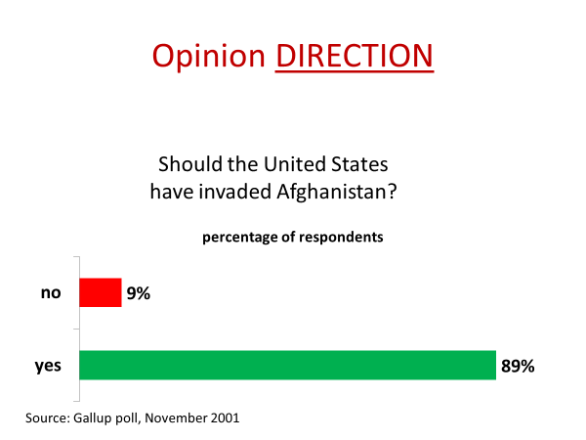
Now, intensity is another opinion attribute. Intensity is a question of how strongly people feel about an issue.
During the 2012 presidential campaign, for example, a Pew Research Center poll asked respondents how important the abortion issue was to their vote, very important, somewhat important, or not at all important.
The intensity level was much higher on the anti-abortion side of the issue.
Compared with those who believed abortion should be legal in all circumstances, those who felt it should be illegal in all circumstances were more than twice as likely to say that the issue was very important in their choice of a candidate. Intense opinions tend to get lawmakers' attention. Intensity is a sign that people might act on what they believe.
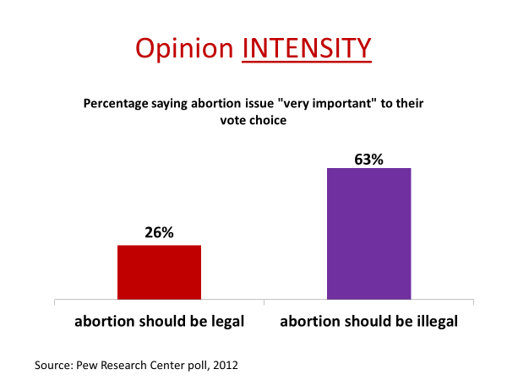
Opinions also have salience, which refers to the importance of an issue relative to other issues.
Salience is related to intensity. The more strongly people feel about an issue, the more likely they are to think it's important.
But intensity and salience are not the same thing. For example, people might have an intense opinion about genetically modified food, but not see it as a salient issue. It could be far down their list of important issues.
In polls, issue salience is often measured by asking respondents what they regard as the country's most important problem.
Pocketbook issues-the economy, jobs, wages-typically are at the top of the list.
Virtually no one in polls mentions genetically modified food. And issue salience matters to elected officials.
They don't risk much by neglecting low-salience issues, but they can get themselves in trouble by ignoring highly salient ones.
Some analysts, for example, have concluded that Barack Obama made a strategic mistake in pursuing health care reform in the first months of his presidency, a time when the economy was uppermost in Americans' minds.
Obama paid for his decision in the 2010 midterms, when Democrats lost control of the House of Representatives and saw their Senate majority dwindle. Exit polls indicated that a majority of voters were upset with Obama's handling of health care and the economy.
Obama's strategy was a sharp contrast with that of Democratic president Franklin Roosevelt during the Great Depression.
Upon taking office in 1932, Roosevelt concentrated on getting Americans back to work and stayed on that issue for three years.
Only then did he ask Congress to enact Social Security.
In both the 1932 midterm and the 1936 presidential elections, Democrats increased the size of their House and Senate majorities.
#
Let's recap what we've noted so far. Opinion direction matters.
If the weight of opinion shifts in one direction, officials are more likely to respond to that side. But we also need to account for intensity. Officials are more likely to respond to intensely held opinions.
And then there's salience. As the salience of an issue rises, the likelihood that officials will respond increases.
Let's look at the interplay of these three opinion attributes through the lens of a single policy issue, gun control. For starters, let me give you a bit of background on guns and gun policy.
America has a lot of guns.There are nearly as many guns in America as there are people. That's the highest ratio in the world. France has one gun for every three people. England has one for every 16.
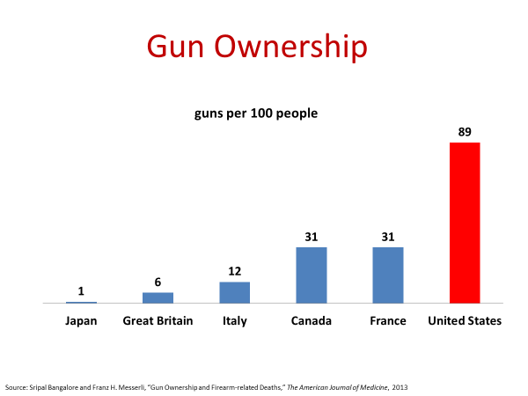
Full disclosure here-I'm a gun owner.
It's a shotgun that I used for bird hunting while in high school in rural Minnesota.
Since then, it's been locked up unused in my brother's house back home.
Now, there are a lot of hunters in the United States, 10 million or so, as well as an uncounted number of skeet, trap, and target shooters.
The United States also has a lot of gun deaths, about 40,000 per year.
Roughly 15,000 of these deaths, an average of one per hour, are homicides. The rest are suicides or accidental deaths.
Now, given the number of gun deaths, it's not surprising that over the years, attempts have been made to control guns. The first major federal laws enacted in the 1930s limited the sale of machine guns, a favorite of organized crime. In the 1960s, the sale of guns to felons and the mentally ill was restricted.
In the 1990s, Congress limited the sale of handguns and military-style assault weapons.
The assault weapons ban had a sunset provision. The law would expire in 2004, unless renewed by Congress.
Since the 1990s, Congress has not enacted a single major gun control law.
In fact, national policy has gone the other way.
When the assault weapons ban came up for renewal in 2004, Congress voted it down.
Later, Congress passed a law protecting gun sellers and manufacturers from being sued if their product was involved in a shooting.
In 2008, the Supreme Court got into the act, citing the Second Amendment right to bear arms and overturning a ban on handguns. The Court did say, however, that some gun regulations were lawful, though it did not list them.
In 2013, advocates of gun control in Congress made a concerted effort to tighten the regulations, including reinstating the ban on assault weapons. Congress voted down that proposal, as well as all the others, including stricter background checks on gun buyers. Now, where does public opinion fit into this picture? What part has it played in what's happened since the 1990s?
Let's look first at the direction of public opinion, where Americans stand on gun control.
As you can see from this chart, Americans are split on the issue of whether gun control should take priority over gun ownership.
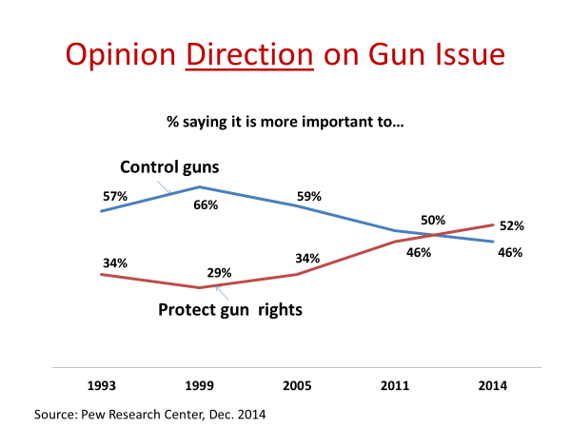
But the chart also shows that a larger number of Americans-at times, twice as many-have wanted stricter controls on guns.
So if we were considering only pro and con opinions, we might have expected lawmakers to place additional restrictions on guns rather than fewer, which has been the case.
So let's look at opinion intensity to see if it helps us understand what's happened.
And here, we begin to get at the answer. As you can see from this chart, gun control opponents are far more willing to act in their opinions.
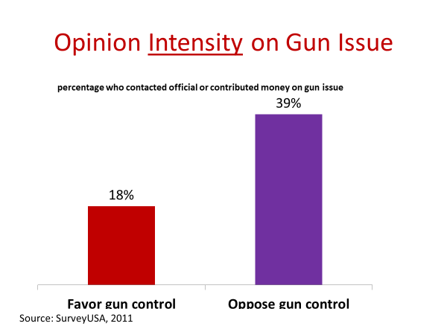
They are twice as likely as those favoring gun control to have written a public official or given money in support of their position.
Now, let's add opinion salience to the mix. For starters, gun violence is not a particularly salient issue.
In most Gallup polls of the past two decades, 1% or fewer of the respondents have named gun violence as the nation's biggest problem.
That would suggest that lawmakers can safely ignore the issue, knowing that only a small number of people see it as a pressing problem.
On the other hand, gun violence has sometimes become more salient. In May 1999, for example, 10% of Gallup poll respondents cited gun violence as the top issue.
More recently, February 2013, gun violence was mentioned by 6%.
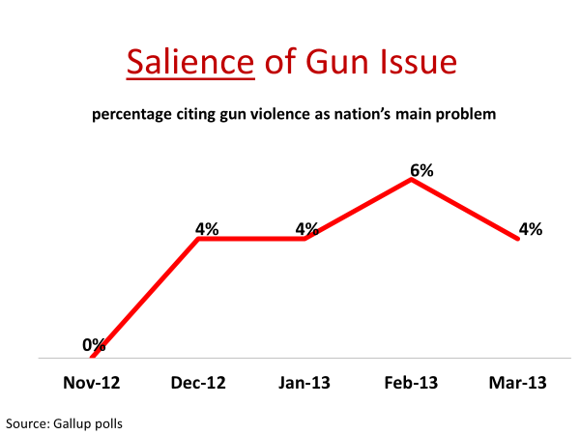
That might seem small, but only five issues were mentioned more frequently in the poll.
So what explains the occasional jump in the salience of gun violence?
It's mass killings.
In 1999, a shooting at Columbine High School in Colorado left 12 students and two teachers dead.
In late 2012, 20 children and six adults were murdered in a shooting at the Sandy Hook Elementary School in Connecticut.
Mass shootings get intense media coverage, providing gun control advocates an opportunity to push for stricter laws.
After the shooting at the Sandy Hook school, for example, President Obama set aside other issues to put pressure on Congress to act.
Yet as we emphasized in previous sessions, legislation in the United States must work its way through a system of divided power, where partisan differences can block action.
So let's take a look at how Republican and Democratic voters feel about guns.
Here's the partisan split on the issue of assault weapons from a poll taken after the Sandy Hook school killings.
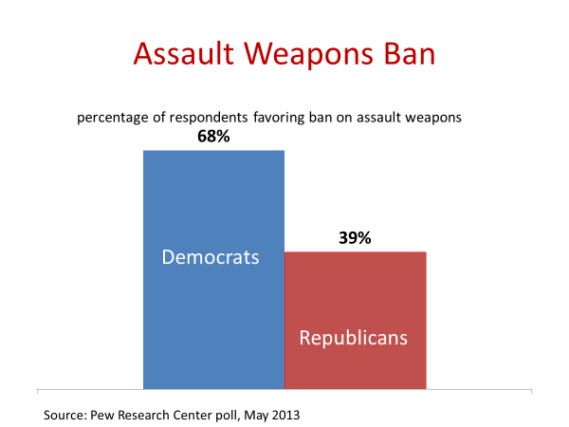
As you can see, Democrats were heavily in favor of banning assault weapons, while only a minority of Republicans favored it.
When the bill to ban assault weapons was considered in Congress in 2013, it did not even come up for a vote in the Republican-controlled House. It was blocked before it reached the floor. In the Democratic-controlled Senate, there was a vote. But the ban was defeated by 60 votes to 40. Every Senate Republican but one voted against the ban.
They were joined by 15 Democrats. Now, that might surprise you. What do you think most of these Senate Democrats had in common?
They were from rural states, where hunting and gun ownership is widespread.
Rural America, as you can see from this figure, ranks gun ownership rights ahead of gun control, while the opposite is true of urban America. Let me note one final thing about the gun issue before we move to another topic. You might recognize this chart from an earlier session.
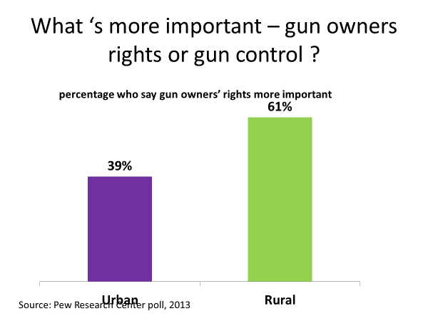
It's based on the costs and benefits of a policy.
Costs and benefits can either be concentrated, targeted at a specific interest, or diffused, spread across society. Where would you place gun control on this chart?
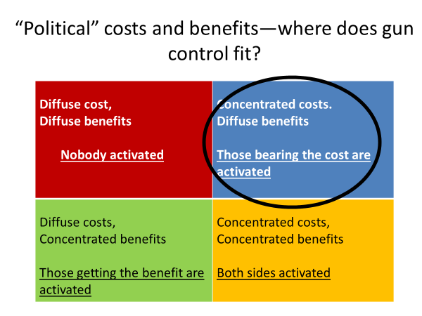
It fits best in the diffuse benefits, concentrated costs category.
The benefits of gun control are diffuse because they're hard to pinpoint.
Fewer people will die or be injured if guns are more tightly regulated, but it's impossible to know who those people are.
And since the odds of being a gun victim are small in the first place, few individuals will think gun control will make them a whole lot safer.
On the other hand, the costs of gun control are concentrated. They restrict the actions of gun owners who do know who they are.
Thus, they individually feel the impact of stricter laws. The distribution of the costs and benefits of gun control helps explain why intensity is much higher on the anti-gun control side.
Individuals on that side of the issue feel they are bearing the costs of gun control policy. It also explains why lawmakers from certain states and districts shy from the issue.
Citizens who oppose gun control are more likely to vote on their opinion than those who favor controls.
#
Now, to this point in the session, the discussion has aimed at explaining the attributes of opinion and how they affect the play of politics. As yet unaddressed is the most basic question about public opinion. How much influence does it have on government? It clearly has some influence, but what's the magnitude? And what are the limits to it?
As it turns out, that's a hard question to answer with any degree of precision.
Policy decisions are rarely the result of a single influence.
Lobbying, partisanship, media coverage, events, public opinion-all these and more can play into the choice of one policy over another.
In addition, public opinion has contradictory elements.
People's opinions don't always line up in a logical way.
For instance, majorities routinely say they would like a large cut in their taxes. But they also say they want more government services, such as better schools and highways. They can't easily have it both ways.
Nevertheless, considerable research has been done on the impact of public opinion, and the findings support some clear conclusions. One is that public opinion constrains officials. It limits their choices.
As political scientist VO Key expressed it, "Officials must operate within the boundaries of what the public will find acceptable."
An example is the Social Security program, which has such broad public support that it's been called the "third rail of American politics," a metaphor for a policy that's likely to hurt any politician that tries to mess with it.
Over the years, a few have tried. In 2005, for example, President Bush proposed privatizing part of the Social Security program. Like the others before him, the public response was so strongly negative that Bush had to back down.
During his 2016 presidential campaign, Donald Trump vowed to cut federal domestic spending and promised that every domestic spending program would be subject to review. Yet when Trump proposed his first set of budget cuts as president, Social Security was not on his list.
The founder of Social Security, President Franklin Roosevelt, predicted that people would fight tooth and nail to protect the retirement benefits they had acquired by paying payroll taxes during their working years.
Said Roosevelt, "No damn politician can ever scrap my social security program."
Now, on the other hand, there's a wide range of policy decisions--most of them, in fact--where public opinion doesn't even come into play.
Most policy decisions take place outside the public eye.
In the area of foreign affairs, for example, there are hundreds of policies on which the public is not remotely aware--foreign aid for the Ivory Coast, safety standard agreements with the European Union, the special tariff on wine from Argentina.
Most domestic policy decisions also take place outside of public view.
How many Americans know or care, for example, that the government has funded research on dairy cows' methane gas emissions?
Policies such as these, rather than being decided in the context of public opinion, are decided largely through the interest group system, a subject we'll examine later in the course.
Now, what about those issues that do catch the public's eye, those that get a lot of attention from the media and attract wide public interest?
Are officials responsive to public opinion in these cases?
A number of studies have looked closely at that question.
They have examined trends in policy and opinion over time, seeking to determine whether changes in public opinion are followed by corresponding changes in public policy. These studies have found that when public opinion changes, so, in most cases, does public policy.
For example, in a study of 350 high-profile policy-opinion relationships spanning a four-decade period, political scientists Bob Shapiro and Ben Page found that changes in public opinion were normally followed by congruent changes in public policy.
They concluded, "When Americans' policy preferences shift, it's likely that changes in policy will follow."
In other words, opinion direction and salience matter.
As opinion direction on high-visibility issues changes, so, typically, does policy. Opinion intensity also matters, as political scientist John Kingdom found in his study.
He concluded that when public opinion is intense and unmistakable as to a preferred course of action, politicians nearly always follow it.
Now, such findings should not be taken to mean that officials blindly follow public opinion.
At times, public opinion trails policy, as opposed to leading it.
For example, the changes in race relations brought about by the 1964 Civil Rights Act helped to change Americans' opinions on race.
Moreover, as political scientist Jeff Manza and Fay Lomax Cook showed in their study, politicians have room to maneuver even when they're responding to public opinion.
For example, although Republican and Democratic lawmakers alike are responsive to public demands for policy action when the economy goes bad, they have different approaches to fixing the economy.
That's a subject we'll examine in a later session.
Nevertheless, decades of research demonstrate that policy on high-profile policy issues usually changes in the direction of public opinion, rather than the reverse.
In a recent exhaustive study of the linkage between opinion and policy, for example, political scientists Robert Erikson, Michael Mackuen, and James Stimson flatly conclude, "Public opinion influences policy."
#
OK. Let's wrap up this session with a summary.
We began with a brief look at early theories of public opinion and how the introduction of opinion polling changed the way public opinion is measured and studied.
We then examined the basics of polling, the use of a sample of people as a means of estimating what the public as a whole is thinking, noting the importance of random selection and sample size to the accuracy of polls.
We then studied attributes of opinion, opinion direction as an indication of the distribution of opinions on an issue, opinion intensity as an indicator of how strongly people feel about their position on an issue, and opinion salience as an indicator of how important people think an issue is relative to other issues.
All three opinion attributes affect whether officials are likely to take public opinion into account in making policy decisions.
And we closed by reviewing research on the general relationship between public opinion and public policy, noting that the link is fairly strong but largely limited to salient issues on which opinion is intense and clear in its direction.

