Transcript: Congress & Constituency Lecture

[ON LOCATION, U.S. CAPITOL BUILDING]
THOMAS PATTERSON: How would you like a job where you show up at the office on Tuesday morning, and at the end of the day on Thursday, you leave the office for the week, and you get paid $175,000 a year? That's the life of most members of Congress, House and Senate alike when they're on Capitol Hill.
But at the end of the day on Thursday when you leave the office, you head for the airport. You fly back to your home state or your home district. And there you spend the next four days talking to local groups, meeting with donors, essentially trying to build support for your next election campaign.
A recent study found that members of Congress work about 70 hours a week on average. That compares with 44 hours for the average American worker. And members of Congress have about half as much personal and family time as the average American.
Well, why do they do it?
Why do they spend so many long hours at their job?
Well, as Yale political scientist David Mayhew put it, they're single-minded seekers of re-election. They're career politicians, and they need to get themselves re-elected again and again and stay in that career. And that means spending a lot of time back home talking to the folks who are going to be the voters in the next election.
Keep the voters happy, and they'll return to Congress.
Displease the voters, and they're very likely to see an end to their career.
That's why the home district and the home state are so important to members of the Congress of the United States.
#
[STUDIO PORTION]
To the framers of the Constitution, Congress was the top branch of government.
It had government's most important power, the power to write the nation's laws.
In the words of the Constitution, "All legislative powers shall be invested in the Congress."
We'll spend this session and the next looking at Congress. In the next, we'll explore the role of political parties in Congress.
In this one, we'll focus on constituency influence, the role that voters in members states and districts play in what happens in Congress. The session will explain how members of Congress relate to their constituencies. And hen we'll explore the impact of constituency on congressional lawmaking.
Now Congress is an atypical national legislature. For one, thing it operates in a system of divided powers.
It has legislative power, while the president holds executive power.
But the president also has the power to veto legislation. Congress has no choice but to keep the president in mind as it goes about its legislative duties.
That's different from a parliamentary system, where the prime minister has both the legislative branch and the executive branch.
It's also the case that Congress is a bicameral legislature. It has two chambers, the House and the Senate.
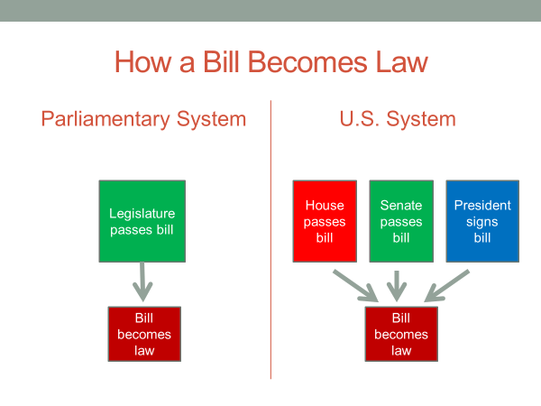
Now that's not unusual in itself. Most national legislatures are bicameral. What's unusual is that the House and Senate are co-equal chambers.
In most democracies, the chambers are not equally powerful. In Germany, for example, the weaker chamber can temporarily block action by the stronger one, but typically can't stop it.
Not so in the US Congress. To become law, a bill must be passed in identical form by both the House and the Senate. If a bill is passed by one chamber but not the other, it's dead. If a bill differs in its Senate and House versions, and the two chambers can't agree on a compromised version, it's dead.
But what truly distinguishes Congress from most other national legislatures is the degree to which its members are free agents. Elsewhere, the members are dependent on their party. They cannot hope to hold office unless the party organization deems to nominate them. Once in office, they risk being denied renomination if they fail to back the party on key bills. Not surprisingly, nearly all of them toe the line.
Congress is different in this respect. The United States is almost alone in using primary elections where the voters, rather than the party organizations, pick the nominees. A candidate who wins the primary becomes the party's nominee in the general election, even if the party organization would prefer someone else.
As well, House and Senate candidates run their own elections. They raise most of the money, create their own campaign organizations, pick the issues on which they'll campaign. They typically get some help from their party. But for the most part, they win or lose on their own.
As a result, members of Congress are free to vote as they please when a bill comes up for a vote.
As you would expect, most of them have more in common with other members of their party than with those of the opposite party. So they usually support the party's position, but they can't be forced to do so.
When Robert Dole was a Republican leader in the Senate, he remarked, "There are a lot of free spirits in the Senate, about 100 of them." 100 of them, that's the entire membership of the United States Senate.
Now the key to winning elections in the American system is constituency support, the backing of the voters in the candidate's home state or district.
To elect its Senate and House members, the United States employs what's called a single-member plurality district system, or as it's also called, a first past the post system.
In it, each elected official is chosen singly from a separate state, in the case of a senator, or a separate district, in the case of a member of the House of Representatives.
The candidate with the most votes wins the election.
This type of election system differs from a proportional representation system, which is what most democracies use. Under a proportional system, parties win legislative seats in proportion to the percentage of votes they receive in the election. A party that receives 35% of the national vote gets 35% of the seats. One that wins 20% of the vote gets 20% of the seats, and so on.
In that type of system, individual candidates do not have to please the voters directly. They win or lose office depending on how well their party does in the national vote.
America's single-member districts system of elections is different.
It's the reason that members of Congress fly back to their home state or district on weekends to give talks and meet with community leaders. They're seeking to build the local support necessary to come out on top in the next election.
Congressional staffs also contribute to the vote-getting effort. Members of Congress have much larger personal staffs than do members of other national legislatures. Elsewhere, a member might have one or two staff members. US senators, on the other hand, have staffs of 30 people or more, while house members have nearly 20 people on staff.
Now some of these staff people work on legislative issues, but most work one scholar describes as thinly disguised re-election campaigns. Staff members put out press releases, help constituents with their problems, and arrange speaking events, all with an eye toward building the member's support among those in his or her state or district.
Upon graduating from high school, I recall getting a congratulation card from Ancher Nelson, a congressman from my home district in Minnesota. I was honored to get it, until I find out each of my classmates also got a card. So did all the other graduating seniors in his district. Ancher Nelson was looking to get our votes.
Constituency influence is also apparent in the legislative work of members of Congress, particularly in their service on congressional committees. Most legislative work in Congress takes place in its standing committees. They're called standing committees because they're ongoing. Each of them has continuing responsibility for legislation in its policy area. Currently, there are 20 standing committees in the House, and 16 in the Senate. Each chamber has, for example, an Armed Services Committee, a Budget Committee, Foreign Affairs Committee, Small Business Committee.
Most legislative work, as I indicated, takes place in these committees. Congress considers several thousand bills each session, and could not manage its workload if each bill was studied by every member, so the members are divided into committees.
You will recall that the Senate is apportioned by population, two for each state, for a total of 100 members. In contrast, the House of Representatives is apportioned by population. With 435 members, it's more than four times the size of the Senate. Those differences are reflected in the size of the committees. For instance, the House Agriculture Committee has 45 members, while the Senate Agricultural Committee has 20 members.
Each committee has its own jurisdiction, a term that refers to the policy area in which it's authorized to act. For example, the House and Senate Agriculture Committees handle bills dealing with farm issues. The role of the standing committees can be seen in this simplified diagram of how a bill becomes law.
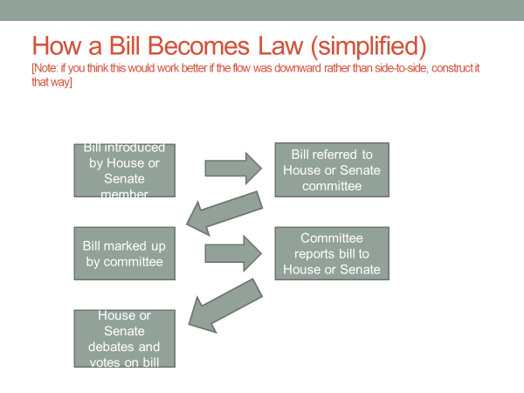
After a bill is introduced by a House or Senate member, it is assigned to the committee with jurisdiction over bills of that type.
The standing committee can't pass a bill on its own. That requires a vote by the full chamber. But committees have the power to rewrite bills. This authority is called markup, the power to change a bill's provisions. A committee can change or amend a bill as it sees fit.
After a bill is worked up in committee, and if it has the support of a majority of committee members, it is submitted to the full chamber for consideration.
The full chamber can amend or defeat the bill. But if it passes, it typically is close in form and content to what the committee decided.
Committees are also the mechanism through which Congress exercises what's called oversight, its responsibility to see that the executive branch faithfully administers the law. Each committee oversees the activities of its parallel executive agency. The House and Senate Agriculture Committees, for example oversee the Department of Agriculture.
If a committee thinks an agency has acted improperly, it can call hearings and require the agency's officials to appear and testify to their actions.
There's a final thing to note about congressional committees, and that's the question of who serves on them.
Here are two possibilities.
Which do you think is more important in determining committee assignment?
The education and job backgrounds of members of Congress who are assigned to committees where their experiences are needed or the nature of the member's state or district?
Members are typically assigned to committees to handle issues affecting their constituency.
Both factors affect committee assignments. But as you might have inferred, the second one is usually more important.
Senators and representatives typically serve on committees that deal with issues affecting their constituencies. The House and Senate Agricultural Committees, for example, are stacked with members from farm states. Here's a map showing the states represented by members of the Senate Agriculture Committee. Notice the heavy concentration of senators from the middle of the country and the South. These are regions of the United States where agriculture is particularly important to the economy.
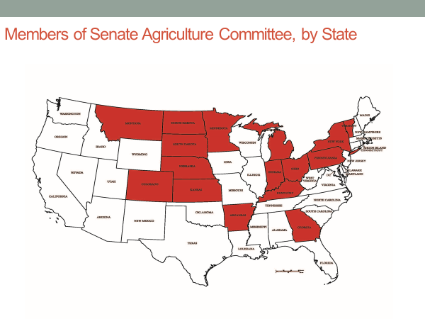
Similarly, the Armed Services Committee includes a disproportionate number of senators from states with major military installations, such as the states of Texas and North Carolina.
Committee assignments such as these enable members of Congress to look after the interests of their constituents. It also gives them an inside track on campaign contributions from groups that benefit from the committee's decisions.
In the most recent election cycle, for example, agricultural interest groups gave 30% of their campaign donations to members of the House and Senate Agricultural Committees, even though these members make up barely more than 10% of Congress.
Just being in Congress is also an advantage when it comes to raising campaign funds. Groups donate mostly to incumbents, recognizing that the large majority of them will win re-election. Less than 20% of a group's campaign contributions go to candidates who are challenging an incumbent.
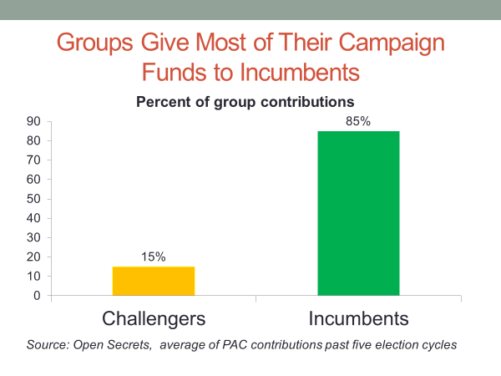
In a few minutes, we're going to discuss a case, the 2014 farm bill, that illustrates constituency influence on congressional action. Before doing so, let's think about legislation in terms of its costs and benefits. Consider this two-dimensional table.
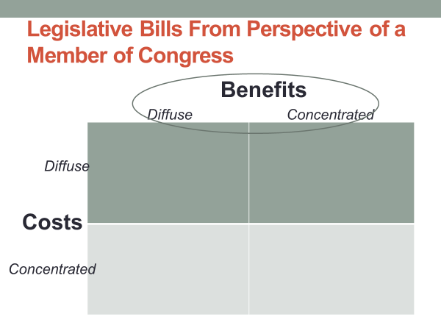
One dimension addresses the benefits associated with the legislative bill.
The benefits can be either concentrated or diffuse.
An example of a bill with a concentrated benefit is one that allocates money to assist the handicapped meet their medical needs.
If you meet the eligibility requirements for the benefit, you get it. In that sense, the benefit is concentrated. It goes to those designated as eligible to receive it.
Now on the other hand, an example of a diffuse benefit is space exploration.
America's space program is beneficial, but it's difficult to pinpoint the exact benefit. Most Americans would have difficulty identifying the ways in which they have benefited directly from the billions the United States has spent on its space program.
Now keeping those distinctions in mind, let's assume for a moment that you are a member of Congress.
In terms of improving your re-election chances, what type of legislation is most advantageous?
Would the legislation provide a concentrated benefit or a diffuse benefit?
If you said concentrated, you'd be right.
Because the benefit is concentrated, the people receiving it will notice it and be grateful for it.
They might even vote for you because of your support for the bill.
In contrast, if the benefit is diffuse, the beneficiaries might not take notice of it. It's not tangible enough to be felt.
Now let's think about the cost side of the table. As with benefits, costs can be either concentrated or diffuse.
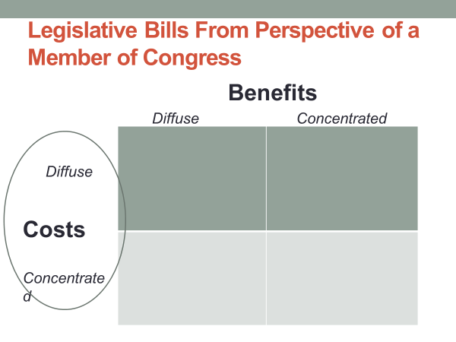
An example of a bill that imposes a concentrated cost is one that would require the owners of coal-fired power plants to reduce their carbon emissions. The cost would be imposed directly on those owners. It would be concentrated.
An example of legislation that would impose a diffuse cost is diplomacy. We have diplomatic efforts around the world, but the cost of those efforts are distributed across the entire taxpaying public.
Now assume again that you're a member of the Congress. In terms of improving your re-election chances, what type of legislation would you find most advantageous? Would the legislation involve a concentrated cost or a diffuse cost? If you said diffuse cost, you'd be right.
Because the cost of the legislation is spread widely, its impact on the individual taxpayer will not be noticed. No one will be angry enough to vote against you because of your support for the bill.
On the other hand, if the cost was concentrated on a particular group, the group would notice it, and its members might be angry enough to vote against you in the next election.
Now let's combine the two dimensions, the benefits and the costs, to identify the type of bill that best serves a member's re-election needs.
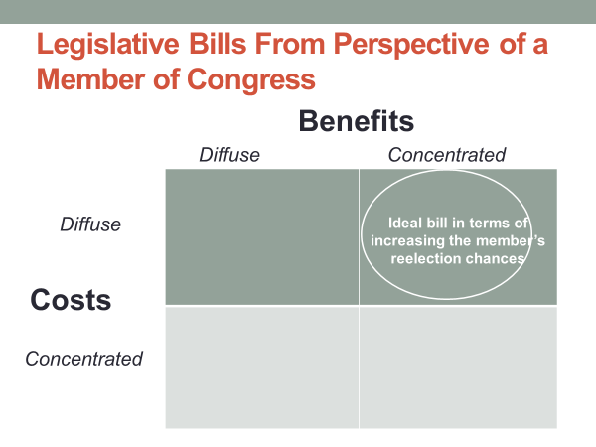
That bill would be one that provides a concentrated benefit, one recognized and appreciated by the group receiving it, while having a cost, one that is spread so widely across the tax-paying public that it's virtually unnoticeable.
Concentrated benefit and a diffuse cost, that's the ideal bill for a member of Congress.
It makes some voters happy without angering others.
Here's an example of a bill that has the two features-a concentrated benefit combined with a diffuse cost-that can help a member of Congress get re-elected.
The bill was passed in late 2011, a time when congressional Republicans and Democrats were deadlocked over budget issues, with Republicans striving for cuts in government spending while Democrats were striving to impose a tax increase on upper incomes.
Despite these differences, they found time to pass a spending bill. The vote was 422 to nothing in the House and 95 to nothing in the Senate, meaning that every Republican and every Democrat in Congress voted for it.
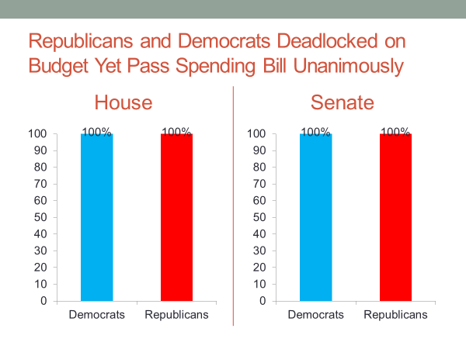
So what was the nature of that bill? Well, it offered a concentrated benefit while diffusing the cost.
The bill authorize the spending of $1.7 billion to help military veterans find jobs. The bill was good politics for a member of Congress. The benefit was concentrated.
Veterans alone would receive it and be thankful for it, while the cost was diffused across the entire taxpaying public so that its effect on any given taxpayer would be too small to be noticed.
The term "distributive policy" is used to describe such bills. They are distributive in that they confer a benefit on a particular group.
Distributive policy can be distinguished from what's called redistributive policy, which takes from one group and gives to another.
An example of a redistributive policy would be tax legislation that increases taxes on higher incomes in order to reduce taxes on lower incomes. That type of bill makes one group happy, but it angers the other.
That's a riskier bill for a member of Congress to support. The losing group might take out its anger on the member in the next election.
Now I don't want to give you the impression that re-election concerns are the primary reason distributive policy bills get enacted.
Such bills typically address a significant need. In the case of the veterans job bill, for example, it was developed in response to the fact that many of the men and women who had served in Iraq and Afghanistan were having difficulty finding a job after leaving the service.
Pell Grants provide another example. Pell Grants are distributive. They allocate a concentrated benefit, college aid to students from lower-income families, while diffusing the cost across the taxpaying public. Pell Grants serve an important purpose. Many of the recipients would not be able to attend college without a Pell Grant.
Moreover, the benefit to society of Pell Grants goes beyond the students who get help. Society as a whole benefits for having an educated workforce. If more Americans have a college education as a result of Pell Grants, that helps everyone.
Moreover, because college-educated workers have higher incomes on average, they end up paying more taxes during their lifetimes. In this sense, Pell Grants more than pay for themselves. They're a win for the recipient, and they're a win for society.
That's typically the case with distributive policy bills.
The fact that such bills also serve the re-election interests of members of Congress does not mean they are wasteful. But it does mean that such bills are more likely than other bills to attract the congressional support necessary to pass them into law.
Now let's go back to the question of constituency influence in Congress by looking at the 2014 farm bill.
Farmers have a job that doesn't provide a guaranteed income. Their income depends on how much they produce in a given year and the market price for their products. A drought or hailstorm can cut a farmer's yield, while weak demand for a product can drive down its price. This uncertainty has prompted the US government to provide income security to farmers.
The 2014 farm bill had that goal. It was drafted primarily in the House and Senate Agricultural Committees, and it was loaded with benefits for farmers.
These benefits included a crop insurance provision, whereby the government pays 62% of farmers' insurance premiums to protect them from losing their crop to drought or hail. The bill also provides support to catfish farmers, who are concentrated in southern states. It also includes support programs for fruit and vegetable growers.
Dairy farmers also get a support program from the 2014 farm bill.
I could go on. The list is quite long, but you get the point.
The farm bill offered benefits to farmers while spreading the costs, billions of dollars, across the taxpaying public as a whole. So what kind of support did the bill attract in Congress?
Well, large numbers of Republicans and Democrats backed it.
But the heaviest support came from members of Congress from states and districts where the agricultural sector is a major part of the economy.
The chart below compares the yes votes on the farm bill for Senators from the states regarded as the farm belt with the votes of other Senators. As you can see, nearly 90% of farm belt Senators supported the bill, as compared with less than 65% of other Senators. The farm bill was good politics for farm state members of Congress. It set them up to claim credit in their next campaign for lending farmers a helping hand.
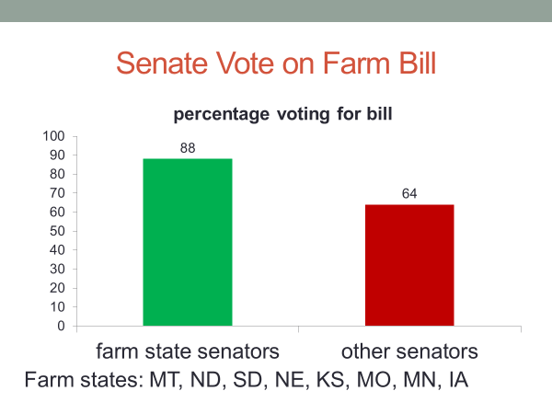
Now as you might have concluded from what's been said in this session, congressional incumbents stand a good chance of getting re-elected.
They have a lot of advantages over their election challengers, everything from their campaign fundraising advantage to their ability to promote legislation beneficial to their constituents.
In recent years, over 90% of House incumbents seeking reelection have won their campaigns. The percentage is somewhat lower for Senate incumbents, but they too have a high probability of victory.
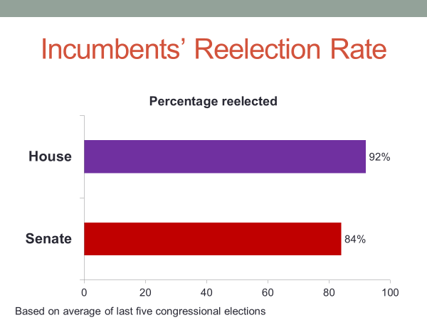
Once in Congress, you have a good chance of being able to stay there.
Now these success rates are largely the result of a factor we haven't discussed.
Many states and most congressional districts are one-sided in their partisanship. In the state of Georgia, for example, Republican voters easily outnumber Democratic voters. As a result, the state's congressional delegation is made up mostly of Republican lawmakers.
Given that most members of Congress come from states and districts that strongly favor their party, you might ask why they work so hard to build support in their constituency.
Don't they already have an easy road to re-election?
Many of them do, but US politicians face a reality that politicians elsewhere do not. That reality is primary elections.
Members of Congress must worry not only about an election opponent of the other party, but the possibility of a primary election opponent from within their own party.
We'll talk more about primary elections in the next session, which as I indicated earlier, we'll look at the influence of political parties on Congress and its members.
#
Let's wrap up the session.
We started by noting that members of Congress have their feet in two places, Capitol Hill, where they do their lawmaking, and the constituency back home, where they position themselves for reelection.
We noted that the nature of US elections, its single-member districts, where candidates bear primary responsibility for winning their own election, gives the members of Congress freedom to act as they please once they're in Congress. They are not compelled, as is the case in many national legislatures, to vote with their party on key legislative issues.
We also noted that the re-election chances of Senators and House members rest on constituency support, which leads them to devote time and effort to nurturing that support back home.
We discussed how the committee system reinforces members' constituency orientation, and gives them opportunities to look after constituency interests.
And finally, we noted the tendency of members of Congress to prefer distributive policies, those that confer a concentrated benefit, such as assistance to a particular group, while spreading the cost across the larger public. This type of legislation allows members of Congress to claim credit with the constituent group that benefits from the legislation without risking much backlash from those bearing the cost.

