Transcript: Congress & Party Lecture

[ON LOCATION, U.S. CAPITOL BUILDING]
THOMAS PATTERSON: Behind me is the Capitol Building, which houses the Congress of the United States.
It's a bicameral legislature, meaning it has two chambers.
The wing to my right houses the Senate, and the wing to my left is where the House of Representatives meets. A bicameral legislature was the result of compromises made during the writing of the Constitution.
The small states would not agree to a Congress where the large states, because they were more populous, had more delegates. On the other hand, the large states would not agree to a Congress where the states had equal representation. And the resulting compromise was the Senate, where each state has two senators and the House of Representatives, where the House is apportioned according to population. The larger states having more members of the House.
Now some delegates feared that this arrangement would pit the large states against the small states on legislative issues.
But as it's happened over the course of American history, that lineup has rarely been seen. Instead, the typical division in the Congress of the United States is around political party.
Political parties were not in existence when the Constitution was written. But shortly thereafter, they became part of the American political system.
And since then divisions within the Congress, splits within Congress, have occurred largely around the party divisions.
Seldom has that been more obvious than in recent years. The parties are quite far apart on the issues deeply deadlocked within Congress, and often times Congress has been gridlocked to such an extent that even pressing national issues have been passed on by the Congress.

#
[STUDIO PORTION]
In the previous session on Congress, we examined the role of constituency.
Here we'll examine the role of political parties.
We'll concentrate on the part they play in congressional leadership and in lawmaking.
Now we noted in the previous session that Congress is a fragmented institution.
It has two co-equal chambers, and its members have a power base in their state or district, which makes them free agents to a considerable degree.
So what holds Congress together? What serves as the glue that binds its members?
The answer is partisanship. Members of the same party typically have more in common with each other then with members of the other party, which enables them to pursue shared goals.
Partisanship is also the basis on which congressional leaders are picked. In both the House and the Senate, the top leaders are party leaders. In the House, the highest- ranking leader is the Speaker. Although theoretically chosen by a vote of the full House, the Speaker has always been a member of chamber's majority party. Its members have enough votes to pick one of their own as Speaker, and that's what they've always done.
Assisting the Speaker is the house majority leader who helps develop the majority party's legislative agenda, and the house majority whip who has the job of making sure that the party's members are in attendance when key votes are taken.
Now the Speaker's role is particularly noteworthy.
The Speaker is sometimes called the second most powerful official in Washington.
The Speaker's power to rise mainly from the fact that the House is a very large body.
It has 435 members. So many members that chaos would result if the House was not governed by strict rules.
The Speaker decides, for example, which members will be allowed to speak on a bill and for how long.
In effect, the Speaker also decides which bills will be taken up by the House, in what order they will be voted upon, and whether amendments to a bill will be allowed.
Now this might sound as if the Speaker has dictatorial powers.
But what must always be kept in mind about Congress is that its members can not be forced to support their party on legislative issues. They owe their election to the constituents of their district or state, rather than the party leaders. As a result, the Speaker and other congressional leaders must be mindful of what their party members will willingly support.
Rather than dictators, congressional leaders are negotiators. They work to develop legislative positions that are consistent with the party's goals, but that are also acceptable to most of their party's members.
On the Senate side the top party leader is the senate majority leader.
Assisting the majority leader is the senate majority whip, who like the house whip, is charged with lining up party votes on key issues.
The senate majority leader is chosen by the chamber's majority and works with it to develop the party's legislative agenda and manage the flow of bills through the Senate.
However, unlike the Speaker, the majority leader does not control Senate debate. Under Senate rules, each member can speak on any bill, and at any length.
Sometimes a minority of the members will exercise that right by talking endlessly in order to stop a bill from coming up for a vote.
That's called a filibuster. It's a tactic that's been employed many times in Senate history.
Now a filibuster can be stopped if 3/5 of the members vote to limit debate. That procedure is called cloture. Notice that cloture requires a 3/5 majority rather than a simple majority. Unless 60 of the 100 senators agree to end it, a filibuster cannot be stopped.
That's an imposing requirement.
The minority party also has its House and Senate leaders. There's a minority leader and a minority whip in each chamber.
Their roles are comparable to those of the majority leader and whip, but they're in a less powerful position because their party has fewer members.
Political parties are also the basis on which Congress's standing committees are organized.
As was discussed in the previous session, most of the work in Congress is done through its standing committees, such as the House and Senate Agriculture committees.
Currently, the House has 20 such committees, while the Senate has 16.
Each standing committee is headed by chair who's chosen by the majority party and is a member of that party. The majority party also has more seats on each committee then does the minority party.
Now this arrangement allows the majority party members to control committee action. If there are united, they have the votes to determine a bill's provisions, and whether the bill will be submitted to the full chamber for a vote.
In these various respects, Congress resembles other national legislatures, which are also organized along party lines.
What makes Congress unusual is that its members are not bound to their party. Unlike party members in most other legislatures, they cannot be forced to support the party on key issues. Their base of power, as I noted earlier, is not the national party, but the constituents in their state or district. They can get away with angering their party leaders as long as they retain their constituents' support.
Now because members are relatively free agents, the role that the parties play in Congress depends on whether a party's House and Senate members share the same policy goals.
If they think alike, they'll work together, and in opposition to the other party.
On the other hand, if they differ widely in their policy goals, party leaders will have difficulty getting them to work together. That was the case for much of the 20th century.
Rather than being united, the congressional parties were factionalized. The Democratic Party had a liberal wing consisting largely of its northern members, and a conservative wing made up largely of its southern members. For its part the Republican Party had a progressive wing consisting largely of its members from the Northeast and upper Midwest, and a conservative wing consisting largely of its members from other parts of the country. These ideological differences were large enough that lawmakers from the same party often voted in opposing ways.
Let me give an example.
It's the vote on the landmark 1965 Medicaid Bill, which provided government-paid health care for lower income families.
The bill was introduced in Congress by liberal Democrats with the backing of Democratic President Lyndon Johnson. At the time, the Democratic Party had a huge majority in Congress. So the Medicaid Bill passed with votes to spare.
But consider the votes of the different party factions. In the Senate, for example, only 61% of Democrats from the South, the party's conservative stronghold, voted for the bill, compared with 98% of Democrats from outside the South.
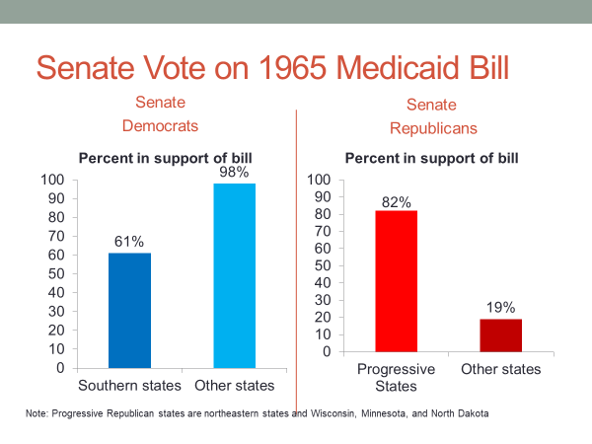
On the Republican side, 82% of senators from the Northeastern and upper Midwest states, the party’s progressive stronghold, voted for the bill, compared to only 19% of Senate Republicans from other states.
Such divisions in Congress were relatively common 50 years ago. Congress was not an institution where one party's members regularly lined up against those of the other party.
That's no longer the case. And it's due to changes set in motion when Northern Democrats took the lead in pushing the 1964 Civil Rights Act through Congress. Their chief opponents were not Republicans, but instead their fellow Democrats. Those from the South.
The Civil Rights Act of 1964 was one of the most bitterly contested bills in the history of Congress. Southern Democrats used every legislative tactic imaginable, from blocking action in committee to a Senate filibuster, in their effort to defeat the bill. It took nearly a year for the 1964 Civil Rights Act to make its way successfully through Congress.
Its passage changed the nation's politics. A fact that President Johnson recognized immediately. In signing the Civil Rights Act into law, Johnson turn to an aid and said, "I've just signed away the South for a generation."
The South, which had voted solidly Democratic in every election since the Civil War Reconstruction began to move away from the Democratic Party. Here's a chart that shows the extent of the shift.
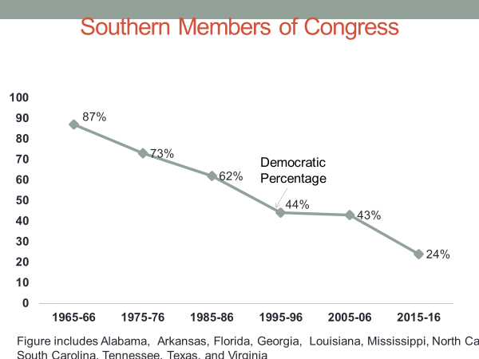
In the mid '60s, at the time of the Civil Rights Act, Democrats held an overwhelming share of the South's House and Senate seats. Today it is Republicans who have a huge edge in the South. The party's positions in the South have been totally reversed.
An effect of this change, which is attributable also to other issues, such as abortion and federal spending, has been to make the Republican congressional party more uniformly conservative. It now includes southern conservatives, as well as its traditional conservatives from other parts of the country.
For its part, the Democratic congressional party has become more uniformly liberal. It has picked up House and Senate members from regions where progressive Republicans once dominated.
Here's a chart that illustrates that trend. As you can see, even as late as the mid-1980s, Democrats held a small share of New England's congressional seats. Today, they have a large share. New England has become a Democratic stronghold.
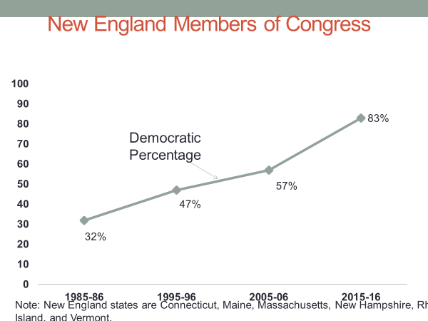
We'll discuss these developments at length in a later session on political parties.
The point I want to make here is that nearly all of today's congressional Republicans are political conservatives, while nearly all congressional Democrats are political liberals. This transformation has changed the way that Congress operates. It now operates very differently than it did a few decades ago.
In today's Congress there's a high level of what's called party unity. Members of the same party voting together on bills.
Nearly all congressional Democrats and Republicans are closer ideologically to members of their party than to members of the opposing party. As a result, Democrats tend to vote in concert with other Democrats, and Republicans tend to vote in concert with other Republicans.
Consider the analysis of congressional roll call votes, by political scientists Keith Pool, and Howard Rosenthal.
Examining these votes for the 1970s, they found that a significant number of congressional Democrats had more conservative voting records than did some congressional Republicans.
That’s no longer the case. In the 2019-20 Congress, rhe most liberal Republications had more conservative voting records than even the least liberal Democrats. In short, Democrats and Republicans in today's Congress are ideologically far apart.
Now this has several implications for how Congress operates.
Most obviously, it allows parties in Congress to act more assertively than they did earlier. A party can put forth a legislative agenda with a high degree of confidence that it will be backed by the large majority of its members.
But the fact that the large majority of Congress's members are positioned on the right or left, means that there are fewer members in the political center.
Such members are often the key to negotiating the compromises that can be necessary to attract enough support in the House and Senate, as well as from the president, to get a bill enacted into law.
In America's system of divided powers, opposition from any one of these power centers is enough to kill a bill.
The left and right in today's Congress are strong, the center is weak.
And so therefore is the institution's capacity to forge compromise legislation. Let me illustrate this point through two examples. One where a bill made it through Congress, and one where it didn't.
#
The bill that made it through Congress is the 2009 Economic Stimulus Bill, which was passed a month after Barack Obama became president.
Although members of Congress from both parties agreed that a stimulus bill was needed to address the steep economic downturn that started the previous year, Republican and Democratic lawmakers differed on the bill's provisions.
Democrats wanted it to be heavy on the spending side, such as construction projects, and unemployment compensation, while Republicans wanted steep tax cuts on business and higher incomes. Either approach would serve to put money into the hands of consumers, which is the goal of a stimulus bill. With more money to spend, consumers buy more, which leaves producers to manufacture more goods, which creates jobs.
Now Democrats had an overwhelming majority in the House, 253 members to the Republican's 176. So their version of the stimulus bill easily won out in that chamber, even though 100% of the House Republicans voted against it.
Democrats also had a Senate majority, but it was not big enough to override a Republican filibuster. To get the 60 votes required to invoke cloture, they needed the support of at least two Republican senators. They obtained it by modifying the bill enough to satisfy the Senate's least conservative Republicans. Senator Snowe and Collins of Maine, and Senator Specter of Pennsylvania.
When the bill came up for a vote in the Senate, all the Democrats backed it, while all Republicans opposed it, except for Snowe, Collins, and Specter. Their support was enough to secure passage of the bill.
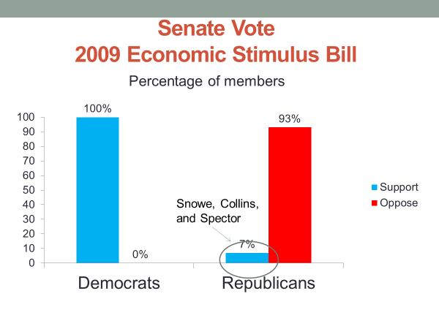
Now let's consider my second example. The bill that didn't make it through Congress.
The legislation at issue is the 2013 Federal Budget.
The federal budget is the nation's spending bill and is renewed each year by Congress.
In 2013, the Budget Bill produced a showdown between the parties.
The membership of Congress had changed from what it was when the stimulus bill passed. Although Democrats still controlled the Senate, Republicans had a majority in the House. House Republicans declared that they would not pass a budget bill unless it defunded the Health Care Reform Act, commonly known as Obamacare.
The Democratic-controlled Senate refused to go along, saying Obamacare had been enacted into law, and needed to be funded along with other federal programs. Declaring that it was their way or no way, House Republicans stood firm in their demand.
"We're 100% united," said Republican representative John Culbertson, of Texas.
When the deadline for renewing the federal budget came on September 30, there was no budget bill.
In that situation, the federal government is required to shut down non-essential services such as the National Parks, and to withhold some federal payments, such as Veterans' benefits. The government shutdown went on for 16 days at an estimated cost to the economy of upwards of $20 billion.
As the shutdown continued, Senate Republicans began pressuring House Republicans to relent, pointing to opinion polls showing that most Americans disapproved of the shut down and were largely blaming it on the Republicans.
With their party's approval rating sinking almost by the day, House Republicans finally gave in and passed a budget bill that included funding for Obamacare.
Now though it's an extreme case, the government shutdown was not radically different from what's happened with many bills in recent years.
Frequently, congressional Republicans and Democrats have been hopelessly deadlocked, and there have not been enough moderates in the middle to bridge the difference.
An indicator of this situation is the number of bills passed by Congress. As this chart shows, they have steadily declined over time.
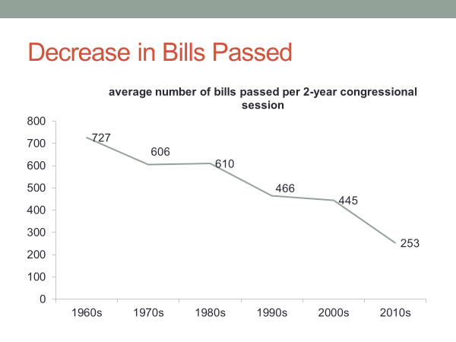
To some observers, that's a sign that Congress isn't working the way it was designed to work. Tom Mann, and Norm Orenstein, two of the nation's top congressional scholars, have labeled Congress "the broken branch."
#
Now at some point in the future, partisan gridlock in Congress will end, and the institution will operate more normally.
Let's consider how Congress works in that situation.
First off, Congress typically has difficulty taking the lead on broad issues of national policy.
The leadership on most major policies, everything from the 1964 Civil Rights Act to the 2010 Affordable Care Act, has come not from Congress, but from the president.
Now why would that be the case, given that Congress rather than the president, has the constitutional authority to make the laws?
Why is Congress not the source of most broad policy initiatives?
Here we need to consider a couple of things we've emphasized about Congress.
First, it's a bicameral legislature. No member of Congress can claim to be its leaders. The House and Senate are separate chambers, and have separate leadership. And they often disagree on the particulars of policy. And it's virtually certain the House and Senate won't see eye to eye if they're controlled by different parties, which is sometimes the case.
Second, members of Congress are free agents to a considerable degree. They can't be told how to vote on legislation. And with 100 members in one chamber, and 435 in the other, you can be sure they'll disagree, sometimes fundamentally on policy issues.
These features make it hard for Congress as a whole to lead on broad policy initiatives. Unless majorities in both chambers agree on a precise course of action, Congress is not in a position to lead.
The presidency is better suited to such leadership. Executive power is constitutionally vested in a single individual, the president. Unlike congressional leaders, who must negotiate with other members to develop a position on a bill, the president can personally choose a course of action.
President George W Bush put it plainly when he declared, "I am the decider."
Now presidential leadership does not mean that Congress will accept what the president proposes. It may reject a proposal outright, particularly if the president is from the opposite party.
On the other hand, when a presidential proposal is somewhat close to what a congressional majority finds acceptable, it serves as a starting point for legislative negotiations.
Congress might modify the president's proposal, but it at least serves to get the legislative process under way.
Now I'm not saying that Congress never takes the lead on broad issues of national policy. Congress had the initiative for example, in creating the 1996 Welfare Reform Act, which overhauled the nation's Public Assistance Policy. But such examples are the exception. Ordinarily, Congress struggles when it tries to lead on broad policy issues.
On the other hand, as political scientist, James Sundquist noted, "Congress is superbly organized to deal with narrow problems." Such problems are handled through Congress's committee system. This system enables Congress to tackle scores of smaller bills simultaneously, because they're distributed among its various committees. As the Agricultural Committee is working on bills related to farm policy, the Armed Services Committee can be working on those affecting the military, while the Financial Committee is tackling those dealing with banking.
In fact, it's hard to imagine a legislative body that's better designed than Congress to work across a range of narrow issues simultaneously.
"Little legislatures," is how Woodrow Wilson, who was a political scientist before he became president, described Congress's committees.
Each committee has authority to call hearings on bills, to modify bills, and to recommend them for passage to the full chamber. Committees are the place where most of the work in Congress gets done.
#
Let's wrap up the session by reviewing what we've said.
We noted that Congress is organized on the basis of political party.
That the top leaders, such as the Speaker of the House, and the Senate Majority Leader are chosen by the chamber's majority party, which also picks the chairs, and has most of the seats on the standing committees.
We noted also that party is the connecting glue in Congress. Members of the same party typically have more in common with each other than with members of the other party, which can enable them to work together to advance the party's legislative agenda.
That's been particularly true in recent years, as a result of the fact that the large majority of congressional Republicans are conservatives. And the large majority of congressional Democrats are liberals.
In fact, as we discussed, there's now little overlap in the ideologies of congressional Republicans and Democrats.
The party divide has been wide enough that Congress is often deadlocked. Republicans unflinchingly on one side of the issue, and Democrats unbendingly on the other side.
Finally, we discussed how Congress's fragmentation, its two chambers, and free agent members make it difficult for Congress to take the lead on broad national policy issues.
That role in modern times, has typically been played by the president.
At the same time, Congress's extensive committee system, though contributing to its fragmentation, makes Congress ideally suited to deal with many narrower issues simultaneously.

