Transcript: Judiciary & Supreme Court Lecture

[ON LOCATION, U.S. SUPREME COURT BUILDING]
THOMAS PATTERSON: If you were to walk up these stairs into that building, through a long hallway, you'd come to the courtroom where the Supreme Court justices, dressed in their black robes, hear their cases.
The Constitution establishes the judiciary of which the Supreme Court is a part as a separate branch of the federal government.
Under the Constitution, it's empowered to hear all cases arising under the Constitution, under the laws of the United States, and treaties.
Alexander Hamilton called the judicial branch the weakest branch of the federal government.
He noted that Congress has the power of money.
The President has the power of the military.
And the courts have the power only of judgment, meaning that the legitimacy of the courts depends on the wisdom of their decisions.
Being the weakest branch does not mean, however, that the judiciary is a weak branch.
The Supreme Court is a very powerful institution. Some of its decisions have as much impact as a major act of Congress or an important decision of the president.
Consider, for example, the Supreme Court's decision in United in 2010. In it, it declared that corporations and unions and, by extension, independent groups, can spend unlimited amounts of money during election campaigns.
That decision has changed the way that we elect our officials. Independent groups now spend well over billion dollars in each federal election in an effort to influence the voters.
#
[STUDIO PORTION]
In this session, we'll look at the US judiciary, concentrating mostly on the Supreme Court.
We're going to take a look at the structure and operation of the federal court system.
We'll look at how the Supreme Court works, including the partisan process through which the justices are appointed.
We'll take a look at Citizens United in more depth to show how law and politics come together in the Supreme Court.
And finally, we'll examine judicial review in the context of the question, is the Supreme Court too powerful?
#
The US federal court system has three layers.
At the bottom are the federal district courts.
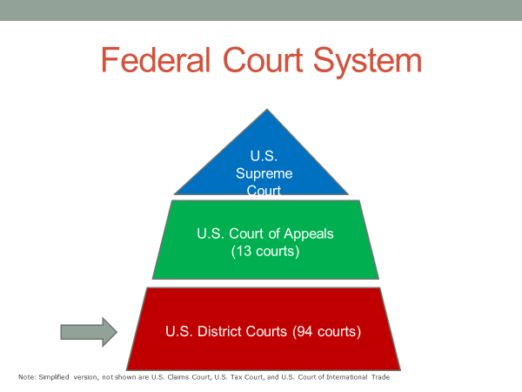
Each of them has what's called original jurisdiction, meaning it's the first court to hear a case.
Such cases take place before a judge and jury where evidence is presented, a verdict rendered. I'm sure you've witnessed that type of court, if not in person than on TV or in a movie.
There are 94 federal district courts with at least one in each state. Larger states like Texas and California have more than one district court.
Now, immediately above the district courts are the Federal Appeals courts or as they're also called, the Federal Circuit courts. These courts have appellate jurisdiction, meaning they hear appeals of cases tried previously by other courts.
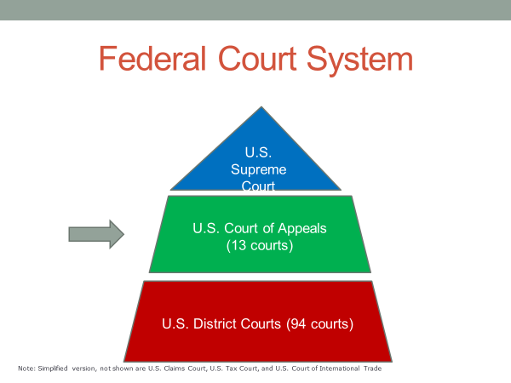
Appellate courts do not retry a case. They don't start from scratch hearing from witnesses and all the rest. Instead, they review previous decisions to see whether the law was applied correctly. If not, the previous ruling is reversed or a retrial is ordered.
There are 13 federal appeals courts, each with a separate geographical jurisdiction. For example, the Fifth Circuit Court handles appeals of federal district court cases originating in the states of Texas, Louisiana, and Mississippi.
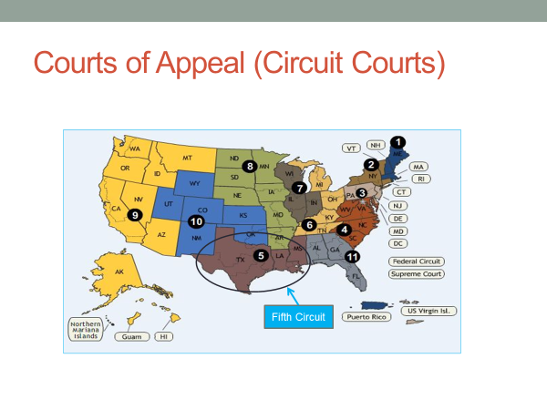
At the very top of the federal system is the Supreme Court, which operates largely as an appellate court. It confines itself almost entirely to reviewing cases previously decided by lower courts.
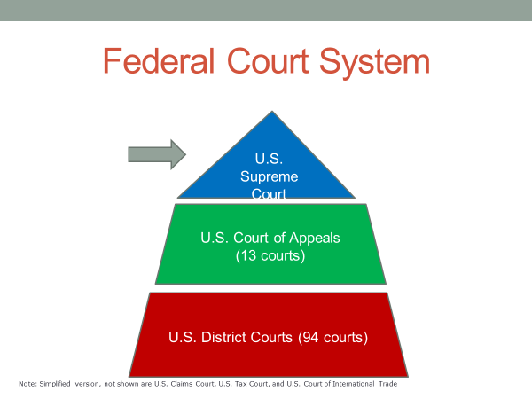
Before I say more about the Supreme Court, let me just say a few words about the state courts. Because the United States is a federal system, the states have their own laws and thus their own court systems.
Each of these state systems has trial courts at the bottom, appellate courts at the top, including a state Supreme Court.
Cases that arise under state law must be tried in state courts. In fact, most legal cases in the United States start and end in the state courts. Most crimes, such as shoplifting, and most civil cases, such as divorce, are governed by state and local law.
Upwards of 95% of legal cases settled in the United States are settled in state and local courts.
Virtually the only time that a state case is heard also in federal court is when a federal issue is involved, such as when an individual convicted in a state court alleges that police violated his or her rights under the Constitution at the time of arrest.
#
For the rest of this session, we're going to focus on the US Supreme Court, which is not only the most powerful US court, but in the view of many observers, the world's most powerful court.
Now, why might that be true? What makes the Supreme Court so powerful?
Which of the following do you think is the best explanation?
Because the justices hold lifetime terms,
because of the US system of divided and limited powers,
or because the Supreme Court has a relatively small number of justices, nine in total.
Keep your answer in mind. We're going to return to the question later in the session.
The Supreme Court has nearly full control of its docket. For the most part, it hears only the cases it chooses to hear.
Each year, about 10,000 losing parties ask the Supreme Court to hear their case.
It only accepts about 100, 1% of the requests.
A case usually gets on the Supreme Court's docket if four justices agree that it's worth taking.
When that happens, the court issues a writ of certiorari, which is a request to the lower court to submit the record of the case to the Supreme Court.
The justices almost never pick a routine case. The court's own guidelines say that there must be compelling reasons for accepting a case.
During his 2012 term, for example, the court accepted a case challenging the Health Care Reform Act passed by Congress in 2010. The court had compelling reasons for doing so. Not only did the act affect the lives of millions, but constitutional challenges in the lower courts had resulted in conflicting rulings, which the Supreme Court felt compelled to resolve.
When a case is heard by the Supreme Court, the opposing sides present their arguments, subject to questioning by the justices. After that oral hearing, the justices meet privately to discuss the case among themselves. They then vote on it and assign one of the justices to take the lead in writing what's called the majority opinion. That's the legal argument held by most or all of the justices who sided with the winning party.
Sometimes the majority, though agreeing on the decision, which party wins or loses the case, cannot agree on the legal basis for the decision. In that case, the lead opinion is called a plurality opinion. It's the view held by most of the justices on the winning side.
There are two other types of opinions.
One is a concurring opinion, which is a separate opinion written by a justice who votes with the winning side but disagrees in whole or part with its legal argument.
The other is a dissenting opinion. In it, a justice on the losing side explains the reason for disagreeing with the majority's decision.
Of these types, the majority opinion is most important because it serves as precedent, a term that refers to a ruling that guides judges decisions when faced with similar cases.
Citizens United is an example. In it, the Supreme Court held that the ban on corporate and union election spending was a violation of their First Amendment right of free speech.
This precedent led independent expenditure groups, which are not corporations or unions, but instead advocacy groups, to challenge limits on the amount they could receive from campaign contributors.
In 2010, a federal appellate court, citing Citizens United as precedent, ruled that the contribution limits violate the First Amendment.
Now, one of the key things to note about Supreme Court decisions is that they are the result of both law and politics.
As a court of law, the Supreme Court operates in the context of law, including provisions of the Constitution and congressional statutes, as well as the precedents set by earlier court rulings.
Nevertheless, the cases that reach the Supreme Court are seldom clear-cut legal disputes. If they were clear-cut, they likely would have been settled by a lower court. The Supreme Court hears the tough cases, those where each side's argument has some merit. In addition, the law is often inexact and therefore not always a precise guide to how a case should be decided.
Consider the Constitution's Commerce Clause, which gives Congress the power to regulate commerce among the several states.
What's included in the definition of commerce? The Constitution doesn't say.
What is meant by commerce among the states as opposed to commerce within the states? The Constitution is silent on that question as well.
These uncertainties create room for judgment, which is where the justices' partisan leanings can come into play.
When the justices are divided in their opinions, which has happened in about two thirds of the cases in recent decades, the best predictor of which side the justices will end up on is their partisan background, those appointed to the court by a Republican president versus those appointed by a Democratic president.
As set out in the Constitution, Supreme Court justices are nominated by the president and then seated on the court if confirmed by majority vote of the Senate. If confirmed, they basically have life tenure, as do the federal judges in the lower courts. The Constitution specifies that judicial officers shall serve during good behavior.
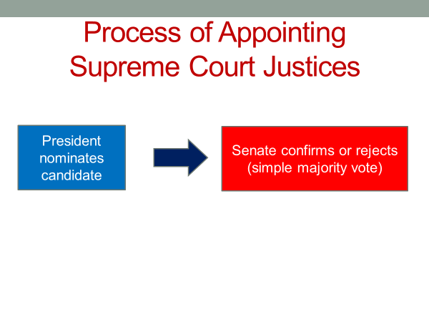
Presidents are very strategic in picking their Supreme Court nominees.
They want nominees whose views on legal disputes align with their own. They don't want to knowingly put someone on the court who will wind up voting against those goals.
This nearly always leads them to nominate a person from their own party. Not since Republican president Richard Nixon nominated Lewis Powell four decades ago has a president picked a nominee from the opposite party. And even Powell was not a typical Democrat, he was a conservative Democrat, a product of his Virginia roots.
The tendency of presidents to pick like-minded justices is not lost on those on the court who are thinking about retiring. They sometimes try to time their departure so that their replacement is someone with a similar judicial philosophy.
A case in point is Thurgood Marshall, who was appointed to the court by Democratic president Lyndon Johnson. Marshall reportedly said to an assistant when Republican Ronald Reagan was in office that "If I die when that man's president, I want you to just prop me up and keep me voting." Marshall made it through the Reagan presidency but resigned because of illness when Reagan's successor, George HW Bush, also a Republican, was president.
Marshall was the first African-American to serve on the court. And Bush appointed Clarence Thomas, the court's second black American, to replace him. Race was about the only thing the two men had in common. Marshall was one of the most liberal Justices of his era. Thomas was to become one of the most conservative justices on the court.
Supreme Court appointments have become increasingly contentious. As the divide between the political parties has widened, the court has become a battleground over policy issues.
Abortion is an example. Ever since the Supreme Court's 1973 Roe v Wade decision, which legalized abortion during their early months of pregnancy, Republicans have been seeking to reverse the decision. For their part, Democrats have been equally determined to protect a woman's right to choose.
That dispute was in the forefront during the 2018 confirmation hearings for Brett Kavanaugh, President Trump's nominee to fill the vacancy created by the retirement of Justice Anthony Kennedy.
Although a Republican nominee, Kennedy had been unwilling to overturn Roe v Wade. When Kavanaugh was questioned by Democratic senators during his confirmation hearings, he was evasive on the abortion issue. The hearings then became increasingly heated when it was alleged that Kavanaugh had engaged in sexual misconduct while in high school and college. Kavanaugh was confirmed by the narrow vote of 50 to 48, with every Republican senator and only one Democratic senator voting to confirm him.
The role of partisanship in Supreme Court appointments does not mean that blatant partisanship rules the day on the court. Justices are officers of a separate branch and they prize their judicial independence. All Republican nominees do not vote the same way, nor do all Democratic appointees. Nevertheless, a justice's partisan background is a good predictor of how he or she will behave on the court.
Consider the findings of a recent study conducted by University of Chicago Law professor, William Landis, and Federal Appellate Court judge, Richard Posner, who was appointed to the branch in the 1980s by President Reagan.
Landis and Posner examined the voting records of all Supreme Court justices, 43 in total, who've sat on the court since 1937.
For each court case, they determine whether a vote could be said to favored the liberal side or conservative side. For example, a case involving a dispute between labor and business, a vote in favor of labor would be considered a liberal vote. And a vote in favor of business would be considered a conservative vote.
Then, by looking at all the votes cast by each of the 43 justices, Landis and Posner were able to rank them from the most conservative justice to the most liberal one.
According to their data, the previously mentioned Clarence Thomas, an appointee of the first President Bush, a Republican, is the most conservative justice to sit on the court in the past 70 years or so. He's voted on the conservative side roughly 80% of the time.
In rank order, the other nine most conservative justices are William Rehnquist, appointed by President Nixon, Antonin Scalia, by Reagan, John Roberts, by the second George Bush, Samuel Alito, also by the second George Bush, William Berger, by President Nixon, Sandra Day O'Connor, by President Reagan, Lewis Powell, who I mentioned before, by Nixon, Charles Evan Whitaker, by Eisenhower, Anthony Kennedy, a Reagan appointee.
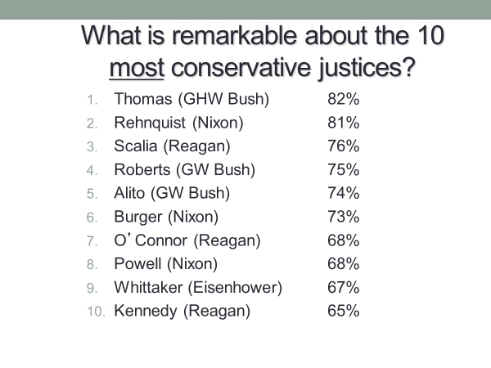
Now, what do all 10 of these justices, the most conservative ones of the past seven decades have in common? They were all appointed by a Republican president.
Did you detect anything else noteworthy about the list? You might have noticed that 5 of the 10 most conservative justices, Thomas, Scalia, Roberts, Alito, and Kennedy, are current or recent members of the court.
Some observers claim that the Supreme Court of recent years has been the most conservative court since the 1930s, a claim that the rankings would appear to support.
Now, the 10 most liberal justices, according to Posner and Landis, are not quite so uniform in their backgrounds, though some tendencies are clear.
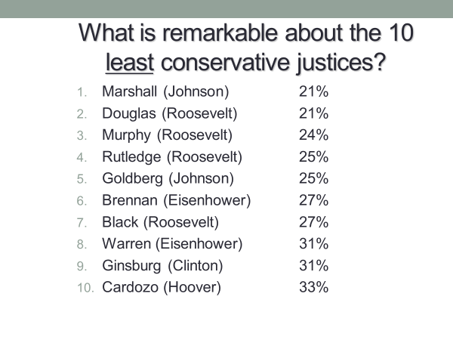
7 of the 10 are Democratic appointees, most of them nominated by either Franklin Roosevelt or Lyndon Johnson, probably the most liberal presidents of the 20th century. Only one of the justices, Ruth Bader Ginsburg, a Clinton appointee, is a recent member of the court.
Of the three non-democratic, liberal justices, two, and they are Earl Warren and William Brennan, were appointed by Republican president Dwight Eisenhower, who expected something different from them than what happened on the bench. Near the end of his presidency, Eisenhower was asked by a reporter whether he had made any mistakes as president. Eisenhower replied, "Yes, two, and they're both sitting on the Supreme Court.
Before going on, let me reinforce my earlier point that partisanship is far from the full story of the Supreme Court.
There are many cases where all or nearly all of the justices, Democratic and Republican appointees alike, see things in the same way.
In a landmark 2014 case, for example, the court unanimously concluded that the constitutional protection against illegal search and seizure barred police in most circumstances from conducting a warrant-less search of a suspect's cell phone.
Nevertheless, the nature of Supreme Court cases and ambiguities in the law allow justices' partisan leanings to seep into their decisions. The court's Citizens United ruling is a case in point. In the five to four ruling, the justices split over the issue of whether corporations and unions, as associations of people, have the same First Amendment free speech protections as single individuals when it comes to campaign spending. In an earlier ruling, the court had held that money counts as speech.
So the issue here was whether Congress had acted constitutionally in restricting, specifically, campaign spending by corporations and unions.
The Supreme Court majority ruled in their favor, saying that if the First Amendment has any force, it prohibits Congress from blocking associations of citizens from engaging in political speech.
The court's minority dissented, saying corporations and unions are not what the framers had in mind in referring to the people in the First Amendment.
So how did the court's justices divide in the Citizens United case?
Which five interpreted the First Amendment in a way that favored corporations and unions and which four interpreted it the other way?
The five in the majority were Roberts, Alito, Kennedy, Scalia, Thomas. In other words, the five most conservative members of the court, all of whom are Republican nominees.
The minority was made up of Breyer, Ginsburg, Sotomayor, and Stevens, all of whom are Democratic appointees, except for Stevens, who was appointed to the court over three decades earlier by President Gerald Ford, a moderate Republican.
In 2014, the Supreme Court decided another campaign spending case, McCutcheon v FEC, by the same five to four margin. It further loosened the limits on election spending by wealthy donors.
The five justices in the majority this time were the exact same ones that had earlier decided the Citizens United case.
The role of partisanship on these two cases would seem unmistakable. Each side interpreted the First Amendment in a way advantageous to its party.
Wealthier individuals and groups tend to back Republican candidates. And indeed, the bulk of the additional money that has come into US elections as a result of these decisions has come in on the Republican side.
The partisan implications of the Citizens United ruling were clear from the moment, the decision was announced. Republican Senate leader Mitch McConnell praised Citizens United as a victory for free speech. Democratic President Barack Obama attacked the decision in his State of the Union address, claiming it opened the floodgates for special interests.
Now, there's a final topic to discuss before we wrap up the session.
That topic is judicial review, which refers to the power of a court to decide whether another governmental institution has acted within its constitutional powers, and if not, to nullify its actions.
Judicial review is the most powerful tool available to a court. By applying it, a court is substituting its judgment for that of another institution, basically telling the other institution that its action doesn't count.
You'll recall that I asked you earlier why the Supreme Court is such a powerful court, even by comparison with the world's other high courts.
Judicial review is part of the answer, but only part. The fact is, the high court in nearly every democracy has the power of judicial review. So the question is why judicial review is more significant in the American case?
Here are the three possibilities I presented to you earlier,
because the Supreme Court justices essentially hold lifetime terms,
because of the US system of divided and limited powers,
or because the Supreme Court has a relatively small number of justices.
The second of these, the US system of divided and limited powers, is the reason.
The court's extraordinary power stems from how the US system is designed. Few democracies divide power as thoroughly as does the United States, which splits it between three branches and also between the national and state levels.
Each of these divisions is a source of disputes.
Where does the constitutional power of one institution and the other institution begin? When such disputes take legal form, the Supreme Court is positioned to decide the outcome. Ultimately, it decides how power in the American political system is to be divided.
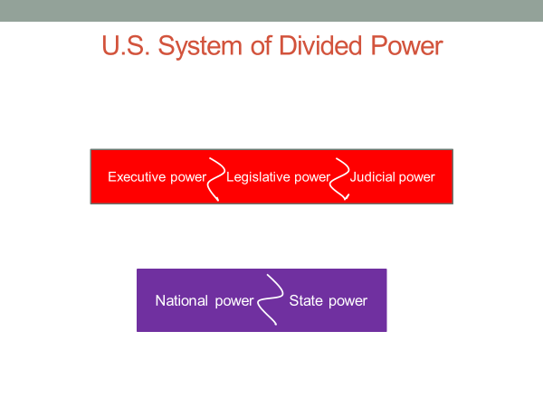

That's a powerful position to be in and one matched by few other high court's.
In addition, the US constitutional system establishes a limited government, one where individuals have a host of protections, individual rights, and guarantees against unwarranted action by government.
The result, again, is a host of constitutional disputes over the limits of government power.
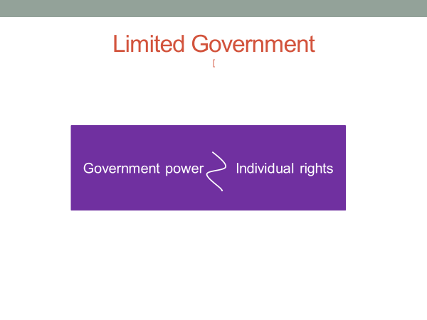
And here, again, the institution with the ultimate authority to decide the question is the Supreme Court. Few high courts are asked to resolve as many such disputes as is the US Supreme Court.
The Supreme Court's position in deciding constitutional disputes, which are abundant in the US system is at the core of its power, so, too, is the fact that its rulings tend to be final. Although Congress can initiate a constitutional amendment to override a court decision, the amending process is so imposing that only once in US history has a Supreme Court decision been directly reversed by that means.
As Charles Evan Hughes, who was Chief Justice in the 1930s, said, "We are under a constitution, but the Constitution is what the judges say it is."
The court's power has made it the frequent target of criticism, nearly always by those who object to its decisions.
In the 1930s, the objectors were liberals, angered that the court was striking down one New Deal program after the next.
In the 1960s, they were conservatives, angered that the court was expanding the rights of the accused at the expense, conservatives argued, of public safety.
More recently, liberals have been the court's most vocal critics, targeting rulings such as Citizens United, which they claim rests on twisted legal reasoning aimed at advancing a conservative political agenda.
In each of these instances, the critics have had a point. Partisanship does play a part in Supreme Court decisions. Moreover, Supreme Court justices don't have a mandate from the voters, as do the president and members of Congress.
In a political system rooted in majority rule, a system rooted in the will of the people, why should nine justices, a tiny elite with life tenure, be allowed to exercise so much power?
On the other hand, the extent of the court's power can be overstated. Yes, it yields considerable influence on the boundaries of constitutional authority. But, no, these are not America's only policy decisions, nor necessarily the most important ones.
Think about public policy, such as social security, military deployments, public education, foreign trade, food subsidies. I could go on for an hour with a list of policies that are largely beyond the reach of the Supreme Court. It doesn't come into play when they are decided.
There's also the issue of compliance with court decisions. The Supreme Court, to a large degree, depends on the cooperation of others for the implementation of its decisions.
That cooperation is not always forthcoming. Police are obliged under the court's Miranda and other rulings to strictly uphold suspect's constitutional rights. Most police do, some do not.
There's also the fact that the US political system is not solely rooted in the principle of majority rule. It's also founded on the principle of individual rights.
No other institution has taken the protection of those rights as seriously as has the court. When in 1989 it upheld the burning of the American flag as a form of free speech, it stood alone, opposed by Congress, the president, public opinion.
So the issue of the court's place in our governing system and whether it has too much power is not an easy one, nor a one-sided one.
But the question of the court's power is impossible to avoid when thinking about how the United States is best governed. It's a question worthy of your attention.
#
OK, let's wrap up this session by summarizing what's been said.
We began by describing the federal court system. At the bottom, are the district courts, which are trial courts. Above them, are the US courts of appeals, which are appellate courts, meaning that they review cases previously decided in a lower court. And at the top of the system is the US Supreme Court, which functions largely as an appellate court and has nearly complete authority to choose the cases it will hear.
We noted that because the United States is a federal system, each state has its own courts which decide cases arising under state law. A case that originates in a state court can only be appealed to a federal court if a federal law is at issue, such as a defendant's claim that police violated his or her constitutional rights.
In discussing the Supreme Court, we noted that its rulings are a product of both law and politics. Supreme Court justices have a duty to base their decisions on law. Yet, most of the cases that come before the Supreme Court pose difficult legal issues. And here, the political backgrounds of the justices affect their decisions. Republican and Democratic appointees tend to interpret the law in different ways.
We concluded the session by talking about judicial review, the power of courts to strike down legislative and executive action on constitutional grounds, and the reasons why the Supreme Court is an uncommonly powerful court.
We pointed out that the US Constitution, its separation of powers between the executive and legislative branches and between the federal and state governments, as well as its guarantees of individual rights, generates endless legal disputes over the limits of governmental power. As the final arbiter of these disputes, the Supreme Court is positioned to determine the meaning of the law.

