Transcript: Federal Bureaucracy Lecture

[ON LOCATION, IRS BUILDING, WASHINGTON, DC]
THOMAS PATTERSON: In this world, nothing could be said to be certain except death and taxes. Those words were spoken by Benjamin Franklin, one of the writers of the Constitution.
I'm standing outside the headquarters of the government agency that represents taxes. It's the headquarters of the Internal Revenue Service.
Americans tend to blame the IRS for just about everything, from the complicated tax forms they have to fill out to the amount of money they owe on tax day. A recent poll found that the IRS is the most hated of the federal agencies. It received twice as many hates as the next closest agency.
The IRS is part of the federal bureaucracy. It's one of several hundred federal agencies. Each of those agencies is created by the Congress and funded by it.
And that's the rub from the perspective of a federal agency. They get criticized for the programs they run, but they're created by Congress.
For example, on your tax form, all the tax brackets, all of the tax credits, all of the tax deductions, all the tax exclusions, those are set by the Congress of the United States. And it's up to the IRS to figure out how to work those into a code so that Americans can file their taxes.
That's not to say that the IRS or other federal agencies are flawless. The IRS, for example, has been criticized for putting too much effort into going after those who haven't paid taxes than assisting those who need help.
Nevertheless, the US federal bureaucracy ranks fairly highly in terms of how well it performs relative to bureaucracies around the world. In his study of bureaucracies, scholar Charles Goodsell said that the United States bureaucracy is one of the best in the world, ranking high on its quality of performance, concluding that very few operate more effectively than does the US federal bureaucracy.

#
[STUDIO PORTION]
In this session, we're going to look at the structure of the federal bureaucracy. We're also going to take a look at how the bureaucracy operates and at the sources of its power in those operations. And then we're going to address an important question, the democratic challenge. Bureaucrats are unelected, and yet, they wield power. So how do you hold the bureaucracy accountable?
And we'll end up this session by looking at a case that illustrates the challenge of holding the bureaucracy accountable.
Now, even though the word bureaucracy might lead you to think of government, it refers to a particular type of organization.
As an organizational form, bureaucracy has the following characteristics-hierarchy, division of labor formal rules. Thus, a college or university is a bureaucracy. It has hierarchy, president at the top, the deans, department chairs. It has a division of labor, faculty, admissions officers, building maintenance crews. And it has formal rules. You can't take an advanced Calc course until you take the basic one. You can't stay in college unless you maintain a certain GPA.
Hierarchy, specialization, and rules, those characteristics of a bureaucracy are the things that make it possible for organizations to take on large and complex tasks. You couldn't run a large university, perhaps not even a small college, if it wasn't a bureaucracy.
You certainly couldn't have a space program without a bureaucracy. People in charge, technical experts, and rules governing safety, design, and the rest.
That's why you find bureaucracy nearly everywhere where large and complex tasks are conducted, whether in government or in a corporation like Apple or General Motors.
Yet the same things that make the bureaucratic form of organization efficient can also make it less than fully responsive. Bureaucracies operate on the basis of rules, which can be a source of rigidity and delay. Perhaps you have been to the Department of Motor Vehicles. You've just moved into a state. And you're trying to get your driver's license. You get to the head of the line, and you don't have any proof that you're a resident. You're staying with friends, so you don't have a signed lease to prove your residency. You're going to be turned away.
Now, in looking at the federal bureaucracy, we will examine both of things that it does poorly, where rigidity gets in the way of the proper functioning of the bureaucracy, and what it does well.
Before we dig in, I want to ask you a question that we'll come back to later in the session.
When there's a major problem of bureaucratic accountability, do you think it's typically the result of a bureaucratic agency acting on its own or a bureaucratic agency acting with the support of a set of powerful lawmakers and groups?
Keep your answer in mind.
Let me say a few words about the organization of the federal bureaucracy.
The federal bureaucracy is made up of several hundred agencies. One type is the cabinet or executive department.
There are 15 in all, such as the State Department, the Department of Defense, the Department of Justice.
It also includes independent agencies like NASA and the postal service. Many of these independent agencies are quite large, but they're separate from the departments because their missions, generally, are narrower. And to put them in a department might compromise their mission.
And then there are regulatory agencies, such as the Securities and Exchange Commission, which overlooks the stock and bond markets, the Environmental Protection Agency, which sees that businesses do not pollute the air and the water.
There are government corporations, such as the Federal Deposit Insurance Corporation, which ensures savers deposits. They're characterized by the fact that they charge for their services. And they have a governing board. And, in that sense, they look like a private corporation. But they do not seek to make profits.
And then, finally, there are presidential commissions. These are set up by presidents to provide advice. An example is the Simpson-Bowles commission, which President Obama set up to provide him advice on how to reduce the federal deficit by looking at how you can increase tax revenues, how you can cut government spending.
Now, it takes a lot of people to run an organization that big. There are 2 and 1/2 million full-time federal workers.
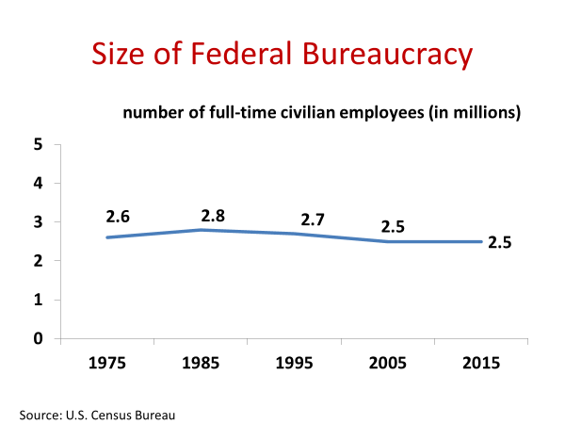And if you look over time at that figure, it hasn't changed very much in recent decades. But that's a little bit misleading because, increasingly, the government has contracted out some of its work. In Afghanistan, for example, where the United States has been since 2001, throughout most of that period, there have been more federal contractors in Afghanistan than there were American troops. And the contractors were providing such things as food services, construction, and even security.
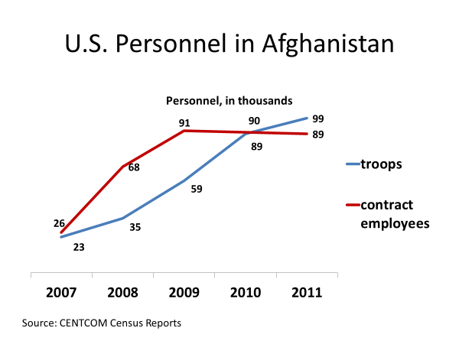
Now, most federal employees hold what are called merit positions, meaning they got their job by qualifying for it. They took a civil service exam and scored high. Or they took the Foreign Service exam and scored high. Or they had special qualifications, like the attorneys in the Justice Department, or the doctors in the Public Health Service or the National Institutes of Health.
More than 90% of federal employees are in merit positions.
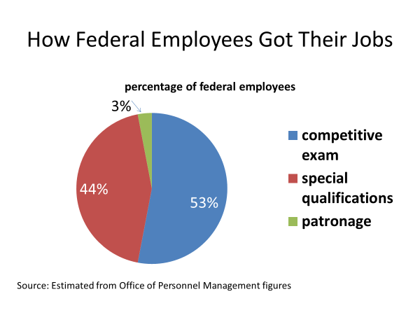
Less than 10% hold patronage appointments, meaning they're appointed politically. The heads of the executive agencies, for example, are presidential appointees. Many are skilled. They're qualified. But they were appointed, in part, because of their political loyalty to the president.
Congressional staff are another example of exempt employees. They're picked by the members of Congress. And they do not have to go through any kind of testing or qualification procedure.
Now, bureaucrats are appointed. They're not elected.
And yet, they have considerable power over policy.
Their primary role is policy implementation, which refers to the process of carrying out the decisions of Congress, the president, and the courts, as when the Department of Transportation oversees Federal Highway construction projects funded by Congress.
Policy implementation might seem straightforward.
And, sometimes, it is, as in the case of mail delivery or the sending out of monthly social security checks. But in other cases, bureaucrats have wide latitude in determining how the law will be carried out.
Think, for example, about the US Park Service. Now, it's charged with administering the national parks. Collectively, our national parks cover 80 million acres. That's an area bigger than all but four states. It's bigger than the entire state of Colorado. It's bigger than the entire state of Michigan. Now Congress has charged the Park Service with what's called a multiple use policy. It's responsible for keeping the parks for recreational purposes, but also for allowing logging, mining, and grazing. Now, there's a lot of discretion that goes with those decisions.
Who makes them? Who decides whether a swath of timber in a national park will remain wild, conserved, or whether it'll be open to a logging company, and at what price, and on what terms? Those policy choices are made by career bureaucrats.
There's another way, too, that bureaucrats do more than simply administer a policy.
They make policy by being a source of policy ideas. In today's world of complex policy problems and options, knowledge is a real source of power. To decide, you must first know.
So where is knowledge embedded in the government? Well, members of Congress are generalists. They get some expertise out of serving on committee. If you're on the agricultural committee, you'll know more about farm issues than most of your colleagues. If you're on the finance committee, you'll know more about finance issues than most of your colleagues. So they get some expertise out of their committee work. But what they're really expert at, because they have to address a wide range of issues, is politics rather than policy.
The president, too, is a generalist. Dozens of issues come across the desk of the President of the United States. The president doesn't have the luxury of concentrating on just one or two. And so the president's attention is spread across a wide range of issues.
In contrast, federal bureaucrats are specialists. Most of them spend the bulk of their career in a single agency where they come to know its programs and its policies. And many of them, like the doctors in the National Institutes of Health, for example, have expert training on top of the experience they gain in their agency.
The bureaucracy is where most of the knowledge in the federal government is embedded. And that gives bureaucrats an important voice in shaping public policy. They have expert knowledge that's invaluable in deciding how best to deal with complex policy problems.
But here's the problem-bureaucrats are deeply committed to the interests of their agency. They're biased, not in the partisan sense of being Republican or Democratic, but in the sense of commitment to their agency. They believe in the importance of what it's doing. And they're going to work to advance that interest, whether it fits or not with what the Congress, the president, and the public would like to see.
This figure, based on a study by political scientists Joel Aberbach and Bert Rockman, illustrates just how substantial the agency point of view can be. When asked about social welfare spending, bureaucrats and social welfare agencies were twice as likely as other bureaucrats to say that social welfare spending should be increased. Two-thirds of them would increase social welfare spending as compared with only a third of bureaucrats in other agencies.
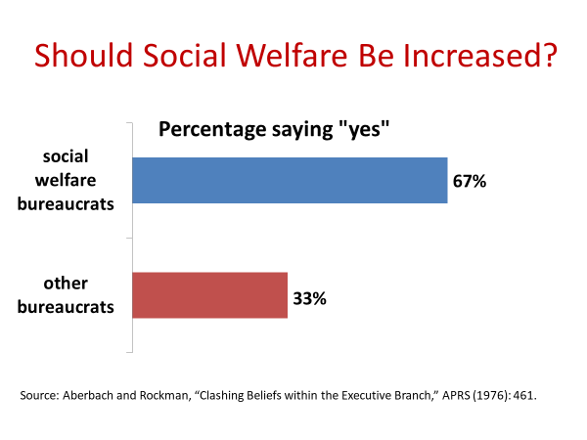
That makes bureaucratic power an issue. Bureaucrats are not elected to act in the people's name. They're not like a member of Congress, who can be held accountable at the next election. Bureaucrats hold jobs through administration after administration, through Congress after Congress, and yet, wield influence.
So how do you hold them accountable? How do you get them to act in terms of the nation's broader interests rather than their agencies narrower interests?
Well, most of that accountability occurs through the president and the Congress. The top appointee in every federal agency, for example, is a presidential appointee, such as the Secretary of State, who heads the State Department, or the director of the Central Intelligence Agency.
Presidents also exert control in other ways. For an agency to get its budget approved, or if it has a policy idea, to get it forwarded to Congress, it must be cleared by the Office of Management and Budget. You may recall that OMB is part of the Executive Office of the presidency, the president's personal bureaucracy. Actions coming out of the agency must be cleared by the OMB to make sure they're consistent with the president's objectives before they can go forward.
Now these are important checks on a bureaucracy, but they have limits.
For example, most of the presidential appointees who head the various agencies are much less knowledgeable about the agency's programs and policies than the career bureaucrats they oversee. So they have to turn to those career bureaucrats for information to understand the agency. That's a weak position for someone at the top of an organization to be in.
Congress, too, has ways of checking the bureaucracy, none more so than the fact that it controls each agency's budget. Each year, agencies have to go before Congress to defend their budget and programs. But here, again, there are limits.
Oversight of federal agencies is only one part and not by any means the largest or most important part of the job of a member of Congress. Plus, there are several hundred agencies. And they collectively spend more than $3 trillion.
There's no way in the world for Congress to oversee everything that the federal bureaucracy does. And it's a reason that congressional oversight of the budget focuses on new spending. That makes it more manageable. But what it means is that most agency funding and most agency programs don't get a close look each year.
And there's one more thing to consider here when thinking about bureaucratic power, and it further complicates this issue of bureaucratic accountability. I'll take you back to the question that I asked you earlier in the session.
When there's a major problem of bureaucratic accountability, do you think it's typically the result of a bureaucratic agency acting on its own or a result of a bureaucratic agency acting with the support of a set of powerful lawmakers and groups?
Usually, it's the second of these.
The self-interest of bureaucratic agencies, their tendency to promote their mission, does not take place in isolation. They have significant sources of support. Within government, this support usually come from members of Congress. Virtually every agency has friends in Congress. Members of the House and Senate from farm states, for example, are very protective of the Department of Agriculture. And most predictably, an agency support comes from the groups that benefit from its programs. They're like the agency, they seldom want to see a program cut back, much less terminated.
These relationships can be visualized in what political scientists call iron triangles. An Iron Triangle consists of an informal set of bureaucrats, legislators, and lobbyists who help each other for their own self-interested reasons.
The three corners of one such triangle, for example, are bureaucrats in the Defense Department, the members of Congress who are on the armed services committees, and the firms that get defense contracts.
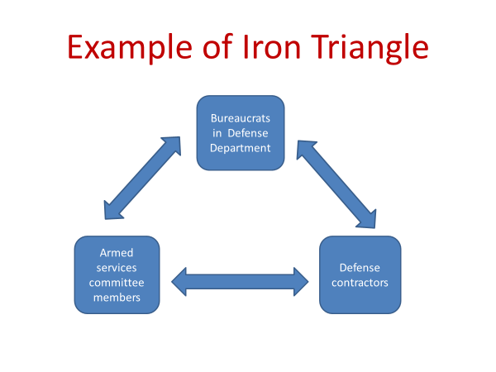
Notice that all three actors have something of value to offer each of the others. From the interest groups and members of Congress, the federal agency gets support when its budget is being renewed. In turn, the agency runs programs that can be a source of votes for the members of Congress and that provide direct benefits to the interest groups.
Let's look at a case that illustrates these connections between groups members of Congress and federal agencies.
The case is the F-22 fighter jet called the Raptor.
Now, the Raptor was authorized in 1986 while the Cold War was still underway. The estimated cost was to be $26 billion for 750 jet fighters, $55 billion in today's dollars.
The main advocate of the F-22 was the Department of the Air Force. It argued that it needed the fighter jet to stay ahead of the Soviet Union and China, even though they had nothing to compete with the Air Force's then current fighter jets, the F-15 and the F-16.
One other fact to note, the United States had not fought in air-to-air war since the Korean War, more than three decades earlier.
A decade later, by the late 1990s, cost overruns on the F-22 were such that only half as many planes could be bought with the money that had been authorized.
In addition, the Soviet Union had collapsed and with it, the prospect that it would build an advanced fighter jet that could compete with what the United States had in its arsenal.
And the Korean War was now nearly 50 years in the past. And there was nothing on the horizon to suggest that an air war was imminent.
So in 1999, the House of Representatives decided that the need for the F-22 was not strong enough and moved to kill the program.
The Air Force department pulled out all stops to save it, including getting all six members of the Joint Chiefs of Staff to testify publicly that termination of the program would jeopardize national security. And the Air Force department mobilized its supporters in the Senate to fend off the house action. Lockheed Martin, the aircraft company building the plane, also lobbied to keep the F-22. And its argument was based on more than just national security. It argued jobs. Lockheed Martin had deliberately spread around the subcontracts for building the F-22. Parts of the aircraft were being built by 1,000 firms in 48 states. All but two states had a piece of the F-22. And collectively, those contractors and subcontractors had nearly 100,000 employees. Kill the F-22, said Lockheed to the senators and representatives from those 48 states, and you'll be killing thousands of jobs that your constituents depend on. When Congress passed the federal budget in 1999, funding for the F-22 was still intact.
10 years later, the F-22 was still being funded and it was in production, but the US economy, by then, was in recession. And Secretary of Defense Robert Gates was trying to reconfigure the military to meet the needs of current warfare. He wanted aircraft that had a dual capacity, that could serve both as fighter jets and in ground support of US troops.
So Gates proposed that the F-22 program be terminated. When the air department pushed back, Gates found reasons to relieve the Secretary of the Air Force and the Air Force Chief of Staff of their jobs. They were two of the F-22's strongest advocates.
Finally, in 2009, nearly a quarter of a century after the program was started, the F-22 failed to get enough votes in Congress to keep the program alive.
But the vote was not all that one-sided. 42 senators, all from states were components of the F-22 was being built, voted to continue the funding.
The case illustrates what is often the pattern, an alliance between a federal agency, members of Congress from states and districts that benefit from the agency's programs, and interest groups that also have a stake in the program. They have a shared interest in a particular program. And all of them act to protect it.
The case illustrates the difficulty of holding agencies accountable. It's not so much that they operate on their own. It's that they have powerful allies.
Now, I don't want to leave the impression that the F-22 is the norm. It's an extreme example. I picked it because it's clear cut. Moreover, for every example of that type, there are plenty of counterexamples.
The US Postal Service, according to studies, is one of the best in the world for its on time delivery, for its cost, and for the extensive of its services. The Social Security Administration is another example of a federal agency that's extraordinarily efficient. It provides payments to more than 40 million Americans every month. And it does so with less than 1% of the cost of running the agency being spent on administration. The Medicare program is another example. It is more efficient than private health care, in part, because it doesn't seek to make a profit.
So the large point that I'm trying to make here is that the federal bureaucracy has all the strengths and all the weaknesses that are inherent in the bureaucratic form of organization. The good and the bad of bureaucracy simply go together.

#
OK, we're ready to wrap up this session.
We've looked at the structure of the federal bureaucracy, focusing on the different types of agencies that exist within it and how it's manned in terms of its personnel.
Then we've looked at the fact that bureaucrats not only administer policy, but they also make it.
And they make it because they have discretion in making many of the decisions when they're implementing policy, and also because they have specialized knowledge that's indispensable in the making of public policy.
And then, finally, we've looked at the challenge of accountability, the fact that bureaucrats despite exercising power are not elected by the public.
And most of that accountability comes through the presidency with such things as presidential appointments and oversight through the Office of Management and Budget, and through Congress in the annual budgetary process.
And yet, to get full accountability is very difficult because bureaucratic agencies have strong supporters in the Congress and among the groups that benefit from their programs. And sometimes, that combination can work against the public interest.

