Transcript: Presidents and Foreign Policy Lecture

[ON LOCATION, WHITE HOUSE]
THOMAS PATTERSON: I'm on the north side of the White House.
To your right is the famed West Wing, where the president and top presidential advisors have their offices. Many important decisions have been made in that wing of the White House.
It was there that President Lyndon Johnson decided to escalate the war in Vietnam, it would last for eight more years.
It was there that President George W. Bush made the decision to invade Afghanistan after the terrorist attacks of 9/11. And two years later, would make a decision to invade Iraq. Those wars would also last for years.
Each of those times, the president went to Congress to get formal authorization for the military action. More often, however, presidents have ordered military action on their own authority.
When the first President Bush sent troops into Panama, congressional leaders were told of the invasion only a few hours before it happened. The troops were already in the air, on their way to Panama.
More recently, when President Barack Obama ordered airstrikes on the Islamic State in Iraq, he did so on his own authority as commander-in-chief. Later, he went to Congress to ask for authorization to expand the operations in that area. But he made it clear that as president, he had the authority on his own to order the airstrikes.
That's a lot of power to put in the hands of a single individual-- the president.
#
[STUDIO PORTION]
In the previous session, we examined president's domestic policy role.
Here, we'll examine their role and foreign policy, which rests on two constitutionally assigned responsibilities.
One is that of chief diplomat, this authority derives from two modest-sounding constitutional clauses. One that says the president shall have the power to receive ambassadors, and one that gives the president the power to make treaties, subject to approval by 2/3 of the Senate.
The second responsibility is that of military chief. It's granted by a brief constitutional clause that says simply the president shall be commander-in-chief.
Now compare those three words with what the Constitution says about Congress's war-making authority. Congress has the power to declare war and make rules concerning captures on land and water. To raise and support armies. To provide and maintain a Navy. To make rules for the government and regulation of the land and Naval forces. To provide for calling forth the militia to execute the laws of the union, suppress insurrections, and repel invasions. To provide for organizing, arming, and disciplining the militia.
Now you might conclude from all that, that the writers of the Constitution intended Congress to be in charge of war-that's exactly the case.
James Madison wrote that the only case in which the executive can enter on a war undeclared by Congress is when a state of war has been initiated by another country.
But that's not been the history of America's recent wars-a point we'll discuss later in this session.
We'll start this session by explaining the information and leadership
advantages that presidents have over Congress in the making of foreign policy.
Then we'll describe the ability of presidents to act on their own in the area of foreign affairs.
Finally, we'll turn to the president's war powers.
#
In the 1960s, the noted political scientist Aaron Wildavsky claimed that though the United States has but one president, it has in effect, two presidencies--one in the realm of domestic affairs and one in the realm of foreign affairs.
Wildavsky based his claim on the tendency of Congress to defer more often to the president's initiatives when they dealt with foreign policy.
We now know that Congress’s greater support for presidents foreign policy initiatives was a product of the Cold War. The United States was facing the threat of Soviet communism. And Republican and Democratic lawmakers alike, rallied behind the president on security issues.
The Vietnam War shattered that consensus. Ever since Vietnam, presidents have had to struggle with, pretty much, the same problems--partisan opposition, strong lobbies, money limits-when proposing foreign policy to Congress as when proposing domestic policy.
Nevertheless, presidents continue to have advantages over Congress when it comes to foreign affairs.
One of these advantages is there greater control over information. As I've noted in previous sessions, information is a source of power. To decide complex issues of policy, you first have to know. You have to have access to relevant information and to experts who can make sense of it. When it comes to foreign policy, much of the policy-related information is held by the state and defense departments. And they're tied closely to the president. White House officials are briefed daily by state and defense. Members of Congress are not.
The intelligence agencies, such as the CIA and NSA, are even more closely tied to the president, who receives a daily intelligence briefing. And has access to the nation's most closely guarded secrets. Members of Congress do not. In fact, their access to intelligence reports is strictly limited.
During the debate over the invasion of Iraq, West Virginia Senator Robert Byrd repeatedly asked the Bush administration to put forth the intelligence on which it based its claim that Iraq was a terrorist threat. Byrd's request was ignored, leading him to ask whether the administration's claims were a manufactured excuse by a president who is determined to take the nation to war.
Secrecy, however, is less Congress's information problem than easy access to it in the formative stage of foreign policy. The presidency permits a level of policy planning that is beyond Congress's scope. Often when Congress is brought into a foreign policy decision, the policy has already been shaped, in large part, by the executive branch.
That doesn't stop Congress from having a role, but it can have the effect of limiting Congress's influence to adjustments in what the president has decided.
Even in areas where Congress has relatively full access to foreign affairs information, presidents have the edge because they have a leadership advantage. This advantage rests on the fact that foreign relations are based on government-to-government contacts. Someone in each government must have the authority to act on its behalf.
No member of Congress is positioned to do that. Congress is an institution where authority is divided among its members and between two chambers. Congress has no single leader that can act authoritatively on behalf of the legislative branch.
In contrast, the executive branch is unified. Executive authority is not divided. The president alone has the final authority over executive decisions. As President George W. Bush put it, "I'm the decider."
This feature of the presidency was a deliberate choice on the part of the writers of the Constitution, a choice they made with an eye toward foreign affairs.
In Federalist Number 74, Alexander Hamilton wrote that, "the exercise of power by a single hand," that of the president, is essential to the conduct of foreign policy.
Accordingly, the president has the unquestioned lead when the United States negotiates with other countries. Members of Congress can make their views known, but they do not have a seat at the bargaining table.
Take, for example, the trade agreements that presidents have negotiated in recent decades, including the North American Free Trade Agreement, or NAFTA-a trade pact between the United States, Canada, and Mexico.
Each pact was negotiated by the White House. And when it came up for a vote in the House and Senate, their members effectively had two choices-vote yes or vote no.
Now to be sure, in negotiating these pacts, presidents had to keep in mind what Congress would be willing to accept. Presidents risk defeat in Congress if they ignore its concerns. But each of these trade agreements reflected primarily, the president's priorities.
Now consider how different type of situation is from what can happen when domestic policy is at issue. Take, for instance, the 2014 Farm Bill, which provides support to America's farmers. President Obama helped shaped the bill, but the details were largely worked out by members of Congress, particularly those in the leadership and those on the House and Senate Agricultural Committees. When the 2014 Farm Bill finally emerged from Congress, it was President Obama who effectively had a yes or no decision to make. He could sign the bill or he could veto it. At one point, when the bill was working its way through Congress, Obama said he would veto it, unless it contained more money for food stamps. The amount was increased. But even so, to Obama's displeasure, the final bill included $8 billion in cuts to the food stamp program. Nevertheless, he chose to sign the bill.
Now there's a second way in which the foreign policy presidency is more powerful than the domestic policy presidency. It lies in the fact that presidents have more opportunities to act on their own when it comes to foreign affairs.
For example, although the Senate must approve any treaty that a president negotiates, presidents can make treaty-like agreements with foreign countries without Senate approval.
These arrangements are called executive agreements. Based on the president's constitutional authority as chief diplomat, they have the same force in law as treaties, with one exception. With the stroke of a pen, a subsequent president can amend an executive agreement. Treaties-- in theory, at least--are binding on future presidents unless the Senate agrees to the modification.
Because executive agreements are more easily negotiated than treaties and do not risk defeat in the Senate, presidents have increasingly preferred that option.
Since World War II, presidents have negotiated roughly 15,000 executive agreements with other nations, covering everything from trade arrangements to overseas military bases. That's more than 10 times the number of treaties to which the United States is a party.
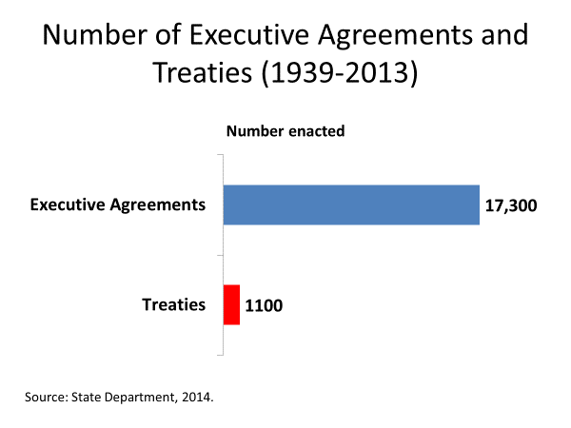
Many executive agreements are worked out in secret negotiations, and then announced by the president, denying Congress even the chance to make its views known beforehand.
Of course, executive agreements require that the other country accept what the president is seeking. In 2019, President Trump traveled to Vietnam for a summit with North Korean leader Kim Jong Un, expecting to leave with an agreement on limiting North Korea's nuclear weapons program. The two leaders were together less than 48 hours before the talks collapsed. Neither side being willing to accept what the other was offering. That's an exception, however. Normally the two sides can reach agreement. And from the American side, it becomes binding when the president signs it.
In no area, however, is the president's capacity for unilateral action clearer than in the use of military force. Since World War II, the United States has engaged in war roughly 150 times.
None-- not one-- was authorized by a congressional declaration of war.
In some cases, as with the Iraq War, the president asked Congress for supporting resolution. But even that's the exception. More than 80% of the time, presidents have taken the United States into war solely on their own authority. In some instances, Congress has been caught nearly by surprise.
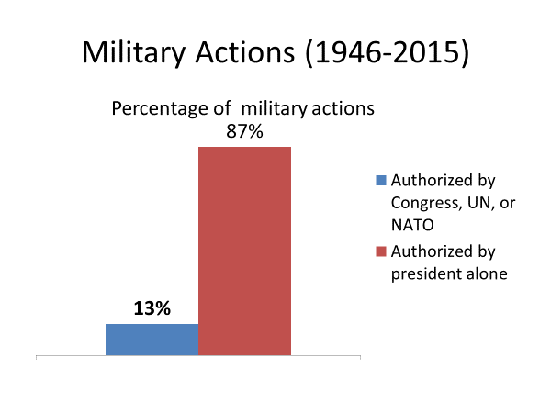
When President Reagan ordered the invasion of Grenada in 1993, he waited until after the invasion had been launched to tell congressional leaders. Speaker of the House Tip O'Neill was among the leaders told by Reagan that combat was imminent. Said O'Neill, "we weren't asked for advice, we were informed what was taking place."
Other members of Congress learned of the invasion through the media. They awoke to news that US Marines had landed in Grenada, and were engaged in heavy fighting.
Now president's ability to start a conflict does not mean that Congress has no influence over war. In the closing days of the Vietnam War-- for example--Congress barred the use of funds for any military action that would serve to intensify the conflict. Nevertheless, Congress has no truly good way to stop a president from starting hostilities. And once they begin, cannot easily withhold funding. To do so, could put the troops in the field at risk.
As well, members of Congress from the president's party usually shy from attacking the president for fear it will hurt the party.
So rather than Congress, public opinion has proven to be the chief restraint on presidential wars. When the public gets fed up with the war, presidents cannot easily persist.
More than anything else, it was the loss of public support that led to American withdrawals from Vietnam, Iraq, and Afghanistan.
Public opinion can also limit president's options. In the decade or so after Vietnam, it was clear that Americans would not support another large war in which the nation's security was not directly threatened. The public's disillusionment with the Afghan and Iraq Wars is a similar constraint at the moment. While Americans are willing to accept the use of air power in the Middle East, they are leery of backing another major US ground war in the region.
On the other hand, presidents have some capacity to convince the public of the need for war.
A case in point is President George W. Bush's efforts more than a decade ago, to gain support in Congress, as well as with the public, for the invasion of Iraq. The first public indication that Iraq was being targeted came in Bush's 2002 State of the Union address, when he lumped Iraq with Iran and North Korea, in what he called the axis of evil. Five months later, speaking at West Point, Bush announced a new doctrine, the Preemptive War Doctrine. Bush declared, "if we wait for threats to fully materialize, we will have waited too long. Our security will require all Americans to be ready for preemptive action."
Now in that speech, Bush didn't identify Iraq as the target of a preemptive strike. But two months later, he did so. He asked Congress to authorize an attack on Iraq, if it refused to turn over its weapons of mass destruction.
To justify an American attack on Iraq, Bush claimed that Iraq had weapons of mass destruction, and was preparing to use them. Citing intelligence reports, Bush said, "the evidence indicates that Iraq is reconstituting its nuclear weapons program.
Satellite photographs reveal that Iraq is rebuilding facilities at sites that have been part of its nuclear program in the past." Bush's claim that Iraq had such weapons and was prepared to use them carried the day in Congress. His House and Senate opponents lacked evidence that could have refuted the claim. The House vote was 297 to 133 in Bush's favor, while the Senate vote was 77 to 23.
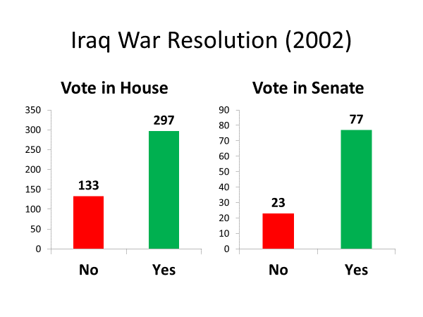
Now throughout the months that Bush was building up to an invasion of Iraq, news outlets were hanging on every word coming out of the White House, allowing it to control the message.
A study of the pre-invasion news coverage found that Bush administration sources were quoted roughly 10 times as often as the war's congressional critics.
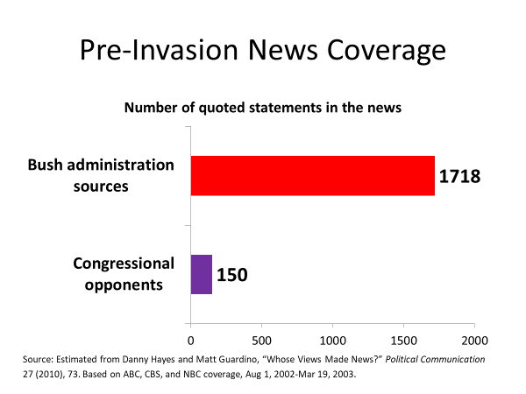
Gradually, public opinion fell into line with the president's message. When Bush first indicated the possibility of an invasion, opinion polls indicated that less than half the public thought it was a good idea. But by the time of the invasion in March of 2003, public opinion had swung in Bush's favor. 72% in a Gallup poll expressed approval of the invasion, with four out of every five of them saying they strongly approved of it.
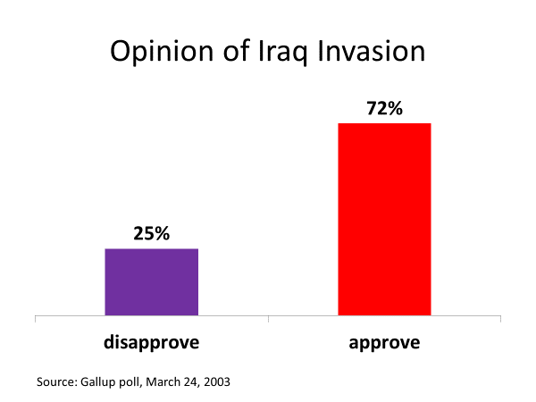
As it turned out, the Bush administration's claim that Iraq had weapons of mass destruction was faulty. Although US weapons inspectors searched high and low in Iraq for such weapons, they found none of consequence.
Critics accuse the administration of fabricating the case for war.
Supporters of the administration said it had been misled by bad intelligence.
But one thing is clear, Iraq was a presidential war, conceived and carried out by the President of the United States.
Now let's step back from that case to think about the historical changes that have shifted control over war to the president.
As I indicated earlier, the writers of the Constitution wanted Congress to control the decision to go to war. So why the miscalculation? Why did the framers get it wrong?
Which of these do you think is the most important reason?
Congress's reluctance to exercise his constitutional authority over war.
President's refusal to obey Supreme Court decisions aimed at limiting their war power.
Or changes in the world that have tipped the balance in war decisions away from Congress and toward the president.
It's the last one.
The security demands of the modern world favorite presidential action over congressional action. During the nation's first century and a half, transportation and communication were slow. As a result, it took time for threats to the nation's security to develop. And it took time for the nation to gear up for a military response. That gave Congress, a slow-acting institution, a major voice in war decisions.
But we live today in a world where threats can materialize overnight from almost anywhere on the globe. And where the United States has the military power to respond quickly to protect its interests. These developments have shifted power to the president because the president can act swiftly and decisively.
One can debate whether presidents have sometimes been too quick to act, but their capacity for swift action is beyond debate. That point was reluctantly conceded by Senator William Fulbright, a leading congressional critic of the Vietnam War. Said Fulbright, "it has been circumstance which has given the executive its great predominance. An entire air of crisis in which urgent decisions have been required again and again, decisions of a kind that Congress is ill-equipped to make. The president has the means at his disposal for prompt action, the Congress does not."
#
OK, let's wrap up what's been covered in this session.
We pointed out that president's authority in the realm of foreign affairs rests on constitutional clauses that establish the president as the nation's chief diplomat and as commander-in-chief of the Armed Forces.
We then noted that though presidents can have difficulty getting foreign policy initiatives through Congress, they have substantial control over the content of such initiatives because of their greater access to the relevant policy information.
We also noted president's leadership advantage in foreign affairs. The fact that presidents, because they have sole executive authority, are positioned to take the lead in dealings with foreign government.
Finally, we pointed out that presidents have more opportunities to act on their own authority in the realm of foreign affairs than in the area of domestic policy. In making this point, we cited as examples the power to initiate war and the power to negotiate executive agreements.

