Transcript: Presidents and Domestic Policy Lecture

[ON LOCATION, WHITE HOUSE]
THOMAS E. PATTERSON: The White House has been the residence of every president since the second, John Adams. But though it's today the center of national attention, that hasn't always been the case.
During most of the 19th century, the country was far more interested in what was happening in Congress on Capitol Hill than what was happening here at the White House.
But we live today in a presidential age, so much so that many Americans think that the president is in charge of National Affairs.
That's a perception that the political scientist Hugh Hecle calls "the illusion of presidential government."
Now, to be sure, the presidency today is far more powerful than it was in the 19th century. Government is much larger, and the president oversees a large number of executive agencies. As well, the United States is a major player on the world stage. That brings the presidency to the forefront.
Yet the reality is, the presidency operates in a system of divided powers.
The presidency is one branch of the national government. The president can propose legislation but unless Congress goes along, there is no law. That's the reality of the American system.
Theodore Roosevelt, one of the great 20th century presidents, said it best. "I wish, if only for a day, to be Congress as well as the president.” Then, said Roosevelt, "I'd truly be in charge of the national government."
#
[STUDIO PORTION]
In this session, the first of two on the presidency, we'll examine the president's domestic policy role. In the other session, the president's foreign policy role will be the focus.
This session has three goals.
First, to identify the president's domestic powers as provided by the Constitution, second, to describe how the president's domestic policy role has expanded over time and how features of the presidential office have contributed to that expansion, and finally, to explain the conditions affecting president's ability to achieve their domestic policy goals.
Now, most of this discussion will focus on president's legislative initiatives. Such initiatives are a defining feature of the modern presidency. In some ways, the defining feature.
As a top assistant of President Richard Nixon said, "legislating is perceived as governing," with the result that presidents' capacity for leadership is usually judged by their legislative success.
Legislative initiatives are also a key to a president's legacy. Historical recognition has gone to those that have left behind a substantial legislative record.
#
Article 2 of the Constitution lists the powers of the president.
This article is strikingly different in its wording than Article 1, which provides for the powers of Congress.
Article 1 is quite specific, providing a precise listing of congressional powers--from the power to print money to the power to establish the postal service.
In contrast, Article 2 is somewhat vague. It uses broad terms to grant the president four different powers, two of which are especially relevant to the president's domestic policy role.
One of these is executive authority, which puts the president in charge of executing the laws passed by Congress. The 2013 Disaster Relief Act, for example, provided assistance to victims of Hurricane Sandy. Responsibility for executing the law, seeing to it, among other things, that the assistance reached the intended recipients, fell to the executive branch, overseen by the president.
The second constitutional power relevant to the president's domestic policy role is a say in legislative matters, including the power to veto acts of Congress and to propose legislative initiatives.
Now, on paper, these grants of power are relatively modest, and early presidents saw them that way.
James Buchanan, who served as president just before the Civil War, said, "my duty is to execute the laws and not my individual opinions."
As the possibility of a civil war increased, Buchanan responded passively, saying it was the duty of Congress to try to prevent it.
As for the presidency's legislative power, even George Washington had a limited notion of its scope. During his eight years in office, he proposed only three laws and vetoed only two.
Modern presidents have a starkly different conception of their office. They routinely put forth legislative proposals and use the veto as a tactical device. The king of the veto was Franklin Roosevelt who exercised it 635 times during his 12 years in office.
No president since then has come close to that number, but the presidents that have followed Roosevelt have averaged more than 60 vetoes while in office.
The evolution of the presidency from a more passive to a more active office is due to several developments, including growth in the size of government. As the US evolved from a rural society to an urban, industrialized, and increasingly interconnected one, the executive branch grew exponentially in response to increased public demands. The federal bureaucracy now has 2 and a half million employees spread across hundreds of agencies-everything from the FBI to the National Park Service. As the chief executive, the president oversees their activities.
Presidents no longer have the luxury of sitting back passively. The executive branch needs to be actively managed so that its programs operate effectively.
Assisting the president in that effort is the Executive Office of the President.
It was created in 1939 and includes hundreds of budget and management specialists who assist the president in carrying out the executive function.
The EOP, as the Executive Office of the President is called, also includes hundreds of policy experts, including economists, scientists, national security analysts.
They, and the even larger number of experts in the executive agencies, give the president an edge over Congress when it comes to developing policy initiatives. Even policy issues that seem relatively straightforward usually have layers of complexity.
As a result, expertise has become a crucial part of modern policymaking, and the president has access to it in abundance. Members of Congress don't have this advantage. Their staffs are relatively small and not organized to tackle complex policy proposals.
It’s a reason that most major policy initiatives are now authored by the White House rather than Congress, even when the idea originates with a member of Congress, which happens frequently.
An example is the Peace Corps created in 1961. Ever since its founding, the Peace Corps has been a signature policy of President John F. Kennedy, even though it was proposed three years earlier by Minnesota senator Hubert Humphrey.
Now, the president has two additional advantages that have tipped major policy initiatives toward the White House. One is the fact that the president is the country's only truly national elected official.
The president is chosen by the country as a whole, whereas members of Congress are elected from individual states and individual districts. As a result, Americans look to the president, rather than Congress, for national leadership.
For example, when the economy recently suffered its steepest downturn since the 1930s Great Depression, Americans looked to President Obama, not to Congress, for a policy response. The result was a $787 billion stimulus bill, aimed at protecting and creating jobs. The public's expectation of presidential leadership gives the president a unique ability to shape the nation's agenda.
Theodore Roosevelt famously described the presidential office as "a bully pulpit." No member of Congress has anything like it.
The final advantage enjoyed by the president stems from the difference between power held by one and power shared by many. Congress has 535 members, none of whom commands or even speaks for the institution as a whole. Even the Speaker of the House, under the best of circumstances, can claim leadership of only half the Congress-the House, but not the Senate.
In contrast, the Constitution vests executive authority solely in the president. In a meeting with his seven-member cabinet, President Lincoln asked for their views on a policy he was thinking about. One by one they voted no, saying it was a bad idea. Said Lincoln, "seven nays and one aye. The ayes have it."
Lincoln and all other presidents have profited from a choice made at the Constitutional Convention in 1787.
There, the delegates debated the possibility of dividing executive authority, but in the end, they gave it entirely to one individual, the president, concluding that to do otherwise would rob the executive of its ability to act decisively.
The unitary nature of presidential authority permits a degree of policy planning and coordination that Congress can rarely achieve.
Once the president decides on a particular policy, the effort in the White House shifts to figuring out the best way forward. Congress often struggles to get to that starting point. Differing policy views among its members can doom a possible initiative from the start. No one in Congress has the authority to dictate a course of action.
Congress has recognized this limit since at least the presidency of Dwight Eisenhower. When he took office in 1953 and didn't immediately put forth initiatives, a House committee chair told him, "that's not the way we do things here. You draft the bills, and we work them over."
That's not to say that Congress hasn't occasionally taken the policy lead. A case in point is the 1996 Welfare Reform Act. Crafted by congressional Republicans, it overhauled the nation's welfare system.
But it's the exception, not the rule. Major initiatives typically emanate from the White House. It's simply better positioned than Congress to develop and promote them.
Now, the president's edge in initiating major proposals does not guarantee that they will be enacted into law.
Congress has the lawmaking authority under the Constitution and countless presidential proposals--most of them, in fact-have been ignored or voted down.
In that respect, America's system of divided government differs from a parliamentary government, which is the type of system most democracies have. In a parliamentary system, there is no separation of power between the executive and legislative branches. The prime minister, who is chosen by a majority in parliament, is both the chief executive and the chief legislator.
When a prime minister forges a major policy, it's nearly assured of getting passed when it comes up for a vote in parliament. Not so for presidents who had a separate branch of government and must persuade Congress to act on their initiatives.
So what best explains whether presidents succeed with Congress? All of the following make a difference.
Which would you rank as most important--
whether the president has just won an election by a wide margin,
whether the president is highly popular with the American public,
whether the president's party has a congressional majority,
or whether the lobbying groups that support the president's proposals are more powerful than those opposing them?
Let's take a look at recent presidencies for an answer.
First, presidents have usually done better with Congress in their first year or two in office than later. At the start, they're fresh off an election victory, and Congress is more inclined to look to them for leadership. Later on, presidents will have lost support in and outside Congress as a result of having to make tough policy decisions. Said a top aide to President Gerald Ford, "each decision is bound to hurt someone. It will satisfy one group but anger three others."
Even more important to presidential success is whether circumstances dictate strong government action. In such situations, Congress and the American people look to the president for leadership.
Presidents with strong records of achievement typically have served during critical times-major wars, sharp economic downturns, periods of social unrest.
No better example exists than Franklin D. Roosevelt, who held the presidency during the Great Depression and during World War II. His policy legacy is nearly unmatched.
Most presidents, however, do not preside during such times, and their opportunities for achievement are fewer. Even great presidents have felt hemmed in by history. Said Abraham Lincoln, "I claim not to have controlled events, but confess plainly that events controlled me."
There is another factor that affects presidential achievement, and it's the most important.
In the final analysis, nothing matters to presidential success than whether Congress is controlled by the president's party. If one or both houses of Congress are controlled by the other party, presidents struggle to enact their initiatives.
President Ronald Reagan is an example. Reagan is widely seen as having been a strong president, and by some standards, he certainly was. Reagan's foreign policies, for example, contributed to the collapse of the Soviet Union. On the other hand, Reagan, for eight years, faced a Congress where the Democrats controlled at least one chamber. Only 18 of his policy initiatives were enacted into law, the second lowest number among post-World War II presidents.
The lowest was Gerald Ford's. In his case, both chambers of Congress were held by the opposite party.
President Obama discovered the importance of Congress's partisan makeup. In 2009 and 2010, his first two years in office, Obama had the backing of a Democratic controlled Congress and a high percentage of his initiatives were enacted. In 2011, control of the House of Representatives shifted to the Republicans, and Obama's success rate plummeted.
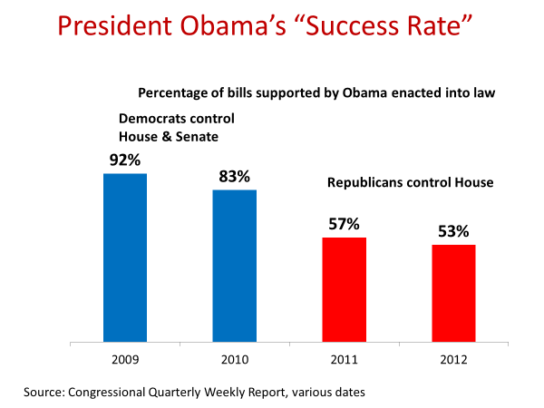
President George W. Bush suffered a similar fate after Democrats took control of the House and Senate in 2007. In the last two years of his presidency, the period of Democratic Congressional control, his success rate was roughly half that of the previous four years, a time when Republicans were in control of Congress.
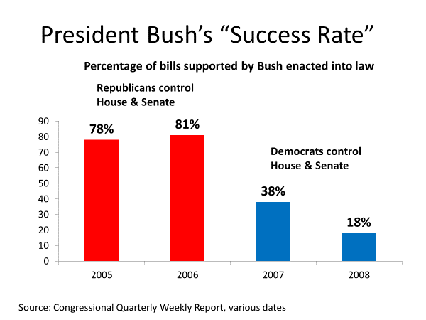
That's been the pattern of recent presidencies. When their party has controlled both houses of Congress, presidents' success rate has been roughly 80%.
When the opposing party has controlled one or both houses, the average has dropped to less than 60%.
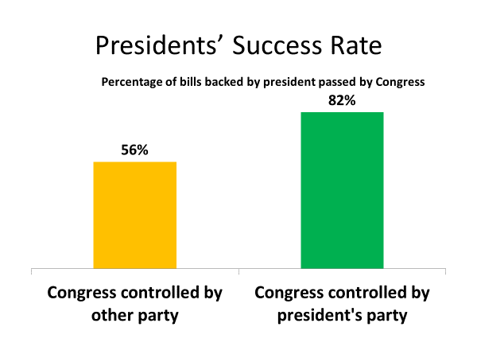
Party is what binds elected officials and also what separates them from those of the other party. If presidents have the good fortune of a Congress controlled by their party, success comes more easily. If not, they tend to struggle.
The historian Arthur Schlesinger, who served in the Kennedy
administration, put it plainly--"in the end," he said, "the arithmetic is decisive."
#
So what are the president's options in the face of a Congress controlled by the other party?
Well, they can resort to executive orders, which are based on their constitutional power as chief executive. Such orders have the force of law. But unlike laws, they don't have a permanence. They can be rescinded by the next president.
When he took office in 2017, Donald Trump overturned several of Barack Obama's executive orders, including one that had halted construction of the Keystone Project, a pipeline for carrying oil from Canada to the Gulf Coast.
Executive orders are also limited by what existing law allows. An example is President Obama's 2014 directive that required federal contractors to pay their workers a minimum of $10 an hour. Obama had tried to persuade Congress to raise the national minimum wage for all workers but Congress rejected it. That limited Obama's options. Having the power to execute the law, presidents can direct how the law will be executed, as long as they do not violate any of the provisions of that law. In Obama's case, there was no legislative provision that mandated a specific minimum wage for federal contracts.
So Obama, as president, was able to exercise his executive power in ordering firms with such contracts to pay their contract workers not less than $10 an hour. On the other hand, Obama lacked the constitutional power to unilaterally increase the minimum wage for other American workers. He couldn't direct Walmart, Apple, or other private firms to raise their workers' pay. Such an increase would have required an act of Congress. It alone has lawmaking authority.
In short, without congressional backing, presidents do not have nearly as much power over policy as the illusion of presidential government suggests.
President Harry Truman expressed the president's dilemma as well as any president. Said Truman, "the people can never understand why the president does not use his supposedly great power to make Congress behave." Truman then said he could kiss or kick its members, but he couldn't force them to say yes.
Before we wrap up, let's take a look at two presidential initiatives-the Food Stamp Act, passed under President Lyndon Johnson in 1964, and the Welfare Reform Act, enacted under President Clinton in 1996. They will help clarify the importance of Congress in presidential success.
The Food Stamp Act was part of Johnson's war on poverty, his desire to use federal power to assist the economically needy.
But unlike some of Johnson's other initiatives, such as Medicare, which provides health care to Social Security retirees, food stamps had neither broad public support nor the backing of powerful lobbies.
Indeed, Johnson's proposal was opposed by most business interests and even by leading agricultural lobbies, who feared that linking food with welfare would undermine public support for their farm subsidies.
What the Food Stamps Bill had was the backing of a determined president, Lyndon Johnson, who had the good fortune to be in office when his party had huge congressional majorities, more than 3/5 of those in the Senate and nearly 3/5 in the House.
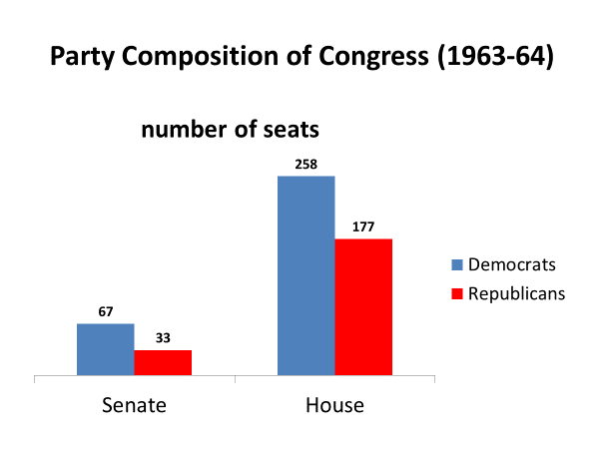
Johnson had arithmetic on his side. Among House Democrats, for example, 226 voted for the Food Stamps Bill and 26 voted against it. House Republicans were overwhelmingly opposed. Only 13 backed the bill, whereas 163 of them opposed it. But even if no Republican had backed the bill, it still would have passed the House. The 226 House Democrats that voted for it constituted a House Majority.
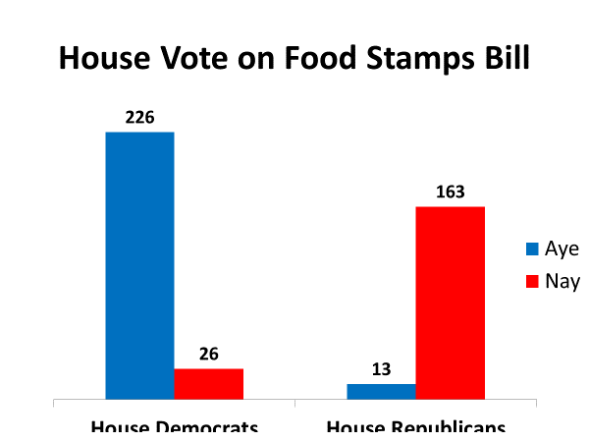
Such was the magnitude of the Democrats' House advantage, they had votes to spare.
Now, let's look at the 1996 Welfare Reform Act, also signed into law by a Democratic president, Bill Clinton. But this time, with a Congress under Republican control.
When he ran successfully for the presidency in 1992, Clinton promised to end welfare as we know it.
Members of Congress from both parties shared his view that the existing welfare system, which gave people government assistance without demanding anything of them in return, was broken. It had the perverse effect of giving people an incentive to go on welfare and stay there.
Nevertheless, Clinton was unable, during his first two years as president, a period when his fellow Democrats controlled Congress, to get them to agree on a fix. When Republicans gained control of Congress in 1995, they immediately set out to write a Welfare Reform Bill. When it was unveiled, its provisions troubled many Democrats who feared it would put too many children and young mothers at risk. After five years on welfare, they could lose their assistance.
Now, Clinton shared their concern but was in a weak political position. He was running for re-election, and his unfulfilled promise to fix the welfare system was a vulnerability.
Polls showed that the public wanted the system changed. An ABC/Washington Post poll the year earlier indicated that 3/4 of Americans believed the welfare system gave people an incentive to avoid work.
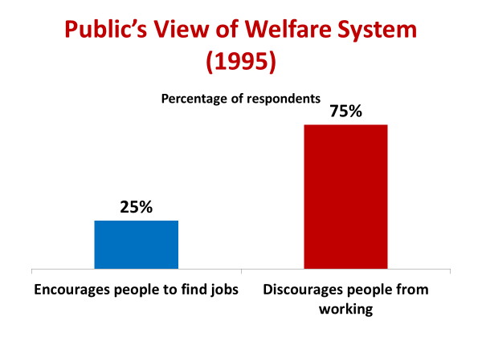
Clinton vetoed the first Welfare Bill passed by congressional Republicans, demanding changes, particularly greater protection of children as a condition of signing it.
He also vetoed their second bill, insisting on more changes. Republicans came up with a few additional modifications, including adding more money for child care for poor working mothers.
When Republicans then passed a third welfare bill and made it clear there would be no more concessions, Clinton was on the spot. Despite criticism from the liberal wing of his party, he signed the Republican bill, vowing that he would work to fix its shortcomings later on.
Clinton had run out of leverage. Unlike President Johnson three decades earlier, his party did not have the numbers in Congress to give him bargaining power, and he didn't have the option of taking his case to the American people. On this issue, they sided with Republican lawmakers.
During his presidency, Clinton was asked about his policy accomplishments, with the questioner implying that they were relatively modest. Clinton replied that he had no choice but to play the hand that history had dealt. Clinton did not hold office when his party had a huge congressional majority or when the nation faced a domestic or foreign crisis, things that would have empowered his presidency. History had dealt Clinton a weak hand.
#
OK. Let's wrap up this session.
I began by pointing out the two constitutional powers--executive authority and a hand in the legislative process-that are particularly relevant to the president's domestic policy role.
We then looked at some of the advantages that presidents have relative to Congress in the development of major legislative initiatives. Presidents have greater access to the expertise and information that modern policy making requires.
Presidents benefit from the public expectation that they, and not Congress, will take the lead on national policy issues.
And presidents have unitary authority, the power on their own to decide a course of action, whereas authority in Congress is divided.
The president's ability to initiate legislation is only the first step, however. The second is to get Congress to agree.
The main factor in securing congressional support is whether Congress is controlled by the president's party. When that's the case, presidents are far more likely to get their proposals passed than when Congress is controlled by the other party.
In the face of congressional resistance, presidents can turn to executive orders, but they're a limited tool, far inferior to new legislation as a means of achieving policy goals.
The importance of Congress to presidential success exposes the illusion of presidential government. The reality is that the president operates in a system of divided powers and at least in terms of domestic legislation, needs Congress's backing.
As political scientist Charles Jones noted, "the plain fact is that the United States does not have a presidential system. It has a separated system."

