Transcript: Welfare & Income Policy Lecture

[ON LOCATION, BOSTON WATERFRONT]
THOMAS PATTERSON: Economic class has not been as big a part of American politics as it has been in Europe. Labor unions have always been weaker here. Only about one in eight American workers belong to a union.
That's true even in the construction business behind me. The European average is twice that.
Europe also has a tradition of working class parties, like the Labour Party in Britain or the Social Democratic party in Germany.
The United States does not have and has never had a major Labor or Social Democratic party.
A reason is the cultural differences between the United States and Europe. Class awareness is much stronger in Europe, which has lent support for labor unions and working-class parties. The United States culture emphasizes individualism, the person making it on his or her own. That's made it harder to get collective action around the workplace.
The fact that economic issues are less important than the United States does not mean, however, that they're insignificant. During the 1930s Great Depression, economic policy was on everybody's mind. The minimum wage, collective bargaining-- those came out of the Great Depression of the 1930s.
Today, economic issues are back to the forefront.
The economic downturn that began in 2008 cost many Americans their savings and their jobs, and there's not a full recovery yet.
Additionally, for the average American worker, wages have been pretty stagnant for the last couple of decades, while at the top, incomes are growing, creating an income gap that's increasingly a political issue.
Generational differences are also playing into the economic issue. Some analysts believe that this generation of young adults will be financially less well-off than their parents.
These developments have made economic issues an increasingly important part of American politics.
#
[STUDIO PORTION]
In this session, we'll look at economic class through the lens of government policy.
Class refers to people who share the same economic status. Some people are well off and are collectively referred to as the upper class, or the wealthy. Others make enough money to have a comfortable lifestyle, though not one free of financial worry. They're typically referred to as the middle class. Then there are those who can make ends meet, but it's a close call, the so-called working class. Finally, there is the lower class, or the poor, those that struggle to keep food on the table and a roof over their heads.
For most people, financial well-being is chiefly a question of employment-what type of job they hold, how secure it is, and how well it pays.
But government policies also play a role in how society's financial resources are distributed.
These policies will be the focus of this session.
We'll examine the nation's social welfare policies, those that help people meet their basic needs, and its income policies, those that help people get ahead financially.
In the course of the discussion, we'll address several subjects explored in previous sessions, including the nation's political culture, its political structure, and its party and group systems.
#
Now, poverty is a large and persistent problem in the United States.
Although the US has less poverty than many countries, it has more poverty than comparable ones. Its poverty level, for example, is twice that of France and Germany. It's also significantly higher than that of Great Britain and also that of our northern neighbor, Canada.
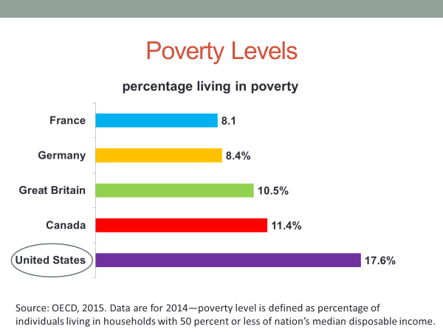
The US government uses the cost of living as the basis for dividing the poverty line, which is the level of income below which a family is defined as poor and thereby eligible for certain forms of public assistance.
The government sets the threshold for poverty as the annual cost of a thrifty food budget multiplied by three to cover the cost of housing, clothing, and other necessities.
By this indicator, as you can see in the chart, it's not a lot of money.
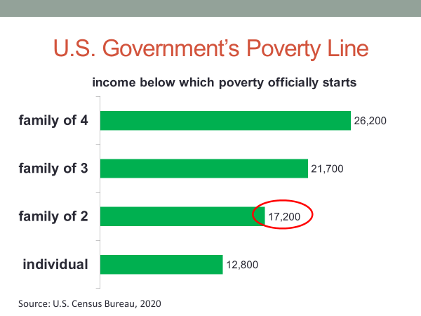
For a family of two, it works out to roughly the same amount of money that many college students pay for room and board, and that's for only one person and just for food and shelter.
By the government's formula, about one in seven Americans live in poverty.That's roughly 45 million people. If they could somehow join hands and form a line, it would stretch all the way from New York City to Los Angeles and then back again. That's a lot of people.
America's poor include individuals of all ages, races, and regions, but it's concentrated among certain groups.
Minority group members have a poverty rate twice that of whites.
Women have a poverty rate exceeding that of men.
Children are one of America's most impoverished groups. Roughly one in five American children live in poverty, most of them in a single-parent family headed by the mother.
Now, until the 1930s Great Depression, state governments had responsibility for the poor. Welfare was among the policy areas deemed reserved to the states by the 10th amendment.
That doctrine changed as a result of the Depression, a period when one in four workers couldn't find a job and another one in four had only part-time work. Income fell sharply. And as it did, so did state tax revenues. Most states were too broke to help their poor.
Federal tax revenues had also declined. But unlike the states, a point we made in an earlier session, the federal government has unlimited power to print and borrow money.
During the Depression, the federal government was in the hands of officials--President Franklin Roosevelt and a Democratic congressional majority-that had no qualms about using the federal government's spending power to help the poor.
Most Depression-era poverty programs were meant to be temporary, such as the Works Projects Administration, which put millions of Americans to work constructing roads, public hospitals, and the like.
But a few programs were designed to last, including Aid for Dependent Children program, which was later renamed the Aid for Families with Dependent Children program, or AFDC.
It provided financial assistance to poor single mothers, those who had little or no income by reason of the father's death or desertion.
The second wave of anti-poverty programs came in the 1960s when the federal government was, again, in the hands of a president, Lyndon Johnson, and a Democratic Congress determined to help the poor.
They enacted the largest set of anti-poverty programs in the nation's history, including the food stamps program, subsidized housing, and Medicaid, which is government-paid health insurance for those of low income.
These programs had public support. A Gallup poll at the time found that 2/3 of Americans believe that government has a responsibility to try to do away with poverty in this country.
The programs also had an element of bipartisan support. Republican lawmakers from New England and the upper Midwest states of Minnesota and Wisconsin, the strongholds of the party's progressive tradition, strongly backed the new programs.
In the House vote on the Medicaid bill, for example, 90% of progressive-state Republicans supported it.
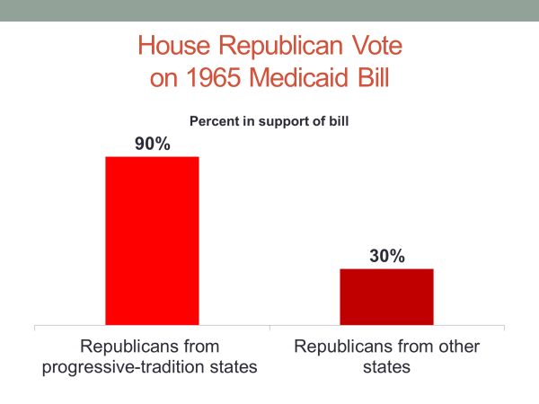
That period was the high watermark of the government's anti-poverty efforts. Since then, there have been only a few new programs, including the 2010 Affordable Care Act, which among its provisions, expands Medicaid eligibility and provides subsidized health insurance to lower-income families.
There have also been cutbacks-- most notably, the 1996 Welfare Reform Act, which reduced the welfare rolls by changing the rules.
As you will recall from an earlier session, the 1996 legislation eliminated the AFDC program, which had placed no limit on how long a family could receive benefits. In its stead, the 1996 law created the TANF program, which limits eligibility for most families to five years.
Now, programs such as food stamps and Medicaid are public assistance programs. They're labeled as such because they're funded with general tax revenues, and they're available only to the financially needy.
Public assistance programs are means tested. Recipients must prove they are poor in order to qualify for the benefit, a requirement that adds to the program's expense.
In addition to payments to recipients, there are administrative costs associated with determining whether an applicant's income falls below the designated amount. These costs account for about 10% of federal spending on food stamps and about 5% on Medicaid.
Means testing is consistent with America's culture of individualism, the belief that people should be self-reliant. That belief supports the notion that public assistance should be available only to those who can prove that they are unable to make it on their own.
The distinctiveness of the American approach can be seen by comparing the US healthcare system with many of those in Europe. In those cases, residents of all income levels are entitled to government-paid medical care. If they become ill, they simply go to a clinic or hospital for treatment at government expense, no questions asked.
In contrast, American s receive government-paid healthcare only if they meet the eligibility criteria. Even then, to be eligible, they must apply beforehand for insurance and prove that they are too poor to buy it on their own.
There's another feature of the American welfare system that's distinctive.
Consider, for example, the difference in the monthly assistance payments to poor families, depending on where they live. The payments range from less than $300 a month to $500 a month and more.
So what explains the difference?
Do you think it's because the locations differ in their cost of living or because the locations are in different states?
It's the second one.
Because of America's federal system, most public assistance programs, although funded primarily by the federal government, are administered by the states, which have a degree of control over benefits and eligibility. There is considerable variation in the amount of family assistance that states provide. Some states provide more than $500 a month, while some provide less than half as much. The average across all the states is roughly $400, but the range is wide.
Now, public assistance programs are not America's only social welfare policies.
These policies also include what are called social insurance programs. As the name implies, they are based on the insurance principle. Individuals must pay into the program in order to receive the benefits.
Social Security is the leading social insurance program. Established in the 1930s as part of Franklin Roosevelt's New Deal, it provides monthly Social Security benefits to retirees who paid Social Security tax on their income while working. The current tax rate is 6.2%. That amount is deducted on pay day from workers' wages.
Social Security is an entitlement program. This means that if an individual meets the eligibility requirement, he or she is entitled to the designated benefit. Government cannot decide one day to cancel an entitlement program or to grant the benefit to some previously eligible recipients while denying it to others.
Public assistance programs don't offer this type of protection. They are not entitlement programs. The poor do not have an unqualified claim to benefits. Government can choose at will to cancel such a program or change its eligibility criteria, as in the case of TANF, which reduced the length of time a family can receive public assistance.
Now, when Medicaid, healthcare for the poor, was enacted in 1965, Congress also enacted Medicare, which is healthcare for retirees. Unlike Medicaid, which is a public assistance program, Medicare is a social insurance program. As is the case with Social Security, it is financed by a special tax, currently 1.45% on workers' wages.
Social Security and Medicare are federal programs in their entirety. States do not administer them or have a say in eligibility or benefits. Accordingly, recipients get the same level of benefits, regardless of where they reside.
Social Security and Medicare are highly efficient programs in that they do not require a large bureaucracy to check and recheck recipients' eligibility. When workers reach the prescribed age and conditions of eligibility, they automatically qualify for the benefits. Less than 1% of Social Security spending is eaten up by administrative costs.
Medicare is more administratively complex, in that it involves payments to doctors and hospitals. Even so, according to a Kaiser Family Foundation study, only about 2% of Medicare spending is for expenses other than patient care.
In contrast, some private insurance companies, which seek to make a profit and heavily market their products, spend up to 20%, 10 times the amount for Medicare, on non-patient care.
Now, Social Security and Medicare are not poverty programs in the literal sense. Recipients come from all income groups. In fact, the higher one's income while working, the larger the Social Security payment upon retirement. Such individuals pay more in Social Security taxes during their working years and accordingly, get a larger benefit when they retire.
The average monthly benefit is about $1,200, but some recipients get less than $1,00, whereas others get more than $2,500.
As it happens, families in the top fifth by income receive more in Social Security and Medicare benefits than the poor receive in total on food stamps, housing, and dependent care.
Nevertheless, Social Security helps to keep millions of Americans out of poverty. About 1/4 of America's elderly have no significant monthly income, aside from what they receive from Social Security.
Public assistance and social insurance programs differ as you might expect in their level of public support. Polls indicate that most Americans are convinced that Social Security, a social insurance program, is worth the cost. Only a small percentage think that too much is spent on Social Security.
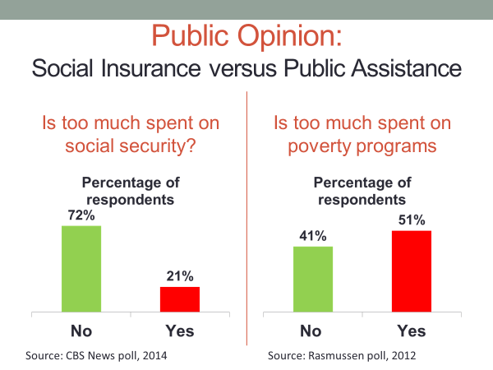
Americans have a much less favorable view of public assistance programs. A large number of Americans think that government spends too much on these programs.
The difference reflects America's cultural values. Social insurance programs are funded by a special payroll taxes on workers and, in that sense, are widely seen as something that recipients have earned.
In contrast, public assistance programs are widely seen as handouts-needed by some but abused by others who are too lazy to get a job.
A recent Pew Research Center poll found, for example, that roughly half the public think the poor have easy lives because they get government benefits they don't work for.
This view makes public assistance programs a political target. They've been caught up in the heightened party polarization we discussed in earlier sessions. In the Pew survey I just mentioned, Republicans were more than twice as likely as Democrats to say that the poor have easy lives. More than 60% of Republicans held that belief, compared with less than 30% of Democrats.
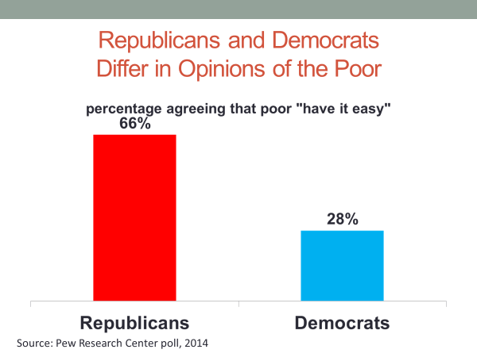
The partisan gap is at least as wide among lawmakers. In 2014, for instance, congressional Republicans sought a $40 billion reduction in the food stamp program, settling for an $8 billion cut after a threatened veto by Democratic President Barack Obama.
Social Security, on the other hand, has withstood partisan challenges.
In 2005, President George W. Bush proposed to partially privatize Social Security. Workers would have had the chance of putting a portion of their Social Security tax payments into a personal retirement account.
Bush was forced to back down in the face of strong resistance from senior citizens, spearheaded by the AARP, a seniors’ group that's one of Washington's most powerful lobbies.
On the other hand, poverty lobbies, groups to petition Congress on behalf of the poor, are relatively weak.
As you can see in this chart, spending on Social Security has risen dramatically in recent years, while spending on TANF assistance to poor families has declined. Public assistance programs like TANF are vulnerable to cultural and partisan forces to a degree that social insurance programs are not.
Let me provide a final example of how cultural values affect poverty policy.
Poll after poll over the past 50 years has found that Americans, consistent with their cultural beliefs, see jobs, rather than public assistance, as the answer to poverty.
Not surprisingly, that principle is the basis for some federal poverty programs. The work requirement of the TANF program is one example.
Another is EITC, which is shorthand for the earned income tax credit. The EITC was created in 1975 when Republican Gerald Ford was in the White House and Democrats controlled Congress.
The EITC provides a refundable tax credit to low-income workers. If your job pays low wages, below about $15,000 a year if you're single, you get the credit, with the amount varying by family size and earnings. The average recipient gets a refund of about $2,500, which is obtained when filing one's annual tax return.
EITC is a reward for working, a program that's in line with America's cultural values.
#
Now let's shift the focus to income policy, government policies that affect people's livelihoods.
Until the 1930s Great Depression, the federal government openly sided with business in its dealings with workers. Efforts to organize unions and improve working conditions were repeatedly blunted by government policy.
That changed in the 1930s.
Congressional Democrats had their largest majority in a century and enacted pro-labor legislation that included the minimum wage law and collective bargaining rights. Congress also made the personal income tax more progressive, meaning that the tax rate was increased for higher incomes. The top rate was set at a high level, 79% on income above $5 million.
Corporate executives claimed that such policies would ruin the nation's economy. But between 1950 and 1970, the economy grew at an unprecedented rate.
With that, workers' incomes rose at a record pace, spawning an ever-larger middle class. This economic boom was fueled, in part, by the strength of America's manufacturing sector. The United States was far and away the world's leading manufacturer. The US had emerged from World War II with its factories intact, whereas those in other major industrial nations had been damaged by the war.
It was a boon for America's factory workers. The best-paying factory jobs were those held by union workers. Armed with collective bargaining rights, they were able to secure high wages, and in some cases, health insurance. Union jobs propelled millions of families into the middle class.
At peak in the 1950s, a third of America's workers were unionized. And depending on occupation, they had incomes 10% to 30% higher than their non-union counterparts.
The minimum wage was also a contributing factor, particularly for unskilled workers. It put a floor on their income and had the added effect of pushing up the hourly pay of others.
Equally dramatic was the impact of the GI Bill, which Congress had enacted near the end of World War II. It gave military veterans cash payments for college and vocational training and provided nearly interest-free loans for home purchases and small business ventures.
Before the GI Bill, college and homeownership were out of reach for most families. By the time the original GI Bill expired in the mid '50s, nearly 8 million veterans had participated in its education benefits, 2 and 1/2 million had acquired a home loan, and hundreds of thousands had received small business and farm loans. The impact was felt from Wall Street to Main Street.
However, the upward momentum did not last. Since 1970, as this chart shows, most Americans have seen almost no growth in real income, which is income adjusted for inflation.
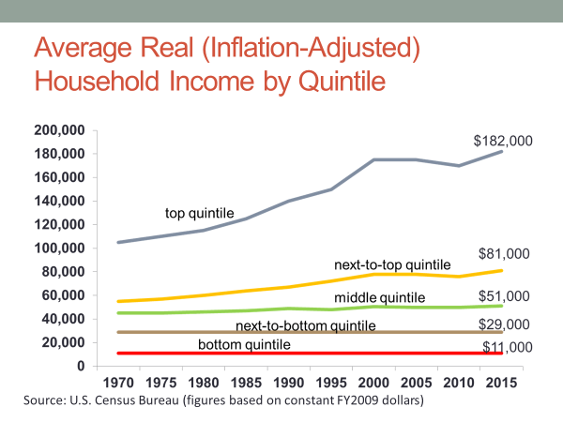
As you can see, the bottom quintile, next-to-the-bottom quintile, and middle quintile of wage earners are no better off today than they were back in 1970, nearly a half a century ago. In other words, the wages of the bottom 60% of workers have been flat year after year. In terms of real income, their pay has stagnated.
In contrast, as you can also see from the chart, the top two quintiles have enjoyed wage growth. For the next-to-top quintile, income in real dollars has gone from about $60,000 on average in 1970 to roughly $80,000 today.
The top quintile has done even better. Their income has risen over four decades from about $100,000 a year on average to roughly $180,000 a year today.
But the biggest winners have been those at the very top, as this chart indicates. Since 1970, the percentage of all national income received by the top 1% of earners has jumped from roughly 10% to roughly 20%. In other words, their real income has doubled, such that the top 1% now gets roughly one in five of all dollars earned by American workers. The median yearly income for this group exceeds $600,000. The mean exceeds $1 million.
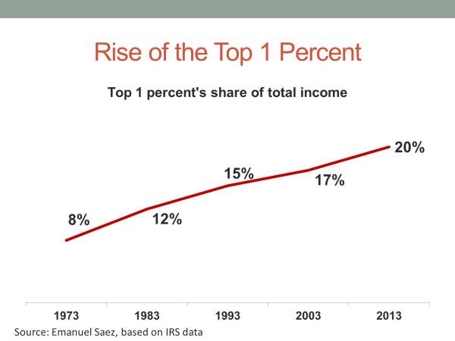
The top 1% are now positioned where they were at the end of the 1920s, the so-called roaring '20s. After the 1920s, the era when the minimum wage collective bargaining and a steeply progressive income tax were in full force, the top 1% saw their share of income decline substantially. But in the past four decades, they've climbed back to that earlier point.
What explains this development?
Why has the income of most Americans stagnated, while that of top earners has shot up resulting in a high level of income inequality? Commentators regularly link the two, as if income gains at the top are the main reason for income stagnation at the bottom.
But in fact, the two developments are only loosely related.
The explanation for why top earners have done so well owes substantially to changes in public policy. In contrast, the explanation for wage stagnation owes chiefly to changes in the structure of the nation's economy.
Let's look at both of these explanations, starting with the role of public policy in fueling income growth at the top.
You'll recall from our previous session the discussion of the supply-side fiscal policies of Ronald Reagan and George W. Bush. The assumption underlying these policies is that reduction in taxes on business and high-income taxpayers will stimulate economic growth.
However, the direct effect of these supply-side policies was a cut in taxes for high earners. The bottom quintile, the poorest fifth, benefited hardly at all from the Bush tax cuts. They received less than 1% of the total tax savings. The middle quintile, the middle 20% of Americans, got about 8%. The winners were those in the top fifth. That group got nearly 3/4, 73% of the tax savings. Within the top 20%, the big winners were the top 1%. They got nearly 1/3 of the total tax savings.
In terms of dollar amounts, as the figure show, the bottom fifth, on average, paid $93 less in taxes in 2005, as a result of the Bush tax cuts. On the other hand, if you were in the top fifth, your savings were more than 60 times greater. The average was just over $6,000. But even that paled alongside the tax savings for those in the top 1%. The average savings for that group in 2005 alone was more than $54,000.
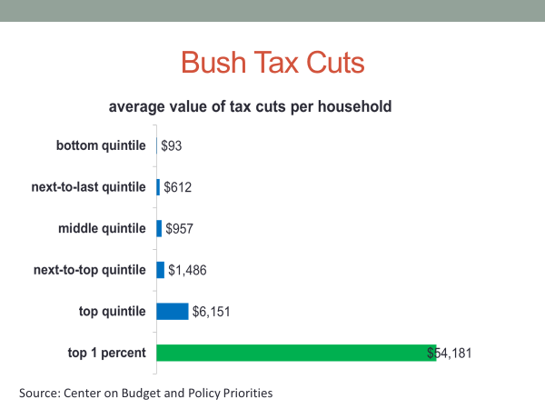
Other public policies have also contributed to the income gap. Reductions in capital gains taxes have overwhelmingly favored the wealthy. They own the large share of stocks, the gains from which are taxed at a much lower rate than the tax on wages.
Financial deregulation and trade agreements, which we'll look at in later sessions, have also disproportionately worked to the benefit of high earners.
I could provide other examples too, but the point would be the same.
America's wealthy have benefited substantially from the public policies of recent decades.
Now, changes in policy do not fully explain income gains at the top. Global economic change has also worked in favor of those with upper incomes not only in the United States, but elsewhere as well. However, America's top 1% has fared much better than the top 1% in comparable countries where government policy has not tilted so heavily in favor of upper incomes.
The wealthy's income gains in the United States have not, however, at least in a direct way, come at the expense of lower-wage earners. The Bush tax cuts for the wealthy were not achieved by increasing the tax burden on others.
As this figure indicates, all income categories realized a tax savings from the Bush tax cuts during the nine-year period from 2004 to 2012 that they were in full effect.
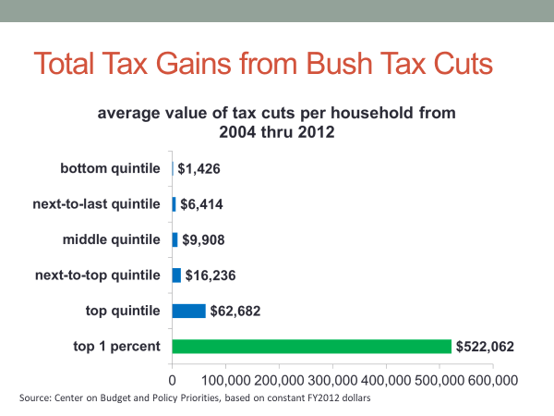
But what stands out most clearly in the figure is the distribution of the tax cuts. For those in the bottom 20%, the total gain over the nine years was less than $1,500. For middle-income households, the savings was roughly $10,000. On the other hand, the top 1%, on average, save more than $500,000 on their taxes during those nine years.
So who paid for the tax cuts?
The cuts were financed through borrowing, which means the cost was shifted to future generations.
The Congressional Budget Office estimates that the Bush tax cuts added about $1.6 trillion to the national debt, not including interest on the borrowing. The sharp increase in wealth among the richest Americans has made tax policy a top issue.
The public as a whole thinks that upper-income individuals pay too few taxes, but there is a large difference of opinion between Democrats and Republicans on the issue. A large majority of Democrats think upper-income individuals pay too few taxes, while most Republicans think otherwise.
The difference is even more pronounced among lawmakers. Congressional Democrats have repeatedly pressed for increased taxes on the wealthy, opposed at each step by Republican lawmakers.
Democrats have framed their argument in terms of fairness, while Republicans have framed their argument in terms of economic growth.
Neither side has shown any willingness to compromise. In 2011, for example, a congressional deadlock over taxing and spending nearly led the US, for the first time in its history, to default on its debt obligations.
#
Now let's turn to the problem of stagnant wages.
As I indicated, the story here is mostly one of changes in the US economy.
The manufacturing-sector economy that America had after World War II, with its well-paying factory jobs, has given way to a service-sector economy.
Until 1970, the United States, as we'll discuss at length in a later session, was a net exporter. Manufacturing goods made in America were being sold around the world.
Since then, the United States has been a net importer, buying more goods from abroad than it's selling abroad. Millions of well-paying factory jobs have been lost in the process. That loss has been accompanied by a sharp decline in union membership. Today, only about one in eight workers is a union member, and most of them work not in the private sector, but in the public sector, such as teachers, police, and civil servants. Less than 10% of private sector workers today are unionized.
The economist Lawrence Mishel has estimated that as much as 1/3 of the wage erosion among some categories of workers owes to the decline of private sector union membership.
Since the 1970s, job growth has been in the service sector, areas such as banking, rental services, healthcare, entertainment, fast food, housekeeping.
Service-sector employees are difficult for unions to organize because they work closely with managers and often in small offices.
Now, some service sector workers do fairly well financially. Those working for large businesses have salaries, on average, that are even slightly higher than those working at manufacturing jobs.
But there's a wide range of service-sector workers-such as waiters, store clerks, hotel staff, artists, lower-level administrators, taxi drivers-that take home substantially less pay than their factory counterparts.
It's also the case that service-sector jobs generate less economic activity than do factory jobs. Jobs generate jobs. That's a basic axiom of economics. Those who work at restaurants, for example, support jobs for workers in firms that supply food and drink to restaurants. Over the course of a year, the average service-sector worker generates nearly $100,000 in related economic activity.
Now, that might seem like a lot, but it's substantially less than the average for manufacturing jobs. That figure is closer to $300,000. Consider auto workers-- when new cars leave the factory, they generate lots of economic activity. They support car dealerships, gas stations, repair shops, auto parts makers, auto supply stores, and more. Factory jobs have a much larger job multiplier than do service jobs.
America's transition from a manufacturing economy to a service-sector economy is due mostly to economic factors. The US-dominated global market that existed after World War II has given way to a highly competitive global market, where US firms must compete with those of Japan, Germany, Korea, China, and other countries, some of which have the comparative advantage of paying lower wages.
Where public policy fits into the story of wage stagnation is largely a story of what government has not done.
The erosion in the value of the federal minimum wage is an example. Today, adjusted for inflation, the minimum wage is about 25% below its peak value in the late 1960s. Congress establishes the minimum wage level, and lawmakers have not increased it enough to keep up with inflation.
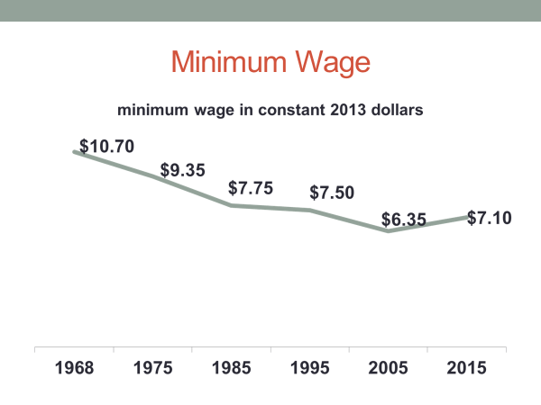
Government has also shied from initiatives that could boost employment and wages. In the 1930s through 1960s, government was active in job creation on a large scale. It launched a wide range of infrastructure projects, everything from the Tennessee Valley Authority to the interstate highway system. The latter, initiated in 1956 at the urging of Republican President Dwight D. Eisenhower, resulted in the construction of 41,000 miles of multi-lane highway, which generated hundreds of thousands of construction and construction-related jobs, not to mention the jobs created by the thousands of roadside businesses that sprung up alongside the interstate.
Is there such a role for government today? There is, at least in the view of the American Society of Civil Engineers. In 2013, it conducted a massive study of the condition of America's infrastructure-- its highways, dams, schools, and other public facilities. Using a standard A to F grading scale, the society gave the United States an overall grade point average of D+, concluding that $3.6 trillion in infrastructure spending is needed by 2020.
How likely is that the government will take on the task of repairing the nation's infrastructure? I'd put the odds at near zero, given the policy deadlock that has seized Washington in recent years.
#
OK, let's wrap up the session. We've looked at two policy areas, social welfare and income policy.
We noted that poverty is a large and persistent problem in the United States, affecting about one in seven Americans.
The federal government has a range of policies aimed at alleviating poverty, including food stamps, Medicaid, and assistance to families with dependent children.
These are public assistance programs that are means tested, available only to those that can prove they need them, a process consistent with America's culture of self-reliance.
Social welfare policy also includes social insurance programs, such as Social Security. Recipients qualify for the benefits such programs offer by paying special taxes on their wages when working. This feature has given them a level of public and political support higher than that of public assistance programs.
We then turn to income policy, starting with policies such as the minimum wage, collective bargaining, and the GI Bill that contributed to the sharp growth in personal income at all levels after World War II.
We then noted the flattening of income since 1970s for most Americans, the development accompanied by a sharp rise in income at the top of the income ladder, trends that have resulted in a huge income gap between the wealthy and the rest of American society.
We explained that these two developments, more wealth at the top and stagnation elsewhere, owe to largely different factors.
Public policies in recent decades, including tax policy, have contributed significantly to wealth accumulation at the top of the income ladder.
On the other hand, wage stagnation is explained mostly by changes in the American economy and particularly by the transition from a manufacturing-based economy to a service-based economy.

