Transcript: Regulatory Policy Lecture

[ON LOCATION, BOSTON HARBOR]
THOMAS E. PATTERSON: I'm at Boston Harbor, which was once so heavily polluted, it wasn't fit even for the fishes.
That made the harbor an issue of the 1988 presidential campaign. The Republican nominee, George H. W. Bush, accused the Democratic nominee, Massachusetts governor Michael Dukakis, of ignoring the harbor.
Bush called it the worst policy mistake in the history of New England. It cost $4 billion to clean up the harbor.
Like so many of America's waterways, the Boston Harbor was treated as an open sewer by local businesses. They dumped the byproducts of their production into the water, including toxic waste.
Today, as a result of federal, state, and local regulatory action, the Boston Harbor is fit for the fishes, and also for swimmers and boaters.
The goal of regulatory action is to prevent the harmful effects of business practices.
Regulation is widespread. The foods that you eat, the drugs you take, the car that you drive and its safety features, all of those things and more are subject to regulatory action.
No one today would argue that we should go back to the era of anything goes. The Boston Harbor is a reminder of that.
But at the same time, the question of how far regulation should extend is an open question.
Regulation imposes costs on business, and they get passed along to consumers.
And that makes regulatory policy a political issue.

#
[STUDIO PORTION]
This session looks at the politics and policies of regulatory action, focusing on some of the harmful business practices it addresses.
We'll look at restraint of trade, which refers to anti-competitive business practices;
inequity, which refers to unfair business transactions;
moral hazard, which occurs when one party engages in risky economic behavior but then passes the risk onto another party;
and negative externalities, which result when firms fail to pay the full costs of their production activity.
Now, although regulatory decisions have the appearance of being based solely on economic considerations, they often have a partisan element.
The heads of regulatory agencies are nominated by the president and confirmed by the Senate, and the appointees typically share the president's policy priorities. Republican appointees, consistent with their party's ideology, are normally more pro-business than our democratic appointees.
A case in point is Scott Pruitt, who was picked by Donald Trump to head the Environmental Protection Agency and immediately began to weaken some of the standards governing air and water pollution, saying they placed an unreasonable burden on business.
#
A central concept of economic theory is efficiency.
Efficiency refers to the relationship between economic output, what's produced, and economic input, what goes into producing those goods and services.
A high level of efficiency is preferable to a low level. It means that society is getting more goods and services out of the same amount of production resources.
Now, our free market promotes efficiency through competition. To compete with other sellers, a firm will try to use as few resources as possible when producing its products in order to keep the price low.
Less efficient firms will be forced to become more efficient to cut their production costs in order to remain competitive on pricing.
But what happens when competition weakens or dries up?
What happens when a producer acquires a monopoly or near-monopoly on a product?
Well, in that case, they can sell the product at whatever price the market will bear. It doesn't have to worry about efficiency. It has a lock on the market.
That situation is known as restraint of trade and is a basis for regulatory action. The most famous of such actions was the breakup in the early 1900s of Standard Oil, owned by John D. Rockefeller, the world's richest man. Standard Oil, at one point, controlled 90% of US oil production, allowing it to set prices.
In 1911, the Supreme Court, citing the Sherman Antitrust Act of 1890, ordered the breakup of Standard Oil into 33 smaller companies as a means of fostering competition in the oil industry.
Today, the primary responsibility for maintaining competitiveness rests with the Federal Trade Commission.
In recent years, for example, the FTC has blocked several proposed hospital mergers on grounds they would deprive local patients of a choice among hospitals, resulting in higher charges for hospital care. That same logic led the FTC in 2016 to block a proposed merger between Staples and Office Depot. The FTC concluded that the merger would create a monopoly in the office supply business in many communities.
Equity considerations are another justification for regulatory action.
An economic transaction is ordinarily considered equitable if each party enters into it freely and ethically. For example, if a seller knows that a product is defective, equity requires that the buyer also know of the defect. Sellers do not always behave ethically. They may try to hide a product's defect from potential buyers.
A recent example is automobile airbags. Their manufacturer, Takata Corporation, discovered nearly a decade ago that its airbags had a defect that could kill or injure a passenger when the bag inflated. Takata chose not to mention the defect when filing its periodic reports with the National Highway Transportation Agency, the federal agency charged with regulating car safety. When the NHTSA finally became aware of the defect, it used its regulatory authority in 2014 to issue a recall, starting in states with high levels of humidity where the risk of death or injury from the defective airbags is highest.
Now, when Congress establishes a regulatory agency, such as the NHTSA, it charges it with protecting the public. That's the agency's mandate. The NHTSA, in ordering the airbag recall, was fulfilling its mandate.
However, regulatory agencies do not always vigorously pursue their public responsibility. They sometimes side with the industry they're supposed to regulate, a situation that scholars describe as agency capture.
Agency capture can result from the fact that regulators work closely with the firms they regulate and rely on them for much of the information that goes into their decisions.
An example of agency capture is the Food and Drug Administration's handling of Vioxx, a pain relief drug for people with arthritis and other forms of chronic or acute pain. The drug's manufacturer, Merck Pharmaceuticals, spent hundreds of millions of dollars developing Vioxx. And when preliminary tests showed the drug effective at reducing pain, Merck convinced the FDA to clear it for market even though the testing had not been totally thorough.
When Vioxx hit the market in 1999, it was an instant success. It attracted tens of millions of users and generated $2 and 1/2 billion a year in sales for Merck.
The problem was that Vioxx was unsafe. Users suffered an abnormally large number of heart attacks and strokes. And five years after its introduction, Vioxx was pulled from the market. Merck eventually paid more than $5 billion in legal claims to Vioxx's victims and their families.
A review panel of the US Institute of Medicine concluded that the FDA's testing process had been slanted in Merck's favor and that the FDA had failed to demonstrate accountability to the public. Two years later, Congress passed legislation requiring the FDA to strengthen its pre- and post-marketing testing procedures.
Now, a third justification for regulation is what's called moral hazard.
In economics, moral hazard occurs when the risk of a transaction are later transferred to another party.
Economist Paul Krugman pointedly describes moral hazard as the situation in which "one person makes the decision about how much risk to take, while someone else bears the cost if things go badly."
An example is auto insurance. Some drivers take greater risks, such as driving on icy streets, than they would if they didn't have insurance, knowing that the costs of an accident will be borne by their insurance company.
The term "moral hazard" dates to the 17th century, where it described fraudulent or immoral economic transactions, which accounts for the word "moral" being part of the term.
Few recent developments illustrate moral hazard more clearly than the subprime home mortgages that helped trigger the near collapse of the American financial sector in 2008.
More than a decade earlier, financial regulations had been relaxed to allow banks to grant mortgages to a wider range of borrowers. Banks jumped at the chance, granting mortgages to poorly qualified homebuyers. By 2006, a third of mortgages were being given to people with weak or unsubstantiated credit.
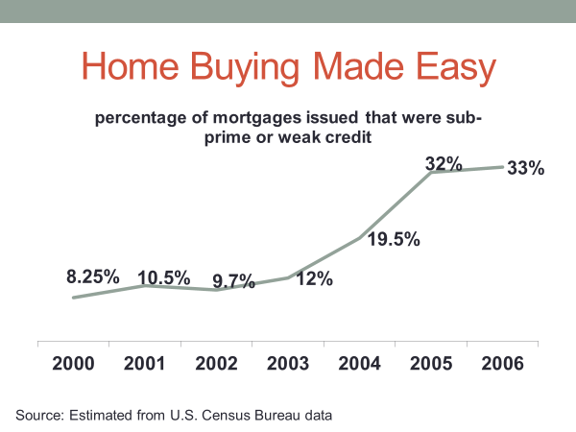
The banks knew that many of the borrowers would not be able to keep up with their payments, so they sold the mortgages, shifting the risk of default from themselves to unsuspecting buyers. It put the entire housing industry at risk if home prices suddenly dropped, which they did, precipitating the financial crisis of 2008.
Now, if banks had been required to keep many of these mortgages, they would not have risked writing so many bad ones. Banks relieved themselves of the risk by shifting it to those who purchased their mortgages.
There was also a second moral hazard at play in the 2008 financial crisis, what has come to be known as the "too big to fail" problem. When the financial system went into a tailspin, Congress and the Federal Reserve stepped in with several trillion dollars in loans to keep large financial institutions, such as bank of America, Citibank, and JPMorgan Chase, from going bankrupt, which would have worsened the financial crisis.
They were too big to fail. If they had gone down, they would have taken the entire economy with them.
Yet, it was their risky investment strategies that had put them on the verge of bankruptcy. They had leveraged their assets at roughly 30 to 1, up from the previous level of 12 to 1, in an effort to make ever more money. But that meant, when the economic downturn started, they didn't have enough assets to cover their losses.
So who paid for the risks they took? Well, not the banks themselves. The government assumed the risk. It bailed them out.
As we discussed in our earlier session on fiscal and monetary policy, Congress responded in 2010 with the Dodd-Frank Act, which tightened banking regulations. Among Dodd-Frank's provisions is a requirement that banks retain a larger share of the mortgages they write, particularly those of higher risk.
Dodd-Frank also specifies that in an economic downturn, government can pump money into the economy for the purpose of providing liquidity to the financial system, but not to aid a failing financial company.
Now, as we noted in that earlier session, the Dodd-Frank bill provoked sharp partisan disagreement. Democratic lawmakers wrote the legislation, claiming it would protect against a repeat of what happened in 2008.
For their part, Republican lawmakers claimed it placed too many restraints on financial institutions and would inhibit economic growth. One of Republican Donald Trump's first actions as president was to weaken some provisions of Dodd-Frank. Trump said his aim was not to give financial institutions free rein, but instead to pursue policies that would, quote, "encourage economic growth and job creation."
As Trump's words indicate, the question of regulation is rarely one of whether to regulate fully or not to regulate at all.
The question is one of finding the proper balance--enough regulation to protect the public from harmful behavior, but not so much regulation as to stifle economic vitality.
Let's look now at negative externalities, or as some economists prefer to call them, spillover effects.
They are also a justification for regulatory action.
A negative externality results when business firms or consumers fail to pay the full cost of production, as in the case of a company whose industrial waste seeps into a nearby lake or river.
The health and cleanup cost of the water pollution, the negative externalities, are borne not by the producer, but by society as a whole.
For a long period, air and water pollution were not major policy concerns. Business was more or less allowed to do as it pleased. Then in the 1960s, pressure started to build for government action. Rachel Carson's book, The Silent Spring, which describes the destructive effects of the pesticide DDT, contributed to the movement. But nothing tipped the scales of public opinion more than a burning river. In 1969, Cleveland's Cuyahoga River, which was so heavily polluted with industrial waste that it bubbled with escaping gases, caught fire. The river became the symbol of business practices that had gotten out of hand.
The next year, Congress passed the Clean Air Act, which was backed by Republican and Democratic lawmakers alike.
The law regulated the emission of hazardous air pollutants.
Soon thereafter, Congress, again on a bipartisan basis, passed the Clean Water Act, which regulated water quality standards.
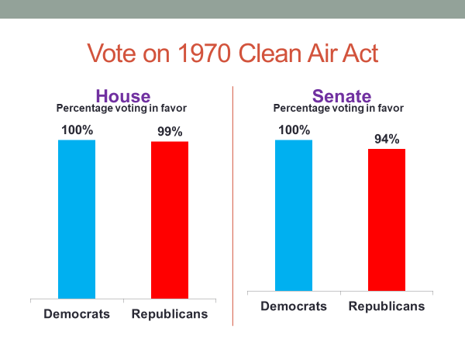
Republican President Richard Nixon proposed creation of a new federal agency to oversee the legislation. The Democratic-controlled Congress agreed, and the EPA, short for the Environmental Protection Agency, was created.
These bipartisan initiatives led eventually to dramatic improvements in air and water quality. Pollution levels today are far below their levels of the 1960s, when yellowish gray fog, known as smog, hung over cities like Los Angeles and Chicago, and when bodies of water, like the Potomac River and Lake Erie, were open sewers.
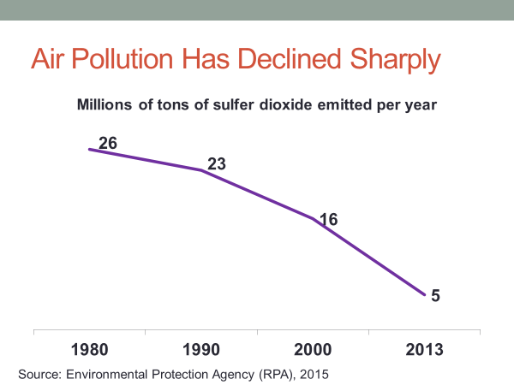
In the past four decades, toxic waste emissions have been cut in half, hundreds of polluted lakes and rivers have been revitalized, and urban air pollution has declined by 60%.
Today, the issue of pollution is less that of local problems, such as polluted lakes and rivers, than that of a global problem, climate change.
In the 1970s, scientists began to note that the Earth's climate was changing at an accelerated rate.
By the 1990s, a scientific consensus had emerged--global warming was taking place, driven largely by carbon-based fuel emissions.
Computer models suggested a greenhouse effect. There was an increased number of carbon particles in the atmosphere, and they were trapping heat rather than allowing it to escape into space.
The theory was backed by a range of evidence, including an increase in global temperature levels, rising sea levels, and glacial and polar melting.
When climate change first caught the news media's attention, it was reported strictly from a scientific angle, a perspective that pollsters also applied in their opinion polls.
Respondents were asked not whether climate change was happening, but how quickly they thought its impact would be felt. In a 1997 Gallup poll, for example, only 9% of respondents said global warming would never happen, while seven times that number felt the impact would be felt during their lifetime.
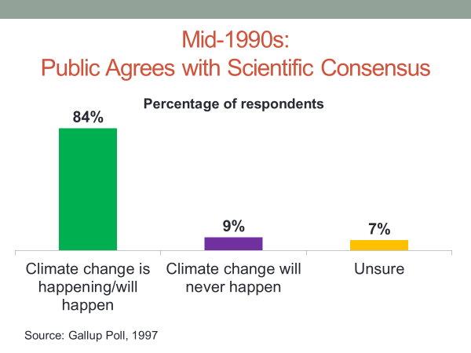
Soon thereafter, however, the nature of both news coverage and public opinion began to change.
Politics had invaded the issue of climate change.
The turning point was the Kyoto conference of 1997, where representatives of the world's nations met in Japan to develop a plan for reducing carbon emissions. Democratic President Bill Clinton signed the resulting agreement, known as the Kyoto Protocol.
He was unable, however, to convince the Senate to approve the treaty. The Senate's objection was that the treaty was unfair to developed countries like the United States. The protocol required them to reduce their carbon emissions while not requiring the same of developing countries, like China and India.
After Republican President George W. Bush took office in 2001, he rejected the Kyoto agreement out of hand, saying it would weaken the nation's struggling economy.
Nevertheless, Bush acknowledged a need to address climate change. "America's unwillingness to embrace a flawed treaty," Bush said, "should not be read as an abdication of responsibility." Some Republicans, including Arizona Senator John McCain, criticized Bush for not showing leadership on climate change.
But a larger group of Republican lawmakers, backed by industry lobbyists and conservative talk show hosts, attacked the science itself, arguing that the evidence of climate change was inconclusive or flat out wrong. For the news media, the partisan argument was too good a story to ignore.
The issue shifted from the science pages to the front pages and was played as a "he said, she said" debate. Rather than sorting through the facts behind the opposing claims, the media played up the fight.
A research study found that conservative politicians, industry-funded think tanks and other sources that claimed climate change was inconsequential or scientifically unproven received the same level of news coverage in the mainstream press during the 1998 to 2002 period as did sources whose views were aligned with the scientific consensus.
The debate intensified with the release of the film An Inconvenient Truth. Featuring Clinton's vice president, Al Gore, the film told of the dangers of climate change. It received the 2006 Academy Award for documentary film and helped Gore win the 2007 Nobel Peace Prize. For proponents of climate change policy, the film was pure gospel.
For some opponents, it was pure propaganda. Said Oklahoma Republican Senator James Inhofe, "If you say the same lie over and over again, people will believe it."
A study of Fox News and MSNBC, the conservative and liberal cable TV networks respectively, reveal just how differently climate change was being portrayed by the opposing sides. On Fox, there were three times as many stories dismissive of the climate change thesis as there were supportive stories. On MSNBC, supportive stories were nearly the only ones aired.
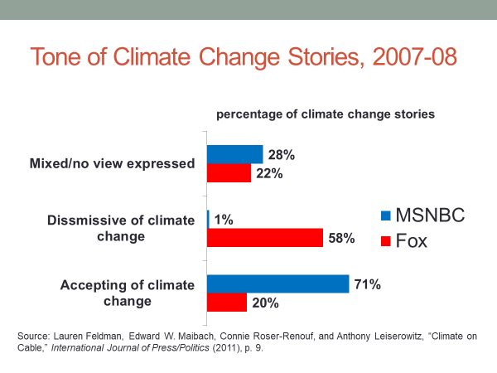
As for the mainstream media, the reporting was beginning to tilt toward the scientific consensus, but there were still plenty of coverage of the opposing view, as a study of the coverage in the New York Times and Wall Street Journal revealed.
Now let's take a look at what was happening to public opinion as the climate change issue became increasingly politicized.
Republicans and Democrats differed only slightly in their views on global warming before the 1997 Kyoto conference.
After Kyoto, they began to diverge, Democrats becoming more accepting of climate change, and Republicans becoming less accepting.
The gap further widened when the Bush administration rejected Kyoto, and it widened still further during that period dominated by the Gore film.
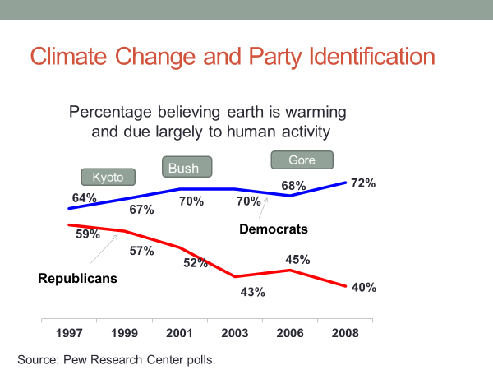
The gap remains wide even today.
In a recent Pew Research Center poll, for example, 79% of Democrats agreed that there is solid evidence the earth has been warming, compared with only 37% of Republicans. We don't have to search hard for an explanation.
Research indicates that when the media play up both sides of partisan debate, citizens tend to pick the side that fits their partisan preference-in this instance, Republicans rejecting the climate change thesis, and Democrats embracing it.
This chart provides further evidence of the media's contribution to the partisan divide over climate change.
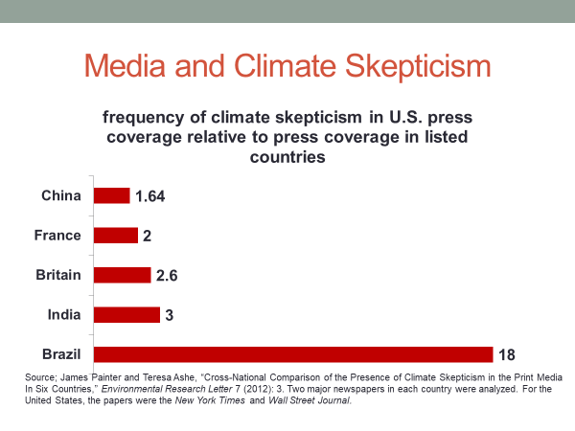
As you can see, the US media are much more likely than the media elsewhere to give voice to those who argue against the scientific consensus on global warming. The American press, for example, is twice as likely to do so as is the French press, three times as likely to do so as is the press in India, and 18 times as likely as is the Brazilian press.
Now, why do you think the issue of climate change has played out so differently than the environmental issues of the early 1970s when bipartisanship characterized the response?
I think there are quite a few reasons.
One is something we've talked about frequently in this course, the rise of party polarization. The parties are now so far apart with so few leaders in the middle that it's hard for them to come together to settle their differences.
The second is that climate change touches multiple sectors of the economy. Whereas industrial pollution of waterways, for example, was largely an issue of particular industries, regulation of carbon emissions would affect the transportation sector, the energy sector, the housing sector, and many other sectors. Policy disputes are invariably harder to resolve when a large number of conflicting interests are involved.
There's also the fact that the issue is a global one. No country by itself can fix the problem. And a country that takes on the issue, if others aren't, places itself at a competitive disadvantage in trade because of the added cost of its production.
A final reason is that climate change is hard to see. In the days when smog hung over America's cities and its waterways had the smell of a sewer, pollution was undeniable. Climate change is invisible by comparison. It's why many doubt its existence or think it's not an urgent issue.
We've made the point in earlier sessions of this course that America's system of divided powers is an obstacle to legislative action on large issues. Without a sense of urgency, lawmaking is often pushed down the road to a later time.
Now, before we wrap up this session, I'd like to make a general observation about regulatory policy. Here's a chart that you've seen in previous sessions.
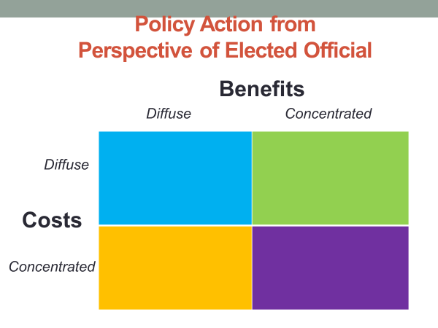
It's based on the cost and benefits of public policies. The cost and benefits can be concentrated-that is, focused on a particular interest--or they can be defuse-that is, spread across the society.
Examine that chart for a moment to locate the cell that you think best describes regulatory policies.
Let me give you a specific policy to think about, one that many economists have proposed as a response to climate change.
It's a tax on carbon. The tax would be levied on carbon emitters as a means of encouraging them to reduce their carbon emissions. As with a carbon tax, most regulatory policy involves concentrated costs and diffuse benefits.
A carbon tax would impose costs on particular interests, such as owners of coal-fueled power plants, while the benefits, fewer carbon emissions and less global warming, would be spread across society as a whole.
In such instances, the targeted interest, the one that's paying the cost, will fight hard to block the policy, while the beneficiaries, since the payoff to them is less tangible, won't work is as to support the policy.
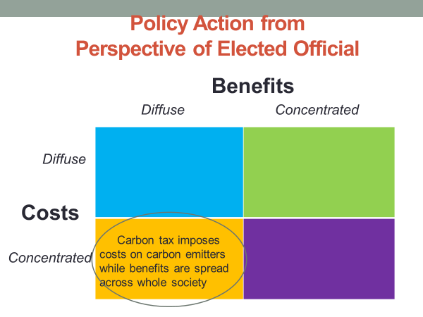
This feature of regulatory policy is a reason that elected officials usually prefer to leave regulation decisions in the hands of federal agencies. They can blame the agency for a policy decision rather than having to shoulder the burden themselves.
You remember from previous sessions that elected officials typically prefer policies that provide a concentrated benefit while diffusing the cost. Such policies allow them to take credit with the interest receiving the benefit while largely voiding blame, since the costs to any single taxpayer are hardly noticeable.
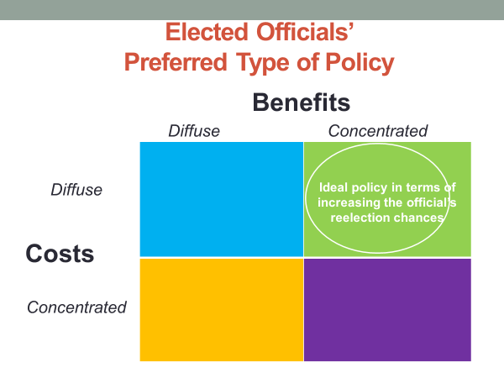
Perhaps it won't surprise you, then, that the few policy actions Congress has taken in response to climate change have been of this type as opposed to the regulatory type.
President Bush, for example, worked with Congress to pass a bill in 2007 that provided funding for alternative sources of energy. Bush called the bill "a major step toward confronting global climate change."
The bill passed by a wide margin, attracting the support of Republican and Democratic lawmakers alike.
The bill contained concentrated benefits and diffused costs. The benefits went directly to developers and producers of clean energy, while the costs are spread across the taxpaying public. From the perspective of an elected official, that type of policy is good politics. They can get the credit without having to shoulder the blame.
#
OK, let's wrap up the session with a review.
As we discussed at the beginning, regulatory policy aims primarily to reduce the harmful effects of business activity.
One reason why regulation might occur is restraintof trade, the situation where a firm gains or could gain a monopoly or near-monopoly, and thus would be positioned to set prices at an artificially high level.
Regulatory action in this case could consist of denying a merger between competing firms or breaking a large firm into a number of smaller, competing firms.
Another reason for regulation is inequity, when one party to an economic transaction has an unfair advantage over another party, as when it hides information about a product's defect.
In this case, regulatory action could include requiring the producer to replace the product or to pay damages.
Another reason for regulation is what's called moral hazard, the situation where one party takes risks and then passes that risk along to another party.
We discussed that problem in the context of bank's risky mortgage practices in the period leading up to the 2008 financial crisis. The regulatory response, in that instance, was Dodd-Frank, which imposes tighter restrictions on financial institutions.
Finally, we talked about negative externalities, the situation where economic actors do not pay the full cost of their decisions, as when their production activity creates pollution.
Regulatory action in such instances can require them to pay part or all the costs to correct or reduce the problem they created.
In our discussion of negative externalities, we took special note of climate change and the partisan challenge to regulation in that policy area.
And we concluded by pointing out that regulatory action typically involves concentrated costs, which heightens opposition to regulation by the firms that would have to pay those costs.

