Transcript: Religion and Politics Lecture

[ON LOCATION, CHURCH IN CAMBRIDGE, MASSACHUSETTS]
When we think of political issues, we tend to think of guns and butter—shorthand for policies that affect our national security and our economic prosperity. Most public policies deal with these concerns.
But they’re not the only issues on our minds. Social issues are as well.
Social issues refer to disputes over values and how we should live our lives. One social issue, slavery, nearly tore the country in half during the mid-nineteenth century. Another social issue, alcohol, was the subject of a constitutional amendment that backfired. Rather than ushering in an era of sobriety, it opened the door to bootleggers, speakeasies, and gangsters.
Social issues are divisive. They end up pitting people against one other, which is the case today for social issues such as immigration, charter schools, police practices, gun rights, legalization of marijuana, television violence and nudity, environmental protection, and discrimination of all kinds.
Disputes over these issues center on the question of the type of society the United States should be, not only at the moment, but in the decades to come.
As it happens, Americans on divided on the nation’s direction. A recent Pew Research Center poll asked Americans whether they consider themselves to be liberal or conservative on social issues. As it happens, Americans are split right down the middle, with as many saying they are conservative on social issues as saying they are liberal.
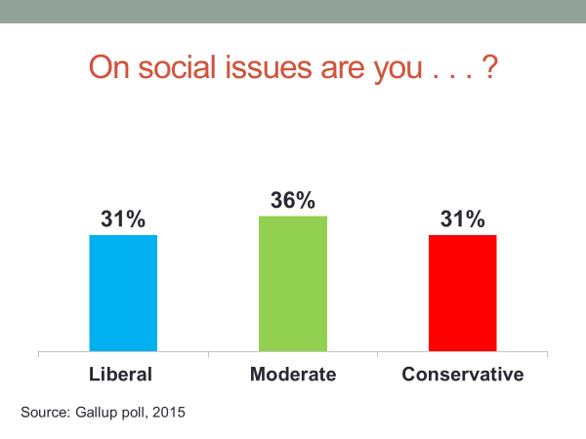
In previous sessions, we touched on several social issues, none more pointedly than discrimination, which was the focus of our session on civil rights.
In today’s session, I’ll look at social issues through the lens of religion.
Over the course of American history, no aspect of society has played more directly into social issues than religion. Social issues arise out of differences in values, and religions are founded on values.
Not surprisingly, the intersection of religion and politics has been a persistent source of conflict within the American system.
#
[STUDIO PORTION]
In the United States, religion plays a larger political role than it does in nearly all other Western democracies. One doesn’t have to search far for the reason—Americans are a religious people.
A Pew Research Center cross-national survey found that American respondents were far more likely than Italian, German, Spanish, or French respondents to say that religion is “very important” in their lives.
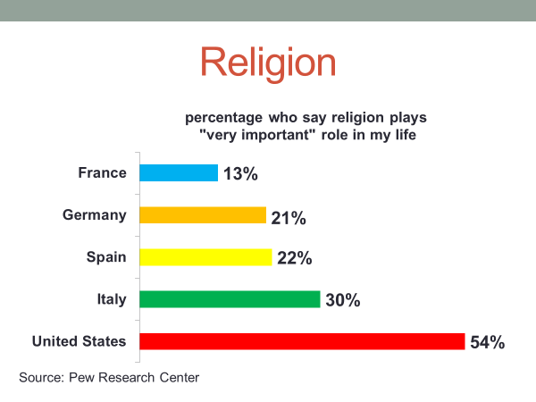
Religion in America is at once uniform and diverse. It’s uniform in the sense that the country is overwhelmingly Christian—it has the most Christians of any country. The Jewish community also has deep roots in American society but accounts for only 2 percent of the population. Other non-Christians, including Muslims, Hindus, and Buddhists, are increasing in number, but together account for less than 3 percent of the population.
At the same time, American Christians are religiously diverse.
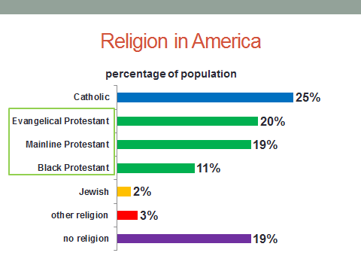
Catholics are the largest single denomination, numbering more than 60 million. Even so, they make up only about 25 percent of the population.
Protestants outnumber them by roughly two-to-one, but are split among more than 200 denominations. The largest is the Southern Baptist Convention, with roughly 16 million members, more than 90 percent of them are white. Second with 8.5 million members is the National Baptist Convention, a nearly all black denomination that broke with the Southern Baptists during the era of racial segregation. Both denominations are evangelical, meaning that they practice evangelism—the spreading of the Gospel to others—and regard the Bible as the literal word of God.
Other Protestant faiths place less emphasis on evangelism and the Bible as a literal text. The largest of these so-called Mainline Protestant religions is the United Methodist Church with 8 million members.
At one time, Mainline Protestants were in the majority. Today, they’re outnumbered by evangelicals.
Religions differ in doctrine, a term that refers to how they instruct their followers on such things as the nature of the universe, the path to salvation, and the proper way to conduct their lives.
The Catholic and Jewish religions, for example, stress the importance of good works, particularly help for the poor, the sick, and the weak. Protestants also do so, but it’s leavened by an emphasis on self-reliance—what the sociologist Max Weber called the Protestant Ethic.
And among Protestants, there’s a split with Mainline denominations placing more emphasis on good works—the so-called “social gospel”—while Evangelical denominations place more emphasis on personal faith—the “individual gospel.”
These differences in doctrine are not sharply defined and, even within each tradition, there’s considerable variation.
Nevertheless, they affect how their followers respond to politics. For example, in a survey that asked Americans whether government should see to it “that every person has a job and a good standard of living,” Jewish and Catholic respondents—consistent with the religious doctrines—were most likely to agree, followed by Mainline Protestants, with Evangelical Protestants the least likely to hold that opinion.

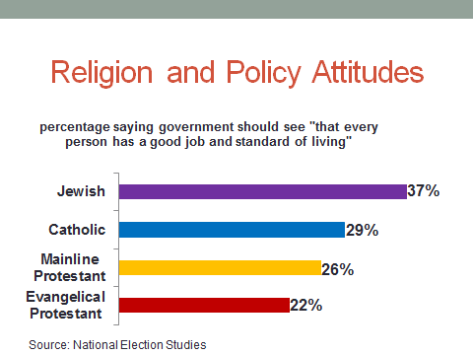

#
In this session, we’ll examine the influence of religion on American politics, starting with
Religion’s impact in the period before the Great Depression. Religious conflict in this period was largely sectarian—Protestants against Catholics.
We’ll then discuss the
Religion’s reemergence in the 1970s as a powerful political force in response to issues such as abortion and same-sex marriage.
As we discussed in a previous session, the nation’s founders sought to separate Church and State. The First Amendment says that “Congress shall make no law respecting an establishment of religion, or prohibiting the free exercise thereof...”
The First Amendment did not, however, keep religion from working its way into American politics. Indeed, historians and political scientists have concluded that, next to race, religion was the leading issue of nineteenth-century politics.
In the nation’s earlier decades, religion was a progressive force. Churches were behind the drive to create public schools and charity houses. They also sparked the abolitionist movement, arguing that slavery was a sin of the highest order and a betrayal of the nation’s promise. Said Angelina Grimke, a leading abolitionist, "God . . . punished [Egypt and] Judea . . . because of slavery. And have we any reason to believe that he [will spare America]?”
The debate over slavery was so intense within some denominations that it led them to split into pro- and anti-slavery branches.
Then, in the 1840s, religion in America took a reactionary turn. Economic hardship in Ireland had suddenly brought large numbers of Irish Catholics to America.
At the time of the Revolution, the United States was 99 percent Protestant. Even as late as 1840 it was more than 95 percent Protestant. Most of them were not happy with the prospect of sharing their country with Irish Catholics.
Today, we think of race largely in terms of blacks and whites. In the mid-nineteenth century, race was a bigger category. The Irish were considered by established Americans to belong to a different race—an inferior one in the minds of many. Said George Templeton Strong, a prominent lawyer and writer: “[The Irish] are almost as remote from us . . . as [are] the Chinese.”
The Catholic influx gave rise to the Know Nothing Party or, as it was officially called, the American Party. The party’s platform called for public schools to hold daily Bible readings and to ban Catholic teachers.
In the 1856 election, the American Party’s presidential nominee, former president Millard Fillmore, attracted nearly 25 percent of the vote—the second-highest third-party total in the nation’s history.
Anti-Catholic sentiment was particularly strong in small towns and rural areas, which in the North after the Civil War were Republican strongholds. Urban areas were more tolerant, and Catholics became the backbone of the Democratic Party organizations in New York, Boston, and other cities. The 19th century religious divide can be seen in this chart.
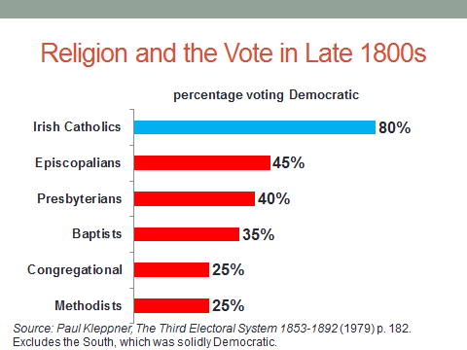

Northern Catholics were heavily Democratic—the margin was four to one—while Northern Protestants of every denomination were Republican, some by a very wide margin. White Protestants in the South, where race trumped religion, were the exception. They were Democrats as a result of the Republican Party’s role in freeing the slaves.
Now, in the late 19th and early 20th centuries, the United States experienced its largest wave of immigration in history, most of it from southern and eastern Europe. The Catholic population tripled as a result, while the Jewish population increased eight fold.
To old-line Americans, this influx threatened the nation’s well-being. A congressional report labeled Eastern European Jews as “mentally deficient,” and “socially undesirable,” concluding that “eighty five to ninety percent [of them] lack any conception of patriotic or national spirit.”
The Protestant backlash led to the rebirth of the Ku Klux Klan.
Formed in the South after the Civil War to repress the newly freed slaves, the Klan was so violent that it lost support even in the South and by 1900 had nearly disappeared.
It was resurrected in 1915 as an organization that was anti-Catholic, anti-Jewish, and anti-Mormon, as well as anti-black. The new Klan succeeded beyond its founders’ wildest dreams. At peak, one in every six Protestant white males in the U.S. was a Klan member. Indiana, a non-southern state, had the largest membership.
Klan organizers would go into city, sign up new members, and cap off the recruitment with a huge rally, marked by the burning of a cross and the ceremonial gift of a Bible to a prominent local Protestant.
The Klan’s political power was on full display at the 1924 Democratic national convention, when it blocked the presidential nomination of Alfred E. Smith, the governor of New York and a Catholic.
The Klan’s choice was one its own, William McAdoo, who’d been President Woodrow Wilson’s Treasury secretary and had married his daughter.
McAdoo was backed by Democratic delegates from southern and rural states while Smith had the support of delegates from northern urban states.
Now, in those days, it took a two-thirds vote of the delegates to win nomination. The balloting went on for days, with neither Smith nor McAdoo reaching the threshold. Finally, they both withdrew, resulting in the nomination of a political unknown, John W. Davis, on the 103rd ballot. It was the longest party convention in U.S. history.
To celebrate Smith’s defeat, the Klan organized a rally that drew thousands of its members, dressed in the Klan’s traditional hooded cape.

Four years later, Smith won the Democratic presidential nomination, but lost in a landslide amid charges he was an agent of the Pope.
For the first time since the Civil War, Republicans carried the heavily Protestant states of Texas, Virginia, and North Carolina and nearly carried the whole of the South.
Religious bigotry was not confined to politics. Many colleges refused to schedule football games with Notre Dame, a Catholic institution. Twice, Notre Dame’s application to join the Big Ten Football Conference was voted down by anti-Catholic coaches and university administrators.
As important as religion was in the 1928 election, its power diminished soon thereafter.
The Great Depression had hit, and Americans were far more concerned with their pocketbook than their neighbor’s religion. The nation’s entry into World War II, where Americans of all faiths fought side by side, further eroded religious resentments. As historian Thomas Bruscino notes, the war produced a “sea change” in “religious relations.” “The war,” he writes, “remade the nation.”
The change in Americans’ attitudes was reflected in the increased rate of inter-faith marriage. The rate of Protestant-Catholic marriages doubled in the 1950s from its earlier level.
Although religion was seldom an issue in 1950s politics, America’s political parties retained a religious flavor—most Catholics and Jews supported the Democratic Party and most northern Protestants backed the GOP, although Democrats, as a result of Franklin Roosevelt’s New Deal, had made inroads with younger and blue-collar Protestants.
Then, in 1960, religion came back into play when Democrats picked John F. Kennedy, a Catholic, as their presidential nominee.
Kennedy sought to assure Protestant voters about his religion.
Said Kennedy: "I am not the Catholic candidate for President. I am the Democratic Party's candidate for President who also happens to be a Catholic. I do not speak for my Church on public matters — and the Church does not speak for me."
A study by scholars at MIT estimated that Kennedy’s religion cost 1.5 million votes nationwide and tipped the states of California, Kentucky, Oklahoma, and Tennessee into the Republican column.

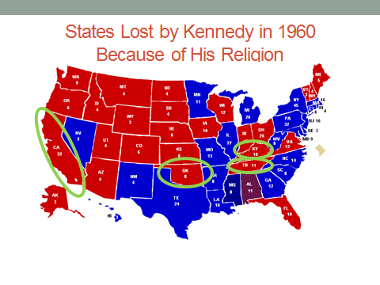
Despite that, Kennedy’s religion may actually have won him the election. Heavy Catholic turnout enabled him to pick up the states of New York, Connecticut, Pennsylvania, and Illinois—they had 22 more electoral votes than the four states he lost because of his religion.

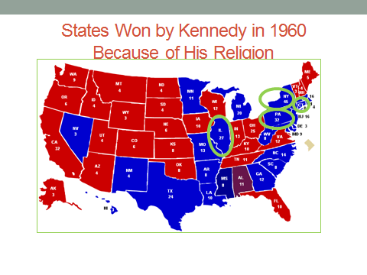
Kennedy’s presidency and his assassination three years later virtually closed the chapter on the conflict between America’s Protestants and Catholics.
When John Kerry ran for the presidency in 2004—the first Catholic presidential nominee since Kennedy—his religion was barely mentioned.
# #
Although the 1960s ended one form of religious conflict, it planted the seeds of another. In 1962, the Supreme Court ruled that prayer in the public schools violated the First Amendment’s establishment clause. A year later, the Court barred Bible readings in the public schools.
Then, in 1965, the Supreme Court, citing a right to privacy, held that states could not prohibit the use of birth control bills, which had been approved for contraceptive use by the Food and Drug Administration.
That ruling was followed by another right to privacy ruling in 1973. In Roe v. Wade, the Supreme Court legalized abortion during the first trimester of pregnancy.
Religious conservatives were dismayed by these rulings, and also by the women’s rights movement that had formed out of the civil rights movement and by the counter-culture movement, with its emphasis on drugs and sexual liberation, that had developed out of the anti-Vietnam War movement.
In the view of religious conservatives, the traditional male-headed family and the nation’s religious values were under attack.
A fault line emerged—secularists and the more liberal religious denominations on one side of the culture debate and the more conservative religious denominations on the other side.
In response to what he described as the nation’s “moral decay,” the Reverend Jerry Falwell, a minister of the Southern Baptist Convention, founded the Moral Majority.
Headquartered in Virginia with chapters in every southern state, and built around a network of evangelical ministers, the Moral Majority at peak had more than four million members and nearly two million donors.
The Moral Majority’s program called for restoring Christian prayer in the public schools, outlawing abortion, preserving the traditional family, boycotting media outlets that carried sexual content, and opposing the Equal Rights Amendment, which would have formally given women the same constitutional standing as men.
In 1980 and 1984, the Moral Majority endorsed Republican Ronald Reagan’s presidential candidacy and spent millions on televised advertising and voter registration drives aimed at securing his election.
The Christian Right’s role in Republican politics was further strengthened when the Reverend Pat Robertson, a Baptist minister who founded the Christian Broadcasting Network, ran for the 1968 Republican presidential nomination. He lost, but ran strongly in the early contests and brought tens of thousands of evangelical Christians into the activist ranks of the Republican Party.
Soon thereafter, Robertson created the Christian Coalition, with chapters in every state. By the mid-1990s, its members held leadership positions in a third of the state Republican Party organizations.
Religious ferment after Roe v. Wade resulted in a denominational realignment. In the 1976 presidential elections, evangelical Christians had divided their vote evenly between the Republican and Democratic nominees. In 1980—Reagan’s first election—more than 60 percent of evangelicals voted Republican. In 1984 and 1988, roughly 80 percent did so.

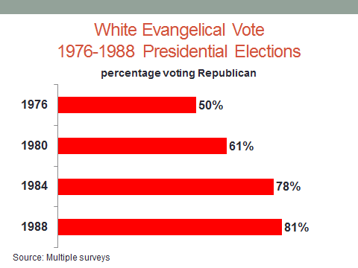
Less dramatic but significant changes had also taken place among other religious groups. Catholics had become a less reliable source of Democratic votes. Those who went to church regularly were now casting most of their votes for Republican candidates.
As political scientist John Green noted: “There isn’t a Catholic vote anymore; there are several Catholic votes.”
Meanwhile, secularists and liberal mainline Protestants were increasingly voting for Democrats.
The parties’ national platforms reflected the change. In 1976, the Republican platform had a plank calling for a ban on abortion—every Republican platform since has included such a plank. The 1976 Democratic platform had a plank endorsing a woman’s right to choose—every Democratic platform since has had such a plank.

#
In the 1990s, Democratic Party leaders began to vigorously contest the growing power of the religious right, centering their push on women’s rights and taking up the issue of gay rights.
During the 1992 presidential campaign, Democratic nominee Bill Clinton proposed to end the ban on gays and lesbians in the armed services.
At their national party convention, Republican speakers played up Clinton position, declaring it an assault on “family values.”
As a political issue, same-sex relations had advantages for both parties. Gays and lesbians were increasingly outspoken in their demand for equal treatment. Their sexual identity was central enough that many were willing to vote on it. According to exit polls, Clinton received roughly 80 percent of the 1992 two-party vote of gays and lesbians.
The appeal to women’s rights was also a source of votes. Clinton won 56 percent of the two-party vote among women. A gender gap—the difference in the vote preferences of men and women— had opened in the 1980s, and the 1990s solidified it.
Ever since, Democratic candidates, at the congressional as well as the presidential level, have run more strongly among women than men.

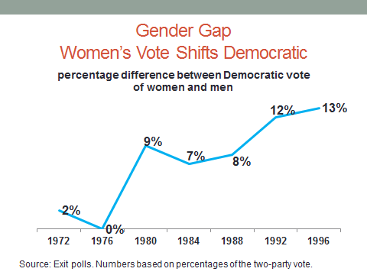
But gender also gave conservatives a potent issue. Referring to same-sex relations, the Reverend Lou Sheldon, head of the Traditional Values Coalition, said: "We now have another front-burner issue in addition to [abortion].”
Republican lawmakers also recognized the issue’s potential. In nearly every state, they introduced bills defining marriage as the union between a man and a woman. By 2001, a majority of states had adopted a statute or constitutional amendment upholding traditional marriage.
In the 2004 elections, Republicans placed a marriage referendum on the ballot in thirteen states, expecting it to draw religious conservatives to the polls. It worked and, in every case, the referendum passed easily. The same strategy was pursued two years later in nine states.
If there was any question about the degree to which religion had become a centerpiece of American politics, it was dispelled by the composition of vote in the 2000 and 2004 presidential elections.
Among voters who went to church regularly, Republican George W. Bush received more than 60 percent of the vote in 2000. Among infrequent and non-attendees, he got less than 40 percent of the vote.
That 60-40 pattern occurred again in the 2004 election.

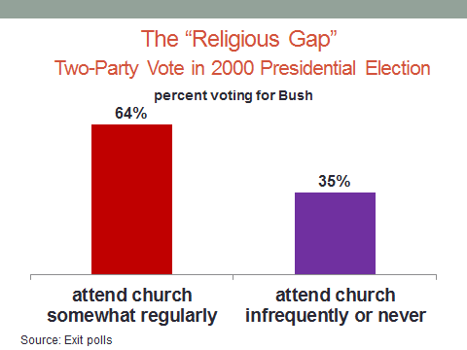
The increasingly close relationship between religion and party can also be seen in the trend in party identification.
In early 1970s, there was basically no correlation between the frequency of church attendance and Americans’ party loyalties. Since then, the correlation has increased, with regular churchgoers increasingly loyal to the Republican Party.

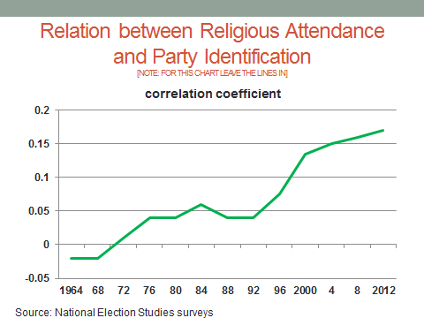
#
Now, where are things headed? What role is religion likely to play in the nation’s politics in the years ahead?
There are some signs that religious-based conflict could be weakening. Some prominent evangelical leaders believe it was a mistake to tie religion to politics, particularly in light of the fact that it has not produced many policy victories. They would refocus the Christian right on its evangelical mission, contending that its identification with the Republican Party has made it harder to preach the Gospel to Democratic-leaning Americans, Hispanics particularly.
Some observers also point to the same-sex marriage issue as a possible sign of religion’s weakening influence. In the entire history of polling, there have been few issues where public opinion has changed as dramatically in so few years as have Americans’ opinions on gay marriage.
In the early 1990s, fewer than 20 percent of Americans backed same-sex marriage. Even a decade later, support was very low. Today, a majority approve of same-sex marriage.

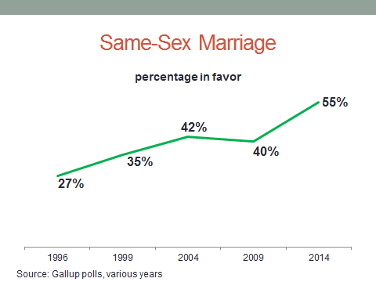
Remarkably, unlike the abortion issue, where Republicans and Democrats have shifted in opposite directions, support for same-sex marriage has increased among Republicans and Democrats alike. There’s a wide gap in partisan opinion on the issue, but the trend for both is upward.

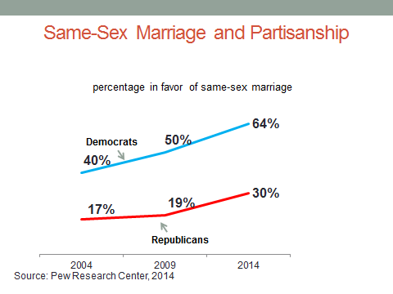
That’s also true for religious groups, as you can see in this figure. Although white Evangelicals are predictably the most opposed to gay marriage, they, like the other religious groups, have become more supportive of it.

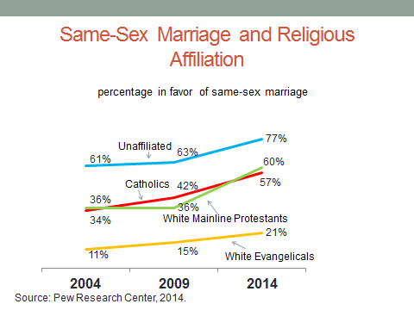
There’s a final reason for thinking that the power of religion in politics is declining—a growing secular trend in American society. Church attendance is declining, particularly among young adults.
In their book American Grace, political scientists Robert Putnam and David Campbell examined eleven separate indicators of religious belief and behavior and, for each, young adults showed a greater decline in religiosity than older adults.
The rise of religion in American politics occurred when religiosity was high. It’s now weakening. In 1992, according to the Gallup poll, only 12 percent of Americans said religion was “not at all important” in my life. Today, the number is twice that.

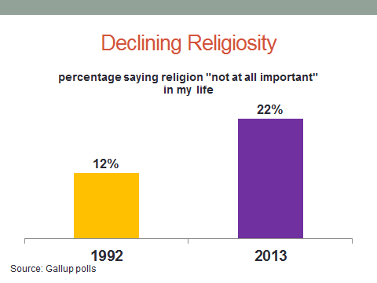
Respect for religious institutions has also declined. In a 1973 Gallup poll, two-thirds of Americans expressed “a great deal” or “quite a lot” of confidence in organized religion. Today, fewer than half do so.
But even if religion is weakening as a political force, it’s not going away anytime soon.
The abortion issue by itself virtually guarantees it. In the four decades since Roe v. Wade, abortion opinions have not changed much in the aggregate. The proportions of pro-life and pro-choice Americans today are roughly the same as they were in the 1970s.

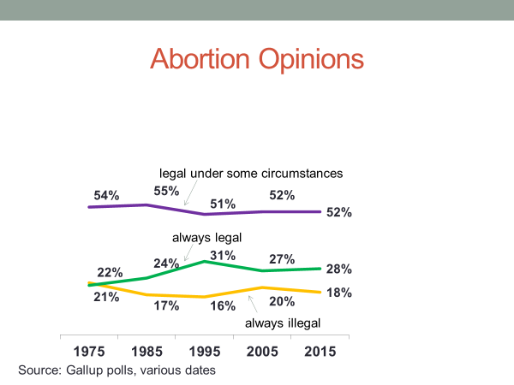
What’s different today is how these opinions align with Americans’ partisanship. As you can see in this figure, Republicans have become increasingly anti-abortion while Democrats have moved in the opposite direction. Republicans and Democrats are now far apart—polarized—on the issue.
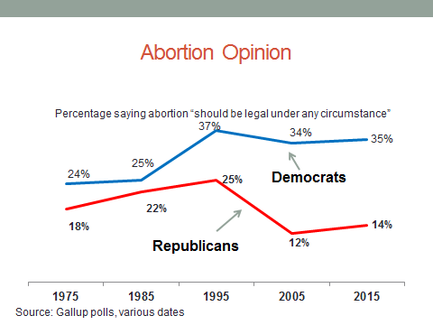
Religion is a component of the party realignment we discussed earlier in the course. Today’s party coalitions are markedly different than they were at the time when Catholics were reliably Democratic and Protestants reliably Republican.
Differences in religious belief—about personal morality, the nature of the family, the need for religious observance, and the like—count for more than religious labels when it comes to Americans’ party loyalties.
As Putnam and Campbell write, “how religious a person is ha[s] become more important as a political dividing line than which denomination he or she belong[s] to.”
That observation was borne out in the 2012 election. The Republican candidate, Mitt Romney, was the first Mormon to win presidential nomination.
Although polls indicate that white Evangelicals, more than any other religious group, question the validity of the Mormon religion, it didn’t stop them from backing Romney.
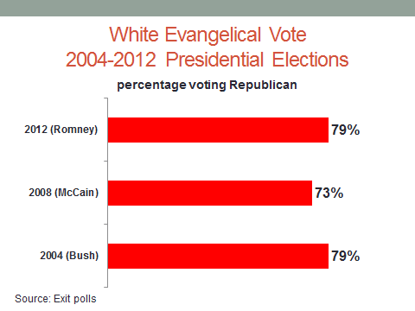
Exit polls found that he received 79 percent of the white evangelical vote—an amount equal to that of George W. Bush in 2004 and six percentage points higher than John McCain in 2008.
To white evangelicals, Romney’s positions on abortion, same-sex marriage, and other social issues easily trumped his denomination.
Party loyalties and religious beliefs are now interlocked. It’s hard to imagine what, if anything, will break that bond in the foreseeable future.
As this figure shows, what’s true of religion and parties is true of social issues generally. Americans as a whole are split evenly between social conservatives and social liberals, but Republicans and Democrats are not. Republicans tilt strongly to the social conservative side while Democrats tilt strongly toward social liberalism. The difference is a predictable source of political conflict in the years to come.

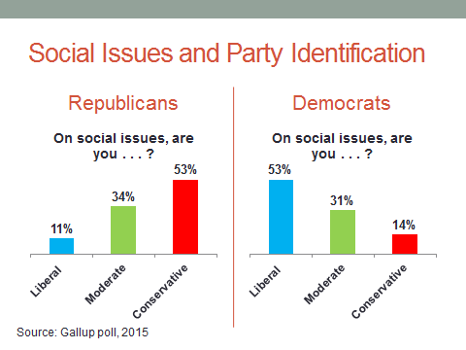
#
Okay, let’s summarize what’s been said in this session on religion and politics.
We began by noting that, despite the constitutional separation of church and state, religion was a powerful force in early American politics, finding expression in sectarian conflict—the dominant Protestant population against the growing number of Catholics.
This conflict worked its way into the party system, with Catholics identifying with the Democratic Party and northern Protestants with the Republican Party.
The heavily Protestant South, where race rather than religion was the top issue, was the exception.
The Great Depression and World War II served to reduce Protestant-Catholic antagonism, which was further diminished after John F. Kennedy’s election in 1960.
Since then, religion’s political influence has come in response to issues such as school prayer, abortion, and family norms. These issues served to mobilize religious conservatives who aligned with, and were embraced by, the Republican Party.
Meanwhile, seculars and religious progressives increasingly sided with the Democratic Party.
Religious observance and party identification are now tightly linked.

