Transcript: Fiscal & Monetary Policy Lecture

[ON LOCATION, FEDERAL RESERVE BUILDING, WASHINGTON, DC]
THOMAS PATTERSON: The building behind me is not on the list of Washington's top tourist attractions, yet it houses one of the most important units of the Federal Government.
It's not that of the CIA, or the FBI, or the IRS. It's the building that houses the Federal Reserve or, as it's commonly called, the Fed. The Fed's chair is often called the second most powerful official in Washington D.C.
Ever since the 1930s, the Federal Government has taken responsibility for managing the nation's economy, keeping unemployment and inflation in check. The Fed is part of that effort. So, too, is Congress through its taxing and spending policies.
But increasingly, the responsibility has shifted over to the Fed. Its economic tools can be more effectively targeted, more quickly applied than the tools available to Congress.
#
[STUDIO PORTION]
Few events have had a bigger impact on US policy than the 1930s Great Depression. In response to the economic crisis, the Federal Government provided a safety net for the economically weak and tightened its regulation of business.
Among the federal agencies created during the depression where the Securities and Exchange Commission, which regulates the stock and bond markets, and the Social Security Administration, which administers the Social Security program.
The Great Depression also changed policymakers' thinking about the government's role in the economy.
Before then, the government had more or less kept its hands off the economy, letting it go through a natural cycle of ups and downs. Every few decades, the economy would take a nose dive.
Prevailing theory held that it would eventually self correct, launching another period of prosperity.
But since the depression, the government has actively managed the economy, seeking to keep it on a more even keel.
In this session, we'll look at two major policy approaches to this effort--
fiscal policy, which refers to the government's taxing and spending decisions and is carried out by Congress and the president.
In that discussion, we'll look at alternative approaches to fiscal policy--demand-side policy, which is based largely on government spending levels, and supply-side policy based on tax levels.
We'll also discuss monetary policy, which involves adjusting the money supply in response to economic conditions.
Monetary policy is exercised primarily through the Federal Reserve.
#
Now when the economy weakens, firms and consumers behave in ways that contribute to the economic downturn. Faced with declining demand for their goods, firms cut back on production, which accelerates the job loss. Meanwhile, consumers pull back on their spending, which weakens demand for goods, resulting in further job loss.
Before the Great Depression, government action also added to the downward spiral. Faced with declining tax revenues as a result of declining incomes and profits, government would cut back its spending, further accelerating the job loss and the slowing of business activity.
The British economist, John Maynard Keynes, argued that government was doing exactly the opposite of what it should do. Instead of cutting back on spending, he argued, government should increase it. By doing so, government would put money into consumers hands, which, when spent, would stimulate job growth and production.
Keynesian fiscal policy centered on the demand side of the supply/demand relationship. Increase the level of aggregate demand-the amount of money consumers are spending-and the effect will be an increase in aggregate supply-the amount producers are supplying.
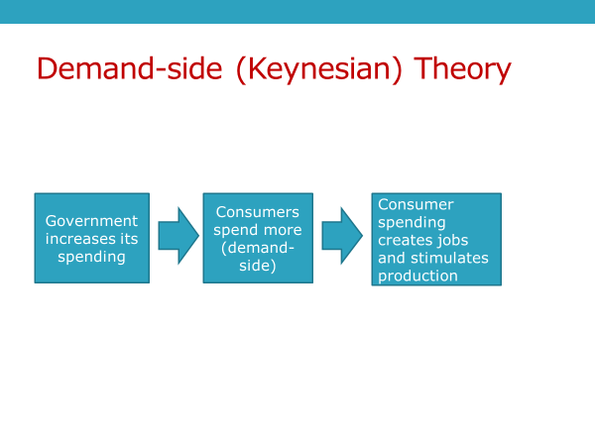
That notion drove some of President Franklin Roosevelt's 1930s New Deal programs. For example, the Works Progress Administration or WPA employed millions of jobless Americans on public works projects--new parks, bridges, and other facilities were built in hundreds of American cities and towns. The workers' pay fed into the economy, boosting production, which led to job hires.
Now not everyone backed such programs. Economic conservatives said government had no business meddling in the markets.
By the 1950s, that argument was fading. But a consequence of demand-side fiscal policy-a bigger federal government-- remained an issue, particularly among Republican lawmakers.
Accordingly, when Republican Ronald Reagan became president in 1981 in the midst of an economic recession, the jobless rate had reached a post-war high of 11%.
He chose an alternative approach. Reagan targeted the supply-side, convincing Congress to give a large tax break to business and upper income taxpayers.
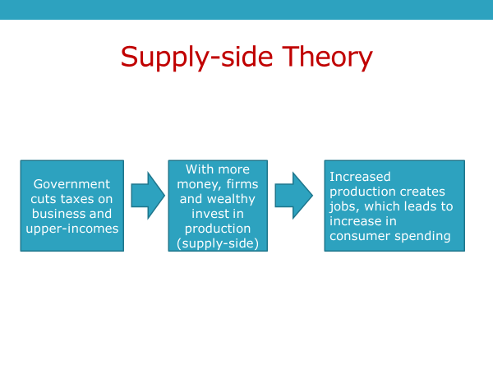
Reagan's logic was that if business and the wealthy had more money, they would invest it in production-- the supply-side of the economic equation. To increase production, business would have to hire more workers. Their pay would then feed into the economy, stimulating further production and hiring.
Reagan's supply-side approach came to be called trickle down economics, the idea that greater wealth at the top of society generates economic activity that trickles down to help those at the bottom.
Before going further, let me summarize the two approaches to fiscal policy so that you have a clear understanding of the difference.
Demand-side policy emphasizes government spending as a means of putting money directly into consumers hands, whereas supply-side policy emphasizes tax cuts for business and upper income individuals, with the idea they will invest more heavily in production.
Both of these approaches aim to reduce the jobless rate.
Now a third approach to stimulating the economy is called monetary policy or monetarism. The leading theorist of monetary policy was economist Milton Friedman, who formulated it at the University of Chicago in the 1950s.
Friedman believed fiscal policy was largely ineffective and argued, instead, that the money supply-the amount of money in circulation-was the key to maintaining a stable economy. When the economy is weak, he said, the money supply should be increased. With more money in circulation, firms and consumers have more money to invest and spend, stimulating both production and spending.
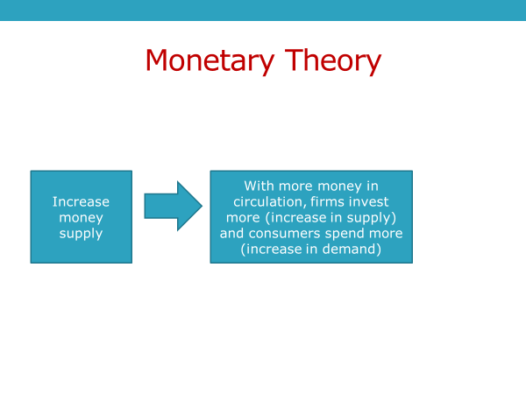
Friedman preferred private control over the money supply, but recognized that the government's Federal Reserve Bank, which is called the Fed for short, had the tools to do the job. And indeed, the Fed has taken on the job.
To understand the Fed, you need to recognize that it's not an ordinary bank. It doesn't have customers like your bank does.
It's a bankers' bank.
Its members are the national banks and those state banks that qualify and choose to join.
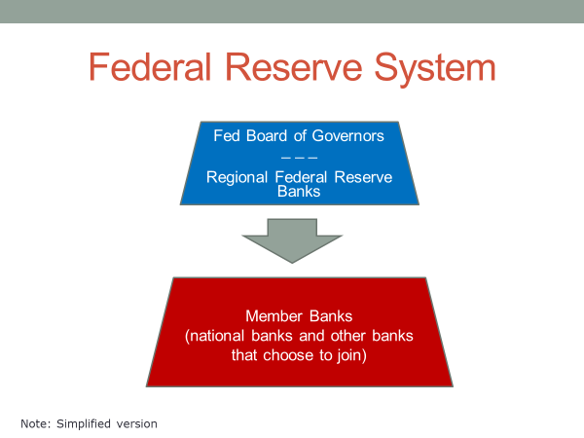
To deal with an economic downturn, the Fed can employ a combination of three tools to increase the money supply.
One, it can lower the interest rate it charges member banks when they borrow from it. The lower the rate they pay for their loans, the lower the interest rate they can give to their customers. Cheaper rates stimulate borrowing, which pumps money into the economy. That is, it increases the money supply.
The fed can also increase the amount of money in circulation by lowering what's called the reserve rate. Member banks are required to keep on deposit a certain percentage of their assets. This percentage is the reserve rate. When the Fed lowers the rate, member banks can loan out more of their assets to customers, thereby putting more money into the economy, helping to stimulate it.
Finally, the Fed buys and sells securities, which is a catch-all term for many kinds of investments-- bonds, notes, treasury bills, and so on. During an economic downturn, it can increase its buying level. When it buys a security, it gives money to the seller, which the seller in turn can spend or invest, helping to stimulate the economy.
Now each of these approaches-- demand-side policy, supply-side policy, and monetary policy-has strengths and weaknesses.
Each one also has a political dimension.
To help you understand these aspects, let's look at an example of each policy approach, beginning with supply-side fiscal policy.
When Republican George W. Bush took office in 2001, the economy was in recession.
That year, in an add-on legislation two years later, Bush persuaded Congress to enact tax cuts that included a decrease in the highest marginal rate on personal income from 39.6% to 35% and a decrease in the capital gains tax, which is the tax on investments, from 20% to 15%.
These tax cuts benefited high income taxpayers, precisely the ones targeted by supply-side policy. The assumption was that they would invest much of the money, giving the economy a boost. Other taxpayers also got a tax cut. But in dollar terms, it was much smaller.According to one estimate, the tax savings to Americans in the top 1% of income was more than $50,000 a year, whereas about $600 a year for those in the middle of the income scale and less than $100 a year for those in the bottom fifth.
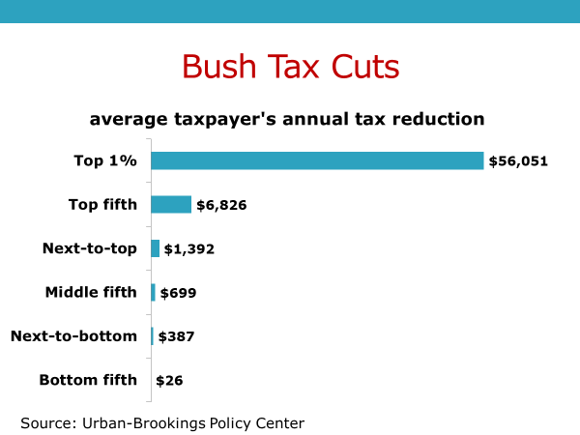
In Congress, the vote on the Bush tax cuts divided along party lines, particularly in the 2003 bill. In the House and Senate, over 90% of Republicans supported it and over 90% of Democrats opposed it.
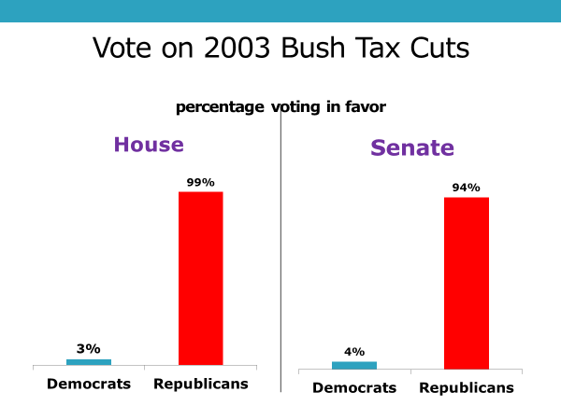
Now why do you think Republicans prefer supply-side fiscal policy?
Would you attribute it to their governing philosophy or the nature of their party coalition?
Actually, it's both. Supply-side policy fits their small government philosophy because tax cuts don't require a new federal program. Tax cuts are implemented through the tax code. And tax cuts on firms and upper incomes go to those who traditionally have sided largely with the Republican Party.
Now what was the effect of the Bush tax cuts? Did they help the economy as they were intended to do?
Economists differ on that question. And there's a wide range between the high and low estimates. The Congressional Budget Office, which has a reputation for being nonpartisan, concluded that the tax cuts had a relatively modest impact on the economy.
Where economists agree is on the effect of the tax cuts on government revenue. Bush, like Reagan before him, argued that the tax cuts would eventually pay for themselves. As the economy strengthened, incomes and profits would rise and, along with that, so would the government's tax revenues.
As it turned out, the Bush tax cuts were too large to be paid back later by higher revenues. According to a study of the National Bureau of Economic Research, the Bush tax cuts added hundreds of billions to the national debt.
Now these assessments have taken some of the luster off supply-side fiscal policy. It has also lost favor because the Bush tax cuts added to the American income divide--the widening gap between the incomes of those at the top of the economic ladder and those at the bottom.
Now let's take a look at recent demand-side and monetary policy action which came into play when the economy, in 2008, took its sharpest downturn since the Great Depression.
Bush was still in the presidency when the downturn began. And he persuaded Congress in early 2008 to enact a tax rebate. It gave $300 per adult and dependent child to taxpayers making less than 75,000 a year or, in the case of a married couple, less than 150,000 a year. This was a demand-side bill because its goal was to put money directly into consumers' hands, so that their spending would spur production and job growth.
Which members of Congress--Republicans or Democrats-- do you think more strongly supported Bush's proposal?
You might have picked Republicans, thinking that they would side with Bush because he was a Republican. In fact, however, congressional Democrats backed the bill more strongly, particularly in the Senate where every Democrat supported it, while a third of the Republicans were opposed. Now why the Democrats?
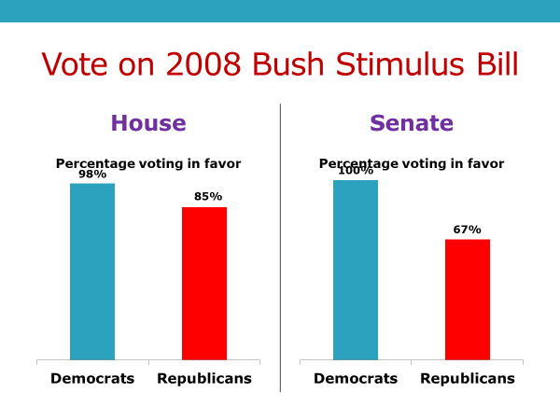
Well, in part, because the Democratic party's coalition tilts toward those of lower income-the main beneficiaries of the tax rebate bill. Upper income taxpayers, who are mostly Republican, were ineligible for the rebate. The 2008 tax rebate cost $150 billion.
When democratic President Obama took office in early 2009, an even larger demand-side stimulus bill was passed by Congress. It totaled $787 billion and included, for example, more than $100 billion in infrastructure spending, such as road construction and updating the electricity grid, nearly $100 billion in unemployment assistance, such as expanded benefits and training for jobless workers, and more than $100 billion to enable state and local governments to retain their workers and services.
These measures consistent with demand-side theory aim to put money in people's pockets, so that they would spend and give the economy a boost.
The legislation, as you'd expect, had the overwhelming support of Democratic lawmakers. 100%-- all of them-- of Senate Democrats and over 95% of House Democrats backed it, while no House Republican and only three Senate Republicans supported it.
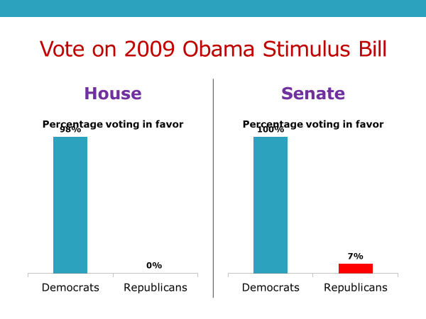
The legislation fit the Democratic party's philosophy of using government to promote economic security. And it mainly helped those who are part of its coalition-- manual workers, government employees, and the marginally employed.
In late 2010, the Congressional Budget Office estimated that the stimulus bill increased the number of full-time equivalent jobs by 2 to 5.2 million compared to what those amounts would have been otherwise.
But if the legislation worked as demand-side theory predicted, it added significantly to the federal debt. The $787 billion tab was paid with borrowed money.
That weakened its public support, which proved important when Obama came back to Congress to ask for a second stimulus bill. Republican opposition blocked it.
Now let's take a look at how the Federal Reserve responded to the economic downturn of 2008. The Fed quickly discovered that one of its tools, the reserve rate, wasn't going to be of much help. Demand for bank loans was weak. And banks had lots of cash on hand.
So lowering the reserve rate, allowing banks to loan out a larger share of their assets, wasn't going to work.
On the other hand, in order to stimulate demand for loans, the Fed rapidly dropped the interest rate it charged member banks for their loans. The rate had been about 5% when signs of trouble in the housing market had first appeared. And by 2009, the rate had dropped to 1%. It would soon go to one quarter of 1%-basically free loans to member banks.
The Fed was also buying securities at a fast clip. The effect was to put money into the hands of sellers, with the hope they would use it in ways that would stimulate economic growth.
By 2009, however, the Fed was running out of options. It had dropped interest rates to near zero. Nothing more could be done on that front.
So the Fed resorted to what's called quantitative easing, a tool of last resort.
It began to purchase the assets of member banks, such as their mortgage backed securities. The goal was to take risky securities off their hands in return for money that they could loan to firms and consumers and at historically low rates.
Now where did the Fed come up with the money to purchase those bank assets? For all practical purposes, the Fed created the money out of thin air. The Fed is the nation's central bank and, essentially, has the power to print money, and keep printing it.
And that's what it did from 2009 until it stopped in 2014. Never in the country's history had so much money been pumped into the economy. All told, the Fed spent more than $3 trillion on quantitative easing.
To give you a sense of how much money that is, it happens to be more money than is generated in a full year by the economy of any country on Earth except the United States, China, Japan, or Germany.
Economists' estimates of the effect of the Fed's efforts to stimulate the economy vary widely. But all concede that the Fed, more than any other institution, contributed to the economic recovery that took place after 2008.
But that's not the full story. Monetary policy--the theory--holds that if the money supply is excessive-if there's too much money in circulation-inflation will eventually occur. That's a fear going forward once the US economy gets on a stronger footing.
Critics of the Fed's tactics also point out that much of the money the Fed pumped into the economy didn't go into consumers' pockets or production increases, which would have stimulated the economy, instead much of it was used by banks and wealthy individuals to play the stock market, which rose sharply because of the influx of so much capital. That widened the income gap, in that the average taxpayer doesn't have the means to play the stock market.
A final issue of the Fed relates to how it operates.
On one side, admirers of the Fed point out that monetary policy is more flexible than fiscal policy. For instance, the Fed can drop its interest rate on a moment's notice, whereas fiscal policy, first, requires Congress to act and is then slow in its implementation. Money for new construction projects, for example, take quite a bit of time to work their way into the economy.
The Fed's admirers also like the fact that it is relatively free of the partisan conflict that can hamstring Congress.
The Fed's chair and the other six members of its board of governors are nominated by the president and confirmed by Congress. But once chosen, they're largely free to act on their own.
Yet to some critics, that's a problem. It means that the Fed is not fully accountable to the people's elected representatives.
And the critics note that some of its actions are aimed mostly at protecting its member banks. A possible case and point is the loans the Fed gave banks to keep them afloat after the market collapse in 2008. The Fed gave those institutions $7 trillion. That's 10 times the amount Congress gave them through its controversial TARP program.
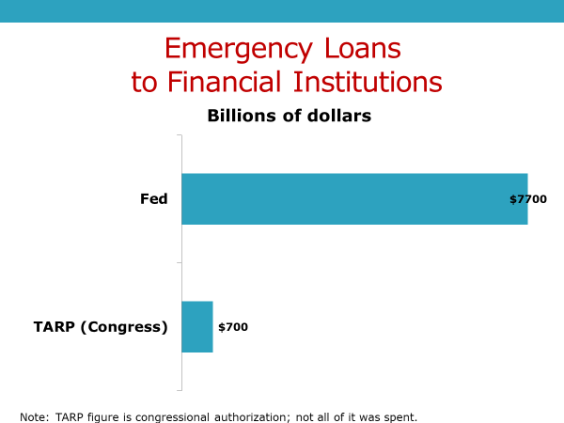
The American public was highly critical of TARP. They disliked the fact that Congress was bailing out banks, while leaving people who were losing their homes to fend for themselves. The public never had a chance to voice its opinion of the Fed's action because it was carried out in secrecy. When it came to light a few years later, the Fed claimed it had acted in secret so as not to panic world markets about the scale of America's banking crisis.
That's no doubt true. But the Fed clearly was protecting its member banks, using public resources to prop them up.
In most democracies, the central bank is subject to greater transparency and greater political control than is the Fed.
In some ways, the Fed's not unlike the federal courts. It operates largely outside the reach of a democratic majority. The justification for that, in the case of the courts, is pretty clear. They need to be independent if they are to protect minority rights. It's less clear why the Fed should have such wide latitude to act on its own.
Before wrapping up this session, let's look at a final example of the use of fiscal and monetary policy-the Federal Government's response to the steep economic downturn caused by the COVID-19 pandemic.
When COVID-19 struck in early 2020, the economic fallout was rapid and severe. Millions of Americans lost their jobs. And hundreds of thousands of businesses, large and small, closed their doors, with many of them facing bankruptcy.
Congress responded with several trillion dollars in stimulus spending. Some of it took the form of forgivable loans to enable firms to keep employees on the payroll. Some of it took the shape of grants to state and local governments to enable them to retain workers and maintain services. Unemployment benefits for the jobless were increased, and the period of eligibility was extended. To further stimulate the economy, most Americans received a direct cash payment from the Federal Government.
On the monetary side, the Fed cut interest rates to zero, allocated $700 billion for quantitative easing, and provided emergency loans to banks and municipalities.
Collectively, the actions of Congress and the Fed were the largest ever government response to an economic crisis. These actions did not prevent the permanent loss of many jobs and businesses, but the toll would have been far higher if government had not acted as quickly and fully as it did.
#
OK, let's wrap up this session.
We began by noting that the Great Depression was a watershed in thinking about the government's role in the economy. In that period, Keynesian economics-the idea that government through its spending should stimulate consumer demand to help reverse an economic downturn-gained support.
Since then, demand-side fiscal policy, which rests on action by Congress and the president, has been an instrument through which government seeks to manage the economy.
We also noted that, for reasons of their party philosophy and coalition, Democratic lawmakers are more inclined than Republicans to favor demand-side fiscal policy.
Republicans, also for reasons of their party philosophy and coalition, tend to favor supply-side fiscal policy where government-- again through action by Congress and the president-- cuts taxes on firms and upper income taxpayers.
The assumption behind supply-side policy is that with the extra money, moneyed interest will engage in activities that stimulate production--the supply-side-which will trickle down into more jobs and consumer spending.
The third economic instrument we discussed is monetary policy, which works through the Federal Reserve.
The Fed has a number of tools--reserve rates, interest rates, the buying and selling of securities, and quantitative easing-through which to manipulate the money supply.
The underlying theory is that expanding the money supply will stimulate the economy, while shrinking it will lead to economic contraction.
Finally, we pointed out that all three of these mechanisms can be effective, but that none of them is free of criticism, or of adverse consequences, or of political controversy.

