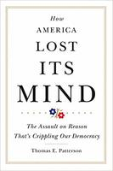
Americans are losing touch with reality. On issues from climate change to immigration, tens of millions of Americans have opinions wildly at odds with the facts, rendering them unable to think sensibly about politics. In How America Lost Its Mind, I examine the rise of a world of “alternative facts” and the resulting consequences. We don’t have to search far for the forces that are misleading us and tearing us apart: politicians for whom division is a strategy; talk show hosts who have made an industry of outrage; news outlets that wield conflict as a marketing tool; and partisan organizations and foreign agents who spew disinformation to advance a cause, make a buck, or simply amuse themselves. The consequences are severe. How America Lost Its Mind maps a political landscape convulsed with distrust, gridlock, brinksmanship, petty feuding, and deceptive messaging

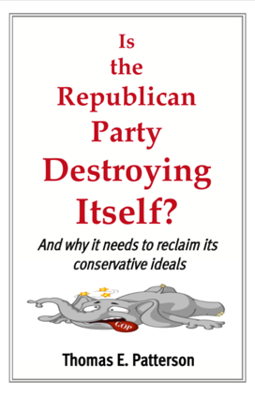
The book explores five traps that the Republican Party has set for itself and endanger its future. The traps vary in lethality but, together, they could cripple the party for a generation or more.
One trap is its steady movement to the right, which has distanced the party from the moderate voters who hold the balance of power in a two-party system. A second trap is demographic change. Younger adults and minorities vote heavily Democratic, and their numbers increase with each passing election. The older white voters that are the GOP’s base of support are shrinking in number. Within two decades, based on demographic change alone, the GOP faces the prospect of being a second-rate party. Right-wing media are the Republicans’ third trap. A powerful force within the party, they have tied the GOP to policy positions and versions of reality that are blunting its ability to govern and impeding its efforts to attract new sources of support. A fourth trap is the large tax cuts that the GOP has three times handed to the wealthy and that has created a split between its working-class supporters and marketplace conservatives. The fifth trap is the GOP’s disregard for democratic norms and institutions, including its effort through voter ID laws to suppress the vote of minorities and lower-income Americans. Such actions have made lasting enemies and created instruments of power that can be used against it.

